RNN
Feed forward NN: sequence on i/p vectors (token embedding) one by one & process
RNN preserves in memory (hidden state)

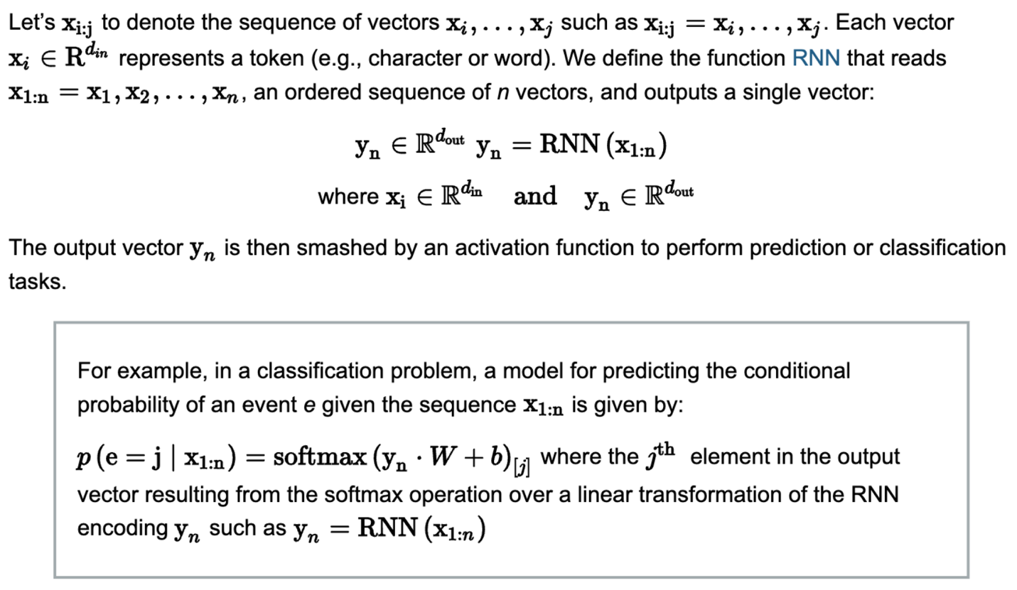

Vanilla RNN
R = step fn
O = o/p deterministic fn

S_i = R(s_i-1, x_i)
Where:
S_i-1 = prev hidden state (/input vector)
X_i = i/p vect
S_i = new hidden state vect
S_0 = initial hidden state vect = zero vect
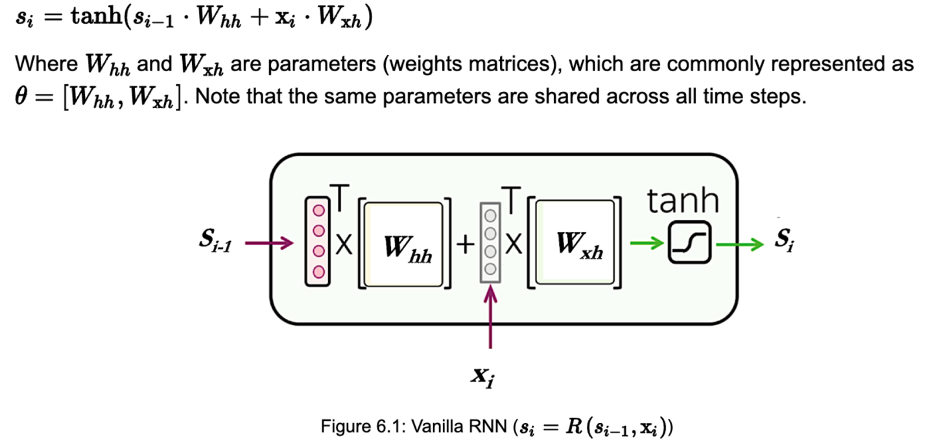
Tanh === non-linearity activation fn

Y_i = O(s_i)

RNN*
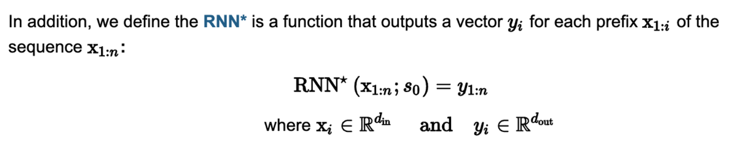

RNN Cell -> RNN cell(R, O)
applies the R and O functions to the previous hidden states
and current input to respectively returns the next hidden state and a potential output.
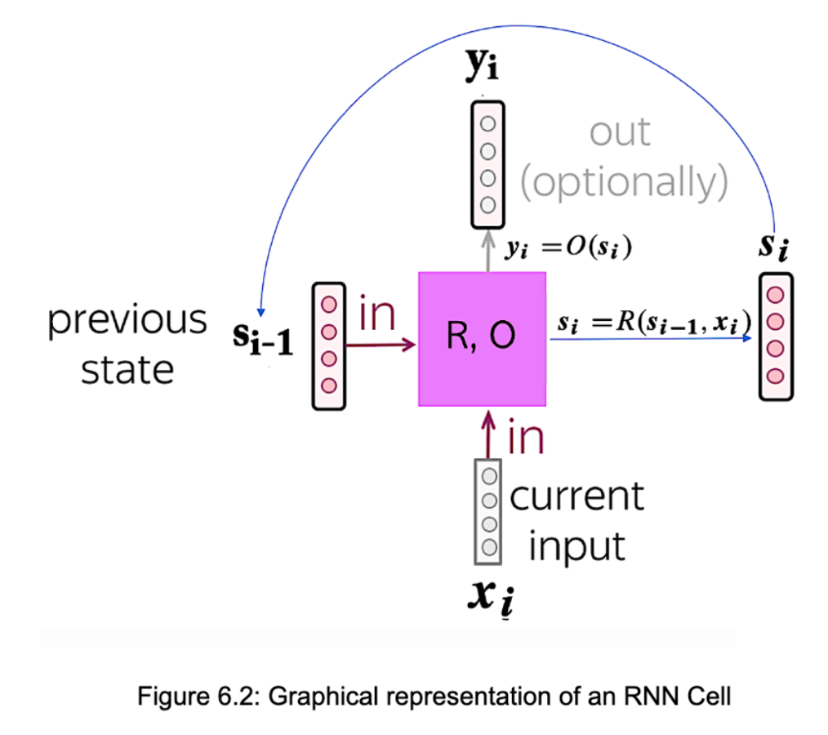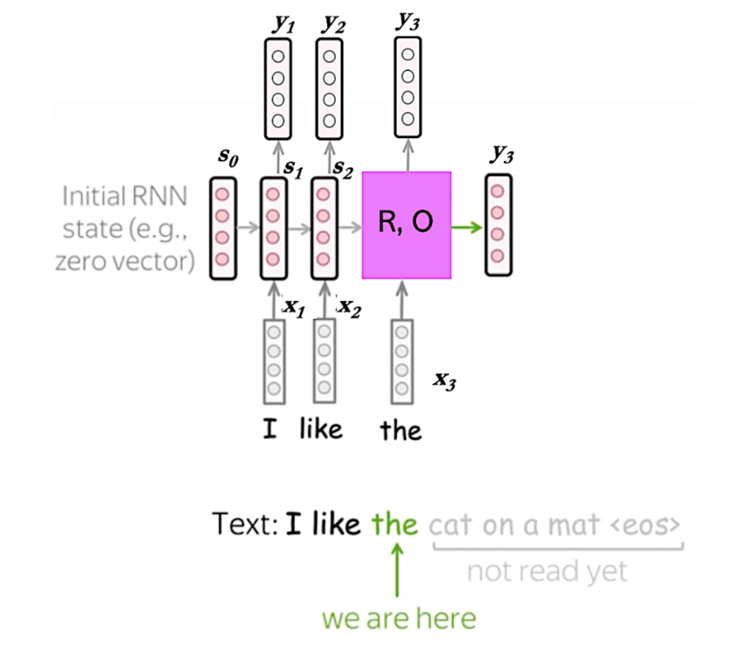outputs y1, y2, y3 are optional
- RNN training requires backpropagation through time (BPTT)
- Unrolled computation graph created
- Loss function added
- Used by backpropagation algo
- Backprop produces gradients and updates params wrt loss function
RNN usage patterns
- RNN-Acceptor -> single o/p (word to word translation)
Y_n=O(s_n)
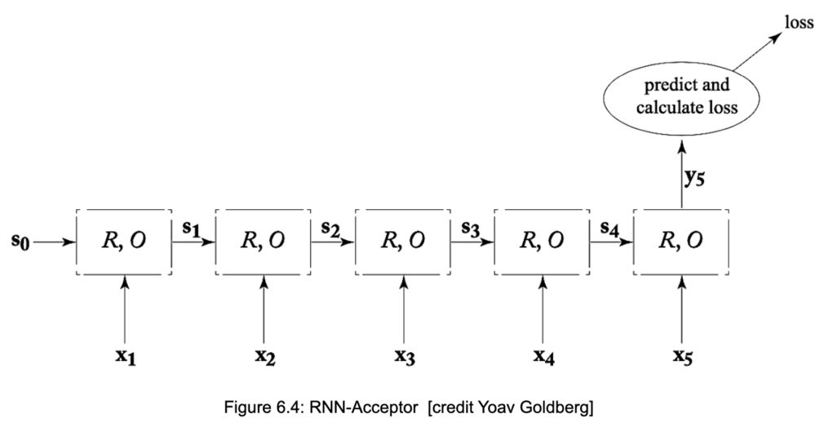

- Encoder -> encoding of entire sequence (machine translation)
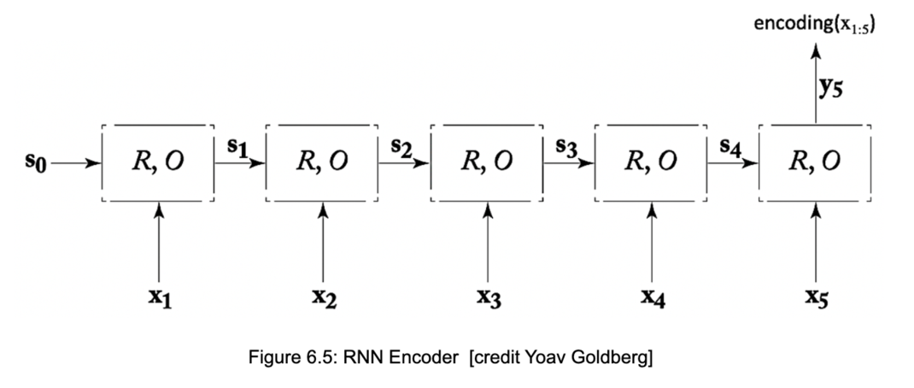

- RNN Transducer -> eg, 2 languages data used for training
o/p = t_i cap for each input sequence token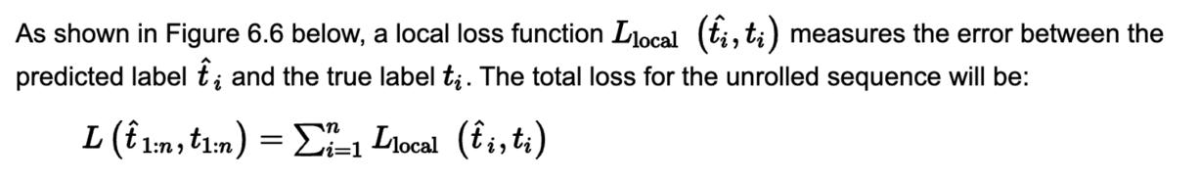
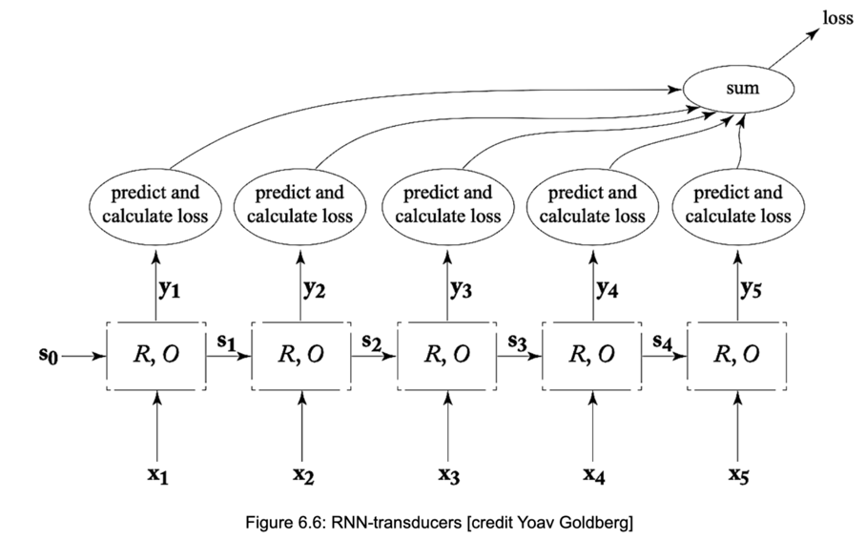
- Bidirectional RNN (Bi-RNN)
2 hidden states =
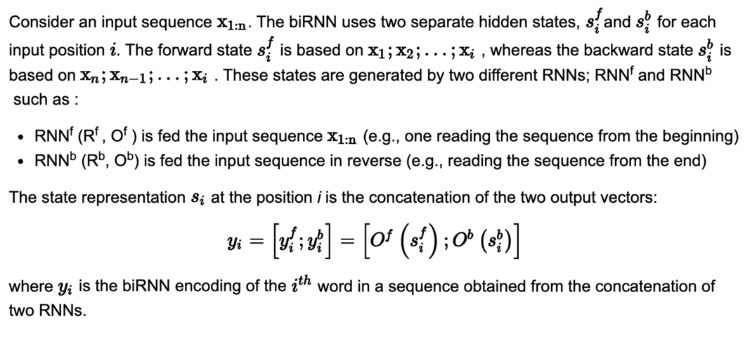

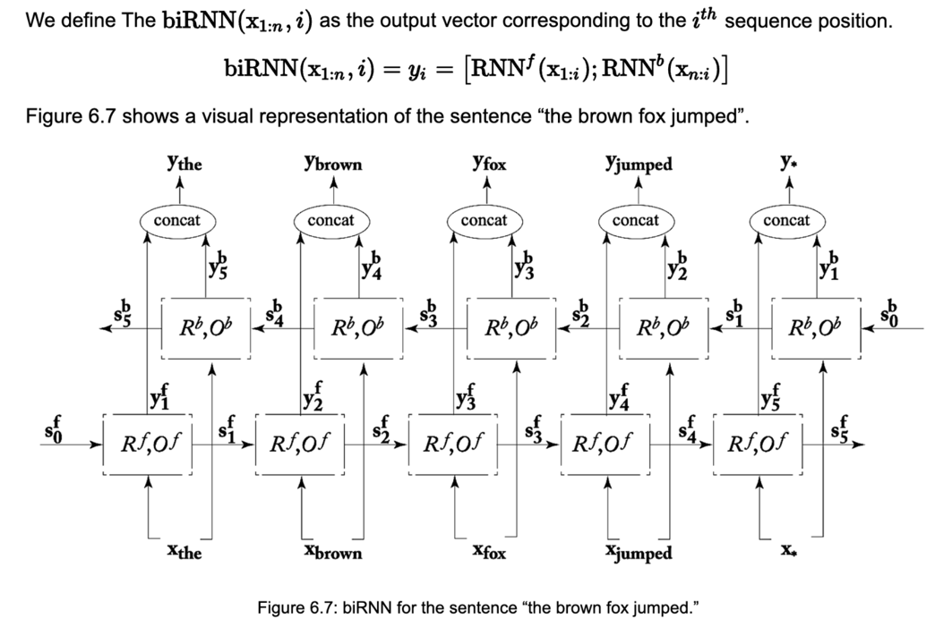

RNN Architectures
- RNN based CBOW

- Simple RNN

- LSTM – solves vanishing gradient problem
Vanishing gradient = o/p becomes too small
No learning happening in backpropagation
Gated architecture
(Long short-term memory)
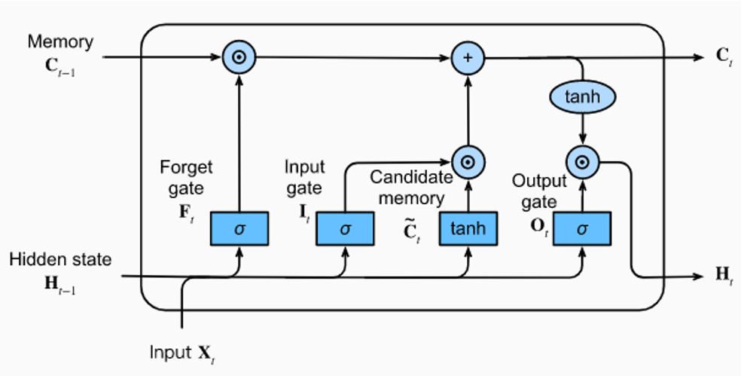

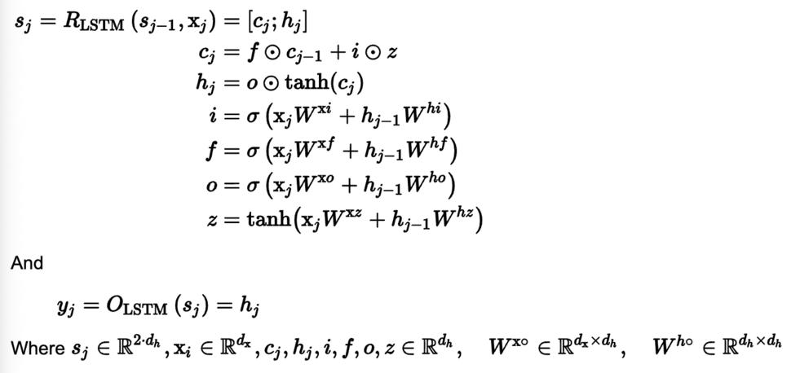
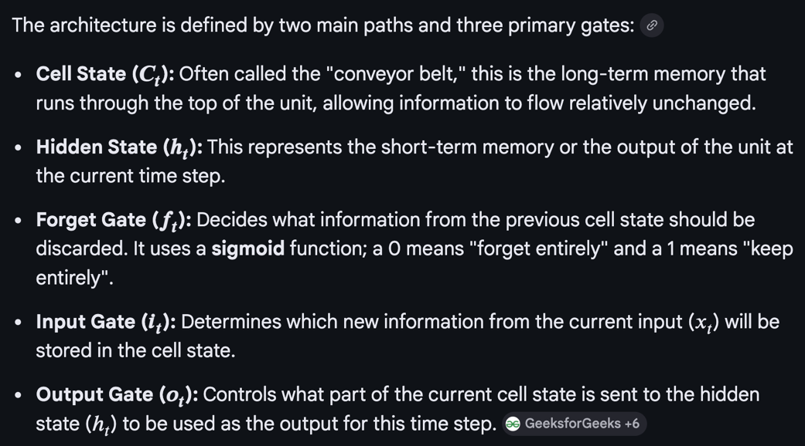
Splits state vector s_i into 2 parts = memory cells + working memory (when control over memory needed)
Slower to train bec parameters + gate
Work well on long sequences, complexity
Machine translation, speech recognition

Eg, LSTM = library
Forget gate = which old books to drop
Input gate = which new books to add
Self gate = self, where books are
Output gate = books to show

- GRU (gated recurrent unit)

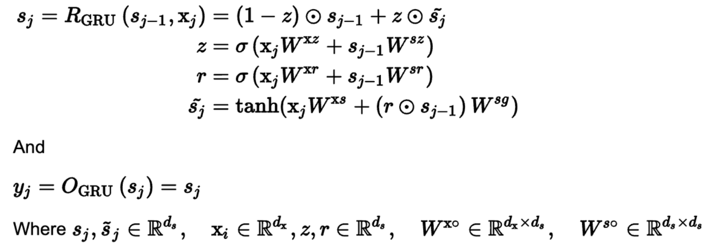
Don’t have separate cell state
Faster to train
Comparable to LSTM on several tasks in performance (not great)
Language modeling and machine translation
Miniature version of LSTM
Eg, GRU like a single bookshelf
Update gate = how to rearrange the shelf (old stuff out, new stuff in)
Reset gate = how much of old arrangement to consider in the rearranged shelf (time)
Hidden state = the current arrangement of books
