BABU BANARASI DAS UNIVERSITY, LUCKNOW
RetailPulse Sales Analysis using IBM Cognos Analytics and Power BI
A Descriptive Report
Name | Dev Kumar
Roll Number | 24
Course | BCA (Data Science & AI) - Descriptive Analytics
Section | BCADS23
Instructor | Ms. Monica Rao
Submission Date | 6 October 2026
Dataset | RetailPulse (sample dataset from Lab Manual)

1. Introduction and Objective
RetailPulse is a retail business that sells through eight stores spread across four regions of India: North, South, East and West. The stores sell four product categories: Electronics, Apparel, Home & Kitchen and Groceries. Managers of such a business need to know where their sales come from, which products matter most, and whether sales are rising or falling.
This report describes the analysis I carried out on the RetailPulse sales data using two tools from the course: IBM Cognos Analytics for building reports and dashboards (Practicals 1 to 6), and Microsoft Power BI for data preparation, modelling, DAX calculations and interactive reports (Practicals 7 to 10). I tried to answer these business questions:
- Which regions and stores produce the highest and lowest sales?
- Which product categories earn the most revenue, and which sell the most units?
- How did sales change from month to month between June and September 2026?
- Where is performance uneven, and what can a manager do about it?
Objective: to prepare the RetailPulse data, build Cognos reports (list, grouped list, filtered list, crosstab, prompt report and dashboard) and a Power BI model with measures and visuals, and then use the results to give clear, practical recommendations to a manager.
2. Dataset Description
Source: the RetailPulse sample dataset supplied by the course instructor in the Lab Manual. It contains 16 records and 6 columns. Each record is one sales entry for one store, one product category and one date. The data covers 23 June 2026 to 19 September 2026 and includes 4 regions, 8 stores (two per region) and 4 product categories. The full table is given in Appendix A.
Table 1: Fields in the RetailPulse dataset
Field | Type | Meaning
Order Date | Date | Date on which the sale was recorded (shown as Sales Date in the Cognos package).
Region | Text | Sales region: North, South, East or West.
Store | Text | Store code and name, for example RP-N01 Delhi Central. Each region has two stores.
Product Category | Text | Electronics, Apparel, Home & Kitchen or Groceries.
Units Sold | Whole number | Number of units sold in the record (called Quantity in the Cognos package and in some lab practicals).
Sales Amount | Currency (₹) | Total value of the sale in Indian rupees.

Overall size of the business in this data: total sales of ₹10,88,800 from 1,332 units, which gives an average of ₹68,050 per record.
3. Data Preparation
Before building any report, I checked the data and prepared it. Each step and the reason for it are listed in Table 2.
Table 2: Data preparation steps
Step | What was done | Why it was needed
1. Quality check | Checked all 16 rows and 6 columns for blank rows, missing values and duplicate rows. None were found. | Missing or repeated rows would give wrong totals.
2. Data types | Set Order Date to Date, Units Sold to Whole Number, Sales Amount to Fixed Decimal Number, and the other columns to Text. | Correct types are needed for sorting, date filters and sums.
3. Derived columns | Added Month (from Order Date), Sales per Unit (Sales Amount ÷ Units Sold) and Sale Size (Large if Sales Amount is 1,000 or more, otherwise Standard). | These make monthly analysis, price comparison and size grouping possible.
4. Check for unusual values | Compared Sales per Unit across all records. | Unusual prices or typing mistakes would distort the results.
5. Date table | Created a continuous Date table and linked it to Order Date in Power BI. | Time-intelligence functions in DAX need a separate, continuous date table.

Observations from the checks. The data was clean. Sales per Unit is the same for every record of a category: Electronics ₹3,000, Home & Kitchen ₹1,200, Apparel ₹800 and Groceries ₹200. This means differences in sales come only from the number of units and the product mix, not from price changes. Also, the smallest record is ₹24,000, so the Sale Size rule with a limit of 1,000 marks all 16 records as Large. For this dataset a higher limit (for example ₹75,000, which would mark 5 of the 16 records as Large) would separate the records more usefully.
4. Cognos Analytics Work
In IBM Cognos Analytics I built six connected reports against the RetailPulse Sales package and the RetailPulse Customers data module (Practicals 1 to 6). Each report builds on the one before it. All screenshots were taken on 6 October 2026.
4.1 First list report (Practical 1)
I opened IBM Cognos Analytics, chose New > Report, selected the RetailPulse Sales package and started from the List template. I dragged Region, Product Category and Sales Amount from the Source tab onto the canvas, ran the report and saved it as "RetailPulse - First Sales Report" in my personal folder. The run shows all 16 sales records with live data from the package, one row per sales entry, in the order they are stored.
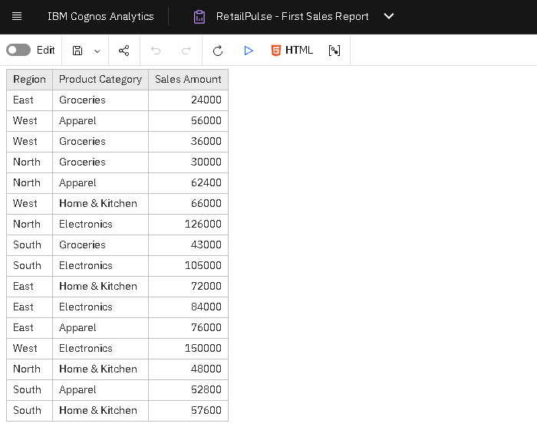
Figure 1: RetailPulse - First Sales Report (list with Region, Product Category and Sales Amount)
4.2 Grouped list report (Practical 2)
The second report is a list report with the columns Region, Store Name, Product Category, Quantity and Sales Amount. I grouped it by Region and then by Store Name, so each region and store appears only once instead of being repeated on every row. Sales Amount is shown as currency and right-aligned, a Total in the list footer adds up the sales of each group, and a page header shows the report title and run date. The output shows a total for each store, each region and the whole report (₹10,88,800). This report answers the question "how much did each store sell?" in detail.
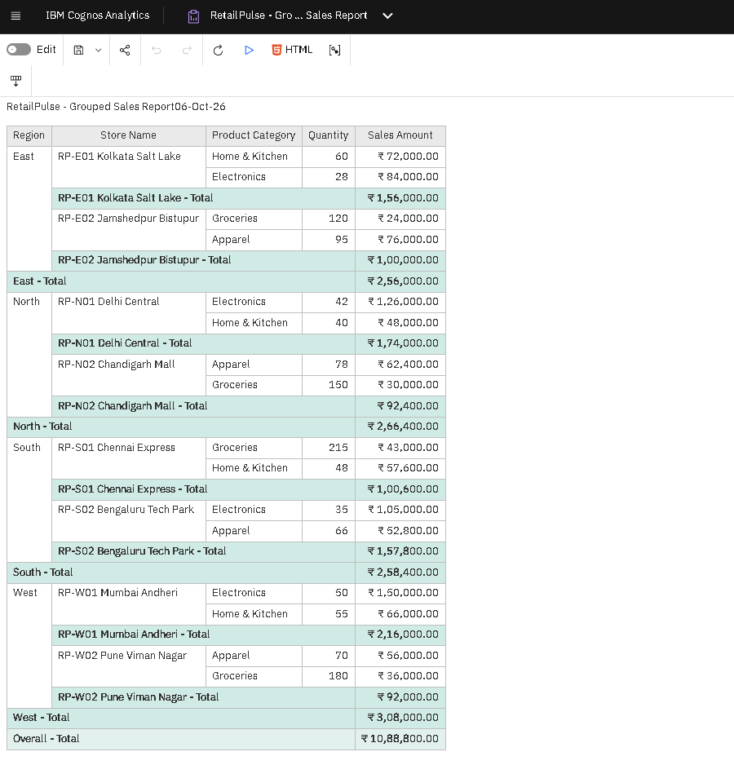
Figure 2: Grouped list report - sales by Region and Store with totals (Cognos Analytics)
4.3 Filtered report (Practical 3)
I added a simple filter, Region = "North", and an advanced detail filter that keeps only dates between the start and end of the quarter, joined with AND. With both filters the report shows only North rows dated in July to September 2026: 4 records, 310 units and ₹2,66,400, made up of RP-N01 Delhi Central (₹1,74,000) and RP-N02 Chandigarh Mall (₹92,400). The row count is clearly smaller than in the unfiltered report. I then turned the Region filter into a prompt so that other managers can reuse the report.
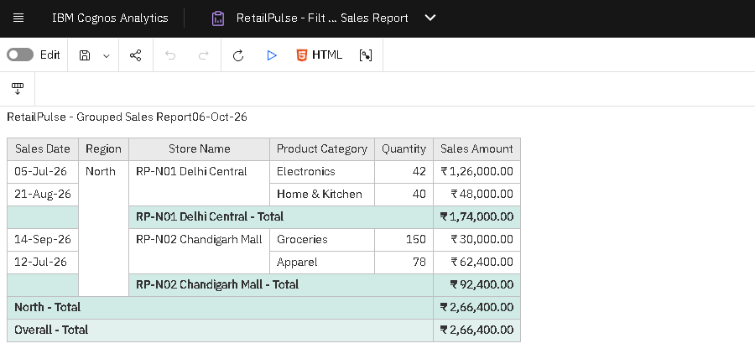
Figure 3: List report filtered to Region = North and Quarter 3 (July to September 2026)
4.4 Crosstab report (Practical 4)
The crosstab shows Region on the rows and Product Category on the columns. The cells hold Sales Amount formatted as currency, and row and column summaries give the totals. Table 3 lists the values shown by the crosstab; its grand total of ₹10,88,800 matches the total of the grouped list report in Figure 2.
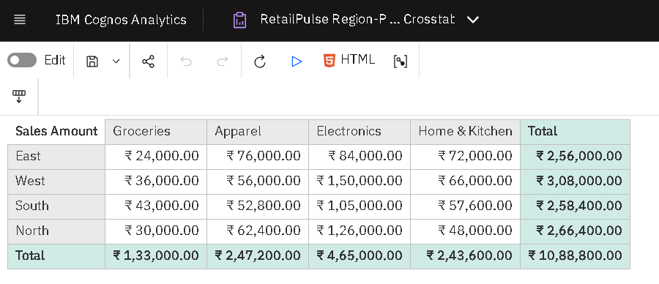
Figure 4: Region × Product Category crosstab with row and column totals
Table 3: Region × Product Category crosstab (Sales Amount in ₹)
Region | Groceries | Apparel | Electronics | Home & Kitchen | Total
East | 24,000 | 76,000 | 84,000 | 72,000 | 2,56,000
West | 36,000 | 56,000 | 1,50,000 | 66,000 | 3,08,000
South | 43,000 | 52,800 | 1,05,000 | 57,600 | 2,58,400
North | 30,000 | 62,400 | 1,26,000 | 48,000 | 2,66,400
Total | 1,33,000 | 2,47,200 | 4,65,000 | 2,43,600 | 10,88,800

4.5 Prompt report (Practical 5)
A prompt report lets the user choose the values before the report runs, so the report does not need to be edited. I added a prompt page in front of the crosstab with three controls: a Value prompt for Region, a Date-range prompt for the reporting period, and a cascading Value prompt for Store whose list changes when the Region changes. Each prompt is linked to a detail filter on the crosstab query by using the parameter name between question marks, for example [Region] = ?pRegion?. The Store filter is set to Optional so the report still runs when the user leaves Store on "All". A Finish button submits the prompts.
Table 4: Prompt controls and the filters they apply
Control | Type | Parameter | Filter on crosstab query
Region | Value prompt | pRegion | [Region] = ?pRegion?
Reporting period | Date-range prompt | pStartDate, pEndDate | [Order Date] between ?pStartDate? and ?pEndDate?
Store | Cascading value prompt | pStore | [Store] = ?pStore? (Optional)

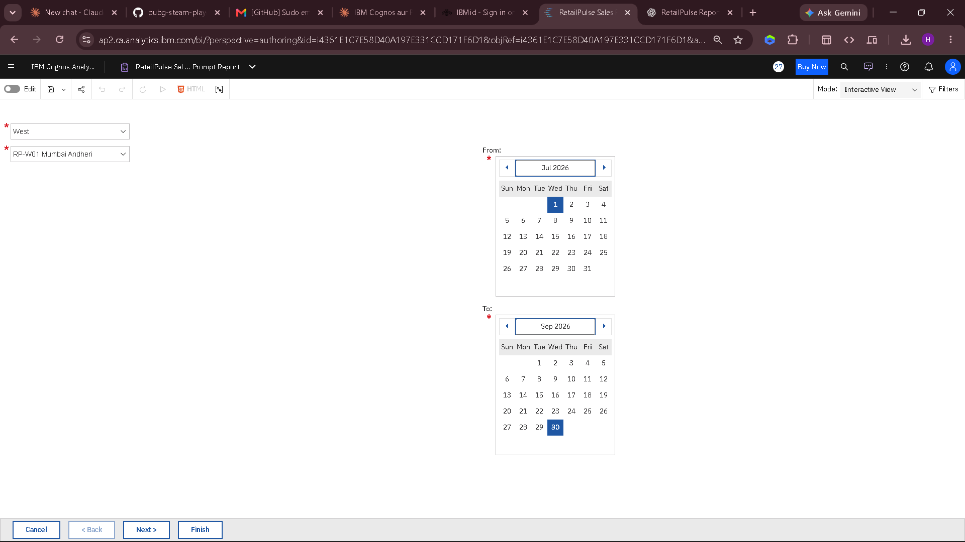
Figure 5: Prompt page with Region, date-range and cascading Store prompts
I tested the report with five cases. Table 5 gives the result that each test should return when the sample data is filtered, so the output on screen can be checked against it. Test 5 is the run shown in Figure 6.
Table 5: Test cases for the prompt report and the expected result
# | Prompt values | Expected result from the data
1 | North, 1 Jul to 30 Sep 2026 | 4 records, 310 units, ₹2,66,400
2 | South, 1 Jul to 30 Sep 2026; Store list shows only the two South stores | 4 records, 364 units, ₹2,58,400
3 | East, 1 Jun to 31 Jul 2026 | Only the 23-Jun and 30-Jul rows: 2 records, 180 units, ₹96,000
4 | West, 1 Jul to 30 Sep 2026 | 3 records, 285 units, ₹2,52,000 (the 27-Jun row is excluded)
5 | West, store RP-W01 Mumbai Andheri | 2 records, 105 units, ₹2,16,000 (Electronics ₹1,50,000 and Home & Kitchen ₹66,000)

In Figure 6 the prompts were set to Region = West and Store = RP-W01 Mumbai Andheri. The crosstab returns only the two categories sold by that store, Electronics ₹1,50,000 and Home & Kitchen ₹66,000, with a total of ₹2,16,000. This matches the Mumbai Andheri total in the grouped list report (Figure 2), which confirms that the prompts are linked correctly to the filters.
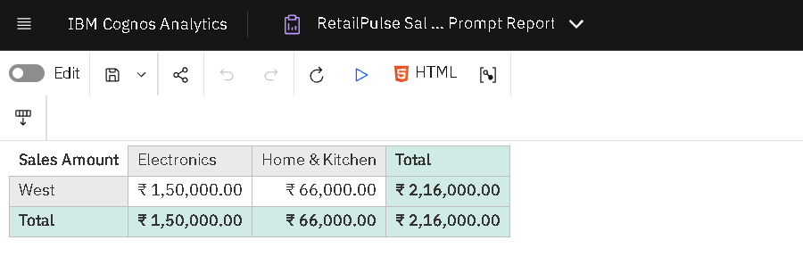
Figure 6: Crosstab returned after submitting the prompts (Region = West, Store = RP-W01 Mumbai Andheri)
4.6 Customer insights dashboard (Practical 6)
The dashboard connects to the RetailPulse Customers data module and combines three widgets with a shared Region filter: a summary card with the number of active customers, a line chart of new versus returning customers by month, and a bar chart of active customers by loyalty segment (Bronze, Gold, Platinum, Silver). With no filter the summary card shows 3,545 active customers (Figure 7). When the Region filter is set to North, all three widgets update together and the card drops to 849 (Figure 8). This is the main difference between a dashboard and a static report.
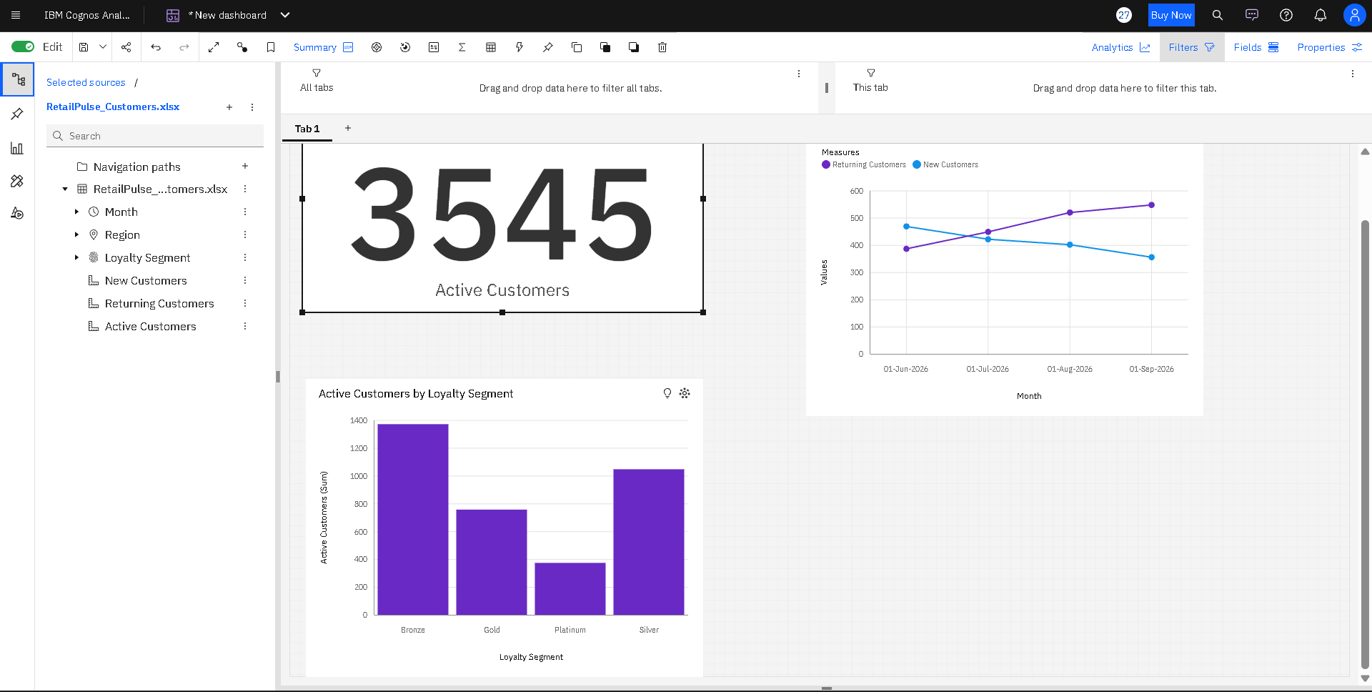
Figure 7: Customer insights dashboard for all regions (summary card, trend line and loyalty-segment bar chart)
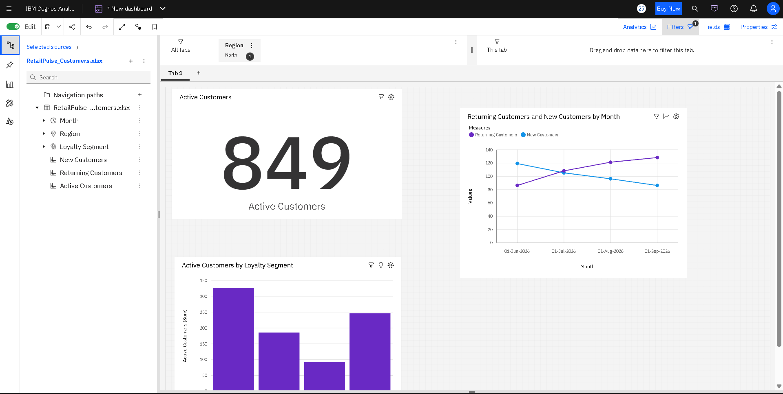
Figure 8: The same dashboard after the Region filter is set to North (all widgets update)
Reading the charts (values are approximate, read from the chart axes): across all regions returning customers rise from about 390 in June to about 550 in September, while new customers fall from about 470 to about 360, so the business is relying more on repeat customers. Bronze is the largest loyalty segment (about 1,400 active customers) and Platinum the smallest (about 370). The customer figures come from the Customers data module used in the practical and are not part of the six-column sales dataset used in the rest of this report.
5. Power BI Work
5.1 Importing and transforming the data (Practical 7)
I loaded the RetailPulse workbook into Power BI Desktop and opened the Power Query Editor. The Applied Steps list records every change: setting data types, checking for and removing blank and duplicate rows (none were found in this dataset), replacing null Quantity values with 0, and adding the Sale Size conditional column. Because Applied Steps are saved, they run again automatically when the data is refreshed.
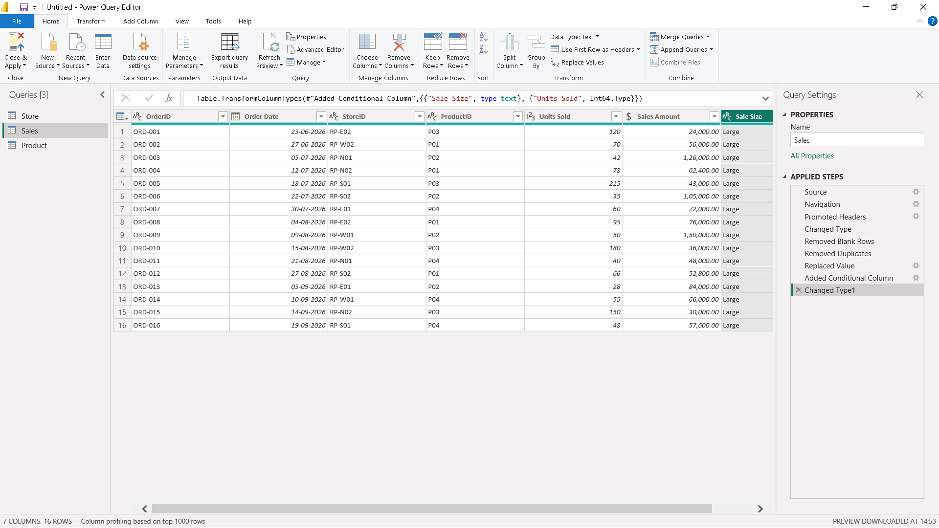
Figure 9: Power Query Editor with the Applied Steps for the Sales query
5.2 Data model and relationships (Practical 8)
In Model view the Sales table is the central (fact) table. The Product table and the Store table are connected to it by one-to-many relationships (Product[ProductID] to Sales[ProductID] and Store[StoreID] to Sales[StoreID]) with single-direction filtering. A dimension-to-fact design is preferred because each product and store is stored once, and a filter on a dimension flows down to the sales rows. A Date table is linked to Sales through the order date.
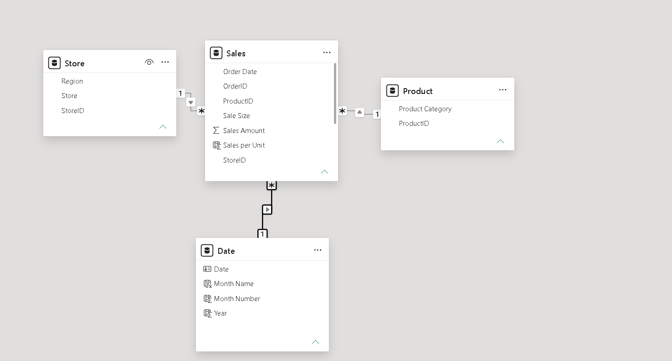
Figure 10: Power BI Model view showing Product, Store, Date and Sales tables with one-to-many relationships
5.3 DAX measures (Practicals 8 and 9)
I wrote the measures below. The column names follow the RetailPulse dataset in Table 1; the formulas can be adjusted if a workbook uses different column names. Total Units and Average Sales per Record are my names for the lab manual's Total Quantity and Average Order Value; because every record is a different order, they return the same values. The last column of Table 6 gives the value each measure should return for the full dataset.
Table 6: DAX measures and the values they return for the full dataset
Measure | Purpose | Result
Total Sales | Adds up Sales Amount | ₹10,88,800
Total Units | Adds up Units Sold | 1,332
Average Sales per Record | Total Sales divided by the number of records | ₹68,050
Sales per Unit (calculated column) | Price per unit for each row | ₹200 to ₹3,000
Region Share % | Share of each region in total sales | West 28.3%, North 24.5%, South 23.7%, East 23.5%
Sales YTD | Running total of sales from 1 January | ₹10,88,800 by 19 Sep
Sales LY and YoY Growth % | Same period last year and growth over it | Blank (data covers under one year)

Total Sales = SUM(Sales[Sales Amount])
Total Units = SUM(Sales[Units Sold])
Average Sales per Record = DIVIDE([Total Sales], COUNTROWS(Sales))
Sales per Unit = DIVIDE(Sales[Sales Amount], Sales[Units Sold]) -- calculated column
Sales YTD = TOTALYTD([Total Sales], 'Date'[Date])
Sales LY = CALCULATE([Total Sales], SAMEPERIODLASTYEAR('Date'[Date]))
YoY Growth % = VAR Curr = [Total Sales] VAR Prev = [Sales LY]
RETURN DIVIDE(Curr - Prev, Prev)
Region Share % = DIVIDE([Total Sales], CALCULATE([Total Sales], ALL(Store[Region])))

Why these functions were used. DIVIDE is used instead of the / operator because it returns a blank instead of an error when the denominator is zero. CALCULATE changes the filter context, and ALL removes the Region filter so that each region's sales can be divided by the total of all regions. VAR makes the YoY formula easier to read. A measure is calculated when the report is used, so it responds to slicers, while a calculated column is stored for every row.
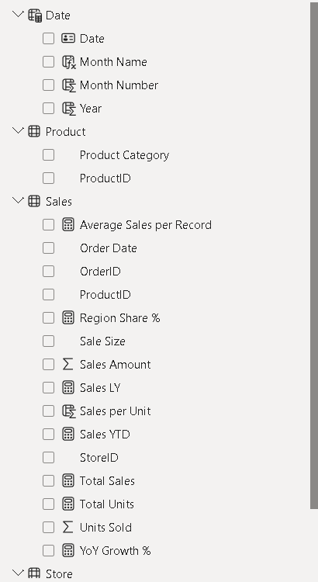
Figure 11: Measures and the calculated column in the Sales table (Power BI Data pane)
5.4 Report page and interactivity (Practical 8)
The report page has a card for Total Sales, a bar chart of Total Sales by Product Category, a line chart of Total Sales by month, and a slicer for Region. Clicking a bar or changing the slicer filters all the other visuals, which I used to confirm that the model works correctly. The Total Sales card shows ₹10,88,800, which equals the sum of the four category bars. A matrix below the charts lists Total Sales, Sales YTD, Sales LY and YoY Growth % for each month. Sales YTD grows from ₹80,000 in June to ₹10,88,800 in September, which equals the total. The Sales LY and YoY Growth % columns are blank because the data covers only about three months and has no earlier year to compare with, which is the expected behaviour.
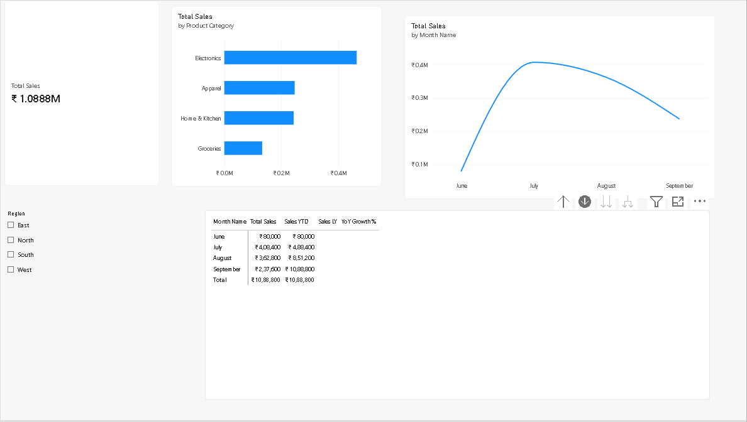
Figure 12: Power BI report page with card, category bar chart, monthly line chart, Region slicer and monthly matrix
5.5 Interactive report and Row-Level Security (Practical 10)
Practical 10 adds interactivity and access control to the report. Year and Region slicers are added, a drill-through page named Store Detail (drill-through field: Store Name) lets a manager jump from any store to its details, and two bookmarks with buttons switch the page between a chart view and a table view. Row-Level Security (RLS) then restricts what each manager can see. Two roles are created under Modeling > Manage roles, each with a DAX table filter on the Store table:
North Manager: Store[Region] = "North"
South Manager: Store[Region] = "South"

When View as is used to test a role in Power BI Desktop, the totals should change to that region only. With the RetailPulse data, the North Manager role should show a Total Sales of ₹2,66,400 (4 records) and the South Manager role ₹2,58,400 (4 records); the other regions are hidden. A user with Contributor or Admin access to the workspace is not restricted by RLS, so roles are tested with accounts that only have viewer access.
Status of Steps 4 to 6. The remaining steps of this practical need the Power BI service, Power Automate and Power Apps, which require a work or school account with a Pro or Premium Per User licence. I could not sign in to these services with my college account, so I was not able to complete them. They are: assigning the dataset roles to test accounts, pinning the Total Sales card to a dashboard with a data alert, creating a Power Automate flow that sends an email or Teams message when the alert fires, and adding a Power Apps visual to the Store Detail page. As the Lab Manual allows when licences are unavailable, these steps are to be demonstrated by the instructor. Their expected behaviour is described in the Lab Manual (the alert triggers the flow and a notification arrives; the Power Apps visual shows details for the store selected on the page), but I have not produced or tested these results myself.
6. Findings and Insights
6.1 Sales by region and by product category
West is the top region with ₹3,08,000 (28.3% of sales), followed by North (₹2,66,400, 24.5%), South (₹2,58,400, 23.7%) and East (₹2,56,000, 23.5%). The gap between the best and weakest region is ₹52,000, so West sells about 20% more than East. The other three regions are close to each other.
Electronics is the strongest category with ₹4,65,000 (42.7% of sales), although it accounts for only 155 units (11.6% of units). Groceries is the opposite: it sells 665 units (49.9% of all units) but earns only ₹1,33,000 (12.2% of sales). Apparel (₹2,47,200) and Home & Kitchen (₹2,43,600) are almost equal.
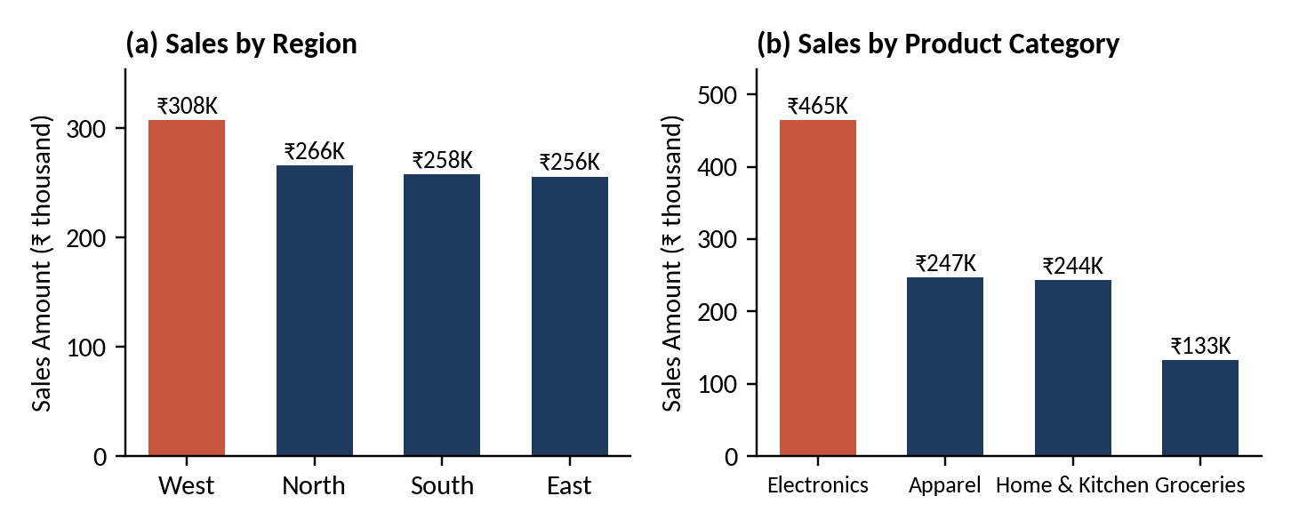
Figure 13: Sales Amount by Region (a) and by Product Category (b); the highest bar is highlighted
6.2 Trend over time
Sales were ₹4,08,400 in July and ₹3,62,800 in August (5 records each). September shows ₹2,37,600 from 4 records, and June shows ₹80,000 from 2 records. June and September are partial months: the data starts on 23 June and ends on 19 September. Therefore the lower September figure should not be read as a real fall in sales.
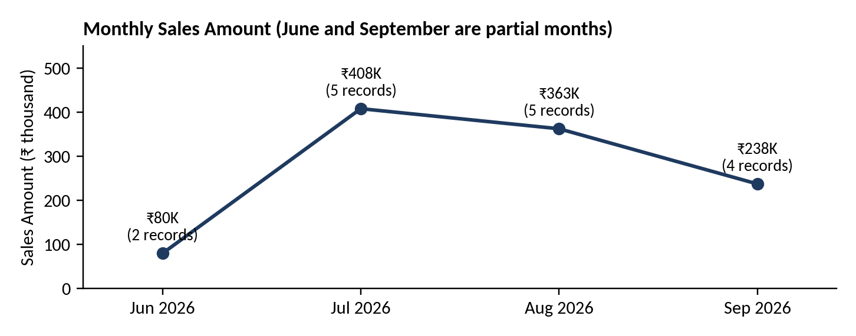
Figure 14: Monthly Sales Amount, June to September 2026
6.3 Store performance
RP-W01 Mumbai Andheri is the best store with ₹2,16,000 (19.8%), followed by RP-N01 Delhi Central (₹1,74,000). The lowest store is RP-W02 Pune Viman Nagar with ₹92,000 (8.4%). Both belong to the West region, so West's strong total hides a large gap between its two stores: Mumbai sells about 2.3 times as much as Pune.
A clear pattern appears in the data: only four stores have an Electronics record (Mumbai Andheri, Delhi Central, Bengaluru Tech Park and Kolkata Salt Lake), and these are exactly the four highest-selling stores. The four stores with no Electronics record (Chennai Express, Jamshedpur Bistupur, Chandigarh Mall and Pune Viman Nagar) are the four lowest-selling stores, each with only 8.4% to 9.2% of total sales.
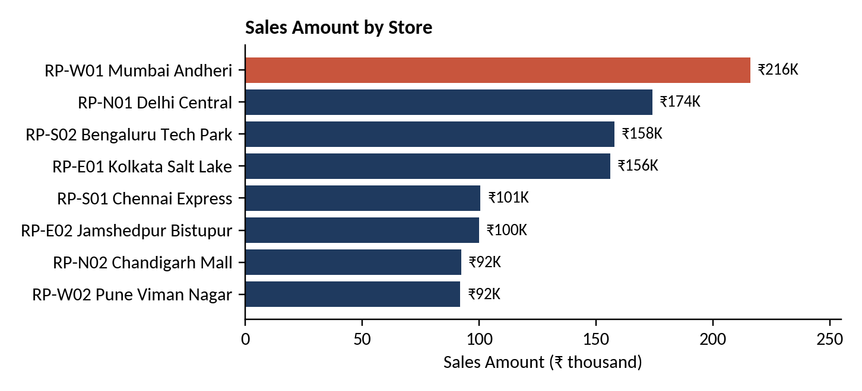
Figure 15: Sales Amount by Store, highest to lowest
6.4 Unusual values
No outliers or data errors were found. Sales per Unit is fixed for each category, and the largest single record is the Mumbai Andheri Electronics sale of ₹1,50,000 (13.8% of total sales). The expected prompt-report results in Table 5 were calculated from the same data, and the Cognos outputs in Figures 3 and 6 agree with them.
7. Recommendations
- Extend Electronics to the four stores that do not sell it. Electronics earns ₹3,000 per unit and gives 42.7% of sales from only 11.6% of units, and the four stores without any Electronics record are the four weakest stores. Offering Electronics there, starting with a small range, is the most promising way to raise their sales.
- Study Mumbai Andheri and copy its practices at Pune Viman Nagar. Both stores are in the West, yet Mumbai sells ₹2,16,000 and Pune ₹92,000. Comparing product range, stock and promotions between the two can show what Pune is missing.
- Use Groceries to bring customers in and pair it with higher-value products. Groceries makes up 49.9% of units but only 12.2% of sales. Bundles or offers that combine Groceries with Apparel or Home & Kitchen items can increase the value of each visit. Profit margins are not in the data, so this should be confirmed with cost figures.
- Keep the returning-customer trend growing. The dashboard shows returning customers rising while new customers fall (Figure 7). Loyalty offers for the large Bronze and Silver segments can move customers up to Gold and Platinum, and a new-customer campaign can stop the decline in new customers.
- Collect a longer and more complete data set and monitor it in Power BI. The current data covers about three months with partial first and last months. A full year or more would allow real trend and year-on-year analysis, and a Power BI alert on Total Sales would warn managers early about any fall.
8. Limitations
- Very small data: only 16 records, with four records for each category and each region, so the findings show patterns but are not proof.
- Short and partial period: data runs from 23 June to 19 September 2026. Year-on-year DAX measures cannot show values and monthly comparisons involving June and September are not complete.
- Fixed prices: every category has one price per unit, so the data does not show discounts or price changes. Profit and cost are also missing, so revenue is not the same as profit.
- Assumptions: each row is treated as one sales record; customer data for the dashboard in Section 4.6 comes from a different data module and was not combined with the sales data. The customer values quoted from the charts are approximate.
- Prompt defaults: the lab sets the default date range to the current quarter. When the report is run in a quarter that has no data (for example October to December 2026), the default range returns no rows, so the dates have to be set to July to September 2026.
- Power BI service steps: sign-in to the Power BI service with the college account was not possible, so Practical 10 Steps 4 to 6 (dataset role assignment, dashboard data alert, Power Automate flow and Power Apps visual) were not completed and are not part of the results in this report.
9. Conclusion
In this project I prepared the RetailPulse data, built list, grouped, filtered, crosstab, prompt and dashboard reports in IBM Cognos Analytics, and created a related data model with DAX measures and visuals in Power BI. The analysis shows total sales of ₹10,88,800, with West as the top region and Electronics as the top category. Electronics availability explains much of the difference between strong and weak stores, and Groceries brings volume but little revenue. I learned how prompts and filters make reports reusable, why a proper data model and date table matter, and how DAX measures respond to filters. The main limitation is the small, short data set, so the recommendations should be tested on larger data before major business decisions are taken.
10. References and Appendix
References and tools
- RetailPulse Business Analytics Lab Manual - IBM Cognos Analytics & Power BI (course material), Practicals 1 to 10.
- IBM Cognos Analytics documentation: https://www.ibm.com/docs/en/cognos-analytics
- Microsoft Power BI documentation: https://learn.microsoft.com/en-us/power-bi/
- DAX function reference: https://learn.microsoft.com/en-us/dax/
- Tools: IBM Cognos Analytics (cloud version), Power BI Desktop (free version), Microsoft Excel. Python (pandas, matplotlib) was used to verify the totals and to draw Figures 13 to 15 in Section 6.
Appendix A - RetailPulse sample dataset (16 records)
Order Date | Region | Store | Category | Units | Sales (₹)
23-Jun-2026 | East | RP-E02 Jamshedpur Bistupur | Groceries | 120 | 24,000
27-Jun-2026 | West | RP-W02 Pune Viman Nagar | Apparel | 70 | 56,000
05-Jul-2026 | North | RP-N01 Delhi Central | Electronics | 42 | 1,26,000
12-Jul-2026 | North | RP-N02 Chandigarh Mall | Apparel | 78 | 62,400
18-Jul-2026 | South | RP-S01 Chennai Express | Groceries | 215 | 43,000
22-Jul-2026 | South | RP-S02 Bengaluru Tech Park | Electronics | 35 | 1,05,000
30-Jul-2026 | East | RP-E01 Kolkata Salt Lake | Home & Kitchen | 60 | 72,000
04-Aug-2026 | East | RP-E02 Jamshedpur Bistupur | Apparel | 95 | 76,000
09-Aug-2026 | West | RP-W01 Mumbai Andheri | Electronics | 50 | 1,50,000
15-Aug-2026 | West | RP-W02 Pune Viman Nagar | Groceries | 180 | 36,000
21-Aug-2026 | North | RP-N01 Delhi Central | Home & Kitchen | 40 | 48,000
27-Aug-2026 | South | RP-S02 Bengaluru Tech Park | Apparel | 66 | 52,800
03-Sep-2026 | East | RP-E01 Kolkata Salt Lake | Electronics | 28 | 84,000
10-Sep-2026 | West | RP-W01 Mumbai Andheri | Home & Kitchen | 55 | 66,000
14-Sep-2026 | North | RP-N02 Chandigarh Mall | Groceries | 150 | 30,000
19-Sep-2026 | South | RP-S01 Chennai Express | Home & Kitchen | 48 | 57,600
Total |  |  |  | 1,332 | 10,88,800

