## FactItemAnalysis – Before

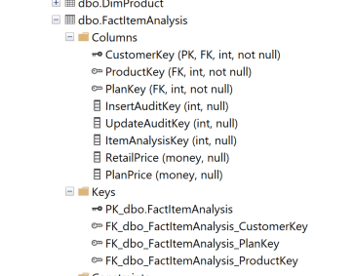

alter table [dbo].[FactItemAnalysis]

drop constraint [PK_dbo.FactItemAnalysis];

alter table [dbo].[FactItemAnalysis]

add constraint [PK_dbo.FactItemAnalysis]

primary key ([CustomerKey], [ProductKey], [PlanKey]);

## FactItemAnalysis – After

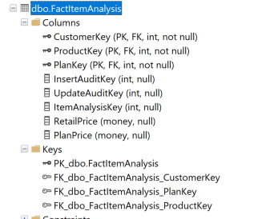

## FactRecommendationPlan – Before (no PK?)

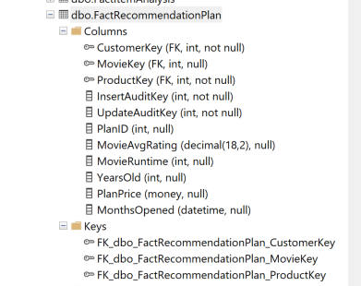

alter table [dbo].[FactRecommendationPlan]

alter column [MovieKey] int not null;

alter table [dbo].[FactRecommendationPlan]

add constraint [PK_dbo.FactRecommendationPlan]

primary key ([CustomerKey], [MovieKey], [ProductKey]);

## FactRecommendationPlan – After

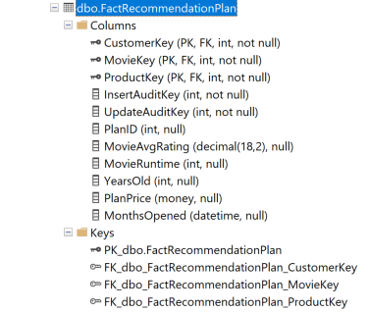

## FactSalesFulfillment – Before

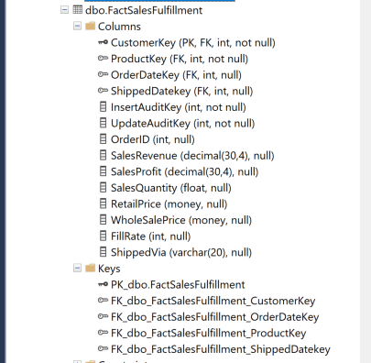

alter table [dbo].[FactSalesFulfillment]

alter column [OrderDateKey] int not null;

alter table [dbo].[FactSalesFulfillment]

alter column [ShippedDateKey] int not null;

--alter table [dbo].[FactSalesFulfillment]

--drop constraint [PK_dbo.FactSalesFulfillment];

select * from INFORMATION_SCHEMA.CONSTRAINT_COLUMN_USAGE where TABLE_NAME= 'FactSalesFulfillment' ;

alter table [dbo].[FactSalesFulfillment]

add constraint [PK_dbo.FactSalesFulfillment]

primary key ([CustomerKey], [ProductKey], [OrderDateKey], [ShippedDatekey]);

## FactSalesFulfillment – After

