Project Milestone 1

# Project Charter

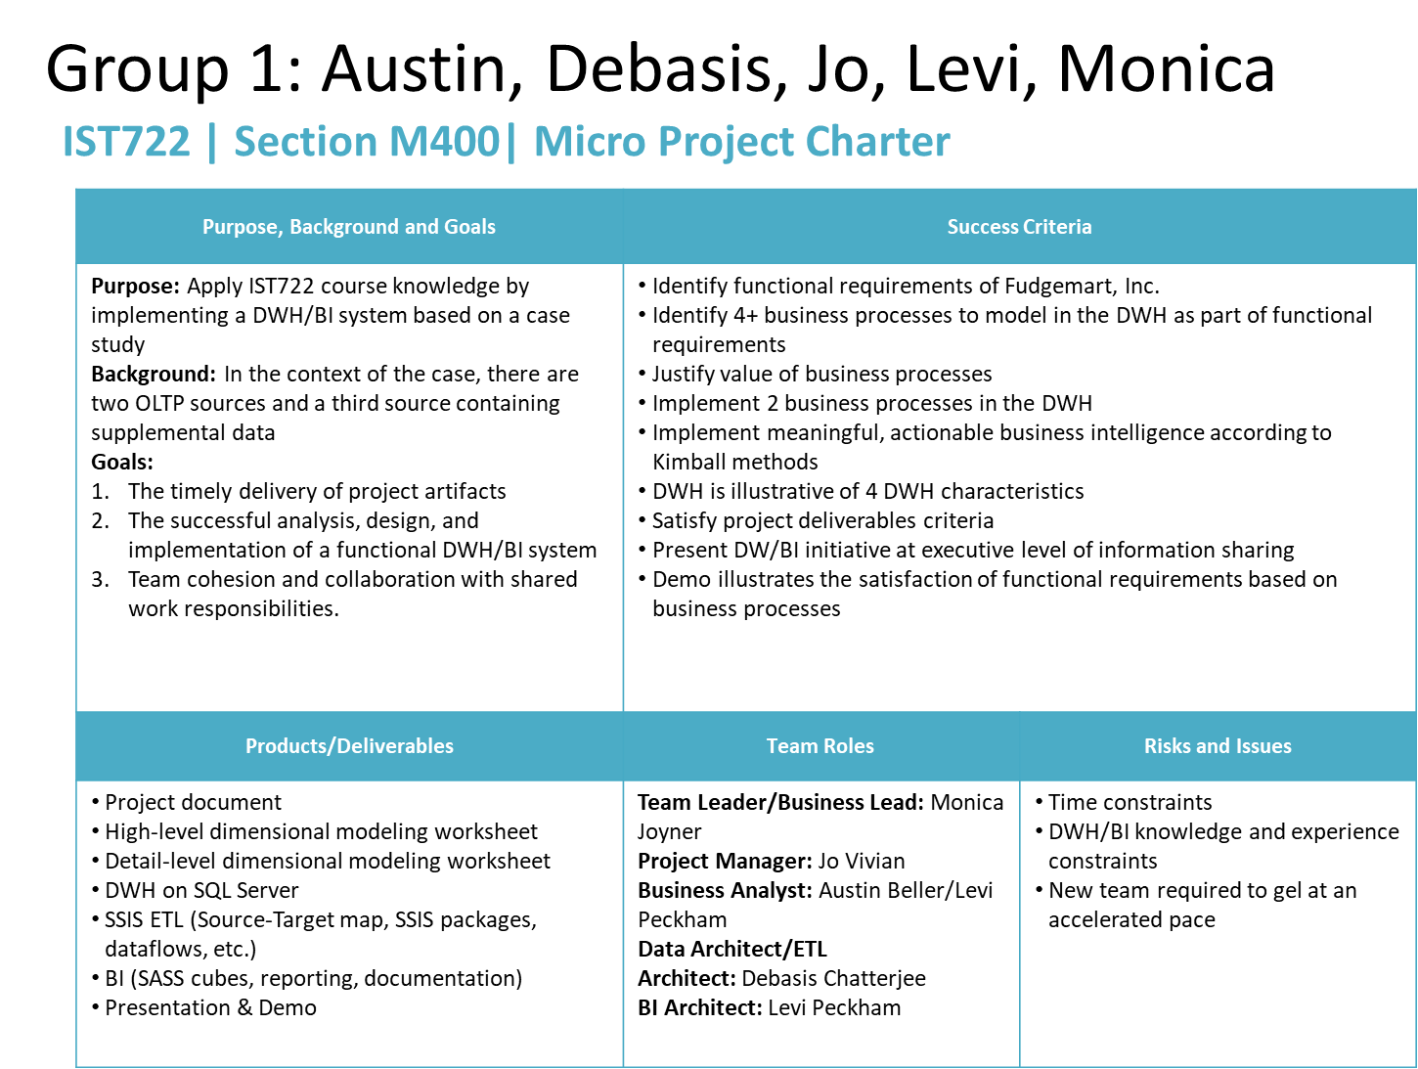

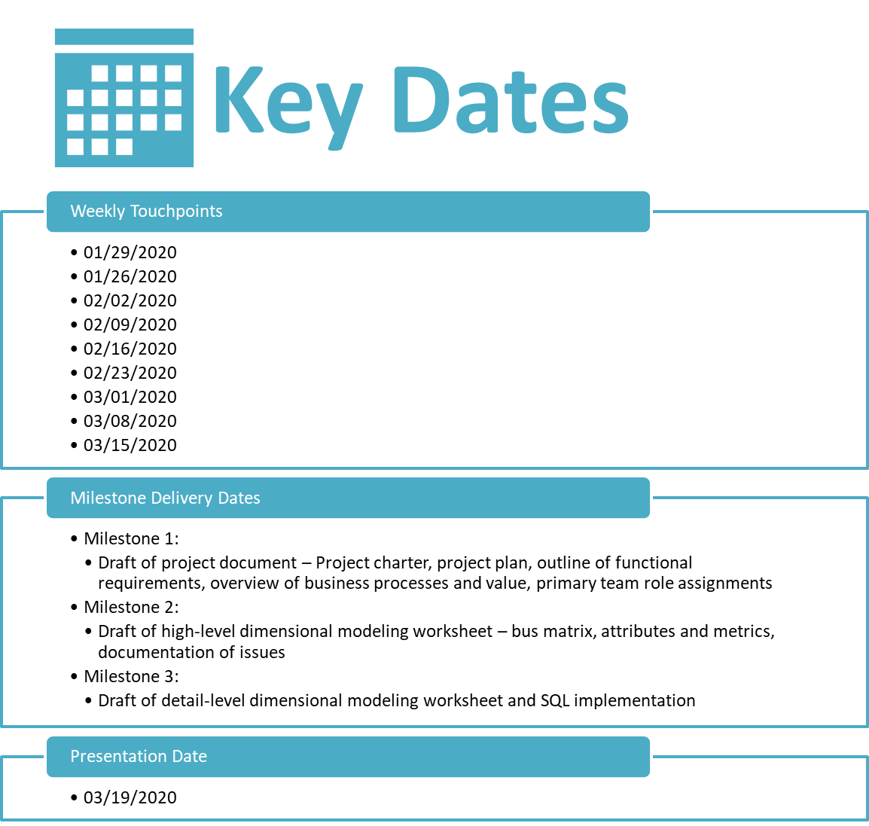

# Project Plan

# Outline of Functional Requirements

# Business Processes and Value

## Data Profiling Exercise

|  |  |  |  |  |  |
| --- | --- | --- | --- | --- | --- |
| Database | Table | Type | Row Count | Business Key | One Row is |
| Fudgeflix_v3 | [dbo].[ff_account_billing] | Business Process | 1,294 | [ab_date], [ab_account_id], [ab_plan_id] | An account billed for service |
| Fudgeflix_v3 | [dbo].[ff_account_titles] | Business Process |  |  |  |
| Fudgeflix_v3 | [dbo].[ff_accounts] | Master Data |  |  |  |
| Fudgeflix_v3 | [dbo].[ff_cast] | Master Data |  |  |  |
| Fudgeflix_v3 | [dbo].[ff_directors] | Master Data |  |  |  |
| Fudgeflix_v3 | [dbo].[ff_genres] | Master Data |  |  |  |
| Fudgeflix_v3 | [dbo].[ff_people] | Master Data |  |  |  |
| Fudgeflix_v3 | [dbo].[ff_plans] | Master Data |  |  |  |
| Fudgeflix_v3 | [dbo].[ff_title_genres] | Business Process |  |  |  |
| Fudgeflix_v3 | [dbo].[ff_titles] | Master Data |  |  |  |
| Fudgeflix_v3 | [dbo].[ff_zipcodes] | Master Data |  |  |  |
| Fudgemart_v3 | [dbo].[fm_creditcards] | Master Data |  |  |  |
| Fudgemart_v3 | [dbo].[fm_customer_creditcards] | Business Process |  |  |  |
| Fudgemart_v3 | [dbo].[fm_customer_product_reviews] | Business Process |  |  |  |
| Fudgemart_v3 | [dbo].[fm_customers] | Master Data |  |  |  |
| Fudgemart_v3 | [dbo].[fm_departments_lookup] | Business Process |  |  |  |
| Fudgemart_v3 | [dbo].[fm_employee_timesheets] | Business Process |  |  |  |
| Fudgemart_v3 | [dbo].[fm_employees] | Master Data |  |  |  |
| Fudgemart_v3 | [dbo].[fm_jobtitles_lookup] | Business Process |  |  |  |
| Fudgemart_v3 | [dbo].[fm_order_details] | Business Process |  |  |  |
| Fudgemart_v3 | [dbo].[fm_orders] | Master Data |  |  |  |
| Fudgemart_v3 | [dbo].[fm_products] | Master Data |  |  |  |
| Fudgemart_v3 | [dbo].[fm_shipvia_lookup] |  |  |  |  |

|  |  |
| --- | --- |
| Business Process | Value |
| Account Billing | Delivers CRM/account management information |
| Account Titles | Delivers insight into customer preference (impacts backlog priority) |
|  |  |