Austing Beller | Debasis Chatterjee | Monica Joyner | Levi Peckham | Jo Vivian

IST 722 | Section m400  | Team 1

The aggregators: group project

# Contents

Project Milestone 1 2

Project Charter 2

Key Dates 3

Project Plan 4

Outline of Functional Requirements 5

Business Processes and Value 5

Fudgeflix 5

Fudgemart 5

Data Profiling Exercise 6

# Project Milestone 1

## Project Charter

|  |  |  |
| --- | --- | --- |
| **Purpose, Background and Goals** | **Success Criteria** | |
| **Purpose:** Apply IST722 course knowledge by implementing a DWH/BI system based on a case study  **Background:** In the context of the case, there are two OLTP sources and a third source containing supplemental data  **Goals:**   1. The timely delivery of project artifacts 2. The successful analysis, design, and implementation of a functional DWH/BI system 3. Team cohesion and collaboration with shared work responsibilities. | * Identify functional requirements of Fudgemart, Inc. * Identify 4+ business processes to model in the DWH as part of functional requirements * Justify value of business processes * Implement 2 business processes in the DWH * Implement meaningful, actionable business intelligence according to Kimball methods * DWH is illustrative of 4 DWH characteristics * Satisfy project deliverables criteria * Present DW/BI initiative at executive level of information sharing * Demo illustrates the satisfaction of functional requirements based on business processes | |
| **Products/Deliverables** | **Team Roles** | **Risks and Issues** |
| * Project document * High-level dimensional modeling worksheet * Detail-level dimensional modeling worksheet * DWH on SQL Server * SSIS ETL (Source-Target map, SSIS packages, dataflows, etc.) * BI (SASS cubes, reporting, documentation) * Presentation & Demo | **Team Leader/Business Lead:**Monica Joyner  **Project Manager:**Jo Vivian  **Business Analyst:**Austin Beller/Levi Peckham  **Data Architect/ETL Architect:**Debasis Chatterjee  **BI Architect:**Levi Peckham | * Time constraints * DWH/BI knowledge and experience constraints * New team required to gel at an accelerated pace |

### Key Dates

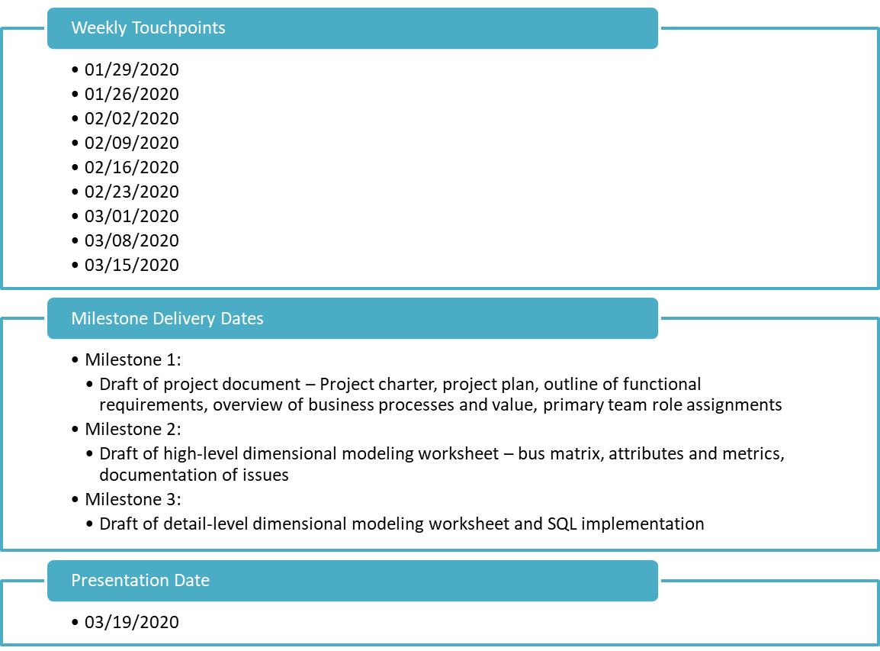

## Project Plan

## 

## Outline of Functional Requirements

1. Every time a customer orders an item that is logged to a worksheet which keeps track of how many times that item is sold
2. Every time a customer orders a product an email is sent to the customer reiterating the order then it emails when the item ships and when the item arrives
3. Employees and supervisors should be able to keep track of time.
4. Customers will be able to view what movies are available to rent
5. When a movie is rented it is then marked as out until no more copies are available which should then state the movie is unavailable.
6. When the account holder selects a plan, a message should be sent to mark which plan has been selected to the account holder thanking them.
7. Movies will be tracked via shipped and possible return date if the movie is close to the end of renting an email will be sent to the account holder.
8. All customers will have to submit a credit card before being able to order any products
9. Products will be ranked by favorability and rating, when a product falls below a set standard then the vendor will be notified the product is under review.
10. All employees must have a title.
11. Employees hours and payroll will be tracked and monitored by management.
12. All plans will be tier rated based on price with highest including streaming and lowest just offering shipping of DVD’s.

## Business Processes and Value

### Fudgeflix

#### BP 1

Track (USA?) Regional Distribution of Rental-Only Plans — may lead to reallocation of warehouse(s) and distribution optimization

ff_plans

ff_account_titles

FR: Weekly report by state indicating number of orders/qty

BI: Regional Heatmap

#### BP 2

Track Regional Increase/Decreases in Rental-Only vs. Streaming-Only Plans — may lead to reallocation of expenditure on tech infrastructure, bandwidth, etc.

ff_plans

FR: Monthly report by state indicating increases/decreases in plan types

### Fudgemart

#### BP 3

Track Employee Hiring and Length of Employment Duration — we aspire to have happy (!) full-time employees who are paid fairly, equally, and want to stay w/us

fm_employees

fm_jobtitles_lookup

fm_departments_lookup

fm_employee_timesheets

FR: Monthly report by department, supervisor, full-time status, hire/term date

BP 4

Track Regional Distribution of Orders by Department — we may wish to increase products or entirely eliminate departments based on sales; also optimize warehouse resources/distribution

fm_orders

fm_products

fm_departments_lookup

FR: Daily report of products sold aggregated by department per USA region (group of USA states)

### 

### Data Profiling Exercise

