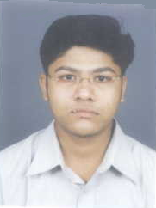

GAURANG SHAH

16 PASSPORT SIZE PHOTO

