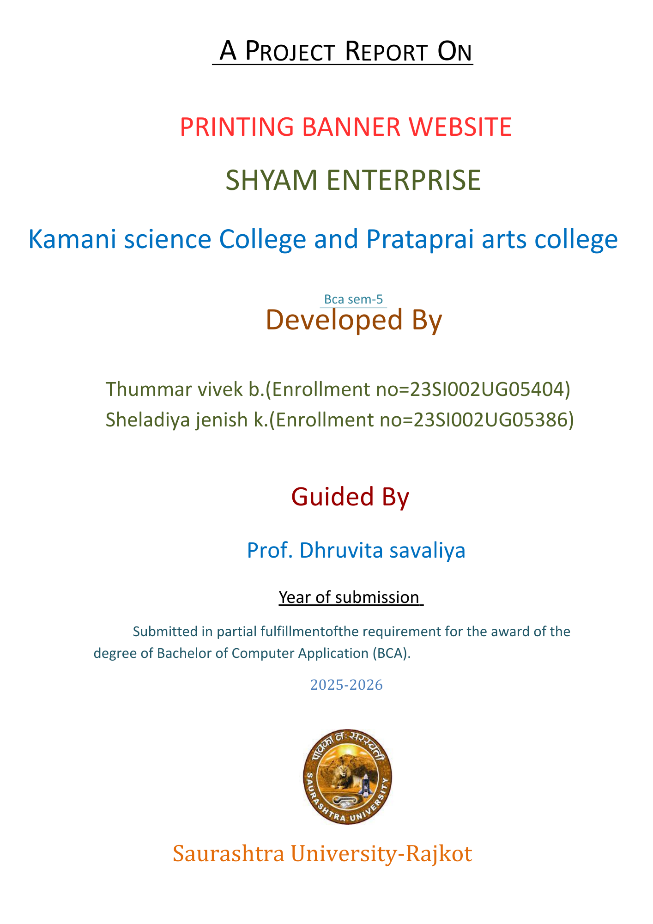

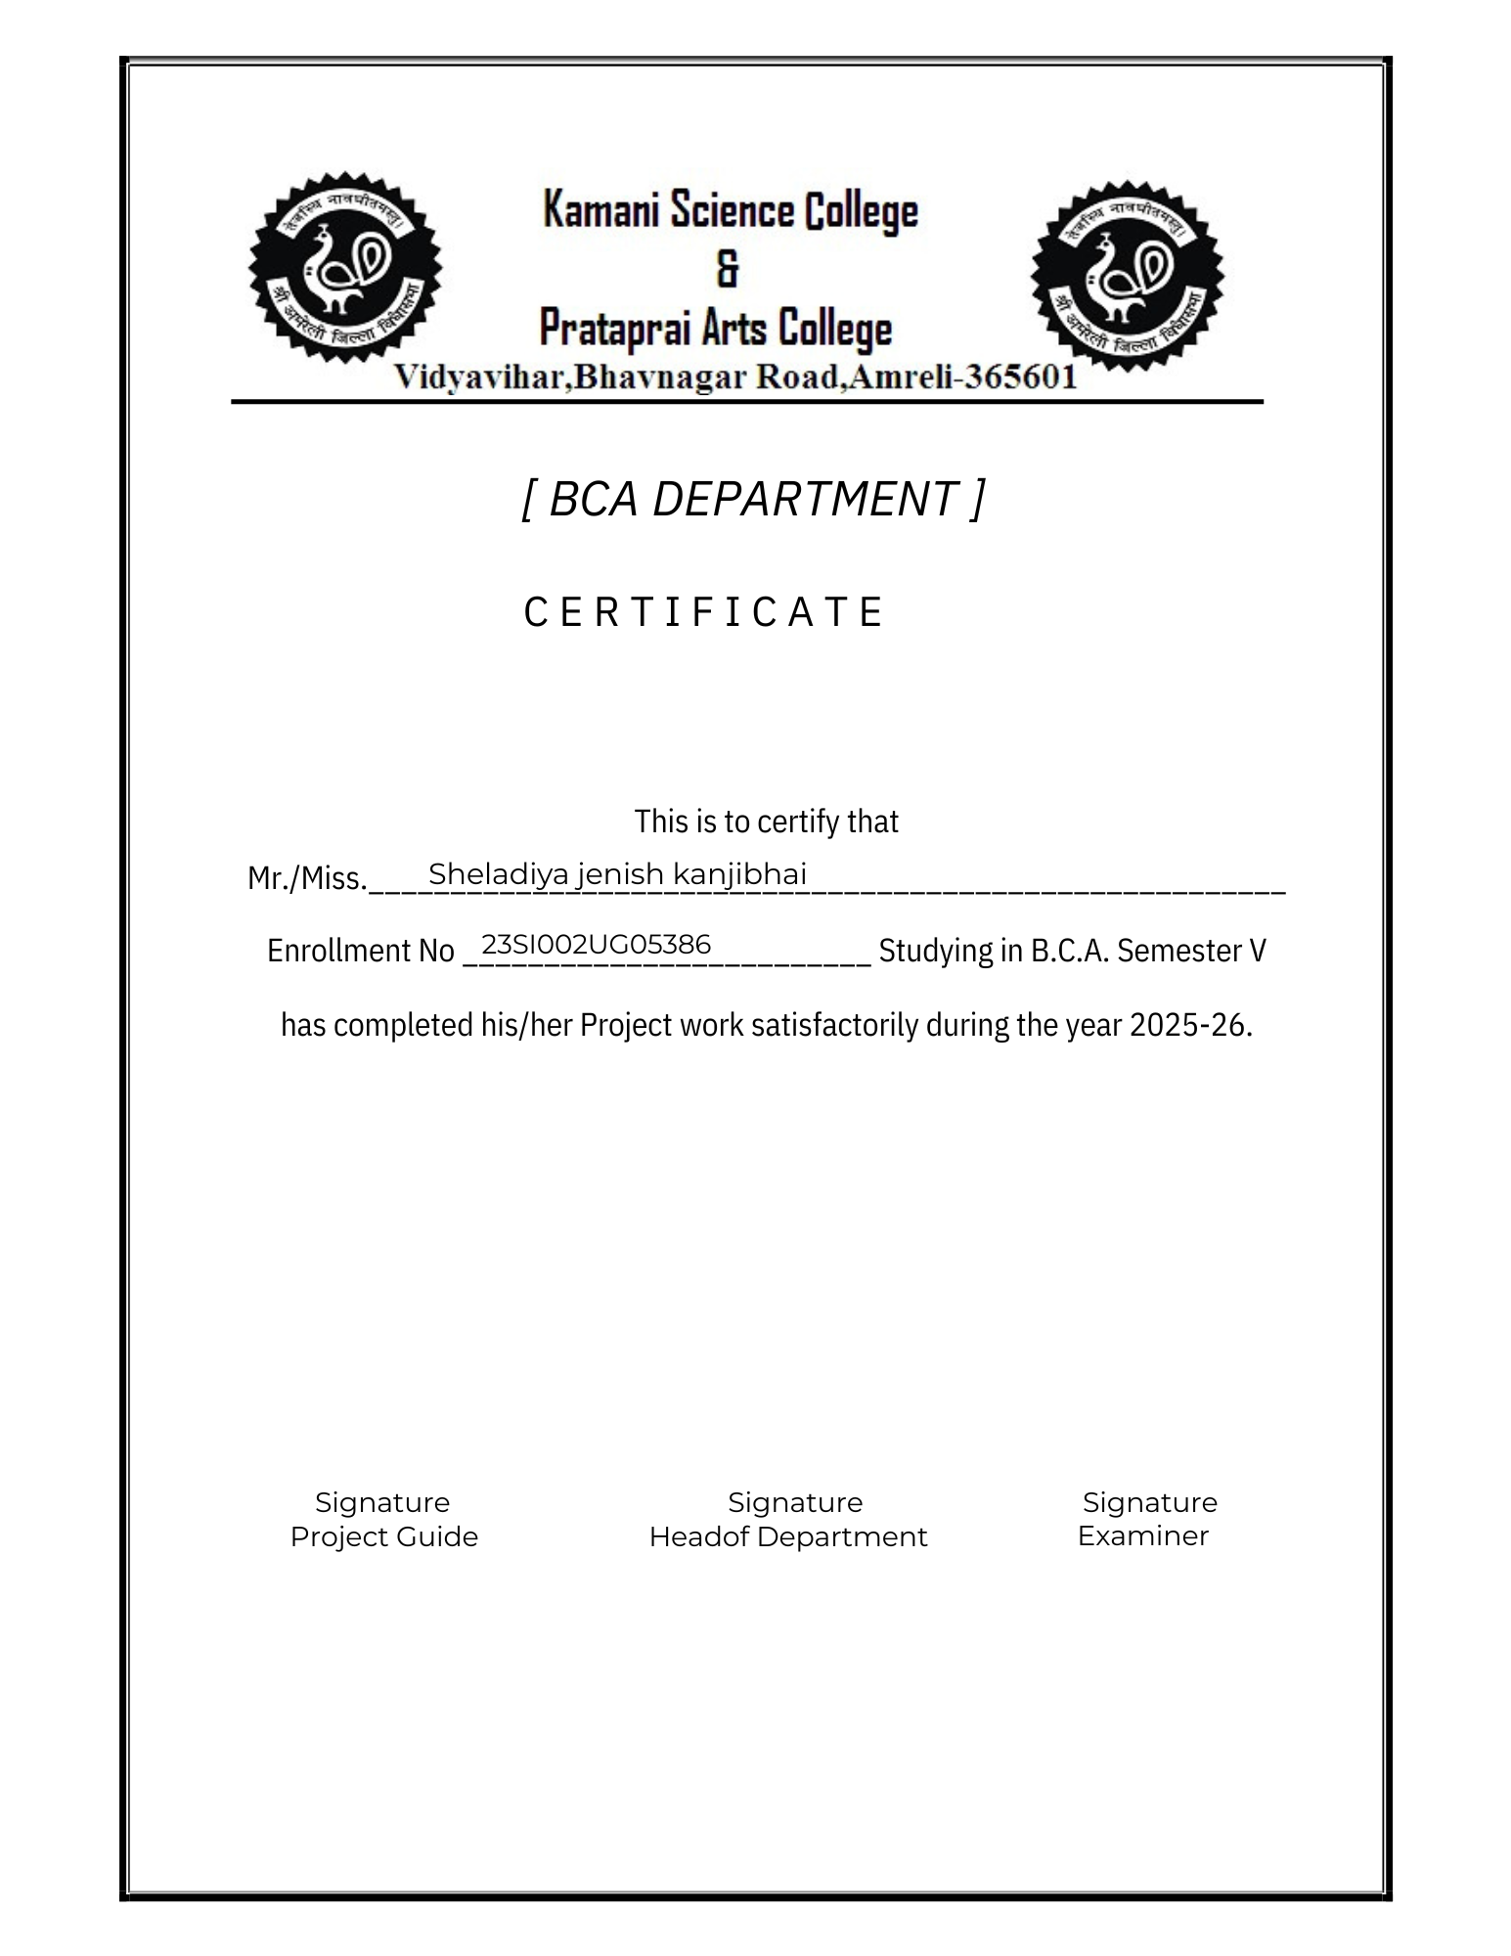

|  |  |  |
| --- | --- | --- |
| No | Index | Page no |
| 1 |  |  |
| 2 |  |  |
| 3 |  |  |
| 4 |  |  |
| 5 |  |  |
| 6 |  |  |
| 7 |  |  |
| 8 |  |  |
| 9 |  |  |
| 10 |  |  |
| 11 |  |  |
| 12 |  |  |
| 13 |  |  |
| 14 |  |  |
| 15 |  |  |
| 16 |  |  |
| 17 |  |  |
| 18 |  |  |
| 19 |  |  |
| 20 |  |  |
| 21 |  |  |
| 22 |  |  |
|  |  |  |

Preface

This project has been developed as a part of academic BCA Application.

The main objective of this project is to create a user-friendly online platform that allows customers to order customized cards.

This website aims to bridge the gap by offering a one-stop solution for placing printing orders online.

It provides features such as design provider, order and service provider.

This project has not only enhanced my understanding of user experience and client needs, but also provided practical knowledge of software development concepts.

Acknowledgment

I would like to express my sincere gratitude to my project guide [Prof. Dhruvita Savaliya], who provided me with valuable guidance, motivation, and continuous support throughout the completion of this project.

I am also thankful to [Kamani Science and Prataprai Arts college] and all faculty members of the Department of Computer Applications (BCA) for giving me the opportunity to work on this project and for their encouragement.

My heartfelt thanks to my friends and classmates for their cooperation, suggestions, and support during the preparation of this project.

Finally, I express my deep appreciation to my family, who always supported and encouraged me during this work. Without their blessings, this project would not have been possible.

Thanks to all

Sheladiya Jenish

Thummar Vivek

Abstract

The project titled “Shree Shyam Enterprises Website” is developed with the aim of creating a simple and effective web application for managing printing-related services such as banners, ID cards, and invitation cards. The system is designed using PHP as the front-end and MySQL as the back-end, making it a dynamic and database-driven platform. The website includes modules like Home, Services, Order Now, Contact Us, and About Us, which provide customers with an easy way to explore services and place their orders online.

To ensure smooth business operations, an Admin Panel has been incorporated where the administrator can manage customer orders, inquiries, services, and website content. This reduces manual effort, avoids paperwork, and ensures that data is stored in a structured manner for future reference. The project not only simplifies the interaction between the enterprise and its customers but also increases efficiency and accuracy in handling services.

By implementing this system, Shree Shyam Enterprises can expand its reach, improve customer satisfaction, and adopt a digital platform that saves time and enhances productivity. This project demonstrates how small-scale businesses can benefit from the use of information technology to modernize their operations and provide better services to their clients.

## SDLC

**Software Development Life Cycle (SDLC)** is a structured process that is used to design, develop, and test good-quality software.

SDLC, or Software Development Life Cycle, is a methodology that defines the entire procedure of software development step-by-step.

The Software Development Life Cycle (SDLC) outlines several tasks required to build a software application.

Requirement Analysis

Maintenance

Defining

Deployment

Designing

Testing

Coding

Introduction of project

In today’s digital era, businesses are rapidly moving towards online platforms to improve customer engagement and service efficiency. Small-scale enterprises also require simple and cost-effective solutions to showcase their services and interact with customers effectively. This project, entitled “Shree Shyam Enterprises Website”, is developed with the purpose of providing such a digital platform for Shree Shyam Enterprises, which offers services like banners, ID cards, invitation cards, and other printing-related products.

The website has been developed using PHP as the front-end scripting language and MySQL as the back-end database, which makes it dynamic, reliable, and user-friendly. It provides key modules such as Home, Services, Order Now, Contact Us, and About Us, which allow customers to explore information, view services, and place orders online in a convenient manner.

Additionally, an Admin Panel is included to manage services, handle customer inquiries, update website content, and keep records of orders systematically. This ensures smooth communication between the enterprise and its customers while reducing manual effort and paperwork. The project ultimately demonstrates how digital solutions can help small enterprises expand their reach, save time, and provide better customer satisfaction.

Requirement Gathering

(1) What is the name of your project?

    My project name is “Shree Shyam Enterprise”, a web-based printing service management system.

(2) What is the main purpose of your project?

    To manage online orders for banners, ID cards, and invitation cards.

(3) Which language did you use?

    I used PHP for backend programming and HTML/CSS.

(4) Which database did you use?

    MySQL was used as the relational database to store all project data.

(5) Which servers are required to run the project?

    The project runs on an Apache server using XAMPP.

(6) Which SDLC model did you follow?

    I followed the waterfall model because requirements were fixed and clear.

(7) What are the inputs of your system?

    Inputs include registration details, product information, and order data.

Time Line Chart:

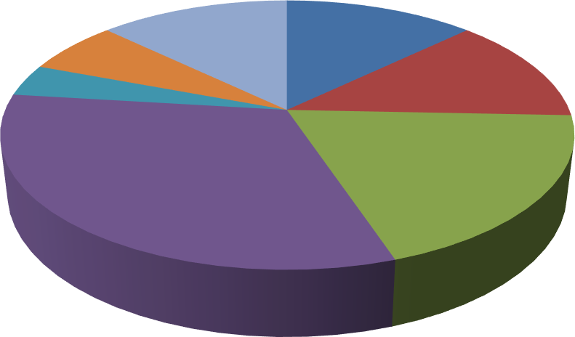

**Sales**

Priliminary

Investigation

13%

Implementation

6%

Testing4%

Maintanance

13%

System Analysis

13%

Coding

32%

SystemDesign

19%

PreliminaryInvestigation  10Days

SystemAnalysis  10Days

SystemDesign  15Days

Coding  25Days

Testing  3 Days

Implementation  5 Days

Maintenance  15Days

* **ProjectName :** Printing- Banner Website
* **Developedby :** Sheladiya jenish

Thummar vivek

* **FrontEnd tool :** PHP
* **BackEndtool :** PHP MySQL
* **OperatingSystem:** Microsoft Windows7&MicrosoftWindows10
* **ComputerSystem:** Pentium-IVorHigher, RAM:256MB
* **ProjectDetails :**This project provides an efficient online platform for Shree Shyam Enterprises. It simplifies order management, provides clear information about services, and enhances customer satisfaction by making services easily accessible online.
* **CompletionTime:** 3Months
* **Guidedby :** Prof. Dhruvita Savaliya
* **Submittedby :** Saurashtra University,Rajkot

## Hardware Requirement

* 512+MBOfRAM
* MultimediaKeyboardAndMouse
* GHzProcessor
* Monitor
* Printer

## Software Requirement

* + **OperatingSystem:** Microsoft windows7&Microsoft windows10
  + **FrontEndTools:**PHP,JavaScript,CSS,Ajax, SublimeText3
  + **BackEndTools :** PHPMySQL
  + **DocumentationTool:**Microsoft word2007
  + **BrowserSpecification:**GoogleChrome,MozillaFirefox

## Project Page Structure

* + - UserSide:

**User Side**

Logout

GetWork

GetApplication

Registration

/Login

PostWork

SendWork

Payment

* + - AdminSide:

**AdminSide**

ManagePayment

ManageEmployers

ViewAllWork

Login

View AllApplication

ManageFreelancers

Logout

**21**

DevelopBy**JayGohil**

DataDictionary

ThedataDictionaryisasetoftable .MySQLusesittomaintain information about this own database.

* **DatabaseName**: jenish_sheladiya

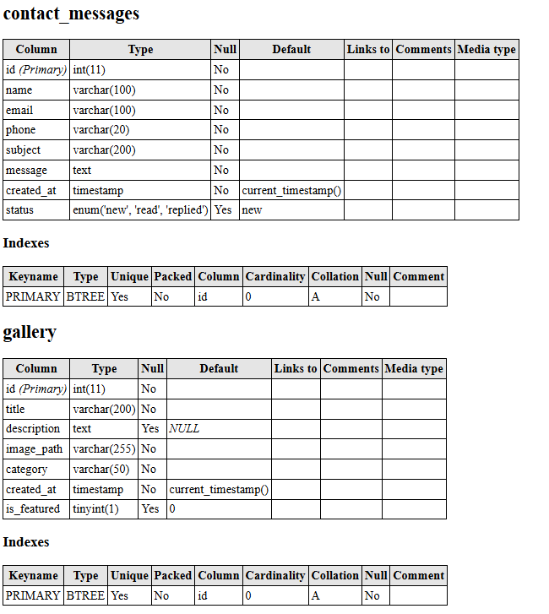

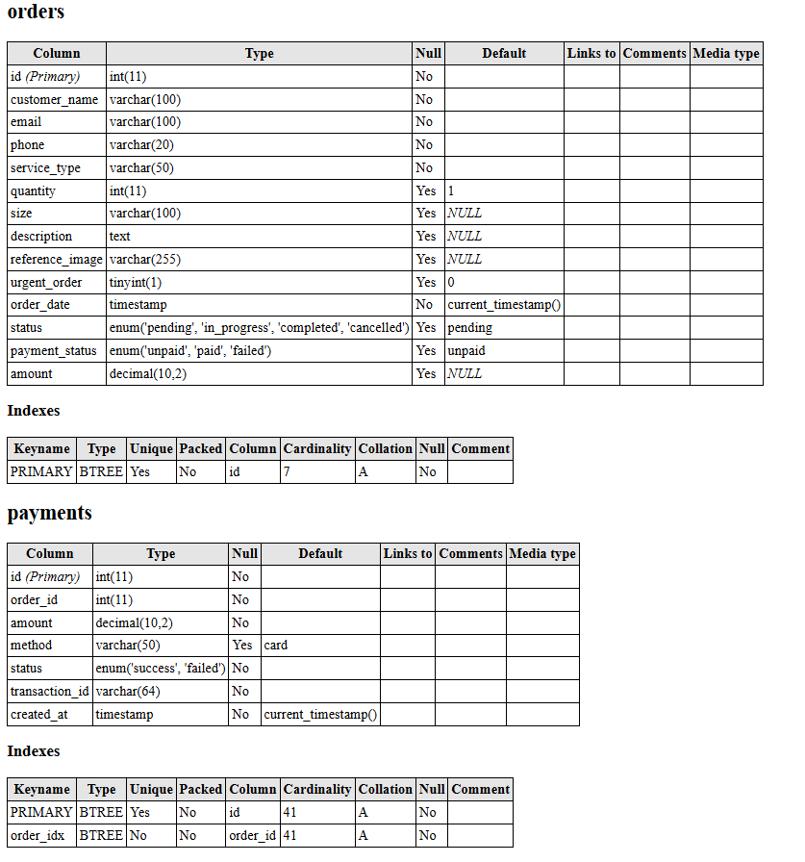

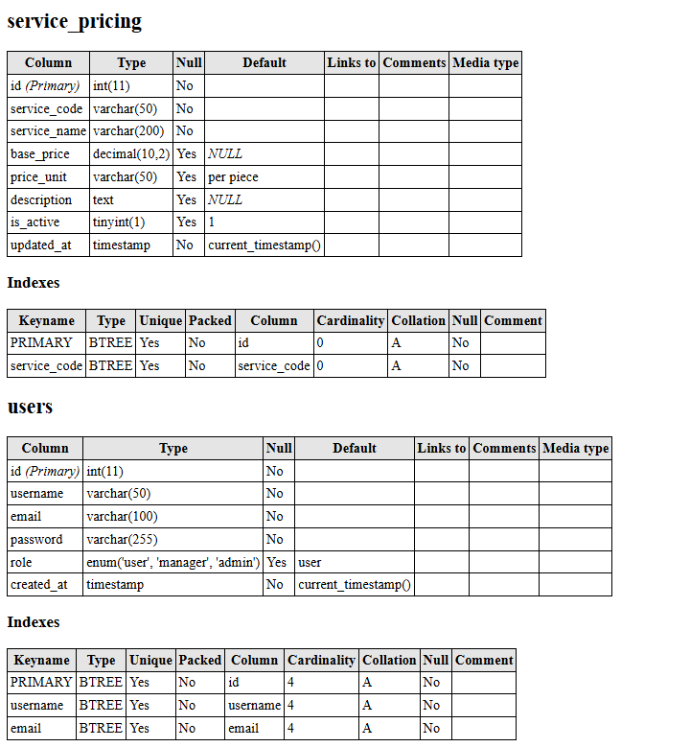

DataFlowDiagram

The DFD gives brief idea on how the designed system is working. It also suggests to us the type of users who using this system and the process involved in the system.

RepresentDataFlow

RepresentaEntity

Represent a DataTable

Representa Processing

ScreenShots:

Front Website

* HomePage :

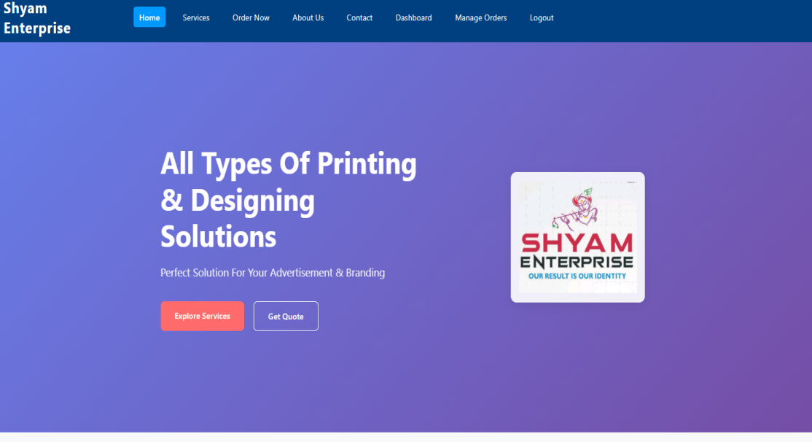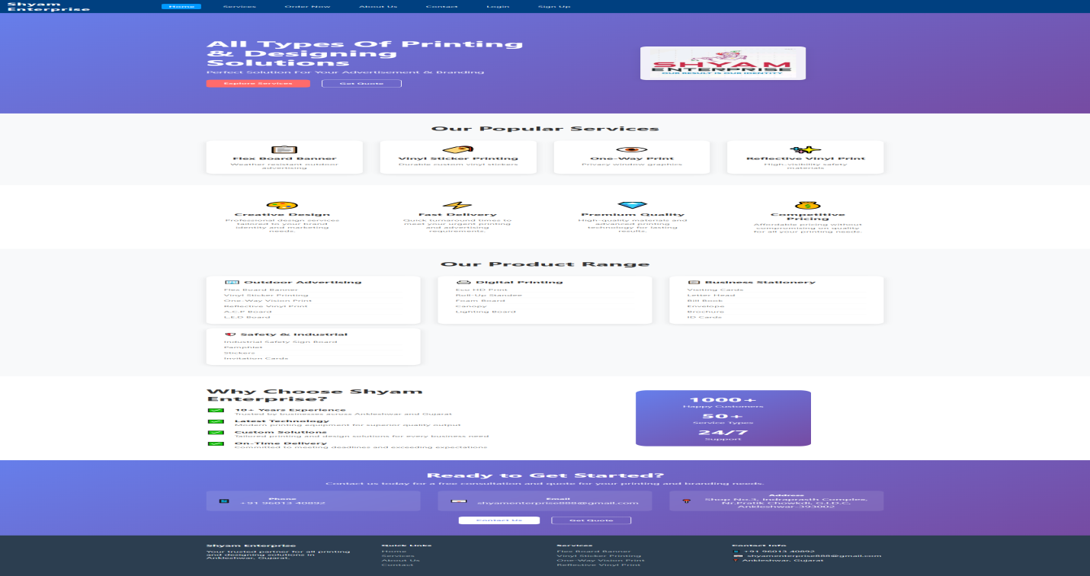

* LoginPage:

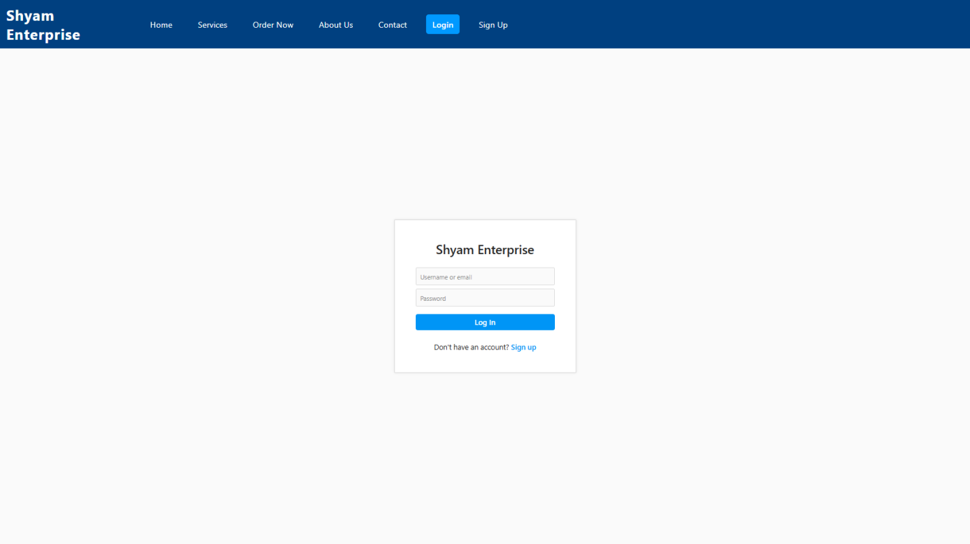

* RegisterForm:

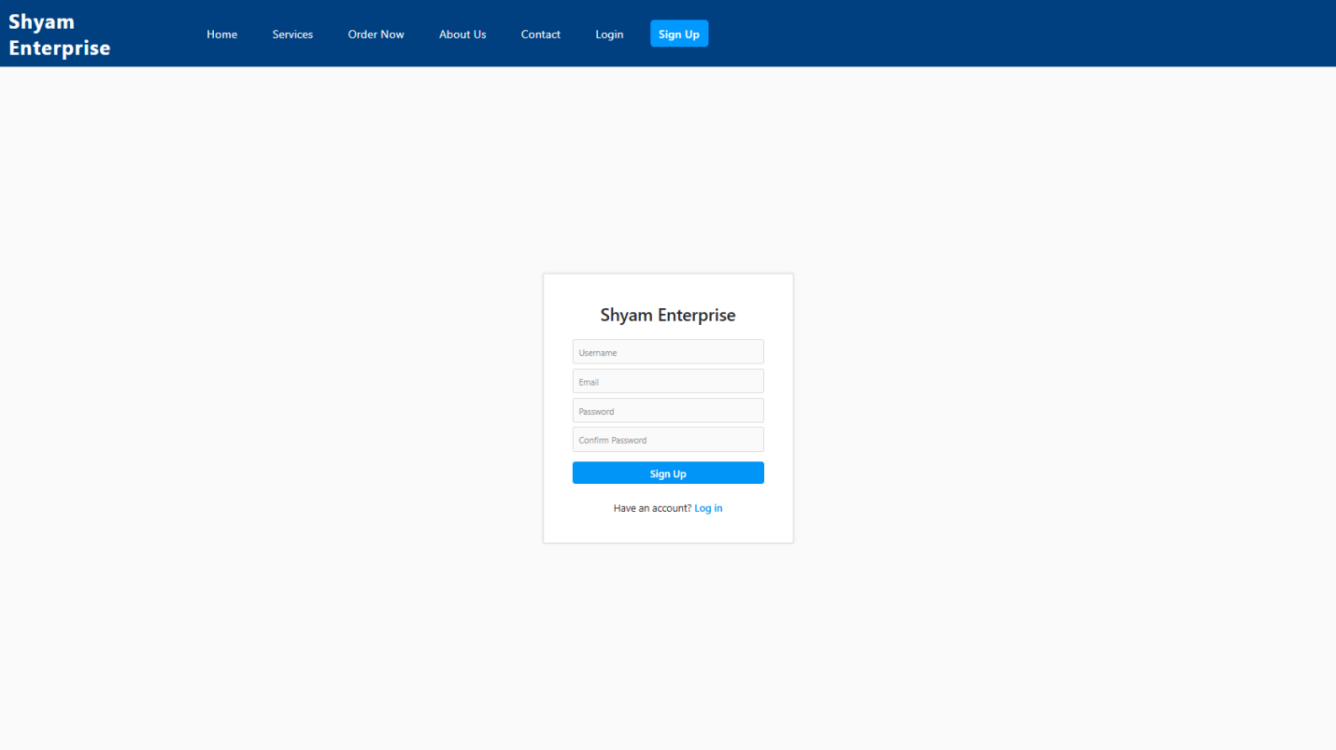

* Services:
* 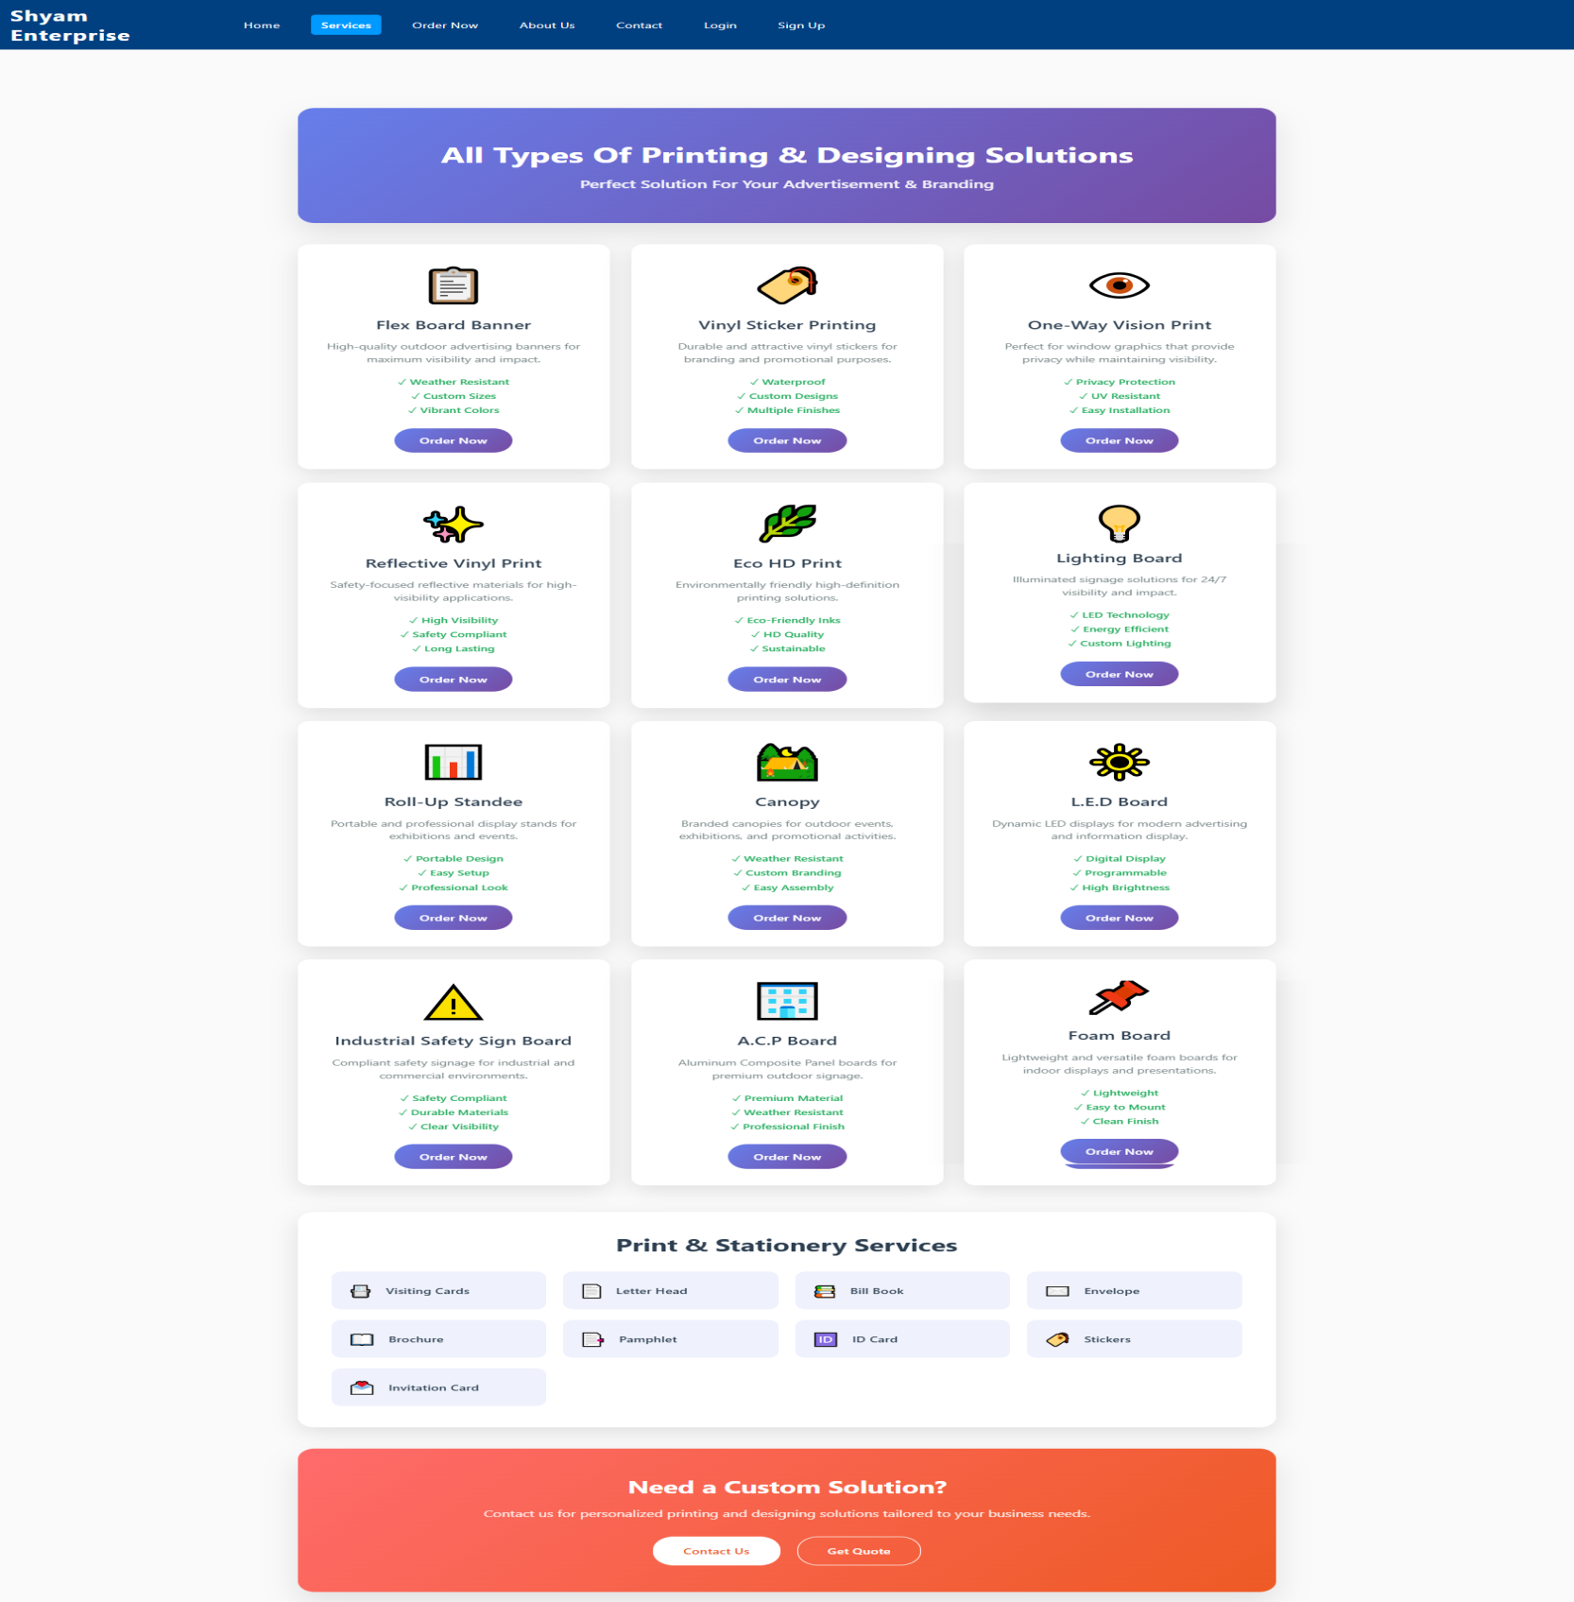
* Order Now:

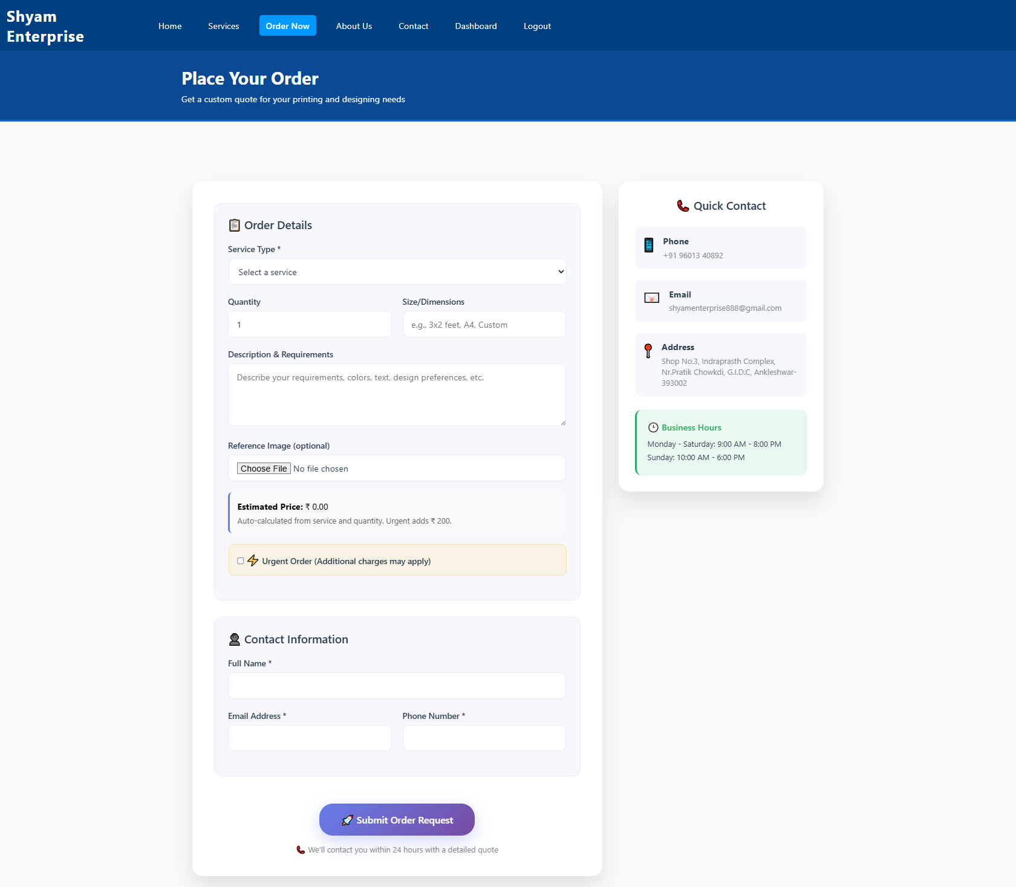

* About Us:

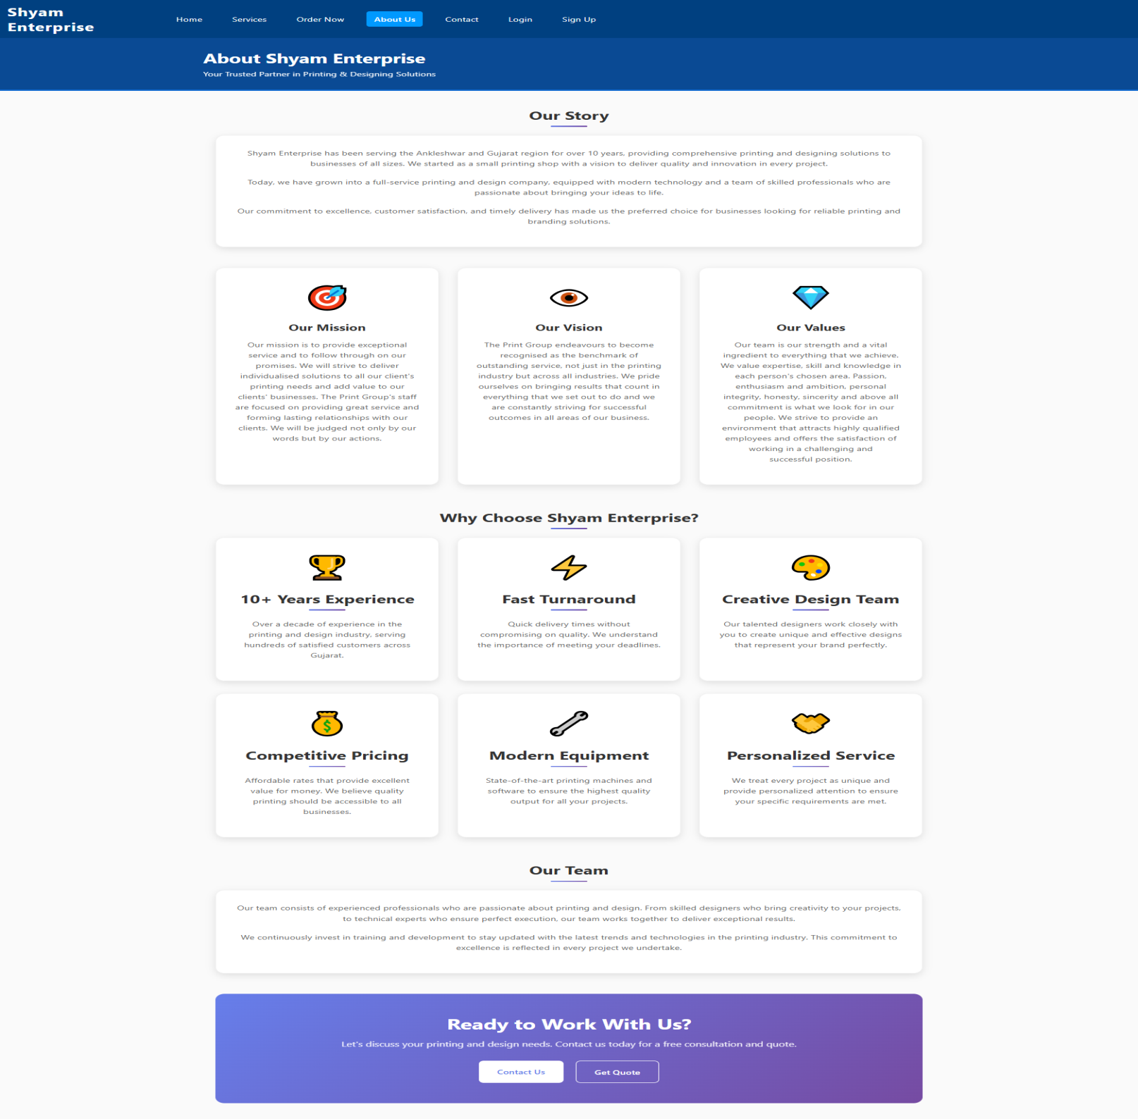

* Contact Us:

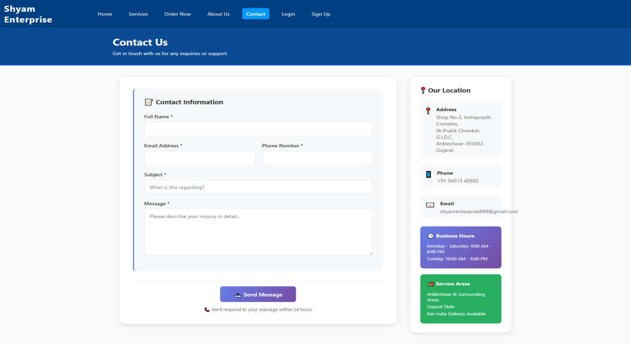

* Logout:

