Assignment 1
Introduction to Web Development
Name: Dev Sharma
Roll No: 2415000500
Section: SB
Q1. Explain the difference between frontend, backend, and full-stack development with suitable real-world examples.
Frontend development deals with everything a user sees and interacts with directly in a browser or app — layout, design, buttons, forms, and animations. It is built using HTML, CSS, and JavaScript (and frameworks like React or Angular).
Backend development handles the server-side logic that the user never sees directly — processing requests, running business logic, and communicating with databases. Common backend languages/frameworks include Node.js, Python (Django/Flask), Java (Spring), and PHP.
Full-stack development covers both frontend and backend — a full-stack developer can build the complete application, from the user interface to the server and database.
Real-world example:
- Frontend: The visual layout of an Amazon product page — images, price display, “Add to Cart” button styling.
- Backend: The system that checks stock availability, processes payment, and updates the order in Amazon's database.
- Full-stack: A developer who builds both the product page UI and the order-processing logic behind it.
Q2. Create a simple diagram showing how the client-server model works in web architecture.
The diagram below shows a client (browser) sending an HTTP request to a server, and the server sending back an HTTP response containing the requested web page or data.
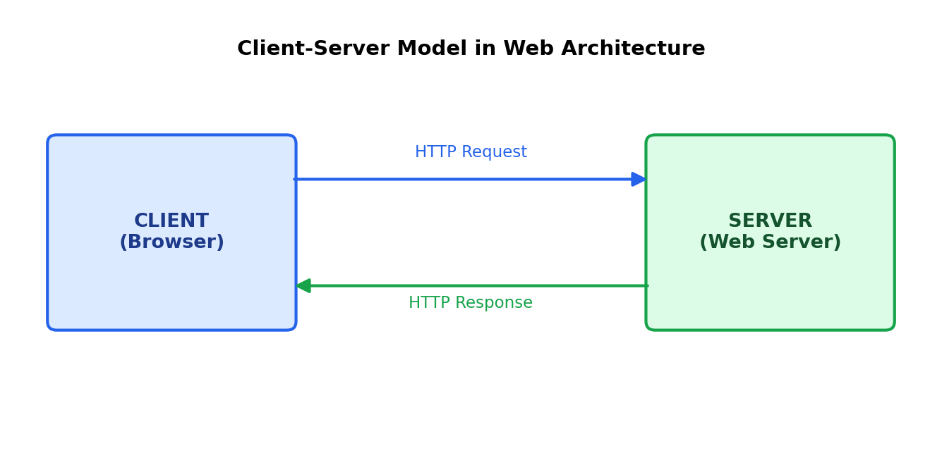
Q3. Describe how a browser requests and displays a web page from a web server.
When a user types a URL or clicks a link, the browser goes through the following sequence:
- 1. DNS Lookup: The browser resolves the domain name (e.g., www.example.com) into an IP address using DNS.
- 2. Establishing Connection: The browser opens a TCP connection to the server (often secured with TLS/SSL for HTTPS).
- 3. Sending the Request: The browser sends an HTTP GET request asking for the webpage's resources.
- 4. Server Processing: The web server receives the request, processes it (fetching data from a database if needed), and prepares a response.
- 5. Sending the Response: The server sends back the HTML, CSS, JavaScript, and other assets (images, fonts) as an HTTP response.
- 6. Rendering: The browser's rendering engine parses the HTML into a DOM tree, applies CSS (CSSOM), executes JavaScript, and paints the final page on screen.
Q4. Identify and list the tools required to set up a web development environment. Explain the purpose of each.
Tool | Purpose
Code Editor / IDE (e.g., VS Code) | Writing, editing, and organizing source code with syntax highlighting and extensions.
Web Browser (e.g., Chrome) | Running and testing the website; includes DevTools for debugging.
Version Control (Git) | Tracking code changes and enabling collaboration through repositories.
Package Manager (npm/yarn) | Installing and managing project dependencies and libraries.
Web Server (e.g., Apache, Nginx, Node.js) | Hosting and serving the website to clients.
Browser DevTools | Inspecting HTML/CSS, debugging JavaScript, and monitoring network requests.
Terminal / Command Line | Running build tools, Git commands, and package manager commands.
Database (e.g., MySQL, MongoDB) | Storing and retrieving application data.
Q5. Explain what a web server is and give examples of commonly used servers.
A web server is software (often running on dedicated hardware) that stores, processes, and delivers web pages and other content to clients over HTTP/HTTPS in response to their requests. It listens for incoming requests, retrieves the requested resource (a static file or dynamically generated content), and sends it back to the client's browser.
Commonly used web servers:
- Apache HTTP Server — one of the oldest and most widely used open-source web servers.
- Nginx — known for high performance, load balancing, and handling many concurrent connections.
- Microsoft IIS (Internet Information Services) — used mainly for hosting .NET applications on Windows servers.
- Node.js (Express) — a JavaScript runtime commonly used to build lightweight custom servers.
- LiteSpeed — a high-performance server often used as a drop-in replacement for Apache.
Q6. Define the roles of a frontend developer, backend developer, and database administrator in a project.
Role | Responsibilities
Frontend Developer | Builds the user interface using HTML, CSS, and JavaScript; ensures responsiveness, accessibility, and a smooth user experience.
Backend Developer | Builds server-side logic, APIs, authentication, and business rules; connects the application to the database.
Database Administrator (DBA) | Designs, manages, secures, and optimizes the database; handles backups, performance tuning, and data integrity.
Q7. Install VS Code and configure it for HTML, CSS, and JavaScript development. Take a screenshot of the setup.
Steps followed to install and configure VS Code:
- 1. Downloaded Visual Studio Code from the official site: code.visualstudio.com
- 2. Ran the installer and completed setup with default options.
- 3. Installed recommended extensions for web development: Live Server (to preview HTML pages with auto-refresh), Prettier (code formatting), and HTML/CSS/JavaScript IntelliSense (auto-complete and error checking).
- 4. Created a sample project folder and verified that HTML, CSS, and JS files were correctly recognized with syntax highlighting.
[Insert your own VS Code setup screenshot here before submitting — showing the editor with an open HTML file and installed extensions.]
Q8. Explain the difference between static and dynamic websites. Provide an example of each.
A static website displays the same fixed content to every visitor. It is built using HTML/CSS (and sometimes basic JavaScript) and does not change based on user input or interact with a database. Static sites are fast, simple to host, and cheap to run.
A dynamic website generates content on the fly, often based on user interaction, login state, or database queries. It uses server-side languages (like PHP, Python, Node.js) along with a database to produce personalized or frequently changing content.
Examples:
- Static website: A simple personal portfolio page or a company “About Us” page with fixed text and images.
- Dynamic website: An e-commerce site like Flipkart, where product listings, prices, and recommendations change based on the user and real-time data.
Q9. Research and list five web browsers. Explain how rendering engines differ between them.
Browser | Rendering Engine
Google Chrome | Blink (forked from WebKit)
Mozilla Firefox | Gecko
Apple Safari | WebKit
Microsoft Edge | Blink (Chromium-based)
Opera | Blink (Chromium-based)
A rendering engine is the part of a browser responsible for parsing HTML/CSS and painting the visual page on screen. Different engines can interpret certain CSS properties, JavaScript APIs, or edge-case markup slightly differently, which is why the same website can occasionally look or behave a little differently across browsers. Blink and WebKit share historical roots (Blink was forked from WebKit), so Chrome, Edge, and Opera tend to render pages very similarly, while Firefox's Gecko engine and Safari's WebKit engine may render some advanced CSS or JavaScript features differently, making cross-browser testing an important part of web development.
Q10. Draw a labeled diagram showing the basic web architecture flow — client, server, database, and APIs.
The diagram below illustrates how a client sends a request to the web server, the server communicates with an API layer for business logic, and the API layer queries the database and returns results back through the same chain to the client.
