# Process 1

Login to dev.azure.com

Select Project

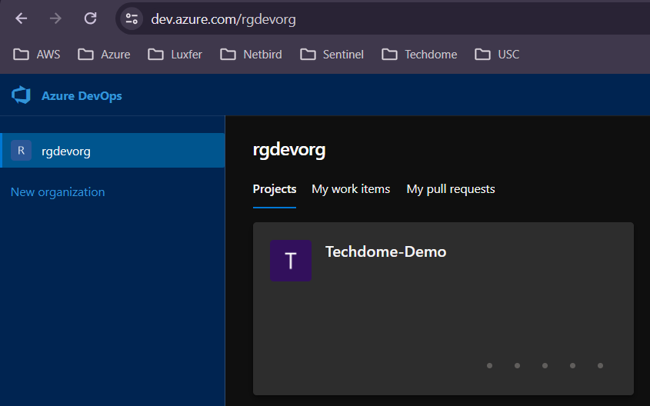

Get repo with files created on project

Click Setup up build

Select Starter Pipeline

Delete everything below steps and click show assistant

Select Azure template deployment

Select appropriate values. Click Add.

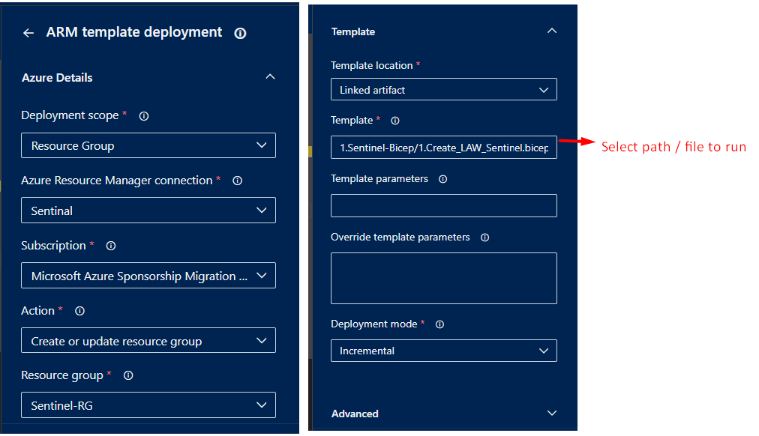

* Azure Resource Manager connection will be created by Administrator. You must have permission for connection.

Align added content. Click on Save.

Give commit a message and save it.

Click Run pipline. Select branch. Click Run.

It will start a job.

# Process 2

Or select pipeline then new pipeline.

Select repo provider

Select project / repo

Continue from “Step 4 - Select Starter Pipeline” from process 1.

