- MyHealthBuddy
Bridging the Gap in Patient Adherence and Health-Seeking Behavior
Project report for the District Level Children’s Science Congress

1. Problem Statements
Chronic diseases such as diabetes, hypertension, psychiatric disorders, neurological disorders, and rheumatic diseases often require long-term treatment, regular monitoring, and timely medical consultation. However, many patients face difficulties in following their prescribed treatment plans and seeking healthcare when needed.
The problem is not always a lack of willingness to follow medical advice. Patients may forget to take medicines, experience adverse effects, struggle with medication costs, misunderstand instructions, face stigma associated with certain conditions, or have difficulty reaching healthcare facilities. Limited health awareness, language barriers, and lack of family or social support may further contribute to these challenges.
Most basic medicine-reminder systems focus on when a medicine should be taken, but do not necessarily identify why a patient misses a dose or delays seeking care. Consequently, the underlying barriers may remain unresolved even when reminders are provided.
The project MyHealthBuddy proposes a mobile application that combines medication reminders, barrier identification, health education, symptom tracking, and healthcare-access support to address these interconnected challenges.
The key problem statements are:
  - How can patients be supported in following their prescribed medication schedules consistently?
  - How can the underlying reasons for missed doses and delayed healthcare visits be identified in a simple, non-judgmental manner?
  - How can accessible health education improve patients’ understanding of chronic diseases and their treatment?
  - How can digital tools encourage timely medical consultation and routine health check-ups?
  - How can a low-cost, user-friendly mobile application provide personalized support while protecting patient privacy and avoiding unsafe medical advice?
The central research question is: Can a barrier-aware mobile health application provide more relevant and useful support for medication adherence and health-seeking behavior than a reminder-only approach?

2. Importance of the Problem in the Target Domain
Medication adherence and appropriate health-seeking behavior are important components of effective chronic disease management. When patients have difficulty following treatment plans or delay seeking medical attention, their health conditions may become harder to manage, increasing the risk of complications and avoidable healthcare expenses.
MyHealthBuddy focuses on the following areas of importance.

2.1 Public health importance
Chronic diseases often require continuous care over many years. Supporting patients in following prescribed treatment and attending regular check-ups may contribute to better disease management and help reduce preventable complications.

2.2 Identification of underlying barriers
A missed dose may result from forgetfulness, financial difficulties, side effects, stigma, poor understanding, or limited access to healthcare. Identifying these barriers is important because different problems require different solutions. MyHealthBuddy aims to move beyond repeated reminders by helping users identify the difficulties they experience.

2.3 Improved health awareness
Patients who understand their conditions, the purpose of their medicines, and the importance of follow-up care may be better equipped to participate in their own healthcare decisions. Providing simple, reliable, and understandable health information can support informed decision-making.

2.4 Accessibility and inclusiveness
People in rural and underserved communities may encounter difficulties accessing healthcare information and services. A mobile application with a simple interface, regional-language support, and low-data requirements could help make health information more accessible. However, access to a smartphone, internet connectivity, and digital literacy must also be considered.

2.5 Psychological and social well-being
People living with psychiatric, neurological, and other chronic conditions may experience stigma, emotional distress, or a lack of social support. A respectful and confidential digital platform can encourage users to seek appropriate professional assistance without fear of judgment.

2.6 Scientific and technological importance
The project applies mobile technology to a practical public health problem. It also provides an opportunity to investigate whether identifying individual barriers produces more relevant support than conventional reminder-based systems.
Recent research on digital health interventions has shown promising but variable results. Therefore, MyHealthBuddy should be evaluated systematically rather than assuming that introducing an app automatically improves adherence.
Target domain: Digital health, chronic disease management, preventive healthcare, health education, and patient-centred technology.

3. Idea and Approach Details
The central idea behind MyHealthBuddy is to develop a digital health companion that helps users manage their prescribed treatment and understand the reasons behind difficulties in following it.
Unlike a conventional medicine-reminder application, MyHealthBuddy will follow a “Remind, Identify, Support and Follow Up” approach.
1. REMIND
Send reminders for prescribed medicines, appointments, and scheduled check-ups.
2. IDENTIFY
Ask the user why a dose was missed or a healthcare visit was delayed.
3. SUPPORT
Suggest an appropriate next step based on the reported barrier.
4. FOLLOW UP
Ask whether the support was useful and help the user plan the next appropriate step.

3.1 Step-by-step approach
Step 1: User registration and personalization
Users select their preferred language and enter basic information needed to configure reminders. They can add their existing prescribed medicine schedule and upcoming appointments. The app should collect only the information necessary for its functions.
Step 2: Medication reminders and tracking
The app sends notifications at user-configured times. Users can record whether they took a medicine, missed it, or need to check their instructions with a healthcare professional. The app records user-reported information rather than assuming that a notification confirms a dose was taken.
Step 3: Barrier identification
When a user reports a missed dose or delayed visit, the app offers a short questionnaire with options such as:
  - I forgot.
  - I could not afford the medicine.
  - I experienced or feared side effects.
  - I did not understand the instructions.
  - I felt embarrassed or worried about stigma.
  - I could not reach a healthcare facility.
  - I was emotionally distressed or lacked support.
  - Another reason, or prefer not to answer.
Step 4: Barrier-specific support
The app provides a relevant, predefined response. For example, forgetfulness may lead to a reminder-setting option, while difficulty understanding instructions may lead to simple educational content and a suggestion to consult a pharmacist or doctor.
Step 5: Health education and symptom monitoring
Users access reliable educational information and optionally record symptoms or measurements relevant to their condition. The information can be reviewed with a healthcare professional.
Step 6: Evaluation and improvement
The app records whether users found the suggestions helpful, subject to appropriate consent and privacy safeguards. This feedback can help determine which features are useful and where improvements are required.

3.2 Scientific principle
The approach is based on the idea that different causes of non-adherence require different forms of support. A reminder may help someone who forgets, but it cannot by itself resolve medicine affordability, adverse effects, stigma, or geographical barriers.
MyHealthBuddy therefore proposes a barrier-based support model. Its effectiveness will need to be assessed through a structured experiment.

4. Solution and Prototype
MyHealthBuddy will initially be developed as a simple, interactive mobile application prototype suitable for demonstration at the District Level Children’s Science Congress.
The prototype will demonstrate the core workflow without requiring access to real patient records or integration with hospital systems.

4.1 Proposed prototype modules
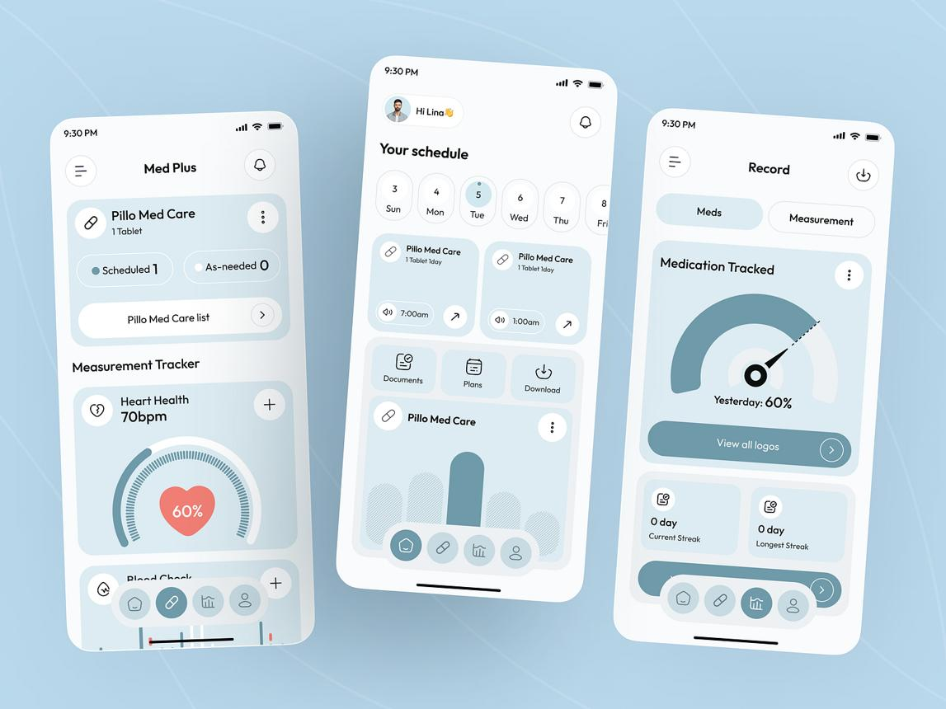
Module 1: Home Dashboard
Displays today's medicine reminders, upcoming appointments, a health tip, and quick access to the app's main features.
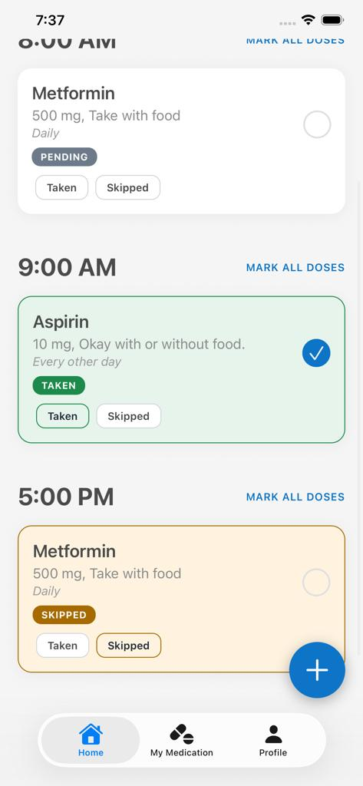
Module 2: My Medicines
Allows users to enter prescribed medicine details, configure reminders, and record their medication history.
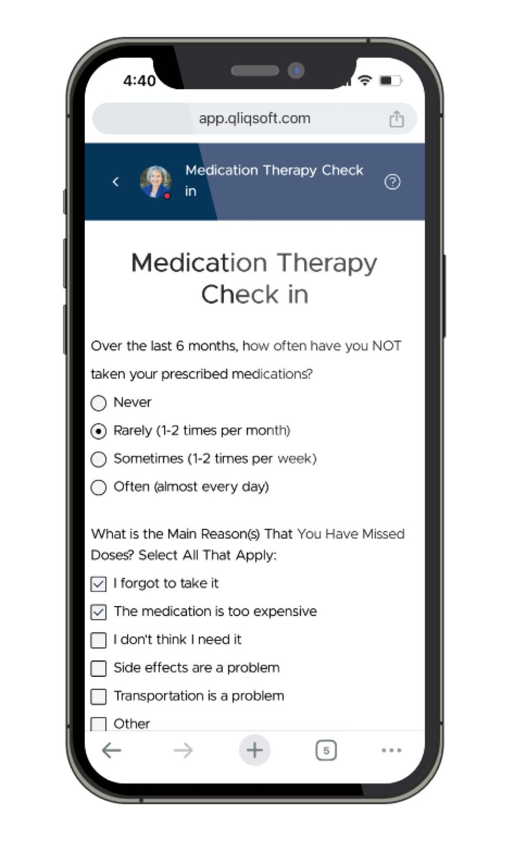
Module 3: Barrier Detective
Asks why a medicine was missed or care was delayed, then displays a relevant, safety-reviewed support suggestion. This is the main innovative feature of the prototype.
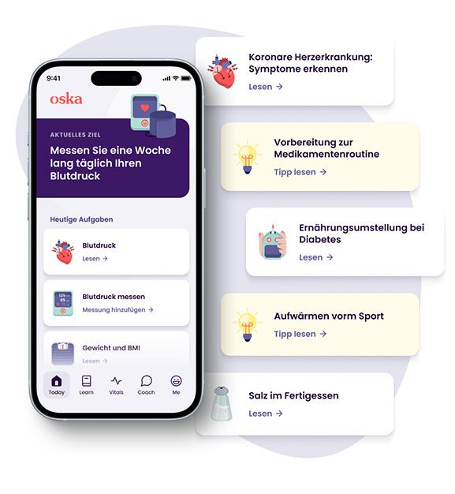
Module 4: Health Learning Corner
Provides easy-to-understand information on chronic conditions, treatment adherence, healthy routines, and when to seek professional advice.
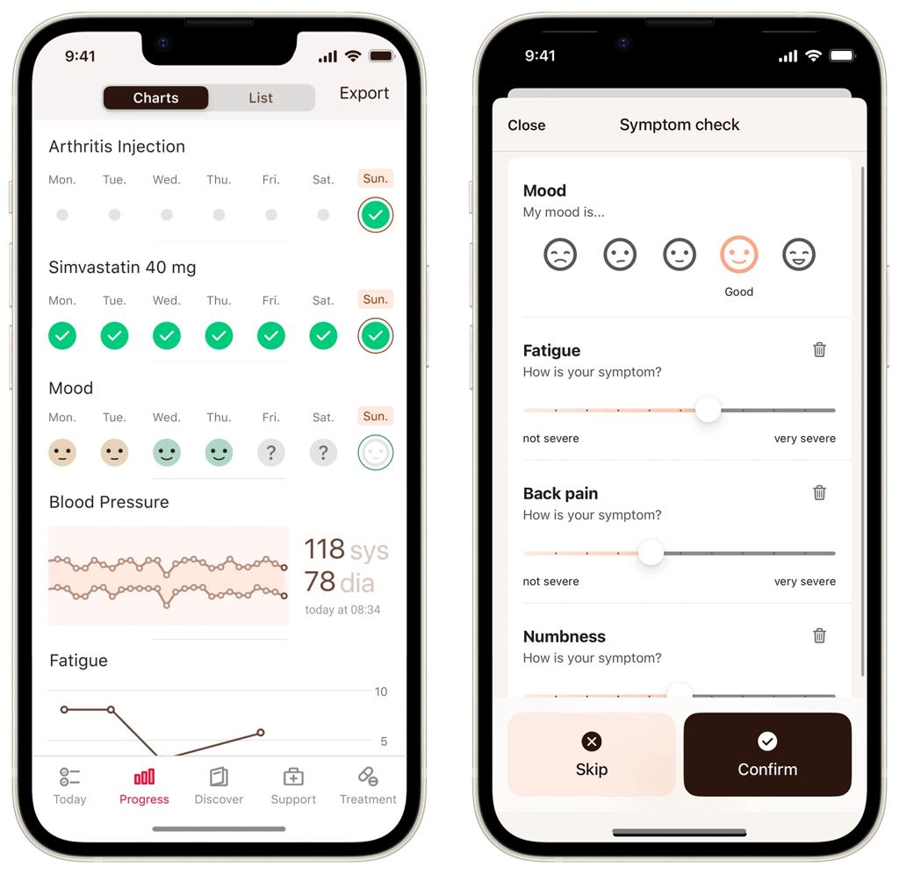
Module 5: Care and Health Tracker
Provides appointment reminders, a symptom diary, and a pathway to locate or contact healthcare services.

4.2 Example of how the prototype works
Consider a fictional patient with hypertension who reports missing a prescribed medicine because it is too expensive.
  - MyHealthBuddy records the reported missed dose.
  - The app asks the user to identify the reason.
  - The user selects “I could not afford the medicine.”
  - The app suggests contacting the prescribing clinician or pharmacist and offers information about verified public healthcare facilities or medicine assistance services where available.
  - It does not recommend stopping treatment, changing the prescribed medicine, or substituting another medicine independently.
  - The app asks whether the suggested support was useful.
This example demonstrates how the application responds to the cause of a problem rather than simply repeating a reminder.

4.3 Proposed evaluation of the prototype
To investigate the usefulness of the idea, the project can use fictional patient scenarios representing different barriers to adherence.
  - Prepare a set of scenarios covering forgetfulness, cost, side effects, stigma, lack of understanding, and difficulty accessing care.
  - Compare the responses generated by a reminder-only approach with those generated by MyHealthBuddy's barrier-based approach.
  - Ask a suitably qualified reviewer or supervised evaluation panel to score the relevance, usefulness, and safety of the responses.
  - Calculate the percentage of scenarios receiving appropriate support.
  - Document incorrect recommendations, limitations, and possible improvements.
The findings should be reported honestly. The prototype should not be described as clinically effective unless further appropriate studies establish that conclusion.

5. Potential Features for Future Development
The first version will focus on the core problem-identification and support mechanism. The following features may be developed in later versions.
Proposed feature | Future benefit
Regional-language and voice interface | Support users with limited literacy and improve accessibility
Offline functionality | Allow access to saved reminders and educational content without continuous internet connectivity
AI-assisted barrier analysis | Identify patterns in user-reported difficulties, subject to validation and appropriate safeguards
Caregiver support | Allow users to share selected reminders or updates with trusted caregivers after consent
Healthcare professional dashboard | Enable authorized professionals to review relevant adherence records with informed consent
Verified medicine-access information | Help users locate appropriate pharmacies, public facilities, and assistance programmes
Teleconsultation integration | Facilitate contact with qualified healthcare professionals
Personalized educational content | Present relevant information based on the user's reported needs and preferences
Chronic disease monitoring | Display trends in user-entered blood pressure, glucose, symptoms, or other relevant measurements
Privacy-preserving analytics | Evaluate common barriers and app performance using appropriately protected, aggregated data
Accessibility enhancements | Include larger text, audio instructions, simple navigation, and support for users with disabilities
Evidence-based emergency guidance | Help users recognize when urgent professional assessment may be needed and locate verified emergency services
AI-based recommendations, clinical monitoring, and healthcare-system integration would require additional technical development, clinical review, privacy protection, and appropriate validation before real-world use.

Expected outcome and social impact
MyHealthBuddy aims to demonstrate how a mobile application can support people living with chronic diseases by addressing not only missed medication reminders but also the reasons behind poor adherence and delayed healthcare-seeking behavior.
The project combines digital technology, health education, user-centred design, and a testable scientific hypothesis. Its immediate achievement will be a working demonstration of the barrier-identification approach and an evaluation of the relevance and safety of its suggested responses.
If subsequent testing demonstrates benefits, the approach could inform the development of accessible digital health support for patients, caregivers, and healthcare professionals.
Conclusion: MyHealthBuddy seeks to bridge the gap between receiving medical advice and being able to follow it in everyday life. Its core principle is simple: understand the barrier, provide appropriate support, and help the user take the next safe step.

