Sets

1. Define each one below with example.
2. Set 2. Subset of a Set 3. Equality of Sets

4. EmptySet 5. PowerSet 6. SingletonSet

7.finiteSet, InfinetSet, Cardinality.

2. Represent the following sets in roster method:

(a) Set of all alphabet in English language.

(b) Set of all odd positive integers less than 25.

(c) The set of all odd integers.

(d) The set of all rational numbers divisible by 5.

(e) The set of all colors in the Indian flag.

(f) The set of letters in the word ELEPHANT.

3. Give examples to show that

(i) A U A = A and A ∩ A = A

(ii) If A ⸦ B, then A U B = B and A ∩ B =A. can you prove these statements formally?

4. What is A U Φ and A ∩ Φ for a set A?

5. If U = {x/x € 25, x€N}. A = {x/x € U, x ≤ 15} and B = {x/x € U, 0 < x ≤ 25}, list the elements of the following sets and draw Venn diagram:

6. List out the laws mentioned in the sets.( min 20)

**Real Numbers**

1. Laws of Exponents for Real Numbers ( at most 10).
2. Simplify.

1 . 6√729 - 11√2048 + 3√1728

2… (12√125 +3√245+√2205 ) / √405



**Algebra**

1. Simplify the following algebraic expressions.
2. - 6x + 5 + 12x -6
3. 2(x - 9) + 6(-x + 2) + 4x
4. 3x2 + 12 + 9x - 20 + 6x2 - x
5. (x + 2)(x + 4) + (x + 5)(-x - 1)
6. 1.2(x - 9) - 2.3(x + 4)
7. (x2y)(xy2) & (-x2y2)(xy2)

2. Simplify the expressions.

1. (a b2)(a3 b) / (a2 b3)
2. (21 x5) / (3 x4)
3. (6 x4)(4 y2) / [ (3 x2)(16 y) ]
4. (4x - 12) / 4
5. (-5x - 10) / (x + 2)
6. (x2 - 4x - 12) / (x2 – 2x – 24)
7. Find any real solutions for the following equations

x3 - 1728 = 0

x3 = - 64

sqrt(x) = -1

sqrt(x) = 5

sqrt(x/100) = 4

sqrt(200/x) = 2

**Trigonometric**

* 1. 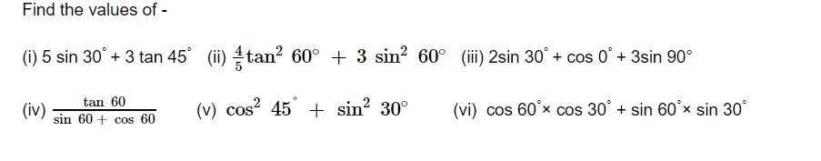
  2. 