**REASEARCH**

Q1. Android is a mobile operating system, which was created by Andy Rubin, Rich Miner, Nick Sears and Chris White. An Android app is an application, which works on the Android Platform.

Q2. The software used in development of Android apps is Android Studio.

Q3. The language most commonly used to develop apps is Java. The other languages used include C++, BASIC, etc. Insti app is used making Python.

Q4. Android activity is basically the single page of an android app, which allows you to place all your WI components in a single page. The Android Activity cycle basically provides us with the invocation of the life cycle methods(In this case we are considering the java Activity class ) of an activity. A basic flow chart (obviously taken from the internet is given below):-

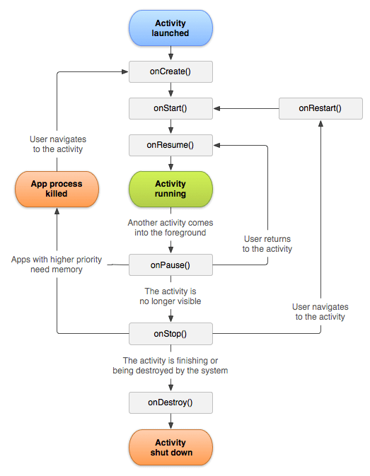

In the flowchart, we can see what the basic life cycle methods are, namely onCreate(), onStart(), onResume(), onPause(), onStop(), onRestart() and onDestroy(). Through the flowchart we can see how an Activity would start and get destroyed.

Q5. The UI componenets are:- A. TextView:- It is a user interface control which is used to display the text to the user. B. EditText:- It is a user interface control which is used to take input from the user. C.ImageView:- It is a user interface control which is used to display an image to the user. D.Button:- It is a user interface control which is used to trigger an action, like starting another activity, when pressed/clicked on. E. Check Box:- It is a user interface control which is used to give the user options which could be selected out of many options. F. Progress Bar:-It is a user interface control which is used to show the user how much of the progress has been done. G.

Q6. Some of the most common salient features are (for both Python and Java) :-

1. Platform independence
2. Object oriented programming
3. A simple language
4. Includes a large standard library

C++ has common features like A., B. and C. (but it has a small puny standard library when compared to python or Java).