

Developed By: Divina Gorospe & Enrique Paredes

Developed For: Diego Fernandez

Course: CS 319 Software Engineering

Contents

Website Link and Log-in Credentials 3

Functionality 3

Developed Functionality 4

Module: Movie Facts developed by Enrique Paredes 5

Module: Discussion Board developed by Divina Gorospe 5

Design 6

Team Experience 6

Divina 6

Enrique 6

Additional Screenshots 7

# Website Link and Log-in Credentials

Link: http://cs.neiu.edu/~fses17g6/

Log-in Credentials

|  |  |  |
| --- | --- | --- |
| Username | Password | User Type |
| admin@admin.com | admin1 | Admin |
| jdoe@neiu.edu | password | Admin |
| c@c.com | password | customer |

# Functionality

1. Module: Movie Facts developed by Enrique Paredes
2. Module: Discussion Board developed by Divina Gorospe

# Developed Functionality

When the user first logs in, they will be redirected to the index page which will display a welcome message. The top right menu bar will display additional navigation links to webpages depending on the user type (Admin, registered users, and non-registered users.

Admin – View Users

|  |  |
| --- | --- |
| user type | additional navigation |
| admin | View Users |
| registered users | Rate Movies |
| non-registered users/not logged-in | Register  Sign in |



Figure Navigation - Admin



Figure Navigation – Registered Users



Figure Navigation - Non registered users

## Module: Movie Facts developed by Enrique Paredes

Link: <http://cs.neiu.edu/~fses17g6/movie_list.php>

List of functionality:

1. The page will display all the movies listed in the database. See Figure 6 Movie Facts - Movie List
2. Users can sort the list with the following criterion: Movies, Year of Release, Rating, and Number of Rewards. See Figure 5 Movie Facts - Movie List
3. Users may click on a movie they wish the receive more info on. A new page will display with additional information such as Year of Release, Rating, and Number of Rewards, etc. An image of the movie poster will also be displayed. See Figure 4 Movie Facts - Movie Info
4. Registered users will be able to rate movies, which is not available for non-registered users. The link will appear on the navigation once the user has logged-in. See Figure 2 Navigation - Customer and Figure 7 Movie Facts - Rate Title
   1. Link: <http://cs.neiu.edu/~fses17g6/rate_title.php>
   2. Once they click on rate movie, a new page will load with a drop-down list and a text box. The movies populated in the drop-down list are in alphabetical order. The user may click a movie they wish to rate and then they may enter a numerical value between 0-100. Error checking is implemented so when numbers greater than 100 or less than 0 are entered, users will see an alert message letting them know to try entering a value again.

## Module: Discussion Board developed by Divina Gorospe

*The two categories are identical in their functionality.

Link: <http://cs.neiu.edu/~fses17g6/movierec.php>

List of functionality:

1. All types of users can view the posts. See Figure 10 Discussion Board
2. Only registered users can reply or submit a post. See Figure 7 Discussion Board - Post User Validation
   1. Users will be prompted this error: You have to be logged in to submit a post. Please log in
   2. Forms validation in client side ie using “required” attribute
3. Users can click on any post and will be redirected to a page that will show the body of the post and all the replies for that post. See Figure 9 Discussion Board - Reply to Post

# Design

* The entire website uses the same template which enforces consistency
* Used CSS and bootstrap
* Used PHP, HTML, MySQL
* Responsive

# Team Experience

## Divina

Working at an international law firm, I am not new to group settings. I know the challenges and the consequences this type of setting brings. Having school group projects, it makes me want to go to work instead. It super stresses me out. I loathe being in a group project. Most students these days are not inclined to do their part and will let others do their work for them. It makes my work load heavier, and it brings my gusto down to complete this project. I know I could have done better on this project.

## Enrique

Working on this project had its ups and downs. The ups included learning a new scripting language which gives the html page more life and functionality. Even though I had to Google and YouTube for weeks, I feel like I can take something away from this project that will help me in the real world. The downs included not having proper team meetings and not all team members pulling their weight on this assignment. Everyone has their own schedule which made meeting up impossible but thanks to technology like Google Docs/Microsoft Online we could communicate and finish work assignments. I’d like to thank Divina for going the extra mile and making all our assignments look more professional (visually appealing). You’re a true pro. Also, thanks to professor Diego for providing us with sample code that in some shape or form did end up being used in this project. More could have been done with MovieGo! but I am content with the results.

# Additional Screenshots

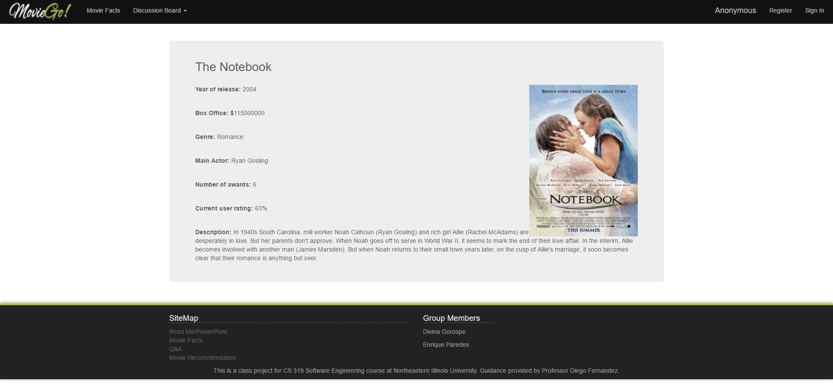

Figure Movie Facts - Movie Info

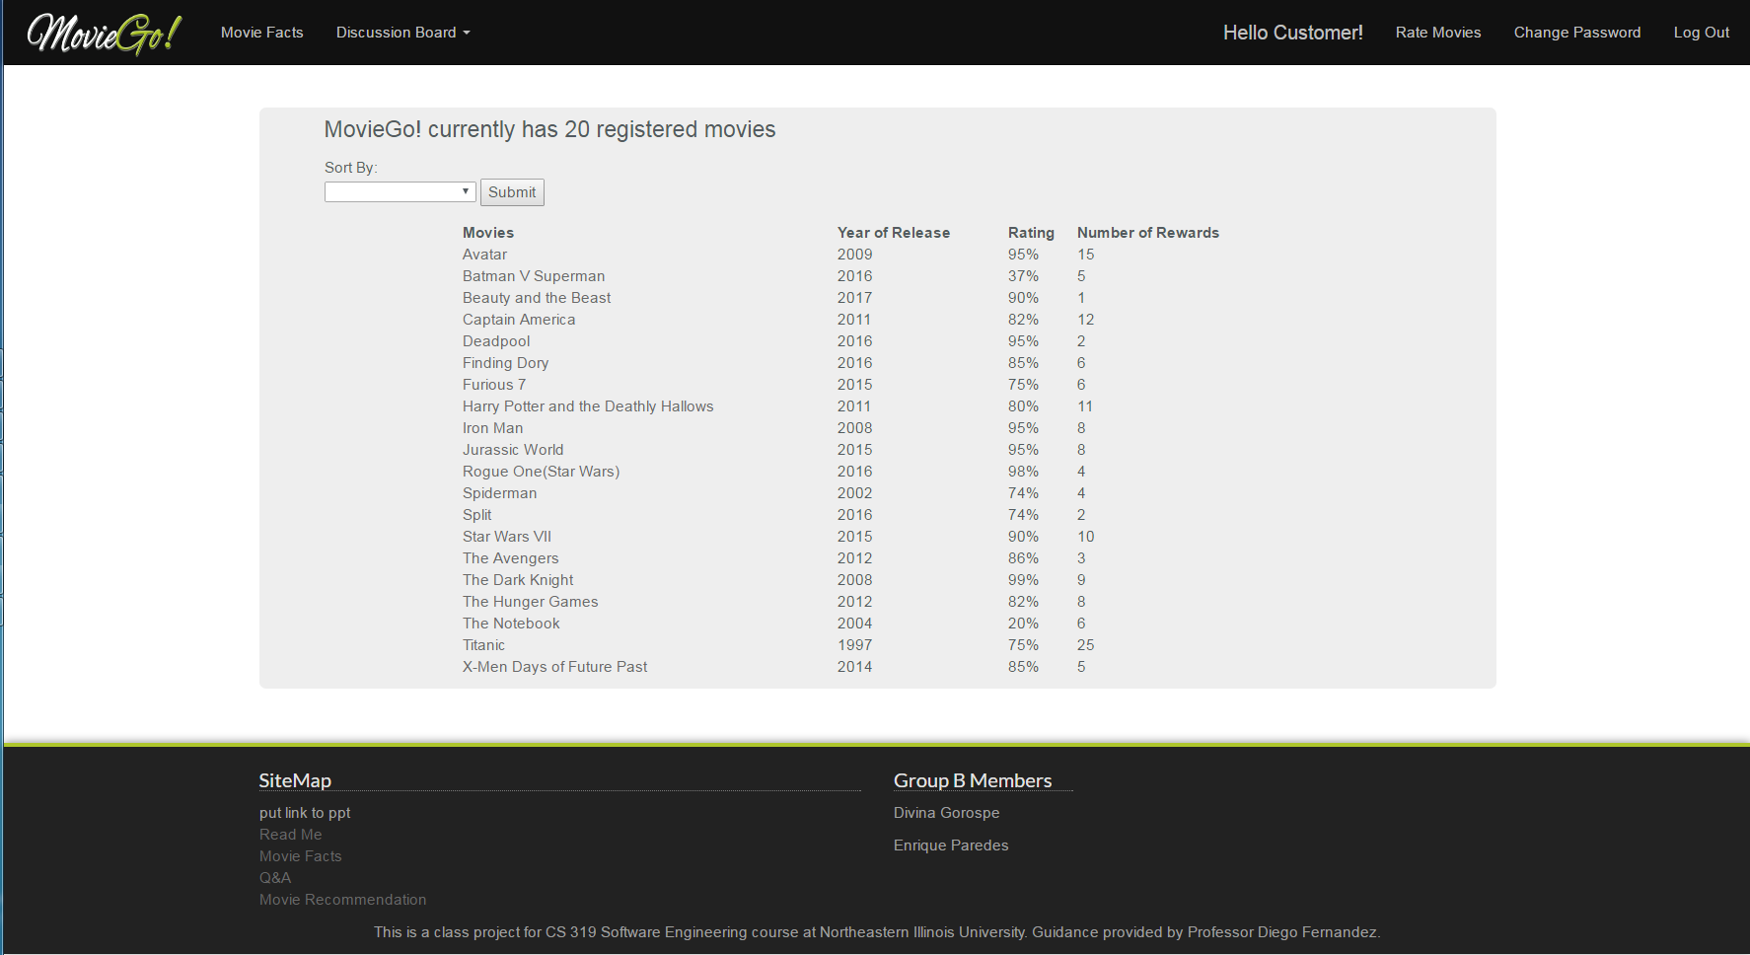

Figure Movie Facts - Movie List w/ Sort

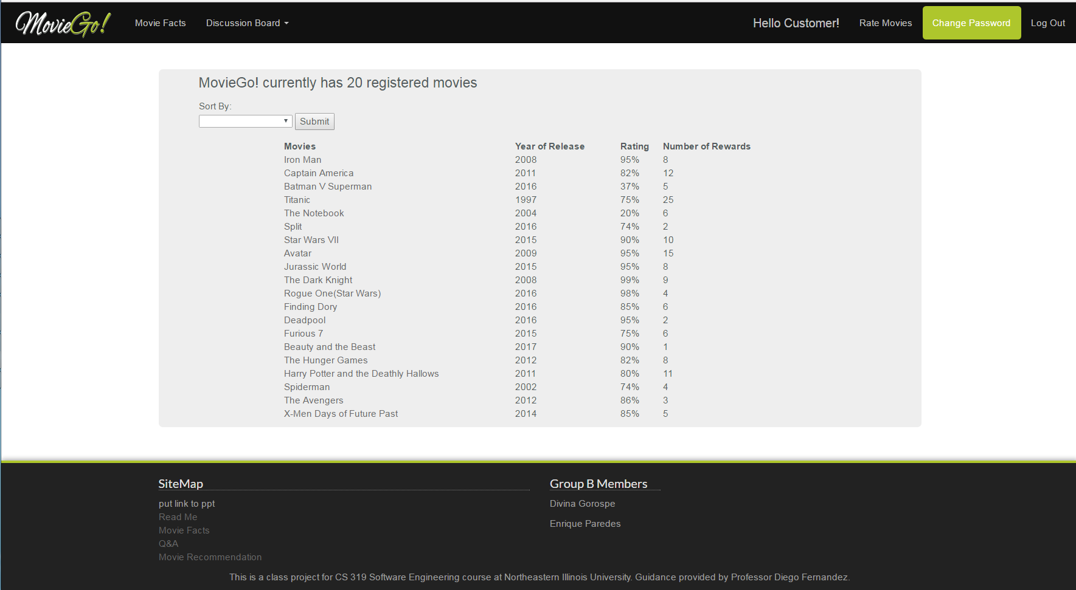

Figure Movie Facts - Movie List

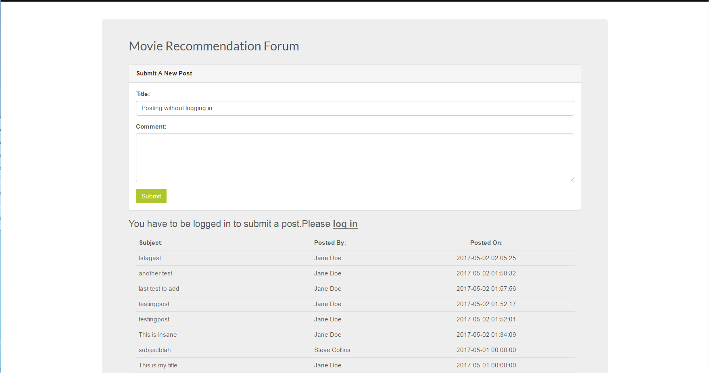

Figure Discussion Board - Post User Validation

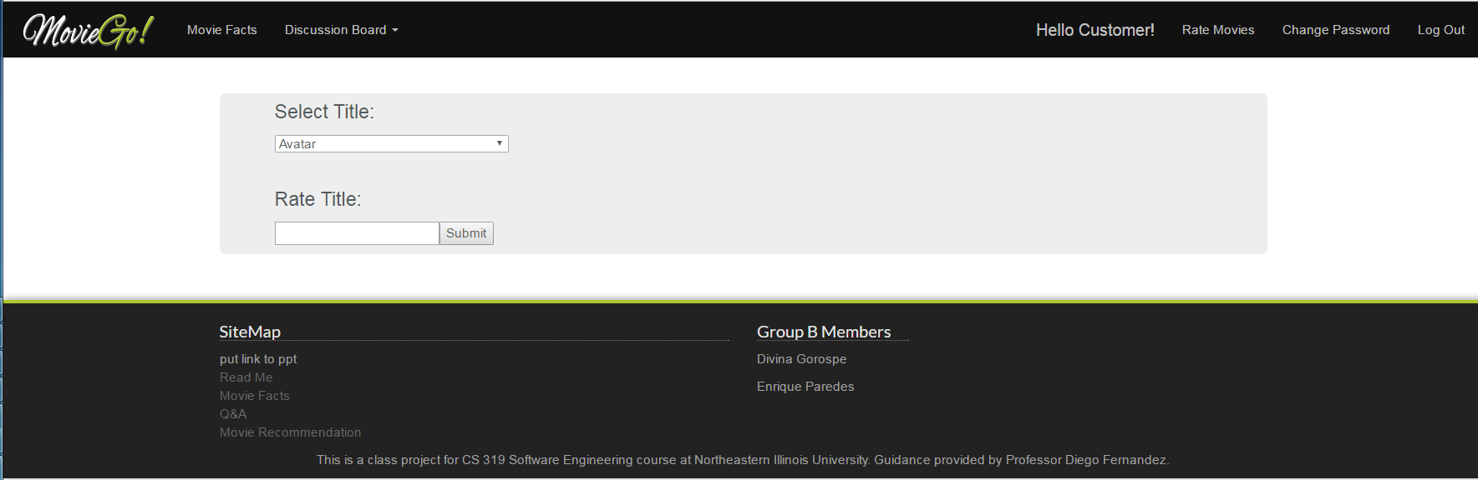

Figure Movie Facts - Rate Title

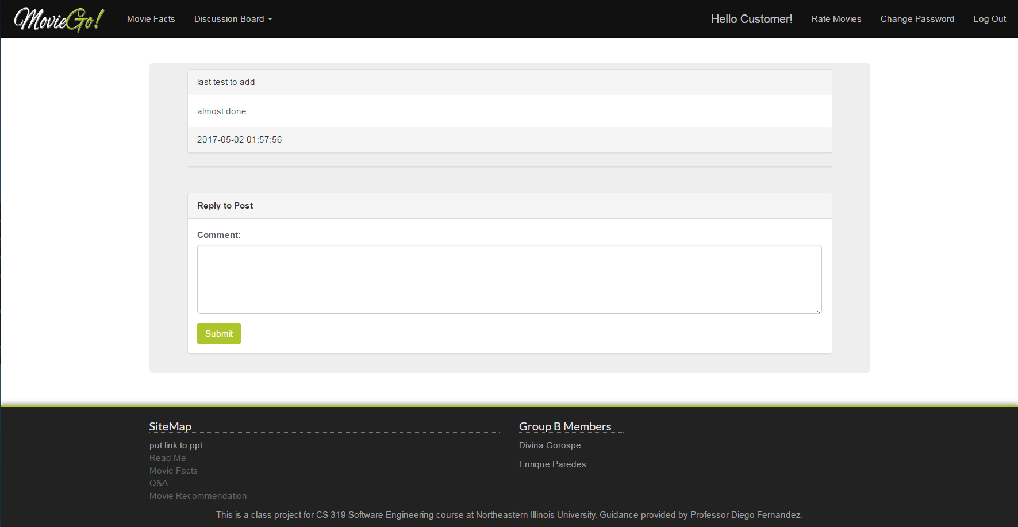

Figure Discussion Board - Reply to Post

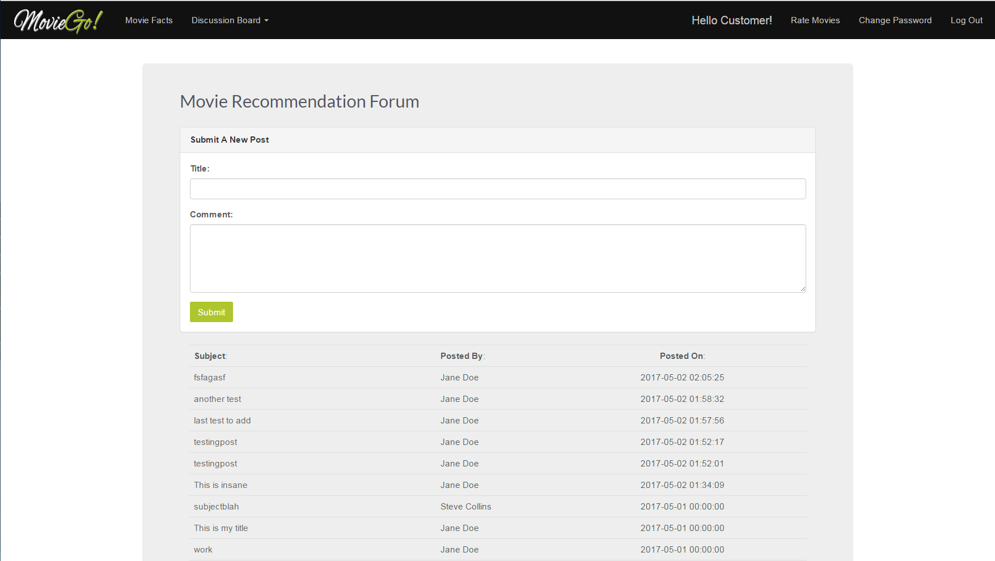

Figure Discussion Board