

Dynamic Websites Practical Task F

Version 1.0

Table of Contents

Units 3

How you will be assessed 3

How this assessment will be marked 4

Resources 7

What you have to do 8

Scenario 9

Tasks 10

Task 1: Add a Shopping Cart facility to the Members Page 10

Task 2: Modify the Members Order Form 12

Task 3: New Order Details 13

What you need to submit for this assessment 14

How to submit your assessment 14

## Units

This assessment counts towards completion of these unit:

* ICTWEB501 Build a dynamic website
* ICTWEB503 Create web-based programs
* ICTDBS504 Integrate database with a website

## How you will be assessed

**This is an ungraded assessment.**

Possible results for this assessment are:

* S – Satisfactory
* U – Unsatisfactory. You may be asked to resubmit the assessment.
* F – Fail.

To achieve a **Pass** you must successfully complete all tasks.

## How this assessment will be marked

A teacher will mark this assessment. The teacher will use the following marking guide to provide you with feedback about your completed assessment. Please use this guide as a double check for you assessment before you submit your work on the OLS.

**You must receive a result of Satisfactory in all tasks in order to pass this assessment.**

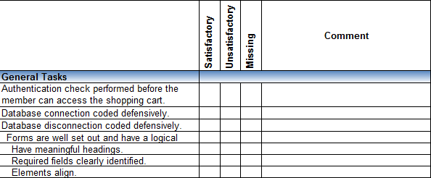

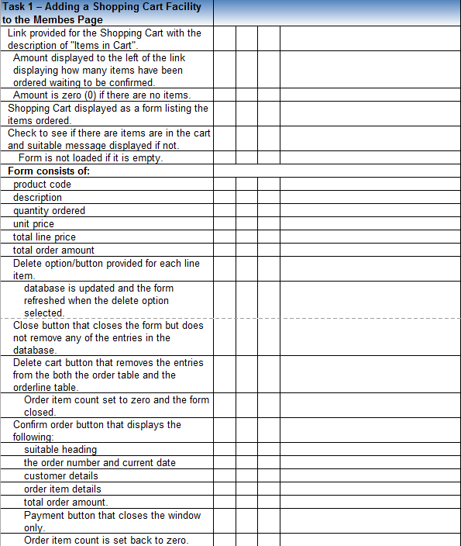

## 

## Resources

To complete this assessment, you will need the following:

* your completed prototype from the **Dynamic Websites Practical Task E** assignment
* web server software such as WAMP installed and running on your computer which includes the PHP programming language and MySQL.
* MySQL Workbench

You will also require

* a web authoring program such as Adobe Dream Weaver or Microsoft Expression Web or Microsoft Visual Studio. The latter two can be downloaded for free though the Microsoft Imagine offer.

## What you have to do

You must complete **all parts** of **all Tasks** for this assignment.

***Before starting this assessment, you should already have successfully completed DHTML CSS Practical Task A, Dynamic Websites Practical Task A, Dynamic Websites Practical Task B,*** ***Dynamic Websites Practical Task C***, ***Dynamic Websites Written Task C, Dynamic Websites Practical D and Dynamic Websites Practical E***

For this assessment you will produce the following outcomes, based on the supplied scenario:

* connect the Bazaar Ceramics database
* write the necessary code to generate a shopping cart order when a member orders items from the members page.
* provide the facility to update or delete the shopping cart
* amend the members page interface to reflect the status of the shopping cart
* create a new order from the shopping cart
* disconnect from the Bazaar Ceramics Database

## 

## Scenario

This assignment is based on the organisation known as Bazaar Ceramics and it will build on the Dynamic Websites Practical Task and Written assignments you have done so far. The client Emma Rich, is impressed with the progress of the website and would now like to see the implementation of a member’s shopping cart / order facility.

Christopher in consultation with yourself and the other members of the project team have come up with some preliminary specifications.

It is assumed that the following pages will need to be authenticated as per the previous practical assignment.

For the members shopping cart order process the following will be required:

* authentication to be applied throughout the process
* update the database with a new order when the member confirms an order. New items can be added and the order finalised when they have completed adding items. The mechanism for ordering an item and adding items will be a shopping cart feature. The shopping cart will be converted to an order upon confirmation from the member.

Christopher has asked that you keep the development of these features as efficient by re-using code as much as practicable.

At this stage the development of the website will still be approached as that of a prototype until it is completely deployed.

All pages are to be HTML5 compliant.

## Tasks

For this assignment you need to apply the same the authentication checks that you performed in the Dynamic Websites Practical Task E assignment.

You will also need to manage the database connection.

*You will need to develop two separate forms for this assignment. The Forms should:*

* *be well designed and have a logical flow. It is acceptable to use a table elements to set-out the forms*
* *have appropriate headings*
* *be clear to the user as to what fields are required*
* *have data labels and data entry fields that align*

## Task 1: Add a Shopping Cart facility to the Members Page

* Provide a link at the top of the Members Page beneath the banner for a Shopping Cart which should have the description of “Items in Cart”  
  ***NB*** *items are placed in the cart when the user orders an item from the order form (see Task # below)*
  + To the left of the “Cart” link an amount should be displayed that is the amount of items a customer has pending to be confirmed
  + If there are no items in the cart the amount should be zero (0).
* When the Cart link is selected the contents of the cart should be displayed. This can be done in a separate window via a form to display the individual item/s with only certain items editable  
  ***NB*** *none of the line items are editable*  
  ***NB*** *if there are no items in the cart then display a message that there are no items in the cart and do not display the form*
  + the page should have a suitable heading, e.g. “Your Shopping Cart” for example
  + the form should display the  
    product code  
    description  
    quantity ordered  
    unit price  
    total line price (quantity x unit price)  
    the current total amount for the order (sum of total line price) should be displayed below the line items
  + provide a delete option for each item ordered. When this option is selected delete the item from the OrderLine table in the database
    - close the window and re-load the Cart page with the updated details
  + the form should have three buttons (apart from the delete buttons/options for each line item)
    - a Close button – when it is selected simply close the window and do not remove any of the items
    - a Delete Cart - when it is selected remove the order and its corresponding entries from the Order and Orderline tables respectively. Set the order item count back to zero and close the window
    - a Confirm Order button – when it is selected display a new window which displays the following information:
      * a suitable heading such as, “Order Complete” for example
      * the order number and date of the order (the current date)
      * the customer details, name, address, suburb, state, postcode
      * the items ordered as per the information specified above for the Cart including the total amount of the order  
        ***NB*** *none of this information is editable*
      * a Payment button that closes the window but does not process a payment  
        ***NB*** *you are free to program this button with an appropriate message*
      * selecting the Confirm Order button should set the order item count back to zero

## Task 2: Modify the Members Order Form

* Modify the member’s order form from the Dynamic Web Pages Practical Task A assignment by replacing the Submit button with a button that has a value of “Add to Cart”
* Write a function that is called when the user selects the “Add to Cart” option
  + the function should check that all required fields are present
  + it should also check that the data is correct:
    - the item being ordered exists – check this against the Product table
    - the quantity amount is numeric and greater than zero
  + any checks that do not pass should add a message to an “error” array describing the error
    - if there are messages in the “error” array display them and do nothing with the order  
      ***NB*** *it us up to you how you relay this information to the user. One approach would be to display the message beside the item on the form that needs fixing*
  + process the validated form by
    - adding the item ordered to the user’s “cart” and update the number of items ordered count
    - adding an entry to the Order and OrderLine tables in the database. If the order is being updated with just another line item then just add a record to the OrderLine table  
      ***NB*** *you can use the function mysqli_insert_id($connection) to return the ID of the last newly created record****NB*** *you could use a “flag” to determine the status of the order to determine if you are adding an item to an existing order or not.****NB*** *it is acceptable to add entries to the database while the cart has not yet been confirmed provided any changes, i.e. deletions or order cancellations are managed by updating the database. Effectively when the member confirms an order the database will not need to be updated as the changes have already happened.*

## Task 3: New Order Details

* Complete the table below with the member details for the new orders you have added to the database.
* You need to create at least three (3) new order records:
  + one at least will be to an existing customer:
    - one of which must be CustomerID 2
    - and must have at least three (3) separate items ordered for different quantities
  + the other two will be to newly created customers:
    - one will have only one (1) item ordered
    - the other will have at least two (2) items ordered.

***NB*** *you are free to add more orders than the minimum amount specified above however, you will need to add to the table on the following page to capture this information.*

|  |  |  |  |  |
| --- | --- | --- | --- | --- |
| OrderID | CustomerID | Order Date | ProductID | Quantity Ordered |
| 102 | 2 | 2021-03-11 | bcpot020 | 5 |
| 103 | 2 | 2021-03-11 | bcpot016 | 4 |
| 104 | 2 | 2021-03-11 | bcpot014 | 3 |
| 105 | 3 | 2021-03-11 | bcpot016 | 2 |
| 106 | 4 | 2021-03-11 | bcpot020 | 1 |

## What you need to submit for this assessment

For this assessment you must submit the following file compressed (zipped):

* **Dynamic_Websites_Practical_TaskF*.*zip** which contains your complete Bazaar Ceramics website to date including the changes you have made for this assignment.

**Note: You must keep your own copy of this file.**

## How to submit your assessment

Using the OLS:

* Go to the Assessment Information page for the units **ICTWEB501 Build a dynamic website**
* Submit your file against the assessment named as **Dynamic_Websites_Practical_TaskF.**