Data Structures and Algorithms
Laboratory Manual — Software Engineering
IDE: Dev C++ (C++ Language)
Lab No: 02 | Duration: 3 Hours | Course: DSA

Implementation of Pointers and Dynamic Memory Allocation/Deallocation

1. Objectives
By the end of this lab, students will be able to:
- Explain what a pointer is and how it relates to memory addresses.
- Declare, initialize, and dereference pointers of different data types in C++.
- Differentiate between static (compile-time) and dynamic (run-time) memory allocation.
- Use the new operator to allocate memory dynamically for single variables and arrays.
- Use the delete and delete[] operators to correctly deallocate memory and avoid memory leaks.
- Perform pointer arithmetic to traverse arrays and pass pointers to functions for call-by-reference behavior.
- Identify and avoid common pointer errors: dangling pointers, memory leaks, and null pointer dereferencing.
- Write, compile, and run C++ programs in Dev C++ that use pointers and dynamic memory management effectively.

2. Relevant Theory

2.1 What is a Pointer?
A pointer is a variable that stores the memory address of another variable, rather than storing a data value directly. Pointers are the mechanism through which C++ allows direct interaction with computer memory, which makes them essential for building dynamic, non-primitive data structures such as linked lists, trees, and graphs (covered in later labs).
Every variable in a program is stored at a unique memory address. A pointer 'points to' that address, allowing indirect access to and modification of the variable it references.

Key Idea
A normal variable holds a value. A pointer variable holds an address — the location in memory where a value is stored.

2.2 Pointer Operators
- Address-of operator (&) — returns the memory address of a variable.
- Dereference operator (*) — accesses (reads/writes) the value stored at the address a pointer holds.
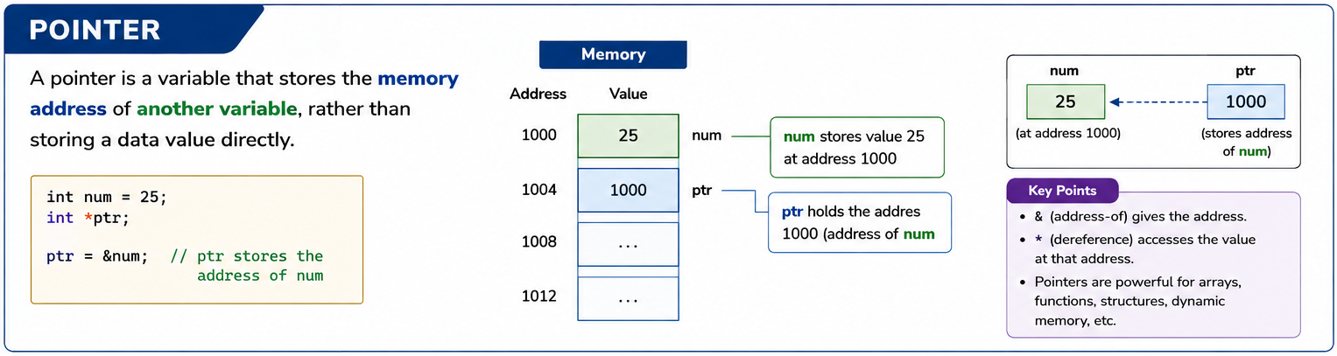

2.3 Static vs Dynamic Memory Allocation
Static memory allocation happens at compile time. The size and type of the variable must be known in advance, and memory is automatically allocated and released as the variable goes in and out of scope (e.g., normal arrays and variables declared inside a function).
Dynamic memory allocation happens at run time. Memory is requested from a region called the heap while the program is running, and it remains allocated until the programmer explicitly frees it. This allows programs to decide how much memory they need while running — for example, based on user input — rather than fixing it in advance.

2.4 Why Dynamic Memory Matters for Data Structures
Non-primitive dynamic data structures like linked lists, stacks (linked implementation), trees, and graphs need to grow and shrink at run time. This is only possible because pointers can be used to request new memory blocks on demand and link them together. Mastering pointers and dynamic allocation in this lab is a direct prerequisite for implementing linked lists in the coming labs.
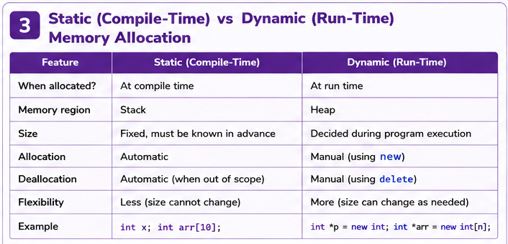

2.5 Pointer Arithmetic
When a pointer points to an element of an array, adding 1 to the pointer moves it forward by exactly one element (not one byte) — the compiler automatically scales the move by the size of the data type. This property allows arrays to be traversed either with index notation (arr[i]) or with pointer notation (*(ptr + i) or ptr++), which is especially useful when working with dynamically allocated arrays.

2.6 Common Pointer Pitfalls
- Dangling pointer — a pointer that still holds the address of memory that has already been deallocated.
- Memory leak — dynamically allocated memory that is never deallocated with delete, wasting memory for the life of the program.
- Null pointer dereferencing — attempting to access the value at a pointer that hasn't been assigned a valid address (or has been explicitly set to nullptr or NULL), causing undefined behavior/crashes.
- Uninitialized pointer — a pointer that has been declared but not assigned any address, pointing to a 'garbage' location.
Best Practice
Always initialize pointers (use nullptr if no address is available yet), and always delete what you new. After deleting, set the pointer to nullptr to avoid it becoming a dangling pointer.

2.7 Comparison Table
Basis | Static Allocation | Dynamic Allocation
Allocation time | Compile time | Run time
Memory region | Stack | Heap
Size flexibility | Fixed, must be known in advance | Can be decided while the program runs
Deallocation | Automatic (end of scope) | Manual — programmer must use delete/delete[]
Keyword(s) in C++ | None (normal declaration) | new, delete, delete[]
Risk | Limited flexibility | Memory leaks / dangling pointers if mismanaged

3. Syntax

3.1 Declaring and Using a Pointer
dataType variableName = value;
dataType *pointerName = &variableName; // pointer stores address of variableName

cout << *pointerName; // dereference: prints the value stored at that address
General syntax for declaring and dereferencing a pointer.

3.2 Dynamic Allocation for a Single Variable
dataType *pointerName = new dataType; // allocate
*pointerName = value; // assign value
// ... use it ...
delete pointerName; // deallocate
pointerName = nullptr; // avoid dangling pointer
Syntax for allocating and deallocating a single dynamic variable.

3.3 Dynamic Allocation for an Array
dataType *arrayPointer = new dataType[size]; // allocate an array on the heap

arrayPointer[0] = value; // access like a normal array

delete[] arrayPointer; // deallocate the whole array
arrayPointer = nullptr;
Syntax for allocating and deallocating a dynamic array.

3.4 Pointers with Functions
void functionName(dataType *paramPointer) {
*paramPointer = newValue; // modifies the caller's original variable
}

functionName(&variableName); // pass the address of the variable
Passing a pointer to a function enables call-by-reference behavior.

3.5 Program Skeleton
#include <iostream>
using namespace std;

int main() {

// your code here

return 0;
}

4. Examples

Example 1: Pointer Basics
Write a C++ program that declares an integer variable and a pointer to it, and demonstrates the & and * operators by printing the variable's value, its address, and the value obtained by dereferencing the pointer. Then modify the variable through the pointer.
#include <iostream>
using namespace std;

int main() {
int num = 50;
int *ptr;
ptr= &num; // ptr stores the address of num
int num2=100;

cout << "----- Pointer Basics Demo -----" << endl;
cout << "Value of num : " << num << endl;
cout << "Address of num (&num) : " << &num << endl;
cout << "Value stored in ptr : " << ptr << endl;
cout << "Value pointed by ptr : " << *ptr << endl;

// Modify num indirectly through the pointer

ptr = &num2;
cout << "Value of num : " << num2 << endl;
cout << "Address of num (&num) : " << &num2 << endl;
cout << "Value stored in ptr : " << ptr << endl;
cout << "Value pointed by ptr : " << *ptr << endl;
return 0;
}
Expected output shows that &num and ptr print the same address, *ptr equals num, and changing *ptr changes num itself.

Example 2: Dynamic Memory Allocation/Deallocation for a Single Variable
Write a C++ program that dynamically allocates memory for a single integer using new, takes a value from the user, displays it, and then correctly deallocates the memory using delete.
#include <iostream>
using namespace std;

int main() {
int *ptr = new int; // dynamically allocate memory for one int

cout << "----- Dynamic Memory (Single Variable) Demo -----" << endl;
cout << "Enter an integer value: ";
cin >> *ptr;

cout << "You entered : " << *ptr << endl;
cout << "Stored at heap address : " << ptr << endl;

delete ptr; // free the allocated memory
ptr = nullptr; // avoid dangling pointer

cout << "\nMemory deallocated successfully." << endl;

return 0;
}
Demonstrates the complete life cycle of dynamically allocated memory: request (new) -> use -> release (delete) -> safety (nullptr).

Example 3: Dynamic Array Allocation/Deallocation
Write a C++ program that asks the user how many elements they want to store, dynamically allocates an integer array of that exact size using new[], fills it with user input, calculates the sum and average, and then deallocates the array using delete[].
#include <iostream>
using namespace std;

int main() {
int n;
cout << "----- Dynamic Array Demo -----" << endl;
cout << "Enter number of elements: ";
cin >> n;

int *arr = new int[n]; // size decided at RUN TIME -> dynamic allocation

cout << "Enter " << n << " integers:" << endl;
for (int i = 0; i < n; i++) {
cout << "Element " << (i + 1) << ": ";
cin >> arr[i]; //*(arr + i);
}

int sum = 0;
for (int i = 0; i < n; i++) {
sum += arr[i]; //sum += *(arr + i);
}
double average = (double) sum / n;

cout << "\nSum of elements : " << sum << endl;
cout << "Average of elements: " << average << endl;

delete[] arr; // deallocate the entire array
arr = NULL;

cout << "\nDynamic array memory deallocated successfully." << endl;

return 0;
}
Highlights the key advantage of dynamic allocation over a normal array: the size n does not need to be known until the program is actually running.

Example 4: Pointer Arithmetic
Write a C++ program that declares an integer array and traverses it in two ways using a pointer: first with the *(ptr + i) notation, then by incrementing the pointer itself (ptr++).
#include <iostream>
using namespace std;

int main() {
int arr[5] = {10, 20, 30, 40, 50};
int *ptr = arr; // array name decays to a pointer to its first element

cout << "----- Pointer Arithmetic Demo -----" << endl;
cout << "Traversing array using pointer arithmetic:" << endl;

for (int i = 0; i < 5; i++) {
cout << "Element " << i << " = " << *(ptr + i)
<< " (address: " << (ptr + i) << ")" << endl;
}

cout << "\nTraversing using pointer increment (ptr++):" << endl;
int *p = arr;
for (int i = 0; i < 5; i++) {
cout << *p << " ";
p++; // move pointer to the next integer location
}
cout << endl;

return 0;
}
Shows that adding 1 to an int pointer advances it by sizeof(int) bytes, not 1 byte — the compiler scales the move automatically.

Example 5: Passing Pointers to Functions (Call by Reference)
Write a C++ program that swaps the values of two integer variables using a function that receives pointers as parameters, demonstrating call-by-reference behavior.
#include <iostream>
using namespace std;

// Function receives pointers so it can modify the caller's original variables
void swapValues(int *a, int *b) {
int temp = *a;
*a = *b;
*b = temp;
}

int main() {
int x = 15, y = 45;

cout << "----- Swap Using Pointers (Call by Reference) Demo -----" << endl;
cout << "Before swap: x = " << x << ", y = " << y << endl;

swapValues(&x, &y); // pass addresses of x and y

cout << "After swap : x = " << x << ", y = " << y << endl;

return 0;
}
Because the function receives addresses, changes made inside it are reflected in main() directly — unlike normal pass-by-value parameters.

Example 6: Safe Pointer Handling (Avoiding Dangling Pointers)
Write a C++ program that allocates memory, deallocates it, sets the pointer to nullptr, and demonstrates a safe nullptr check before any further dereference — illustrating the recommended defensive pattern.
#include <iostream>
using namespace std;

int main() {
cout << "----- Safe Pointer Handling Demo -----" << endl;

int *ptr = new int(75); // allocate and initialize in one step
cout << "Value before delete : " << *ptr << endl;

delete ptr; // deallocate memory
ptr = NULL; // immediately set to nullptr to avoid a dangling pointer

// Safe practice: always check for nullptr before dereferencing
if (ptr == NULL) {
cout << "Pointer is now null - cannot be safely dereferenced." << endl;
} else {
cout << "Value after delete : " << *ptr << endl; // never reached
}

// Demonstrate correct re-use of the same pointer
ptr = new int(200);
cout << "\nPointer re-allocated. New value: " << *ptr << endl;

delete ptr;
ptr = NULL;

return 0;
}
This pattern (delete, then set to nullptr, then check before use) is the single most effective habit for avoiding dangling-pointer bugs.

5. Lab Tasks
Attempt the following tasks in Dev C++. Save each program as LabTask1_YourRollNo.cpp, LabTask2_YourRollNo.cpp, and so on.

Task 1 (Pointer Basics)
Declare two integer variables and a single pointer. Point the pointer first to one variable and print its value, then reassign the pointer to the second variable and print again — demonstrating that a pointer can be redirected to point to different variables.

Task 2 (Pointer Basics)
Write a program that uses a pointer to find and print the largest of three integer variables, accessing each variable's value only through pointers (not directly by name) inside the comparison logic.

Task 3 (Dynamic Allocation — Single Variable)
Write a program that dynamically allocates memory for a float, takes a temperature reading from the user, converts it from Celsius to Fahrenheit, displays the result, and then deallocates the memory.

Task 4 (Dynamic Allocation — Array)
Write a program that dynamically allocates an integer array based on a user-specified size, fills it with user input, finds the maximum and minimum elements, and deallocates the array afterward.

Task 5 (Pointer Arithmetic)
Write a program that dynamically allocates an array of n integers, then uses pointer arithmetic (not index notation) to reverse-print the array from the last element to the first.

Task 6 (Debugging / Conceptual)
The following code snippet has a memory management bug. Identify the bug (dangling pointer / memory leak), explain why it is a problem, and rewrite the code correctly:
int *p = new int;
*p = 25;
delete p;
cout << *p << endl; // <-- What's wrong here?

Submission Checklist
Submit all .cpp source files along with a screenshot of each program's output from the Dev C++ console. Ensure your name, roll number, and section are included as a comment at the top of every file.

