N20DCCN031

Nguyễn Nhật Kha

D20CQCNPM01-N

**Homework 5**

**Part 1a**

# MSSV: N20DCCN031

# Nguyễn Nhật Kha

# Lớp: D20DCCNPM01-N

import cv2

import numpy as np

import os

import matplotlib.pyplot as plt

def linear_average_filter(image):

    padded_image = cv2.copyMakeBorder(image, 3, 3, 3, 3, cv2.BORDER_CONSTANT, value=0)

    result = np.zeros((262, 262))

    # Convolution

    for row in range(3, 259):

        for col in range(3, 259):

            result[row, col] = np.sum(padded_image[row-3:row+4, col-3:col+4]) / 49

    # Drop padding

    result = result[3:259, 3:259]

    return result

def create_full_contrast(input):

    min_val = np.min(input)

    max_val = np.max(input)

    if min_val == max_val:

        return np.zeros_like(input, dtype=np.uint8)

    scale = 255/(max_val - min_val)

    normalized = np.round(((input - min_val) * scale))

    return normalized

# Load image

parent_directory = os.path.dirname(os.path.abspath(__file__))

image = np.fromfile(f"{parent_directory}/salesman.bin", dtype=np.uint8).reshape(256,256)

# Apply linear average filter

filtered_image = linear_average_filter(image)

# Show images

plt.figure(figsize=(8,6))

plt.subplot(1,2,1)

plt.imshow(create_full_contrast(image),cmap="gray")

plt.axis("off")

plt.title("Original")

plt.subplot(1,2,2)

plt.imshow(create_full_contrast(filtered_image),cmap="gray")

plt.axis("off")

plt.title("Filtered Image")

plt.show()

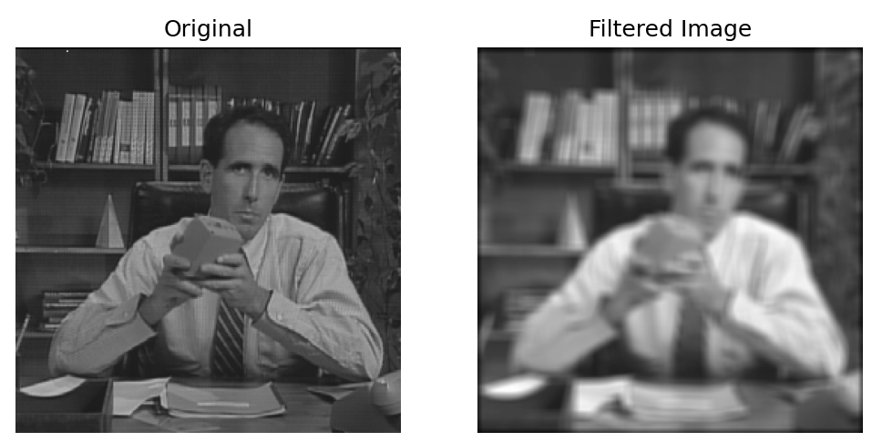

**Part 1b**

# MSSV: N20DCCN031

# Nguyễn Nhật Kha

# Lớp: D20DCCNPM01-N

import cv2

import numpy as np

import os

from matplotlib import pyplot as plt

def create_full_contrast(input):

    min_val = np.min(input)

    max_val = np.max(input)

    if(min_val == max_val):

        return np.zeros(input.shape, dtype=np.uint8)

    scale = 255/(max_val - min_val)

    return np.round(((input - min_val) * scale))

# Load image

parent_directory = os.path.dirname(os.path.abspath(__file__))

original_image = np.fromfile(f"{parent_directory}/salesman.bin", dtype=np.uint8).reshape(256,256)

# Create impulse response H

H = np.zeros((128, 128), dtype=np.float32)

H[62:69, 62:69] = 1/49

# Zero-pad the original image

padded_original = cv2.copyMakeBorder(original_image, 0, 128, 0, 128, cv2.BORDER_CONSTANT, value=0)

# Zero-pad the impulse response H

zero_padded_H = cv2.copyMakeBorder(H, 0, 256, 0, 256, cv2.BORDER_CONSTANT, value=0)

# Compute the DFT

dft_original = np.fft.fft2(padded_original)

dft_H = np.fft.fft2(zero_padded_H, s=dft_original.shape)

# Compute the centered log-manitude

centered_original = np.log(1 + np.abs(dft_original))

centered_H = np.log(1 + np.abs(dft_H))

# Compute convolution by the pointwise multiplication

convo_output =  dft_original * dft_H

# Compute the IDFT of the result

padded_output = np.abs(np.fft.ifft2(convo_output))

# Crop padding

final_output = padded_output[65:256+65, 65:256+65]

plt.figure(figsize=(10,8))

plt.subplot(2,4,1)

plt.imshow(create_full_contrast(original_image), cmap="gray")

plt.axis("off")

plt.title("Original")

plt.subplot(2,4,2)

plt.imshow(create_full_contrast(padded_original), cmap="gray")

plt.axis("off")

plt.title("Zero Padded Image")

plt.subplot(2,4,3)

plt.imshow(create_full_contrast(zero_padded_H), cmap="gray")

plt.axis("off")

plt.title("Zero Padded Impulse Resp")

plt.subplot(2,4,4)

plt.imshow(np.fft.fftshift(centered_original), cmap="gray")

plt.axis("off")

plt.title("Log spectrum of padded original")

plt.subplot(2,4,5)

plt.imshow(np.fft.fftshift(centered_H), cmap="gray")

plt.axis("off")

plt.title("Log spectrum of padded H")

plt.subplot(2,4,6)

plt.imshow(np.fft.fftshift(np.log(1 + np.abs(convo_output))), cmap="gray")

plt.axis("off")

plt.title("Log spectrum of padded result")

plt.subplot(2,4,7)

plt.imshow(create_full_contrast(padded_output), cmap="gray")

plt.axis("off")

plt.title("Zero Padded Result")

plt.subplot(2,4,8)

plt.imshow(create_full_contrast(final_output), cmap="gray")

plt.axis("off")

plt.title("Final Filtered Image")

plt.show()

def linear_average_filter(image):

    padded_image = cv2.copyMakeBorder(image, 3, 3, 3, 3, cv2.BORDER_CONSTANT, value=0)

    result = np.zeros((262, 262))

    # Convolution

    for row in range(3, 259):

        for col in range(3, 259):

            result[row, col] = np.sum(padded_image[row-3:row+4, col-3:col+4]) / 49

    # Drop padding

    result = result[3:259, 3:259]

    return result

# Get result of part a

A = linear_average_filter(original_image)

print("Max difference from part a:",end=' ')

print(np.max(np.abs(create_full_contrast(final_output) - create_full_contrast(A))))

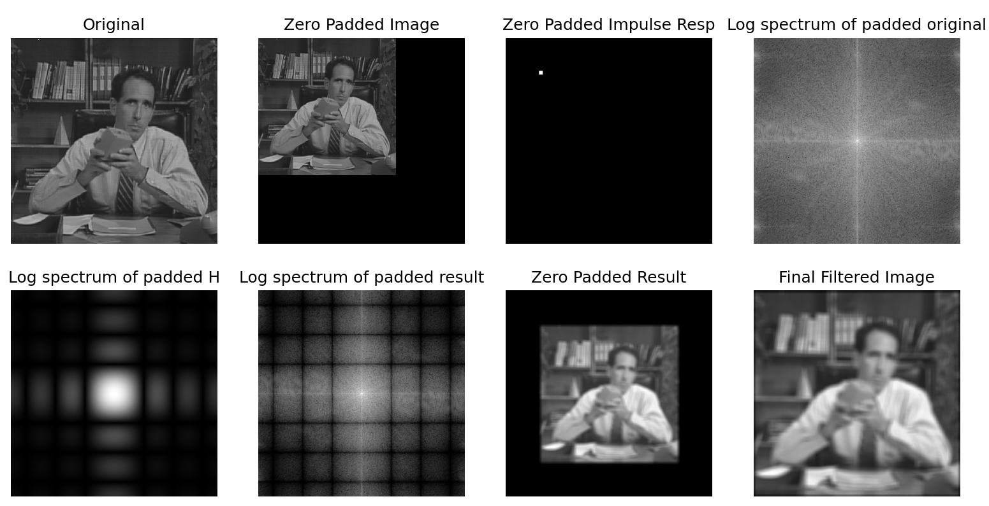



**Part 1c**

# MSSV: N20DCCN031

# Nguyễn Nhật Kha

# Lớp: D20DCCNPM01-N

import numpy as np

import os

import matplotlib.pyplot as plt

import cv2

def create_full_contrast(input):

    min_val = np.min(input)

    max_val = np.max(input)

    if(min_val == max_val):

        return np.zeros(input.shape, dtype=np.uint8)

    scale = 255/(max_val - min_val)

    return np.round(((input - min_val) * scale))

# Load image

parent_directory = os.path.dirname(os.path.abspath(__file__))

original_image = np.fromfile(f"{parent_directory}/salesman.bin", dtype=np.uint8).reshape(256,256)

# Create the zero-padded original image

padded_original = np.zeros((512, 512))

padded_original[:256,:256] = original_image

# Make the 256x256 impulse response image H

H = np.zeros((256, 256), dtype=np.float32)

H[125:132, 125:132] = 1/49

# Get the true zero-phase impulse response image

H2 = np.fft.fftshift(H)

# Create the zero-padded impulse response image

padded_H = np.zeros((512, 512))

padded_H[:128, :128] = H2[:128, :128]

padded_H[:128, 384:512] = H2[:128, 128:256]

padded_H[384:512, :128] = H2[128:256, :128]

padded_H[384:512, 384:512] = H2[128:256, 128:256]

# Compute the filtered result by pointwise multiplication of DFT's

final_output = np.fft.ifft2(np.fft.fft2(padded_original) * np.fft.fft2(padded_H))

# Drop padding and take the real part

final_output = final_output[:256, :256].real

plt.figure(figsize=(10,8))

plt.subplot(2,2,1)

plt.title("Original Image")

plt.imshow(original_image, cmap="gray")

plt.axis("off")

plt.subplot(2,2,2)

plt.title("256x256 H")

plt.imshow(H2, cmap='gray')

plt.axis('off')

plt.subplot(2,2,3)

plt.title("512x512 zero-padded H")

plt.imshow(padded_H, cmap='gray')

plt.axis('off')

plt.subplot(2,2,4)

plt.imshow(final_output, cmap='gray')

plt.title('Final Filtered Image')

plt.axis('off')

plt.show()

def linear_average_filter(image):

    padded_image = cv2.copyMakeBorder(image, 3, 3, 3, 3, cv2.BORDER_CONSTANT, value=0)

    result = np.zeros((262, 262))

    # Convolution

    for row in range(3, 259):

        for col in range(3, 259):

            result[row, col] = np.sum(padded_image[row-3:row+4, col-3:col+4]) / 49

    # Drop padding

    result = result[3:259, 3:259]

    return result

# Get result of part a

A = linear_average_filter(original_image)

print("Max difference from part a:",end=' ')

print(np.max(np.abs(create_full_contrast(final_output) - create_full_contrast(A))))

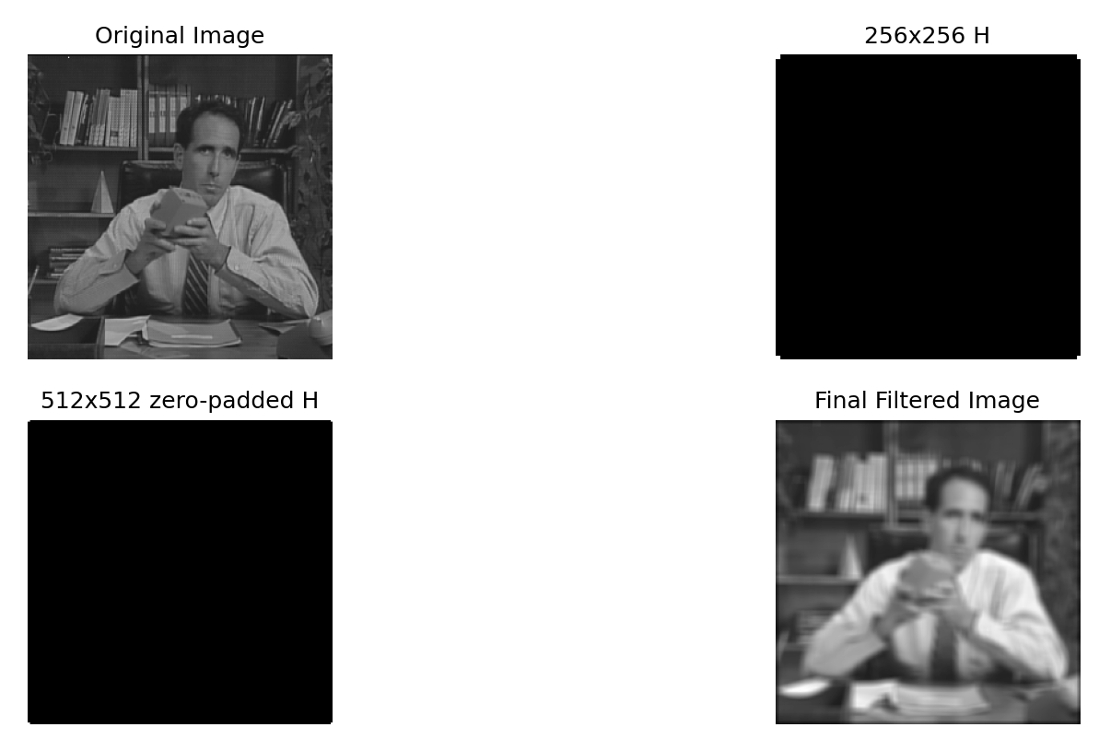



**Part 2a**

# MSSV: N20DCCN031

# Nguyễn Nhật Kha

# Lớp: D20DCCNPM01-N

import numpy as np

import os

import matplotlib.pyplot as plt

# Load image

def get_file(name):

    current_file_path = os.path.abspath(__file__)

    parent_directory = os.path.dirname(current_file_path)

    return np.fromfile(f"{parent_directory}/{name}", dtype=np.uint8)

girl = get_file("girl2.bin").reshape(256,256)

girl_noise = get_file("girl2Noise32.bin").reshape(256,256)

girl_hi_noise = get_file("girl2Noise32Hi.bin").reshape(256,256)

# Compute MSE

MSE_hi_noise = np.mean((girl_hi_noise - girl) ** 2)

print(f'MSE of girl2Noise32Hi: {MSE_hi_noise}')

MSE_noise = np.mean((girl_noise - girl) ** 2)

print(f'MSE of girl2Noise32: {MSE_noise}')

plt.figure(figsize=(10,8))

plt.subplot(1,3,1)

plt.title("Original")

plt.imshow(girl, cmap="gray")

plt.axis("off")

plt.subplot(1,3,2)

plt.title("Girl2Noise32")

plt.imshow(girl_noise, cmap="gray")

plt.axis("off")

plt.subplot(1,3,3)

plt.title("Girl2Noise32Hi")

plt.imshow(girl_hi_noise, cmap="gray")

plt.axis("off")

plt.show()

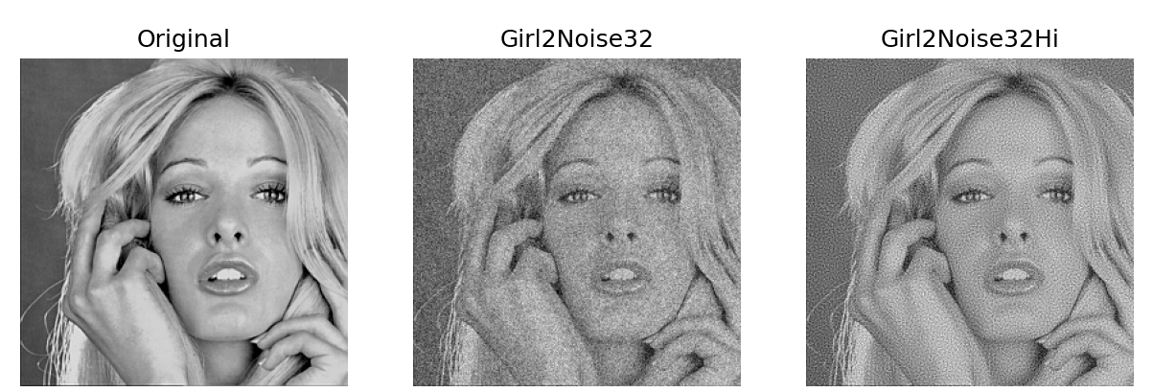



**Part 2b**

# MSSV: N20DCCN031

# Nguyễn Nhật Kha

# Lớp: D20DCCNPM01-N

import numpy as np

import os

import matplotlib.pyplot as plt

# Load image

def get_file(name):

    current_file_path = os.path.abspath(__file__)

    parent_directory = os.path.dirname(current_file_path)

    return np.fromfile(f"{parent_directory}/{name}", dtype=np.uint8)

original = get_file("girl2.bin").reshape(256,256)

Noise = get_file("girl2Noise32.bin").reshape(256,256)

HiNoise = get_file("girl2Noise32Hi.bin").reshape(256,256)

U_cutoff = 64

U, V = np.meshgrid(np.arange(-128, 128), np.arange(-128, 128))

HLtildeCenter = np.double(np.sqrt(U**2 + V**2) <= U_cutoff)

HLtilde = np.fft.fftshift(HLtildeCenter)

# Apply ideal low-pass filter to the original image

LPF_original = np.fft.ifft2(np.fft.fft2(original) * HLtilde).real

MSE_LPF_original = np.mean((LPF_original - original)**2)

print(f'MSE: ideal LPF on Original: {MSE_LPF_original}')

# Hi Pass Noise Image: Apply filter, compute MSE, ISNR

LPF_HiNoise = np.fft.ifft2(np.fft.fft2(HiNoise) * HLtilde).real

MSE_LPF_HiNoise = np.mean((LPF_HiNoise - original)**2)

ISNR_LPF_HiNoise = 10 * np.log10(np.mean((HiNoise - original)**2) / MSE_LPF_HiNoise)

print(f'MSE: ideal LPF on Noise32Hi: {MSE_LPF_HiNoise}')

print(f'ISNR: ideal LPF on Noise32Hi: {ISNR_LPF_HiNoise} dB')

# Noise Image: Apply filter, compute MSE, ISNR

LPF_Noise = np.fft.ifft2(np.fft.fft2(Noise) * HLtilde).real

MSE_LPF_Noise = np.mean((LPF_Noise - original)**2)

ISNR_LPF_Noise = 10 * np.log10(np.mean((Noise - original)**2) / MSE_LPF_Noise)

print(f'MSE: ideal LPF on Noise32: {MSE_LPF_Noise}')

print(f'ISNR: ideal LPF on Noise32: {ISNR_LPF_Noise} dB')

def create_full_contrast(input):

    min_val = np.min(input)

    max_val = np.max(input)

    if(min_val == max_val):

        return np.zeros(input.shape, dtype=np.uint8)

    scale = 255/(max_val - min_val)

    return np.round(((input - min_val) * scale))

# Display images

plt.figure(figsize=(10,8))

plt.subplot(1,3,1)

plt.title('LPF on Original')

plt.imshow(create_full_contrast(LPF_original), cmap='gray')

plt.axis('off')

plt.subplot(1,3,2)

plt.title('LPF on Girl2Noise32Hi')

plt.imshow(create_full_contrast(LPF_HiNoise), cmap='gray')

plt.axis('off')

plt.subplot(1,3,3)

plt.title('LPF on Girl2Noise32')

plt.imshow(create_full_contrast(LPF_Noise), cmap='gray')

plt.axis('off')

plt.show()

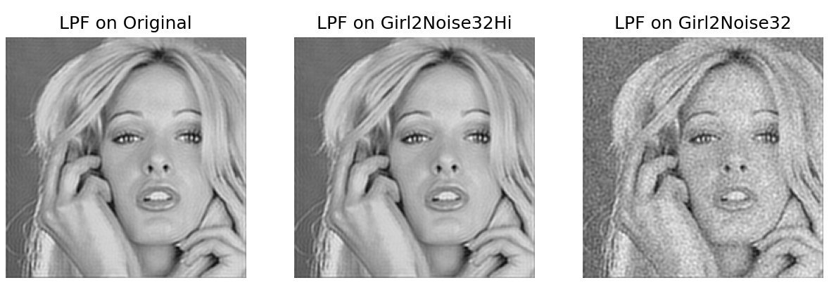

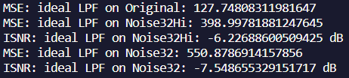

**Part 2c**

# MSSV: N20DCCN031

# Nguyễn Nhật Kha

# Lớp: D20DCCNPM01-N

import numpy as np

import os

import matplotlib.pyplot as plt

# Load image

def get_file(name):

    current_file_path = os.path.abspath(__file__)

    parent_directory = os.path.dirname(current_file_path)

    return np.fromfile(f"{parent_directory}/{name}", dtype=np.uint8)

original = get_file("girl2.bin").reshape(256,256)

Noise = get_file("girl2Noise32.bin").reshape(256,256)

HiNoise = get_file("girl2Noise32Hi.bin").reshape(256,256)

U_cutoff_H = 64

SigmaH = 0.19 * 256 / U_cutoff_H

U, V = np.meshgrid(np.arange(-128, 128), np.arange(-128, 128))

HtildeCenter = np.exp((-2 * np.pi**2 * SigmaH**2) / (256**2) * (U**2 + V**2))

Htilde = np.fft.fftshift(HtildeCenter)

H = np.fft.ifft2(Htilde).real

H2 = np.fft.fftshift(H)

ZPH2 = np.zeros((512, 512))

ZPH2[:256, :256] = H2

# Original: Apply Gaussian low-pass filter and compute MSE

ZP_original = np.zeros((512, 512))

ZP_original[:256, :256] = original

LPF_original = np.fft.ifft2(np.fft.fft2(ZP_original) * np.fft.fft2(ZPH2)).real

LPF_original = LPF_original[128:384, 128:384]

MSE_LPF_original = np.mean((LPF_original - original)**2)

print(f'MSE: Gaussian LPF on Original: {MSE_LPF_original}')

# Hi Pass Noise: Apply Gaussian low-pass filter, compute MSE and ISNR

ZP_HiNoise = np.zeros((512, 512))

ZP_HiNoise[:256, :256] = HiNoise

LPF_HiNoise = np.fft.ifft2(np.fft.fft2(ZP_HiNoise) * np.fft.fft2(ZPH2)).real

LPF_HiNoise = LPF_HiNoise[128:384, 128:384]

MSE_LPF_HiNoise = np.mean((LPF_HiNoise - original)**2)

print(f'MSE: Gaussian LPF on Noise32Hi: {MSE_LPF_HiNoise}')

ISNR_LPF_HiNoise = 10 * np.log10(np.mean((HiNoise - original)**2) / MSE_LPF_HiNoise)

print(f'ISNR: Gaussian LPF on Noise32Hi: {ISNR_LPF_HiNoise} dB')

# Noise: Apply Gaussian low-pass filter, compute MSE and ISNR

ZP_Noise = np.zeros((512, 512))

ZP_Noise[:256, :256] = Noise

LPF_Noise = np.fft.ifft2(np.fft.fft2(ZP_Noise) * np.fft.fft2(ZPH2)).real

LPF_Noise = LPF_Noise[128:384, 128:384]

MSE_LPF_Noise = np.mean((LPF_Noise - original)**2)

print(f'MSE: Gaussian LPF on Noise32: {MSE_LPF_Noise}')

ISNR_LPF_Noise = 10 * np.log10(np.mean((Noise - original)**2) / MSE_LPF_Noise)

print(f'ISNR: Gaussian LPF on Noise32: {ISNR_LPF_Noise} dB')

# Display images

plt.figure(figsize=(8,10))

plt.subplot(1,3,1)

plt.title('Gauss on Original')

plt.imshow(LPF_original, cmap='gray')

plt.axis('off')

plt.subplot(1,3,2)

plt.title('Gauss on Noise32Hi')

plt.imshow(LPF_HiNoise, cmap='gray')

plt.axis('off')

plt.subplot(1,3,3)

plt.title('Gauss on Noise32')

plt.imshow(LPF_Noise, cmap='gray')

plt.axis('off')

plt.show()

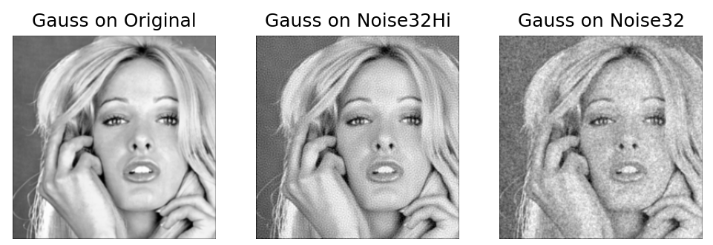

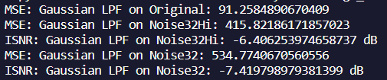

**Part 2d**

# MSSV: N20DCCN031

# Nguyễn Nhật Kha

# Lớp: D20DCCNPM01-N

import numpy as np

import os

import matplotlib.pyplot as plt

# Load image

def get_file(name):

    current_file_path = os.path.abspath(__file__)

    parent_directory = os.path.dirname(current_file_path)

    return np.fromfile(f"{parent_directory}/{name}", dtype=np.uint8)

original = get_file("girl2.bin").reshape(256,256)

Noise = get_file("girl2Noise32.bin").reshape(256,256)

HiNoise = get_file("girl2Noise32Hi.bin").reshape(256,256)

U_cutoff_H = 77.5

SigmaH = 0.19 * 256 / U_cutoff_H

U, V = np.meshgrid(np.arange(-128, 128), np.arange(-128, 128))

HtildeCenter = np.exp((-2 * np.pi**2 * SigmaH**2) / (256**2) * (U**2 + V**2))

Htilde = np.fft.fftshift(HtildeCenter)

H = np.fft.ifft2(Htilde).real

H2 = np.fft.fftshift(H)

ZPH2 = np.zeros((512, 512))

ZPH2[:256, :256] = H2

# Original: Apply Gaussian low-pass filter and compute MSE

ZP_original = np.zeros((512, 512))

ZP_original[:256, :256] = original

LPF_original = np.fft.ifft2(np.fft.fft2(ZP_original) * np.fft.fft2(ZPH2)).real

LPF_original = LPF_original[128:384, 128:384]

MSE_LPF_original = np.mean((LPF_original - original)**2)

print(f'MSE: Gaussian LPF on Original: {MSE_LPF_original}')

# Hi Pass Noise: Apply Gaussian low-pass filter, compute MSE and ISNR

ZP_HiNoise = np.zeros((512, 512))

ZP_HiNoise[:256, :256] = HiNoise

LPF_HiNoise = np.fft.ifft2(np.fft.fft2(ZP_HiNoise) * np.fft.fft2(ZPH2)).real

LPF_HiNoise = LPF_HiNoise[128:384, 128:384]

MSE_LPF_HiNoise = np.mean((LPF_HiNoise - original)**2)

print(f'MSE: Gaussian LPF on Noise32Hi: {MSE_LPF_HiNoise}')

ISNR_LPF_HiNoise = 10 * np.log10(np.mean((HiNoise - original)**2) / MSE_LPF_HiNoise)

print(f'ISNR: Gaussian LPF on Noise32Hi: {ISNR_LPF_HiNoise} dB')

# Noise: Apply Gaussian low-pass filter, compute MSE and ISNR

ZP_Noise = np.zeros((512, 512))

ZP_Noise[:256, :256] = Noise

LPF_Noise = np.fft.ifft2(np.fft.fft2(ZP_Noise) * np.fft.fft2(ZPH2)).real

LPF_Noise = LPF_Noise[128:384, 128:384]

MSE_LPF_Noise = np.mean((LPF_Noise - original)**2)

print(f'MSE: Gaussian LPF on Noise32: {MSE_LPF_Noise}')

ISNR_LPF_Noise = 10 * np.log10(np.mean((Noise - original)**2) / MSE_LPF_Noise)

print(f'ISNR: Gaussian LPF on Noise32: {ISNR_LPF_Noise} dB')

# Display images

plt.figure(figsize=(8,10))

plt.subplot(1,3,1)

plt.title('Gauss on Original')

plt.imshow(LPF_original, cmap='gray')

plt.axis('off')

plt.subplot(1,3,2)

plt.title('Gauss on Noise32Hi')

plt.imshow(LPF_HiNoise, cmap='gray')

plt.axis('off')

plt.subplot(1,3,3)

plt.title('Gauss on Noise32')

plt.imshow(LPF_Noise, cmap='gray')

plt.axis('off')

plt.show()

