# Project Proposal: Mapbox Usability Testing

# 



# Debashish Pradhan, Chun-Jung Huang, Yanzhi Shen, Arjun R. Reddy

# INST 631

# Project Proposal: Mapbox

# Debashish Pradhan, Arjun Reddy, Chun-Jung Huang, Yanzhi Shen

**OVERVIEW**

Mapbox is a digital platform that provides users with customizable online maps that can be embedded in their websites and applications. The map design tools and libraries empower developers to create functioning, dynamic maps that can be adapted to the users’ personalized design language and data. In addition to being a significant contributor to open source mapping libraries, Mapbox functions across platforms including web, mobile, AR and even Automotive. Mapbox provides navigation, search, data, on-site/offline services and a studio suite for designing maps. The Mapbox Studio interface will be the subject of research. Mapbox utilizes a feature called Components to aid users in editing their custom map settings. Components comprise of Layers—panels that implement individual changes to specific elements of the map. Components enable users to group these Layers such as place labels, road networks, walking/cycling routes, etc. This is implemented to improve the ease of use from a cartographic map-design perspective, abstracting a need to know the properties of each individual Layer. Not only does this make individual editing efficient and seamless but this also helps users to associate Layers better in order to manage property changes.

In the studio suite, our team will be researching Layers in the Components feature. This advanced formatting and formula based tool needs to be better understood. With multiple panels and functionalities appearing the deeper you go, tasks appear much more complex. There doesn’t seem to exist a hierarchy that guides users to prioritize common or most used functions. This ambiguity is so prevalent that the advanced users of the studio suite prefer injecting their own JSON code rather than attempting to work with the Layer tools. The power of Mapbox studio is the availability of multiple settings but understanding which tools are more commonly used and which aren’t as much can provide some direction to designing better UI.

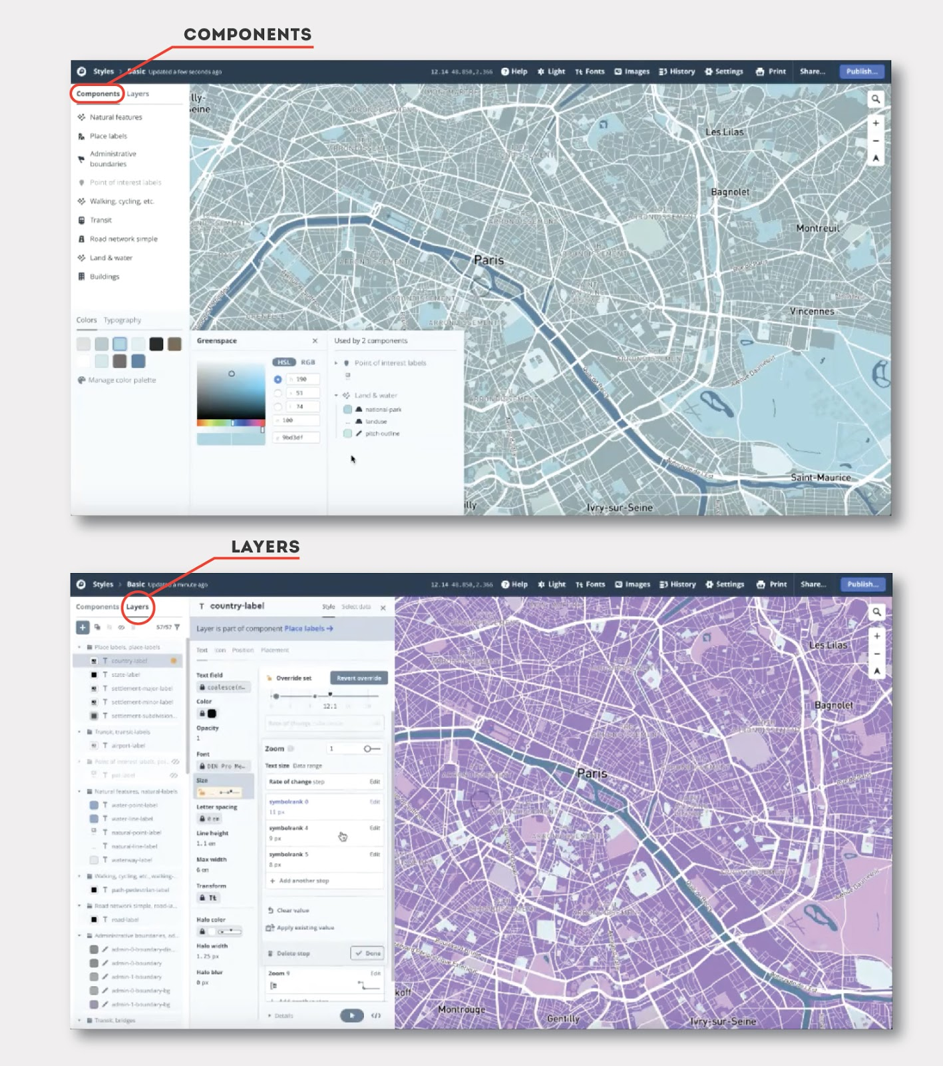

**RESEARCH OBJECTIVE**

The perceived problem of Mapbox studio is that Layers have a challenging user experience and require improvement in usability. With numerous functions to style and frame maps, the relationship between different Layers is unclear. Mapbox studio caters to developers from novice to advanced users. Novice users commonly use Components with template styled maps while the advanced users may take the time to work through the interface to understand Layers better. Intermediate users, however, find it daunting to attempt the advanced functions of Layers. The current UI isn't inclusive enough to support a comfortable learning curve for novice and intermediate users making that transition. The research goal is to identify how these users can better understand advanced operations through an improved user interface in order to adopt them quickly. Thus, making the transition from being a novice or intermediate user to a more experienced user smooth and seamless. The project focus is primarily on usability, but we will also be conducting a heuristic evaluation for accessibility (WCAG guidelines).

**TARGET USERS**

The diaspora of users for Mapbox Studio ranges from large public app/web developers (eg: Uber and Snapchat) to smaller individual users. Therefore, the population of representative users has an assortment of skill levels with the interface. The target users for this project will focus on the developers who are beginners and intermediate users of the studio suite. These users typically have a basic knowledge of the Studio GUI but have trouble understanding the functions beyond the Component panel and are usually not programmers. Additionally, there are those users who are moving from a different product but have some foundational understanding of mapping and GIS and want the UI to guide them through learning the new product.

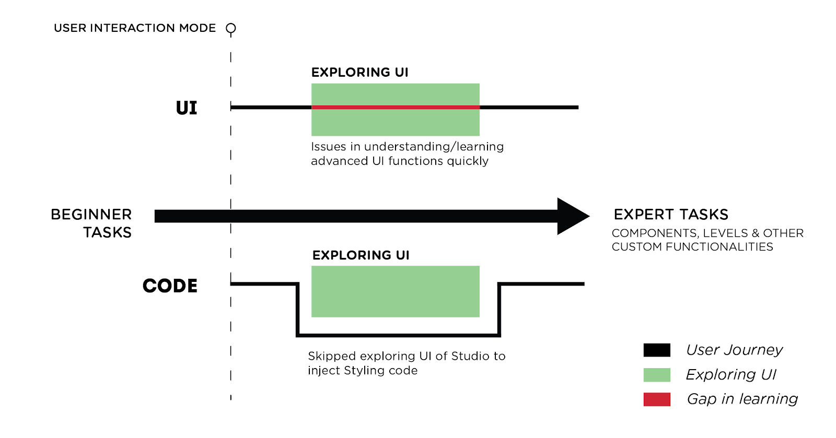

Early Studio users frequently begin learning through the UI. Once they are familiar and are comfortable with Components, users tend to follow two divergent paths.

One path has users attempting to achieve expert knowledge through only the UI functionality while the other set of users apply styling code in order to skip the process of understanding the interface altogether.

The research team will be recruiting participants through school resources and online communities. The team has also approached Mapbox for some support in the recruiting process. We will attempt to recruit map designers from M. P. S. in GIS (Geographical information system) students at UMD. We will be reaching out to online networks to recruit users through Reddit r/Mapbox, MapBox blog, GitHub and other developer communities. The team will utilize snowball sampling methods to draft and screen out more participants who can help us achieve our research objectives. It is not expected that there will be a large percentage of users with disabilities.

**OUTCOMES**

We hope to discover and understand the underlying problems that users face when trying to learn the GUI features of the Layers panel. We would like to validate the current unknowns of the map customization interface. We intend to identify a hierarchy that users can use to distinguish tasks and execute a workflow devoid of hassle. Based on our findings we hope to make design recommendations that will potentially aid users to adopt the GUI and understand Layers better. Consequently, our proposed changes could sway users who prefer injecting code to use the GUI instead.

**ROLES**

|  |  |  |
| --- | --- | --- |
| Name | Attributes | Role |
| Debashish | Used Mapbox before, Developer, Figma Expert | Design recommendations, Design tasks, Moderator, Remote testing if required, SUS survey, Validator |
| CJ | Connections with GIS people using ArcGIS, Developer, Sketch/XD prototyping | Heuristics evaluation, Screening & Recruiting,  Prototype, Moderator, Validator |
| Yanzhi | Knowledge of Data(MIM), Developer, Product Design Experience, Axure Prototyping | Moderator, Design Tasks, Manager, Validator |
| Arjun | Visual/Graphic Designer, (Adobe Suite) Illustrator/Photoshop/XD proficiency, Prototyping/Wireframing | Prototype development, Design recommendations, Moderator, Validator |