Project Proposal: Mapbox Usability Testing





Debashish Pradhan, Chun-Jung Huang, Yanzhi Shen, Arjun R. Reddy

INST 631

**Project Proposal: Mapbox**

Debashish Pradhan, Arjun Reddy, Chun-Jung Huang, Yanzhi Shen

**OVERVIEW**

Mapbox is a digital platform that provides users with customizable online maps that can be embedded in their websites and applications. The map design tools and libraries empower developers to create functioning, dynamic maps that can be adapted to the users’ personalized design language and data. In addition to being a significant contributor to open source mapping libraries, Mapbox functions across platforms including web, mobile, AR and even Automotive. Mapbox provides navigation, search, data, on-site/offline services and a studio suite for designing maps. The Mapbox Studio interface will be the subject of research. Mapbox utilizes a feature called Components to aid users in editing their custom map settings. Components comprise of Layers, panels that implement individual changes to specific elements of the map. Components enable users to group these Layers such as place labels, road networks, walking/cycling routes, etc. This is implemented to improve the ease of use from a cartographic map-design perspective, abstracting a need to know the properties of each individual Layer. Not only does this make individual editing efficient and seamless but this also helps users to associate Layers better in order to manage property changes. In the studio suite, our team will be researching Layers in the Components feature. This advanced formatting and formula based tool needs to be better understood. With multiple panels and functionalities appearing the deeper you go, tasks appear much more complex. There doesn’t seem to exist a hierarchy that guides users to prioritize common or most used functions. This ambiguity is so prevalent that the advanced users of the studio suite prefer injecting their own JSON code rather than attempting to work with the Layer tools. The power of Mapbox studio is the availability of multiple settings but understanding which tools are more commonly used and which aren’t as much can provide some direction to designing better UI.

**RESEARCH OBJECTIVE**

The perceived problem of Mapbox studio is that Layers have a challenging user experience and require improvement in usability. With numerous functions to style and frame maps, the relationship between different Layers is unclear. Mapbox studio caters to developers from novice to advanced users. Novice users commonly use Components with template styled maps while the advanced users may take the time to work through the interface to understand Layers better. Intermediate users, however, find it daunting to attempt the advanced functions of Layers. The current UI isn't inclusive enough to support a comfortable learning curve for novice and intermediate users making that transition. The research goal is to identify how these users can better understand advanced operations through an improved user interface in order to adopt them quickly. Thus, making the transition from being a novice or intermediate user to a more experienced user smooth and seamless. The project focus is primarily on usability, but we will also be conducting a heuristic evaluation for accessibility to better cater to the novice users who are in the pursuit of understanding advanced layer functions.

**TARGET USERS**

The diaspora of users for Mapbox Studio ranges from large public app/web developers (eg: Uber and Snapchat) to smaller individual users. Therefore, the population of representative users has an assortment of skill levels with the interface. The target users for this project will focus on the developers who are beginners and intermediate users of the studio suite. These users typically have a basic knowledge of the Studio GUI but have trouble understanding the functions beyond the Component panel and are usually not programmers. Additionally, there are those users who are moving from a different product but have some foundational understanding of mapping and GIS and want the UI to guide them through learning the new product.

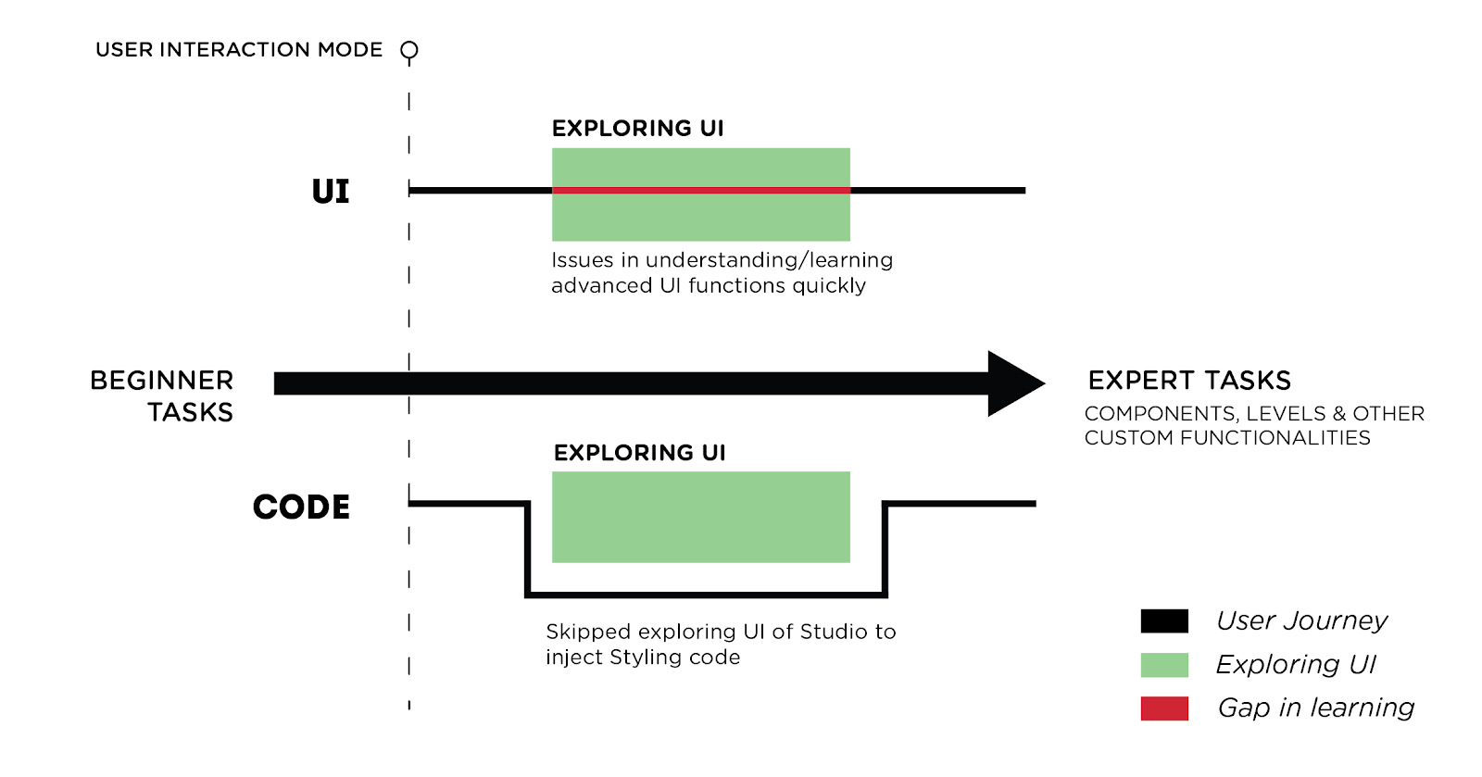

Early Studio users frequently begin learning through the UI. Once they are familiar and are comfortable with Components, users tend to follow two divergent paths.

One path has users attempting to achieve expert knowledge through only the UI functionality while the other set of users apply styling code in order to skip the process of understanding the interface altogether. In retrospect, users trying to learn or familiarize themselves with the advanced features of Studio in order to make more detailed changes to their maps fundamentally define our target users.

The research team will be recruiting participants through school resources and online communities. The team has also approached Mapbox for some support in the recruiting process. We will attempt to recruit map designers from M. P. S. in GIS (Geographical information system) students at UMD. We will be reaching out to online networks to recruit users through Reddit r/Mapbox, MapBox blog, GitHub and other developer communities. The team will utilize snowball sampling methods to draft and screen out more participants who can help us achieve our research objectives. Since MapBox Studio was created for designers, developers and product managers there isn’t a largely identifiable percentage of users with disabilities. The Studio Suite is fundamentally visual and hence relies heavily on visual perception. In the pursuit of recruiting users, the team hopes to enlist some users who can add value to accessibility.

**METHODS AND OUTCOMES**

We would be following the Agile usability testing approach over the course of 4 weeks. It includes:

* Assessing if design meets expectations
* Remove design flaws
* Business decision to real-world use
* Simultaneous course correction (assess if we are on the right track)
* Success/failure rate of the users
* 5 users per sprint

This would involve a combination of formative and summative evaluation methods. These evaluation methods are spread across 4 key steps during the usability testing process:

**Creating a test plan (Understanding key tasks to perform)**

The team would be recruiting users after an initial screening process. Because this is not a statistical test we would be sticking with the typical 15-20 number of users. This would help us gauge the experience level of the representative users. Next, we would be laying out specific objectives, the context of testing with respect to user tasks. Following this, a quick heuristic evaluation would help us determine the number of user tasks we would like to give to users. The team would then establish metrics we would like to evaluate to assess “How successful our users are with their tasks”. For example,  Task performance (success/failure) and time performance. These metrics would help us communicate with our stakeholders using concrete numbers rather than “gut feeling” or opinions.

|  |  |  |  |  |
| --- | --- | --- | --- | --- |
| Objective | Tasks | Scenario | Outcome | Changes needed |
|  | * Task A * Task B |  |  |  |
|  | * Task A * Task B |  |  |  |

**Facilitating the test**

Usability tests are unpredictable, and the test participants might not act as we anticipated when we planned the test. It’s much easier to run a smooth usability test if we give our participants the right instructions from the beginning—then they’ll know what to expect and what they need to do. The steps we would take in helping them understand:

* Appreciation of participants’ time
* Explain the purpose of the test
* Highlight why our users need to think aloud
* Explain the tasks - Each task one at a time and go on to the next when they’re ready

The tasks will undergo a mock-run by 2-3 users for sanity checks and validations so that the actual process is smooth. Mock-run process:

* Testing the test
* Validation
* Verify the software is working
* No impossible tasks
* A back-up plan if there are any connectivity issues (preferably a print paper version of the screen for backup)

The team would then exercise think-aloud protocol which would help users externalize their emotions and needs. Users will be presented with a pre-defined task and our team would observe the users while they are performing the task. The tasks would be sequenced based on their difficulty level. Easier, orientation tasks would be first and difficult tasks would be in the middle. We will sometimes intervene while the user is performing the tasks, and interview them to uncover/discover hidden user needs, while identifying design opportunities, usability issues, and design problems.

Users might be recorded while they are performing the tasks. During this phase, the team would assign specific roles, such as Moderators, Interviewers.

|  |  |  |
| --- | --- | --- |
| Pre-Test | Actual Test (Most Important) | Post-Test |
| * Task A * Task B * Task C | Think Aloud | Satisfaction Usability Scale(SUS):  To ascertain if the tasks were indeed successful or the users think they were successful |

Card Sorting and Tree Sorting methods will be performed to understand underlying difficulties with the interface/menu options.

Finally, a subjective satisfaction questionnaire will be distributed amongst the users to assess user satisfaction.

**Analyzing the test**

Based on the outcomes, we would analyze the user behavior, identify problem areas, assess navigation. Following are the metrics we would use for analyses:

Qualitative:

* Stress Responses (Non-verbal cues, changes in user behavior)
* SUS report
* Perceived effort of difficulty

Quantitative:

* Time on Task
* Success/failure rate
* # of confusions
* # of errors

**Creating the test report**

The final test report will include the review of video footage, design issues, best practices, and design recommendations, covering Dr. Lazar’s deliverables requirements.

**Expected Roles:**

The team will divide into roles of moderators and observers while facilitating the tests. Two sub-teams will conduct Card sorting and tree sorting.

Post that, we will distribute tasks amongst each other based on the background we come from.

|  |  |  |
| --- | --- | --- |
| Name | Attributes | Role |
| Debashish | Used Mapbox before, Developer, Figma Expert | Analyzing the tests, Design recommendations, Design tasks, Moderator, Remote testing if required, SUS survey, Validator |
| CJ | Connections with GIS people using ArcGIS, Developer, Sketch/XD prototyping | Heuristics evaluation, Screening & Recruiting,  Prototype, Moderator, Validator |
| Yanzhi | Knowledge of Data(MIM), Developer, Product Design Experience, Axure Prototyping | Moderator, Design Tasks, Manager, Validator |
| Arjun | Visual/Graphic Designer, (Adobe Suite) Illustrator/Photoshop/XD proficiency, Prototyping/Wireframing | Prototype development, Design recommendations, Moderator, Validator |

**TIMELINE**

Nov 1 - Nov 5: Screening & recruiting

Nov 6 - Nov 15: 1st usability test, other methods  
Nov 19: 1st usability test Due

Nov 20 - Nov 25: Prototyping

Nov 26: Improved Interface

Dec 2 - Dec 13: 2nd usability test

Dec 17 - Final Deliverable 