**How to configure tomcat on windows 10 and deploy war file on server:**

Step1: Download and install tomcat service.

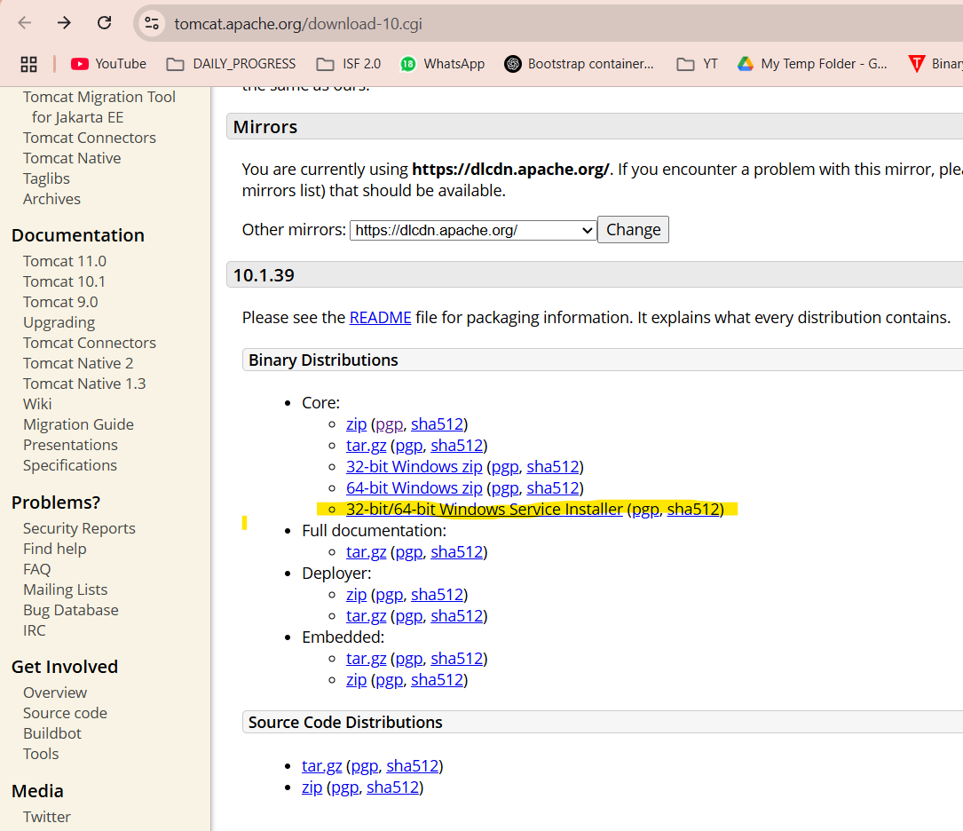

Step 2: open localhost:8080 and go to “Manage App”

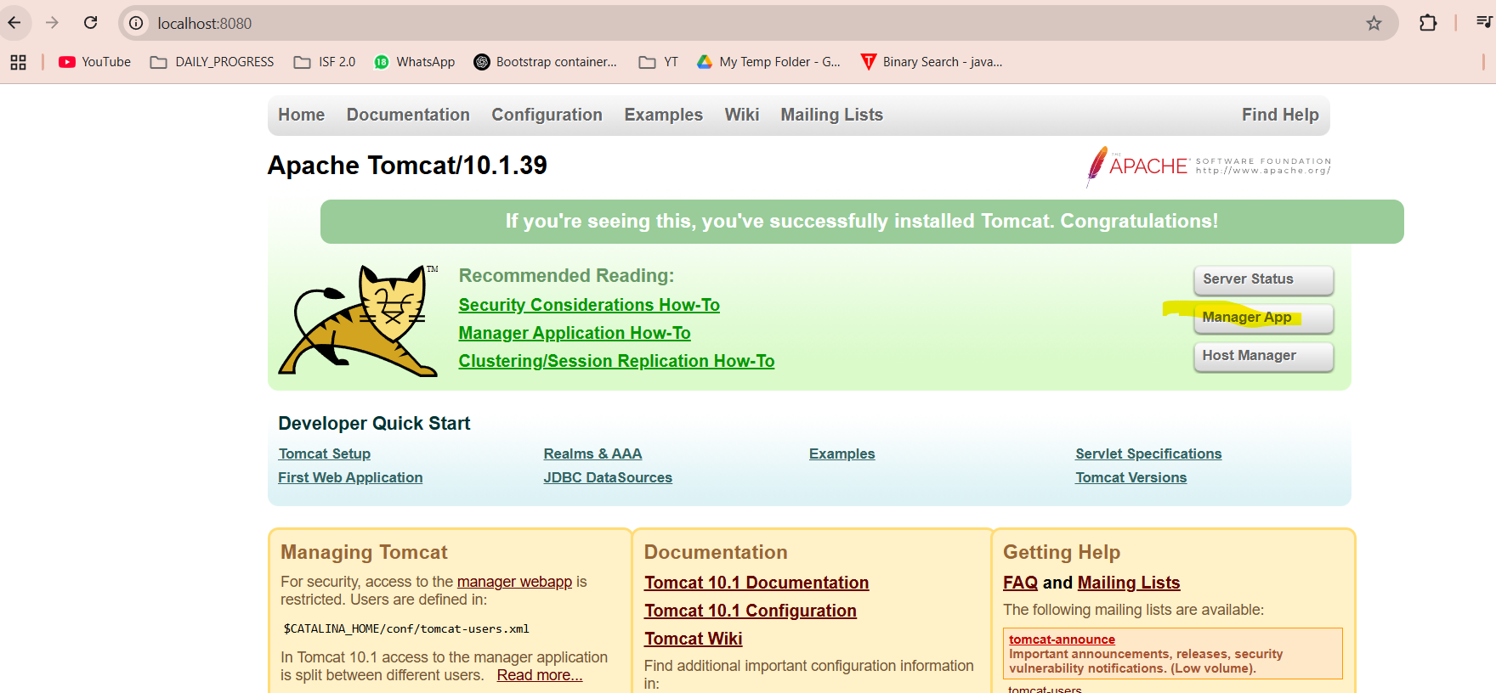

Step 3: upload application “war” file and deploy

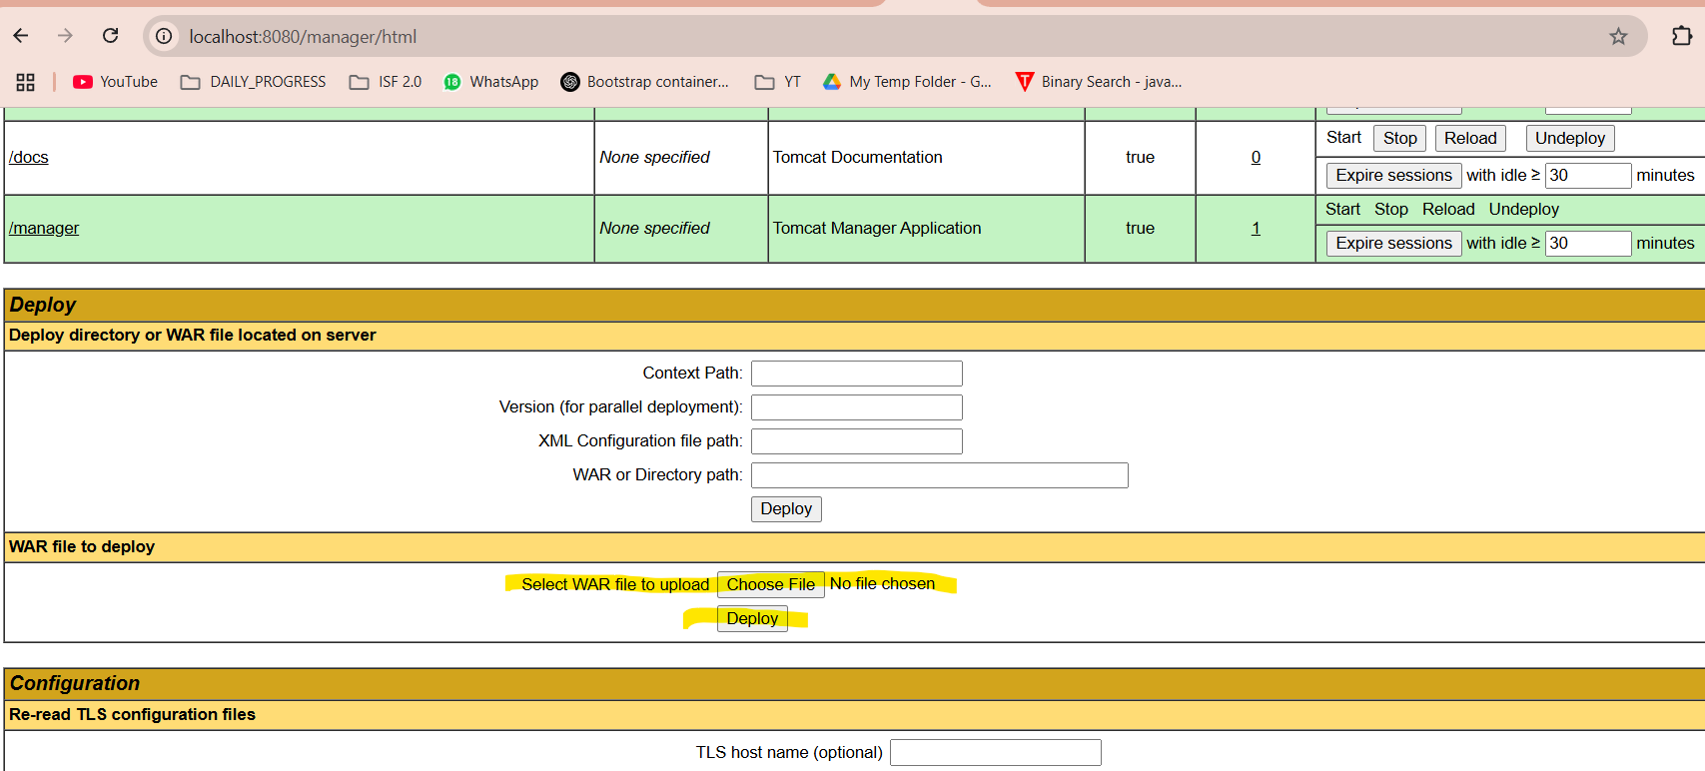

Step 4: check OK and path, application should be deployed

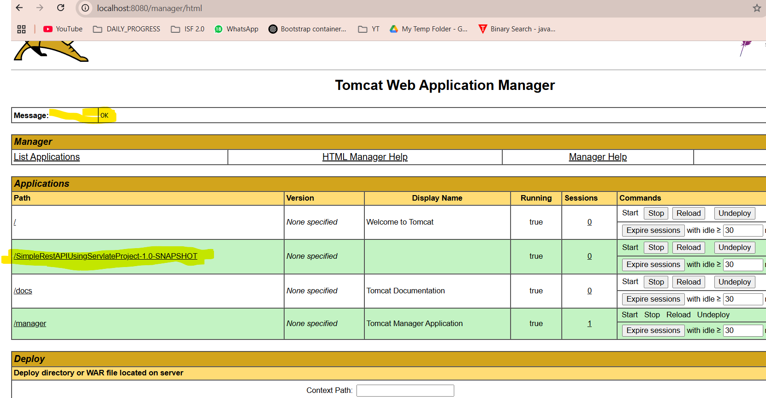

Servlet response:

