Full Paper Title (Style Title)

{Leave one line blank}

Author Name1*, Author Name2& Author Name 3(style Author)

1Department, Institute, City, Country (style affiliation)

2Department, Institute, City, Country

3Department, Institute, City, Country

*E-mail: corresponding.author@institute.com

**Abstract** (style **Abstract**)**:**

This document demonstrates layout of paper for the **International Conference on Innovations and Sustainability in Civil Engineering: Shaping Tomorrow’s Infrastructure.** All you need to do is copy the entire file to your hard disk, print it for reference, overwrite this text with your own and save it as a file bearing the first name of the first author- e.g., AUTHOR.DOC or AUTHOR.DOCX in this case. Your abstract should not exceed 250 words in length; it should not contain artwork. The abstract should present a concise statement of the scope, principal findings, and conclusions of the paper.

**Keywords:** Up to 6 relevant keywords listed, separated by a comma and a space (style **Keywords**).

# Introduction **(Times New Roman 10 Case Bold – style** Heading 1**)**

Please adhere to the provided format of the paper to ensure that all contributions in the final publication are professional and consistent.

## Heading Level 2**(Times New Roman 10 Case Bold– style** *Heading 2***)**

This text is in Times New Roman10-point. This template will make it easy to layout your paper for the proceedings. (style **Body Text**)

Insert your own text selecting the appropriate style as you go. Be careful when cutting and pasting as sometimes the style is pasted too; be sure to highlight each bit of text and select the right style.

When you have completed your paper, check that you have deleted all instructions and headings in this template.

This template paper is supplied to you in Word (.docx) format. Text should be single-spaced and fully justified. Styles in this template should ensure that you achieve the correct format with a minimum of effort. All styles used in this document are in **red colour**.

The presenting author should be underlined and the affiliations of all the authors should be given using the numbering system shown above. Email contact details should appear below for the corresponding author.

The paper should be structured into an introduction, main body (arguments, results, discussion, etc.), and a concluding section.

Papers should be no more than 10 pages in length.

### Heading Level 3 (Times New Roman10 Title Case – style Heading 3)

Limit using up to three heading levels.

## Margins and Page Allowance

Set out your paper on A4 size the same as this, with margins as described in Table 1.

## Guidelines for Putting Figures in your Paper

Figures should be of high quality with good clarity. Graphic objects such as charts, photos and line drawings should be in electronic form and be pasted into the document directly. Floating frames are useful for convenient positioning of graphics. Original line drawings, photos, etc. should be scanned before insertion. If possible, use either PDF or JPEG formatted graphic files, as they are more compact than bitmaps like BMP or PCT. By all means use color if it enhances the meaning of the figures. All labels must be readable. Figures and tables must be referenced in the main text. Number your figures Figure 1, Figure 2, etc. with a short caption under each in 9-point Times New Roman to distinguish it from the main text. The style Figure Caption should be used.

## Tables

Tables should be labeled Table 1, Table 2, etc. at the top of each table followed by a table caption. The style **Table caption** should be used for the table caption.

**Table 1.** Margins to use in this paper. (style **Table caption**)

|  |  |  |
| --- | --- | --- |
| Margin | Size | Size |
| Left | 25mm | 1in |
| Right | 25mm | 1in |
| Top and bottom | 25mm | 1in |

For Microsoft Word users the Page Setup Dialog (in Layout Tab) should appear as shown in Fig. 1. Center your Figures and Tables. Also center the caption.

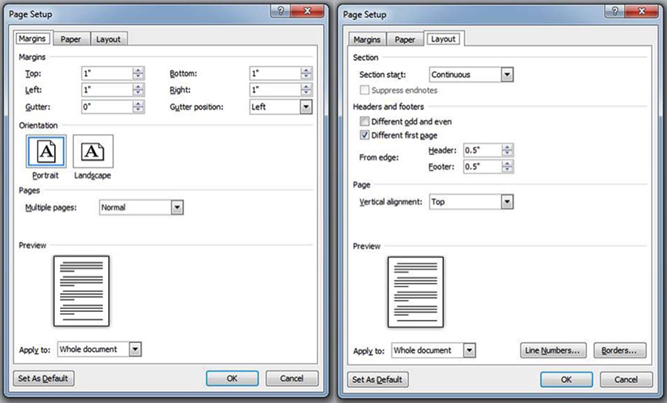

**Figure 1.** The Page Setup Dialog Box (Margins) for formatting paper in MS Word. (style **Figure** **Caption**)

Please **DO NOT modify** headers or footers. Please **DO NOT** use page numbers. These will be applied when the proceedings are compiled.

## Units

All units should be expressed using the SI system (Système International). If desired, ES (English System) units can also be included in parentheses following the SI units.

## Footers and Headers

**DO NOT** use headers and footers. These will be applied separately when the proceedings are compiled. It is best to avoid footnotes; suggest using parentheses in the text if needed.

## Equations

Mathematical equations should be laid out wherever possible using an equation editor and be numbered consecutively as in this example (using the style **Equation**10 pt). Please provide description of each term used in equation as well. Please leave a single tab from left margin to insert the equation.

$Q=v_{1}×A_{1}=v_{2}×A_{2}$ (1)

where *Q* is the volumetric flow rate, *v* the mean flow velocity value and *A* is the cross-sectional flow area (always explain relevant symbols in the text). A blank line above and below should separate the equation from the text, and the equation number should be right aligned. The equation reference format in the text should be as follows: From Eq. (1), it can be seen that the continuity equation holds.

## Bullets and Numbering

* If there is no sequence, then use bullet points.
* Bullet points and numbering should be indented.

1. Preferably, use standard numbering.
2. As per the above point.

# ACKNOWLEDGMENTS

This work was conducted in collaboration with the departments of X,Y and Z. Also list here, where applicable, funding sources for the work described and contributors who are not authors to its intellectual content.

# REFERENCES

The ASCE journal format should be used for all referencing. References should be presented in the body of the text as follows: Barker (1992) or (Barker 1992) for one author, Jones and Smith (1998) or (Jones and Smith 1998) for two, and Feugard et al. (1994) or (Feugard et al. 1994) for three or more authors. References should be listed in alphabetical order (based on first author) according to the example formats in Section 4. Where the original author’s words are repeated verbatim, references should include the page number for the quote, e.g., ‘… this is the quote’ (Black, 1996: 38).

# References Placed at the End of the Paper

The general format for references is as follows:

Author’s surname, initials. (Year of Publication). Title in Italics, Name of Publisher, Place of Publication. (style **References**10pt Times New Roman)

Some specific examples of reference styles for different publication types are given in the rest of this section.

***Journals:***

King, S., and Delatte, N.J. (2004). “Collapse of 2000 Commonwealth Avenue: Punching shear case study.” *J. Perf. Constr. Facil.,* 18(1), 54-61.

***Conference Proceedings and Symposia:***

Fwa, T.F., Liu, S.B., and Teng, K.J. (2004). “Airport pavement condition rating and maintenance-needs assessment using fuzzy logic.” *Proc., Airport Pavements: Challenges and New Technologies*, ASCE, Reston, Va., 29-38.

Include the sponsor of the conference or publisher of the proceedings, AND that entity’s location— city and state or city and country.

***Book References:***

Smith, N.J., and Jones, M. (1979). A Companion Guide to Good Authorship, Social Work Press, Sydney.

Book references must include author, book title, publisher, and the publisher’s location. If a specific chapter is being used, list the chapter title and inclusive page numbers. For reports, include the full institution name (not just the acronym) and its location.

***Unpublished Material:***

Unpublished material is not included in the references. It may be cited in the text in the following forms: (John Smith, personal communication, May 16, 1999) or (Jones et al., unpublished manuscript, 2002). As an exception to the rule, articles that are accepted for publication may be included in the references as follows: Gibson, W. (2003). “Cyberspace: The postmodern frontier.” *J. Comp. in Fiction,* in press.

***Web Pages and On-line Material:***

Burka, L. P. (2002). “A hypertext history of multiuser dimensions.” *MUD history,* <http://www.ccs.neu.edu> (Dec. 5, 2003).

Include an author, if possible, a copyright date, a title, the Web address, and the date the material was accessed or downloaded (in parentheses at the end).

**Please remember Papers should be no more than 10 pages in length.**

Please note that submissions, which do not follow the formatting instructions and templates, will not be accepted by the Organization for inclusion in the proceedings or in the scientific program.