Exercise1:

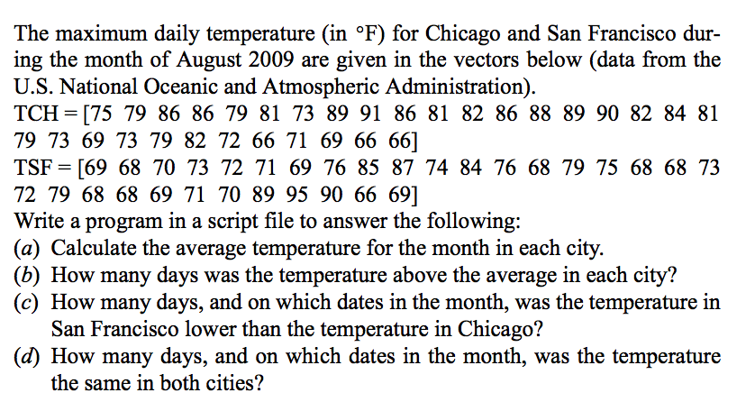

Solution:

﻿

chicagoTemps = [75 79 86 86 79 81 73 89 91 86 81 82 86 88 89 90 82 84 81 79 73 69 73 79 82 72 66 71 69 66 66];

sfTemps = [69 68 70 73 72 71 69 76 85 87 74 84 76 68 79 75 68 68 73 72 79 68 68 69 71 70 89 95 90 66 69];

avgChicago = mean(chicagoTemps);

avgSF = mean(sfTemps);

aboveAvgChicago = sum(chicagoTemps > avgChicago);

aboveAvgSF = sum(sfTemps > avgSF);

lowerThanChicago = sum(sfTemps < chicagoTemps);

datesLowerThanChicago = find(sfTemps < chicagoTemps);

sameTempDays = sum(chicagoTemps == sfTemps);

datesSameTemp = find(chicagoTemps == sfTemps);

disp('(a) Average temperature for the month:');

disp([' Chicago: ', num2str(avgChicago)]);

disp([' San Francisco: ', num2str(avgSF)]);

disp('(b) Number of days temperature was above average:');

disp([' Chicago: ', num2str(aboveAvgChicago)]);

disp([' San Francisco: ', num2str(aboveAvgSF)]);

disp('(c) Number of days, and dates, SF temperature was lower than Chicago:');

disp([' Days: ', num2str(lowerThanChicago)]);

disp([' Dates: ', num2str(datesLowerThanChicago)]);

disp('(d) Number of days, and dates, temperature was the same in both cities:');

disp([' Days: ', num2str(sameTempDays)]);

disp([' Dates: ', num2str(datesSameTemp)])

(a) Average temperature for the month:  
 Chicago: 79.129  
 San Francisco: 74.5484  
(b) Number of days temperature was above average:  
 Chicago: 16  
 San Francisco: 11  
(c) Number of days, and dates, SF temperature was lower than Chicago:  
 Days: 23  
 Dates: 1 2 3 4 5 6 7 8 9 11 13 14 15 16 17 18 19 20 22 23 24 25 26  
(d) Number of days, and dates, temperature was the same in both cities:  
 Days: 1  
 Dates: 30

Exercise2:

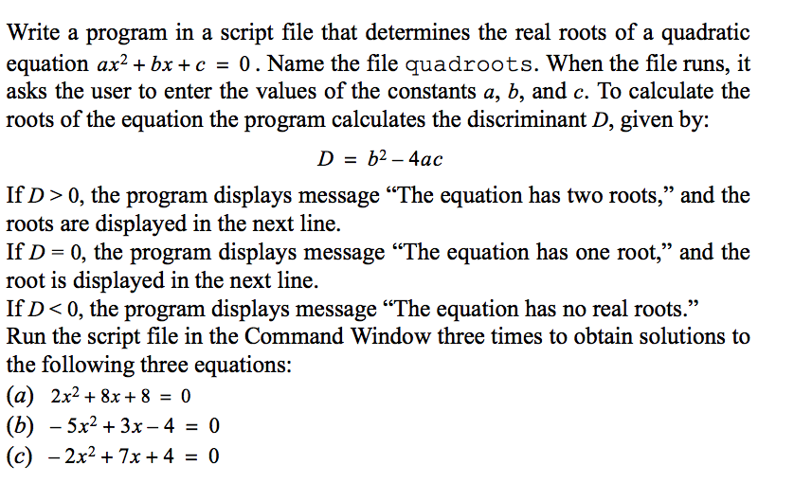

Solution:

﻿

Exercise3: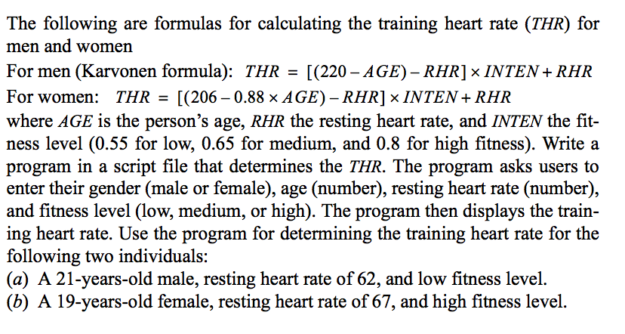

Solution:

Exercise4:

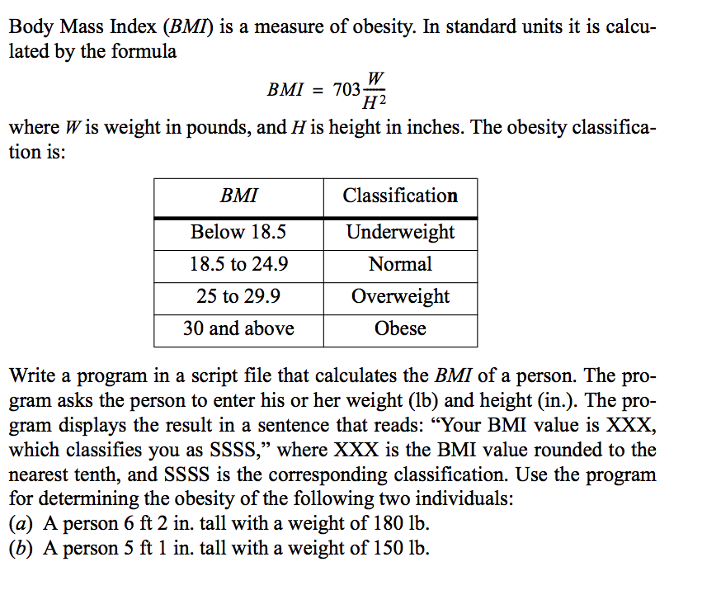

Solution: (1ft=12 in.)

﻿

Exercise 5: A script file that demonstrates the use of the if-elseif-else-end statement.  
 The program calculates the tip in a restaurant according to the amount of the bill. If the bill is less than 10$ the tip is $1.80. Between $10 and $60 the tip is 18% of the bill. Above $60 the tip is 20% of the bill.

6. Write a program in a script file that calculates the cost of renting a car according to the following price schedule:

metin, yazı tipi, sayı, numara, ekran görüntüsü içeren bir resim

Açıklama otomatik olarak oluşturuldu

The program asks the user to enter the type of car(SEDAN or SUV), the number of days, and the number of miles driven. The program then displays the cost (rounded to cents) for the rent. Run the for the following cases:

1. Sedan, 10 days, 769 miles
2. SUV, 32 days, 4056 miles