**Exercise1:**

(a)Write a script that calculates the function **f(x)= cos(4*x)+cos(4.1*x)** and use it to plot f(x) from x=1 to 10

f = @(x) cos(4*x) + cos(4.1*x);

x = linspace(1, 10, 1000);

y = f(x);

plot(x, y);

title('Plot of f(x) = cos(4*x) + cos(4.1*x)');

xlabel('x');

ylabel('f(x)');

grid on;

(b) Write a function y = Mid3(a,b,c) that returns the middle of the three values a, b, and c.

function y = Mid3(a, b, c)

y = a + b + c - min([a, b, c]) - max([a, b, c]);

end

(c) Complete the following function so that it performs as specified:

function x = IsPythag(a,b,c)

% x has the value of 1 if a triangle with sides a, b, and c is

% a Pythagorean triangle and 0 otherwise.

% a, b, and c are positive integers.

function x = IsPythag(a, b, c)

sides = [a, b, c];

sides = sort(sides);

x = sides(1)^2 + sides(2)^2 == sides(3)^2;

end

(d) Write a function called ‘check1’ that takes a vector as input and prints an error message for all vectors that do not have exactly three components.

function check1(vec)

if numel(vec) ~= 3

error('Input vector must have exactly three components.');

else

disp('Input vector is valid.');

end

end

(e) Write a MATLAB **function** that accepts time ***t*** as an input and returns a voltage corresponding to the following equation: *v* = e-*t*sin(5*t*).

function v = CalculateVoltage(t)

v = exp(-t) .* sin(5 * t);

end

**Exercise2:**

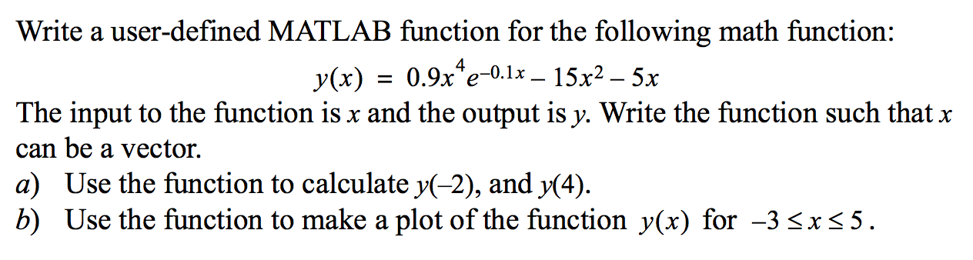

**﻿**

function y = myFunction(x)

y = 0.9 * x.^4 .* exp(-0.1 * x) - 15 * x.^2 - 5 * x;

end

-----------------------------------

y_minus_2 = myFunction(-2);

y_4 = myFunction(4);

disp(['y(-2) = ', num2str(y_minus_2)]);

disp(['y(4) = ', num2str(y_4)]);

x_values = linspace(-3, 5, 1000);

y_values = myFunction(x_values);

figure;

plot(x_values, y_values, 'LineWidth', 2);

title('Plot of y(x) = 0.9x^4 * e^(-0.1x) - 15x^2 - 5x');

xlabel('x');

ylabel('y(x)');

grid on;

**Exercise3:**

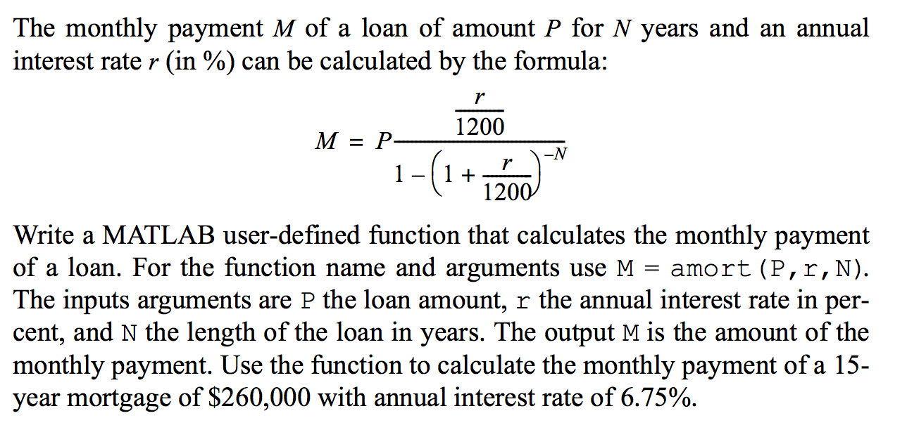

function M = amort(P, r, N)

r = r / 100;

monthly_rate = r / 12;

num_payments = N * 12;

M = P * (monthly_rate / (1 - (1 + monthly_rate)^-num_payments));

end

loan_amount = 260000;

annual_interest_rate = 6.75;

loan_years = 15;

monthly_payment = amort(loan_amount, annual_interest_rate, loan_years);

disp(['Monthly Payment: $', num2str(monthly_payment)])

**﻿**

**Exercise 4: Write a user defined MATLAB function for he following math function:**

$$r\left(θ\right)=2\cos{θ\sin{θ\sin\left(θ/4\right)}}$$

**﻿**

The input to the function is $θ$ (in radians) and the output is r. Write the function such that $θ$ can be a vector.

1. Use the function to calculate $r(\frac{3π}{4})$ and $r(\frac{7π}{4})$.
2. Use the function to plot (polar plot) $r(θ)$ for $0≤θ≤2π$.

**﻿** function result = polarFunction(theta)

result = 2 * cos(theta) .* sin(theta) .* sin(theta/4);

end

theta_1 = 3*pi/4;

theta_2 = 7*pi/4;

result_1 = polarFunction(theta_1);

result_2 = polarFunction(theta_2);

disp(['r(3*pi/4) = ', num2str(result_1)]);

disp(['r(7*pi/4) = ', num2str(result_2)]);

theta_values = linspace(0, 2*pi, 1000);

r_values = polarFunction(theta_values);

figure;

polarplot(theta_values, r_values, 'LineWidth', 2);

title('Polar Plot of r(\theta) = 2cos(\theta)sin(\theta)sin(\theta/4)');

grid on;