# Blast heard in Pakistan's Lahore, says media report

## Basic Information

|  |  |
| --- | --- |
| URL | https://www.thehindu.com/news/international/blast-heard-in-pakistans-lahore-says-media-report/article69551939.ece |
| Source | thehindu.com |
| Publication Date | 2025-05-08 |
| Media Type | Article |
| Created | 2025-05-08 08:57:56 |

## Screenshot

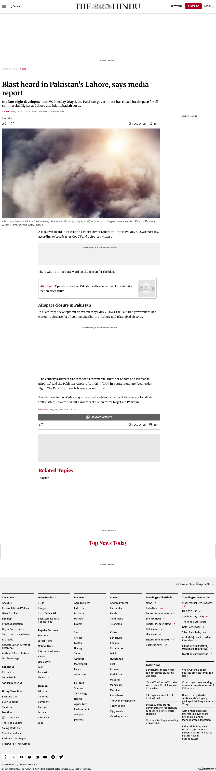

Screenshot taken on 2025-05-08 23:19:37

## Summary

May 8, 2025e-Paper The View From India  
 Looking at World Affairs from the Indian perspective. Karnataka Today  
 Your daily dose of news highlights from Karnataka First Day First Show  
 News and reviews from the world of cinema and streaming. Today's Cache  
 Your download of the top 5 technology stories of the day.

## Notes

No notes available