# Operation Sindoor LIVE Updates: Pakistan resorts to cross border shelling in Karnah area of J&K's Kupwara for second day after 'Operation Sindoor' - The Times of India

## Basic Information

|  |  |
| --- | --- |
| URL | https://timesofindia.indiatimes.com/india/operation-sindoor-live-updates-jammu-and-kashmir-pahalgam-terror-attack-indian-army-military-strikes-pok-pakistan/liveblog/120950644.cms |
| Source | timesofindia.indiatimes.com |
| Publication Date | 2025-05-08 |
| Media Type | Article |
| Created | 2025-05-07 23:31:34 |

## Screenshot

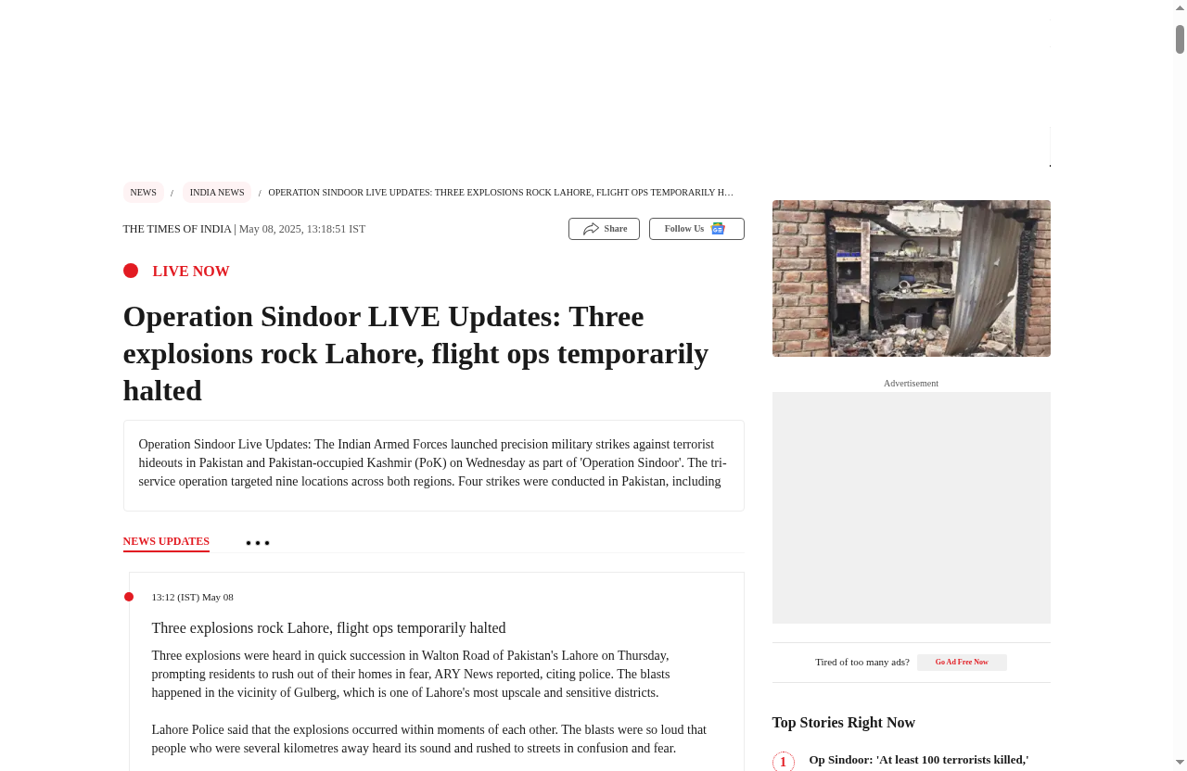

Screenshot taken on 2025-05-08 08:39:59

## Summary

Three explosions rock Lahore, flight ops temporarily halted Three explosions were heard in quick succession in Walton Road of Pakistan's Lahore on Thursday, prompting residents to rush out of their homes in fear, ARY News reported, citing police. The blasts happened in the vicinity of Gulberg, which is one of Lahore's most upscale and sensitive districts.Lahore Police said that the explosions occurred within moments of each other. The blasts were so loud that people who were several kilometres away heard its sound and rushed to streets in confusion and fear.Emergency response teams, including Rescue and Firefighting units, have reached the site of the incident. Furthermore, the police have cordoned off the area, ARY News reported.According to officials, investigations were being made to determine the nature and source of the explosions. The authorities have sealed the area and unrelated people have been restricted from entering the area as bomb disposal and intelligence teams start the...

## Notes

No notes available