# Untitled Article

## Basic Information

|  |  |
| --- | --- |
| URL | https://askubuntu.com/questions/539498/where-does-chromedriver-install-to |
| Source | askubuntu.com |
| Publication Date | Unknown |
| Media Type | Article |
| Created | 2025-05-08 08:40:29 |

## Screenshot

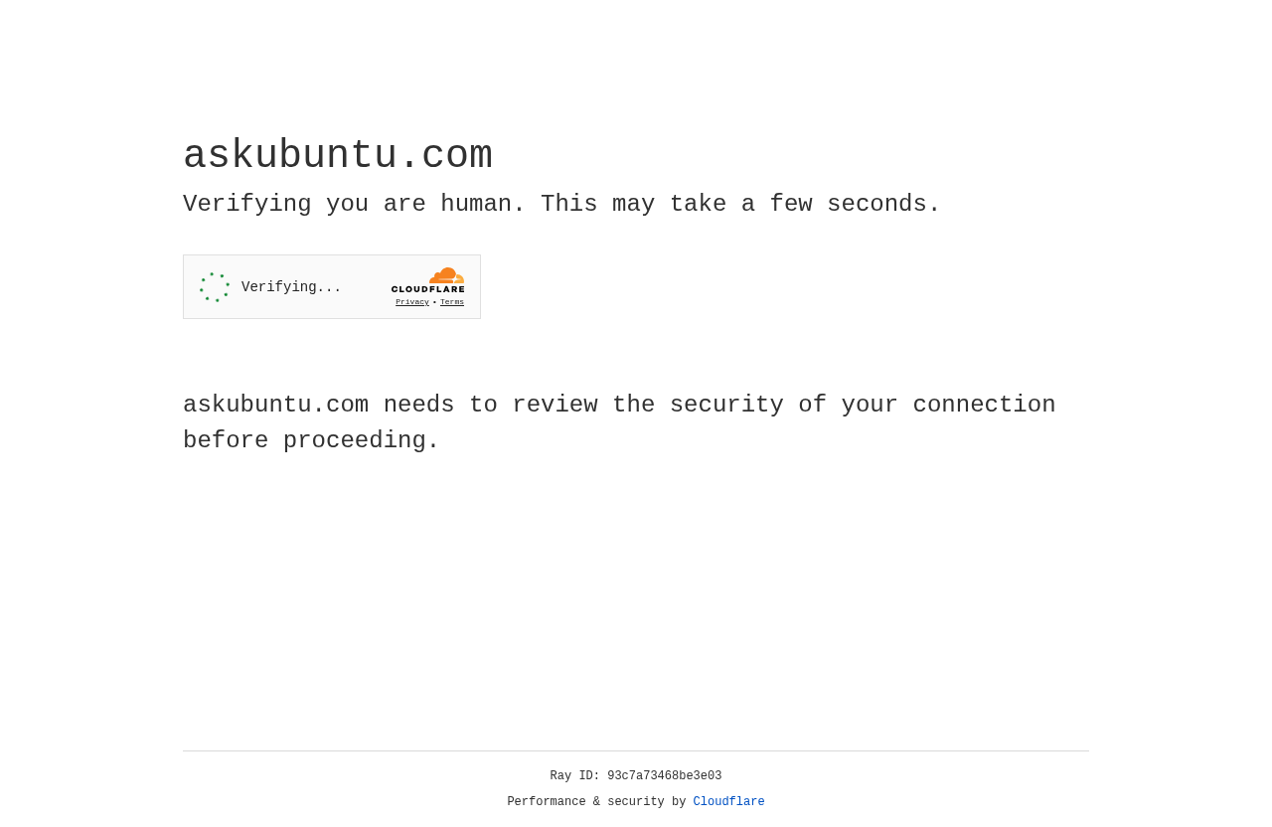

Screenshot taken on 2025-05-08 08:40:37

## Summary

Error extracting summary: 403 Client Error: Forbidden for url: https://askubuntu.com/questions/539498/where-does-chromedriver-install-to

## Notes

No notes available