# **LAB ASSIGNMENT-3**

# **Date of the Submission:** 27/01/2022

# **Course Code:** CSLR42

# **Subject:** Operating Systems Lab

# **Submitted by:**

# **Roll Number**: 106120030

# **Name:** Devipriya Sozharajan

# **Class:** Btech CSE-B



#!/bin/sh

echo "Enter username to be checked: "

read userName

usr="$(id -u -n)" #usr holds the current user id

if [[ $usr == $userName ]]; then

echo "Yes user exist"

else

echo "No user does not exist"

fi

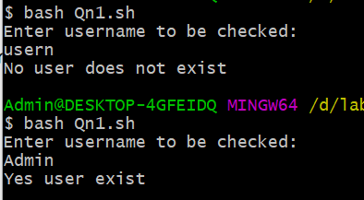



echo "Enter an alphabet: "

read alp

ls -a | grep "^$alp"

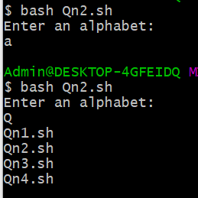



#!/bin/sh

echo "Enter file name: "

read filename

filePermission="$(stat -c %A $filename)"

if [[ ${filePermission:3:1} == "x" ]]

then

echo "$filename has execute permission"

else

echo "$filename don't have execute permission"

fi

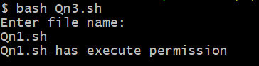



max=0

filename=''

for FILE in *;

do #stat used to get file details

size=$(stat -c %s $FILE)

if [ $size -ge $max ]

then #compare and find largest file

max=$size

filename=$FILE

fi

done

echo "$filename is the largest file with size $max bytes"

