

ECOCHRONICLES : A GAMIFIED ENVIRONMENTAL EDUCATION FOR SCHOOLS AND COLLEGES

A MINI PROJECT REPORT
Submitted by
DEVADHARSHINI S | (922524148016)

in partial fulfillment for the award of the degree
of
BACHELOR OF ENGINEERING
in
COMPUTER SCIENCE ENGINEERING (AI & ML)

V.S.B. ENGINEERING COLLEGE, KARUR-639111

(An Autonomous Institution)

ANNA UNIVERSITY :: CHENNAI 600 025

JULY 2026

ABSTRACT

Environmental literacy among school and college students is often limited by textbook-driven, one-way instruction that struggles to hold learner attention or connect abstract concepts such as climate change and biodiversity loss to everyday action. EcoChronicles is a browser-based, gamified learning platform designed to make environmental education engaging, measurable, and accessible in both English and Tamil. The system organises content into seventeen progressively harder levels — from foundational topics such as ecosystems and natural resources to advanced themes such as renewable energy, environmental policy, and a capstone project-based mission — each delivered as an interactive multiple-choice quiz with instant feedback, experience points (XP), lives, and streak tracking to sustain motivation.
The platform integrates a rule-based conversational assistant, referred to within the application as the Eco Tutor, which answers learner questions on environmental topics using a curated knowledge base and contextual matching, without depending on a paid third-party AI service. Learner progress, including quiz scores, accuracy, and language preference, is persisted locally in the browser and synchronised to a cloud-hosted Firebase Firestore database, enabling a companion Teacher Dashboard where educators can monitor class-wide performance, filter results by level, language, and performance band, and identify learners who need additional support.
The application was implemented using HTML5, CSS3, and vanilla JavaScript on the client side, with Firebase Firestore providing lightweight, serverless data storage. The results demonstrate that a lightweight, gamified, bilingual web application can meaningfully increase engagement with environmental content while giving teachers real-time visibility into learning outcomes.
Keywords: Gamification, Environmental Education, Web Application, Firebase Firestore, Bilingual Learning, Rule-Based Chatbot, E-Learning Analytics.

TABLE OF CONTENTS

CHAPTER NO. | TITLE | PAGE NO.
 | ABSTRACT | i
1 | OBJECTIVES AND SCOPE OF THE PROJECT | 1
 | 1.1 Objectives of the Project | 2
 | 1.2 Scope of the Project | 2
2 | LITERATURE SURVEY | 3
 | 2.1 Web-Based and Gamified Learning Platform | 4
 | 2.2 Environmental Education Tools and Applications | 4
 | 2.3 Rule-Based Eco Tutor Systems | 4
 | 2.4 Gamification Elements: XP,Streaks and Badges | 4
 | 2.5 Comparative Analysis | 5
3 | EXISTING SYSTEM | 6
 | 3.1 Existing System | 7
 | 3.2 Drawbacks of Existing Systems | 7
4 | PROPOSED SYSTEM | 8
 | 4.1 Proposed System | 9
5 | SOFTWARE CODE DEMONSTRATION | 10
 | 5.1 Student Registration and Local Storage | 11
 | 5.2 Quiz Scoring and XP Management | 11
 | 5.3 Saving Scores to Firebase Firestore | 11
 | 5.4 Teacher Dashboard Analytics | 12
 | 5.5 Local Eco Tutor Knowledge Base | 12
6 | OUTPUT SCHREENSHOTS | 13
 | 6.1 Did You Know? Awareness Screen | 14
 | 6.2 Student Registration Screen | 14
 | 6.3 Student Dashboard Screen | 14
 | 6.4 Eco Tutor Chat Screen | 15
 | 6.5 Quiz Result Screen | 15
 | 6.6 Leaderboard Screen | 16
 | 6.7 Eco Waste Identification Screen | 16
 | 6.8 Teacher Login and Dashboard Screen | 16
 | 6.9 AI analytics, Waste ID Screen | 17
7 | FUTURE WORK AND CONCLUSION | 18
 | 7.1 Future Work | 19
 | 7.2 Conclusion | 20
 | REFERENCES | 21

OBJECTIVES AND SCOPE OF THE PROJECT

CHAPTER 1
OBJECTIVES AND SCOPE OF THE PROJECT

3.1 OBJECTIVES OF THE PROJECT
The primary objective of EcoChronicles– AI-Powered Environmental Education Platform is to create an interactive and engaging learning environment that increases environmental awareness among students through gamification and modern web technologies. The project aims to transform traditional environmental education methods into an enjoyable and motivating digital experience.
The major objectives of the project are:
- To promote environmental awareness and sustainable practices among school and college students.
- To make learning more engaging through gamification techniques such as XP, badges, leaderboards, levels, and achievements.
- To provide a structured environmental curriculum consisting of multiple difficulty levels ranging from beginner to advanced concepts.
- To support multilingual learning by allowing students to access content in their preferred language.
- To provide instant environmental guidance through the EcoTutor module.
- To encourage students to participate in eco-friendly activities through daily environmental challenges.
- To monitor student learning progress and performance using analytical dashboards for mentors and teachers.
- To develop a lightweight and scalable web platform that can operate efficiently using free cloud services.

3.2 SCOPE OF THE PROJECT
The scope of EcoChronicles extends to various educational environments including schools, colleges, environmental clubs, and awareness programs. The platform can be used both as a classroom learning aid and as a self-paced educational tool for students interested in environmental conservation.
Students can improve their knowledge by participating in quizzes, completing daily challenges, earning rewards, and interacting with the EcoTutor module. Mentors and teachers can use the dashboard to analyze student performance, identify weak areas, and track overall progress. EcoChronicles supports multilingual learning, making environmental education accessible to students from diverse linguistic backgrounds. The platform's modular design enables future enhancements such as mobiles.

LITERATURE SURVEY

CHAPTER 2
LITERATURE SURVEY

2.1 WEB-BASED AND GAMIFIED LEARNING PLATFORMS
Gamified learning platforms have demonstrated significant improvements in student engagement and knowledge retention through the use of game elements such as points, levels, badges, and rewards. Features like experience points (XP), streaks, and progress tracking motivate learners to participate regularly and complete learning activities. EcoChroniclez adopts these proven gamification techniques and applies them specifically to environmental education, creating an enjoyable and interactive learning experience for students.

2.2 ENVIRONMENTAL EDUCATION TOOLS AND APPLICATIONS
Most existing environmental education resources primarily focus on delivering information through websites, videos, and digital documents. While these resources provide valuable knowledge, they often lack interactivity, progress tracking, and personalized learning experiences. EcoChroniclez addresses these limitations by offering a structured, multi-level curriculum combined with quizzes, challenges, and performance analytics, enabling students to learn environmental concepts progressively and effectively.

2.3 RULE-BASED ECO TUTOR SYSTEMS
Educational chatbot systems are increasingly used to provide instant support and guidance to learners. Rule-based tutors use predefined knowledge bases and keyword matching techniques to answer user queries accurately within a specific domain. Compared to advanced AI models, rule-based systems are lightweight, reliable, cost-effective, and easier to maintain. The EcoTutor module in EcoChroniclez follows this approach by using a curated environmental knowledge base to provide quick and accurate responses to student questions.

2.4 GAMIFICATION ELEMENTS: XP, STREAKS, AND BADGES
Research in educational technology indicates that immediate rewards and visible progress indicators significantly improve learner motivation. Experience points encourage continuous participation, streaks promote regular learning habits, and badges provide recognition for achievements and milestones. EcoChroniclez integrates these elements through XP rewards, daily learning streaks, achievement badges, and leaderboards, creating a motivating environment that encourages long-term engagement with environmental education.
The literature survey highlights that combining gamification, environmental learning resources, and intelligent tutoring systems can greatly enhance student participation and knowledge retention. EcoChroniclez leverages these concepts to develop an interactive, scalable, and engaging platform for environmental education.

2.5 COMPARATIVE ANALYSIS
Platform Type | Structured Curriculum | Gamification | Regional Language | Teacher Analytics
Static eco-awareness websites | No | No | Rarely | No
Generic quiz apps | Partial | Yes | Rarely | No
Language-learning style apps | Yes (non-eco) | Yes | Varies | No
EcoChronicles (proposed) | Yes — 17 levels | Yes | English + Tamil | Yes

EXISTING SYSTEM

CHAPTER 3
EXISTING SYSTEM
3.1 EXISTING SYSTEM
In most schools today, environmental education is delivered through textbook chapters, occasional guest lectures, or one-off awareness events such as tree-planting drives. Assessment, where it exists, is typically a paper-based test administered at the end of a term. Digital resources are mostly limited to reference websites or unstructured YouTube videos, and there is no mechanism for a teacher to see, in real time, which concepts a particular student has or has not understood.

3.2 DRAWBACKS OF EXISTING SYSTEMS
- No immediate feedback: students do not know whether they have understood a concept until a formal test, by which time misconceptions may have solidified.
- No gamified motivation: textbook-based learning offers no points, streaks, or sense of progression to encourage regular study.
- Single-language content: most resources are in English only, disadvantaging regional-language learners.
- No teacher-facing analytics: teachers cannot easily identify struggling students or weak topics across a whole class.
- No always-available doubt resolution: students must wait for the next class to ask a question.

PROPOSED SYSTEM

CHAPTER 4
PROPOSED SYSTEM

4.1 PROPOSED SYSTEM
EcoChronicles proposes a single-page web application with two connected roles. The Student Platform presents a splash screen with striking environmental statistics, a simple email/name login, a sidebar-based dashboard listing seventeen levels grouped by difficulty, an interactive quiz engine with lives and a progress bar, and an Eco Tutor chat panel for open-ended questions. The Teacher Dashboard, a separate page protected by a shared password, retrieves every learner's quiz attempts from Firebase Firestore and presents aggregate statistics (total students, total attempts, average score, perfect scores) plus a filterable, sortable results table.
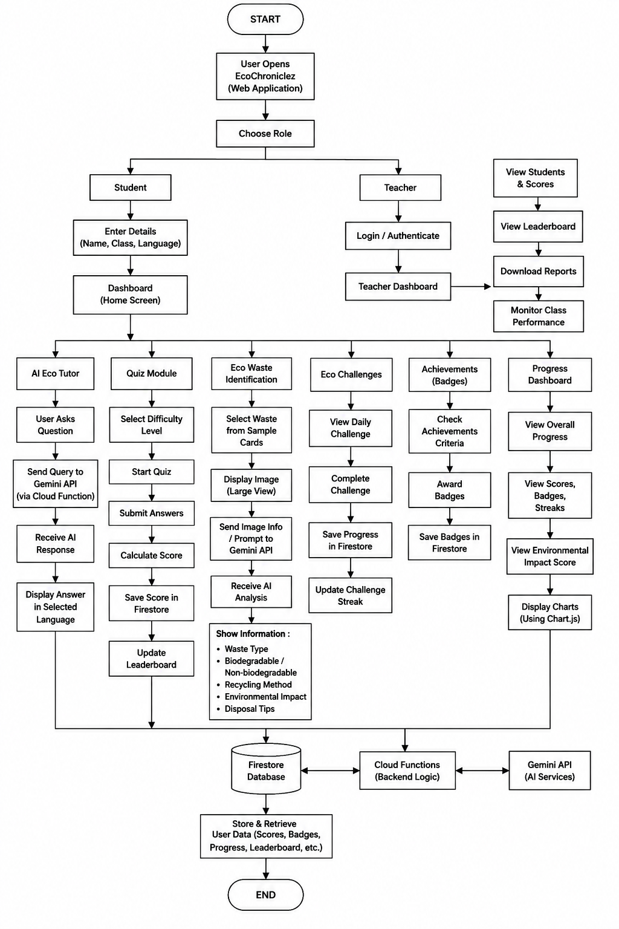

SOFTWARE CODING DEMONSTRATION

CHAPTER 5
The EcoChroniclez platform was developed using HTML, CSS, JavaScript, and Firebase Firestore. The software implementation follows a modular architecture where each module handles a specific functionality such as student registration, quiz processing, leaderboard generation, and teacher analytics. The following code snippets demonstrate some of the important functionalities implemented in the system.

5.1 STUDENT REGISTRATION AND LOCAL STORAGE
The student registration module collects the student's name, class, and preferred language and stores them locally using browser storage for session persistence.
function registerStudent() {
const student = {
name: document.getElementById("name").value,
class: document.getElementById("class").value,
language: document.getElementById("language").value
};

localStorage.setItem("student", JSON.stringify(student));
window.location.href = "dashboard.html";
}

5.2 QUIZ SCORING AND XP MANAGEMENT
The quiz module awards experience points (XP) for correct answers and updates the student's progress dynamically.
function submitAnswer(selectedIndex) {
const question = quizBank[currentLevel][currentQuestion];

if (selectedIndex === question.answer) {
score++;
studentXP += 10;
totalCorrect++;
}

currentQuestion++;
updateProgress();
}

5.3 SAVING SCORES TO FIREBASE FIRESTORE
Quiz results are stored in Firebase Firestore to enable leaderboard generation and teacher analytics.
await addDoc(collection(db, "scores"), {
studentName: student.name,
level: currentLevel,
score: score,
xp: studentXP,
timestamp: serverTimestamp()
});

5.4 TEACHER DASHBOARD ANALYTICS
The teacher dashboard calculates important statistics such as average score, total attempts, and student count.
const averageScore = scores.length
? scores.reduce((sum, s) => sum + s.score, 0) / scores.length
: 0;

document.getElementById("avg-score").textContent =
averageScore.toFixed(2);

5.5 LOCAL ECOTUTOR KNOWLEDGE BASE
The EcoTutor module provides predefined responses for environmental questions without relying on external AI services.
const ecoTutor = {
"what is recycling":
"Recycling converts waste materials into reusable products.",

"what is global warming":
"Global warming is the increase in Earth's average temperature."
};

The EcoChroniclez platform was developed using HTML, CSS, JavaScript, and Firebase Firestore with a modular architecture. Student details are stored using localStorage, while quiz scores and leaderboard data are stored in Firestore. The quiz module calculates scores, awards XP, badges, and streaks, and updates student progress. The Teacher Dashboard retrieves and analyzes performance data from Firestore. The Eco Tutor uses a local knowledge base to answer environmental questions, and the Waste Identification module provides recycling information using predefined waste samples. The entire application runs successfully using only Firebase Hosting and Firestore on the Firebase Spark Plan.

OUTPUT SCREENSHOTS

CHAPTER 6
OUTPUT SCREENSHOTS
The output screens of EcoChronicles – AI-Powered Environmental Education Platform represent the graphical user interface and the functional modules of the system.

6.1 DID YOU KNOW ? AWARENESS SCREEN
The Did You Know screen is displayed when the application starts and presents important environmental facts and awareness messages to attract students' attention. This screen motivates learners to understand environmental issues and encourages them to begin their learning journey with EcoChronicles.
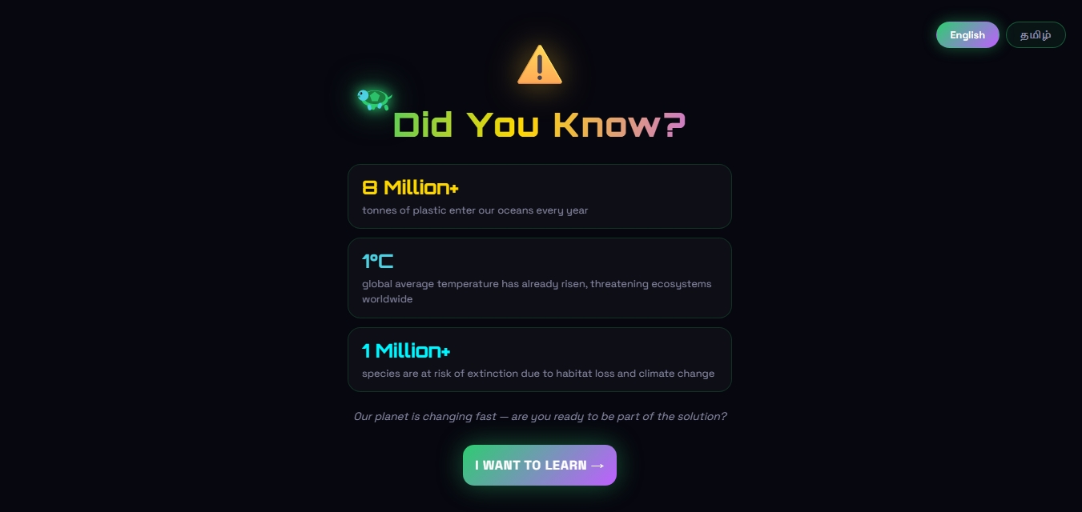

6.2 STUDENT REGISTRATION SCREEN
The Student Registration screen allows learners to enter their email address, name, and class information before accessing the platform. The entered details are stored locally to create a personalized learning experience and maintain individual progress records.
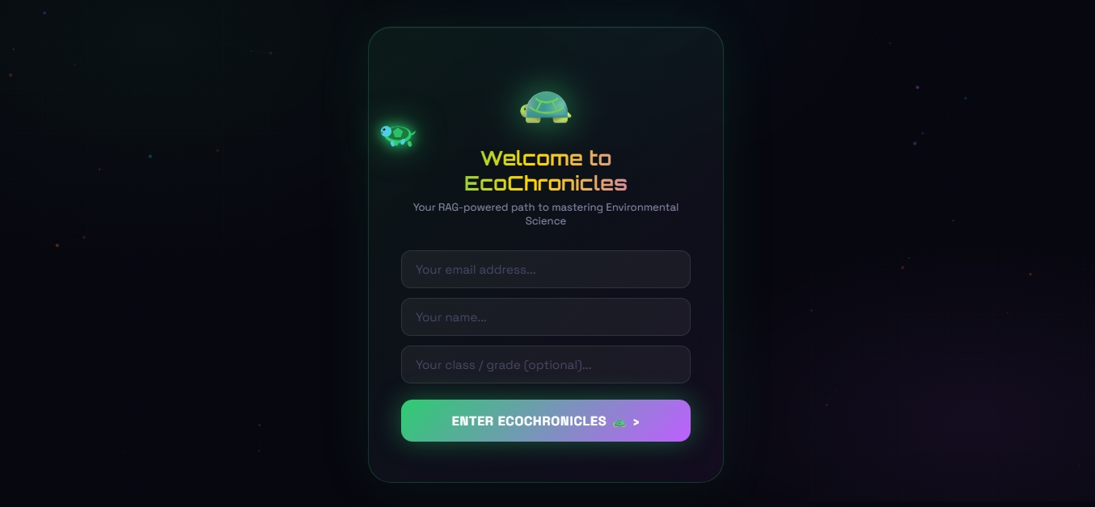

6.3 STUDENT DASHBOARD SCREEN
The Student Dashboard provides an overview of the learner's environmental learning progress, including XP points, completed levels, learning streaks, and achievements. It also offers quick access to quizzes, Eco Tutor, waste identification, and leaderboard modules.
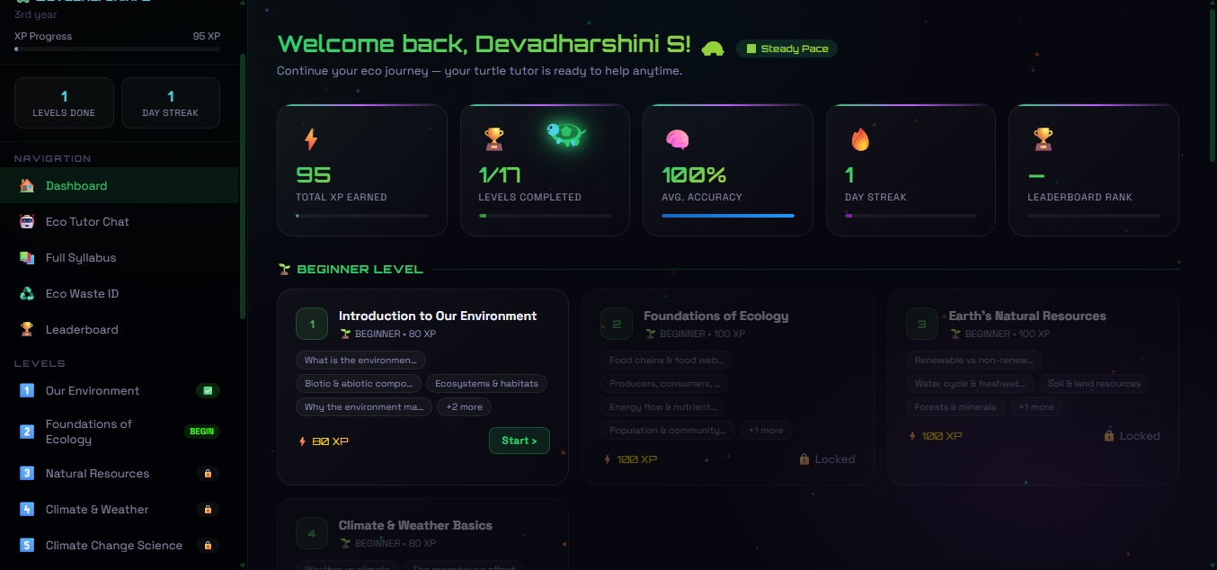

6.4 ECO TUTOR CHAT SCREEN
The Eco Tutor Chat screen enables students to interact with the local AI-powered environmental tutor named Shelly. Students can ask questions related to climate change, biodiversity, pollution, sustainability, and receive instant educational responses.
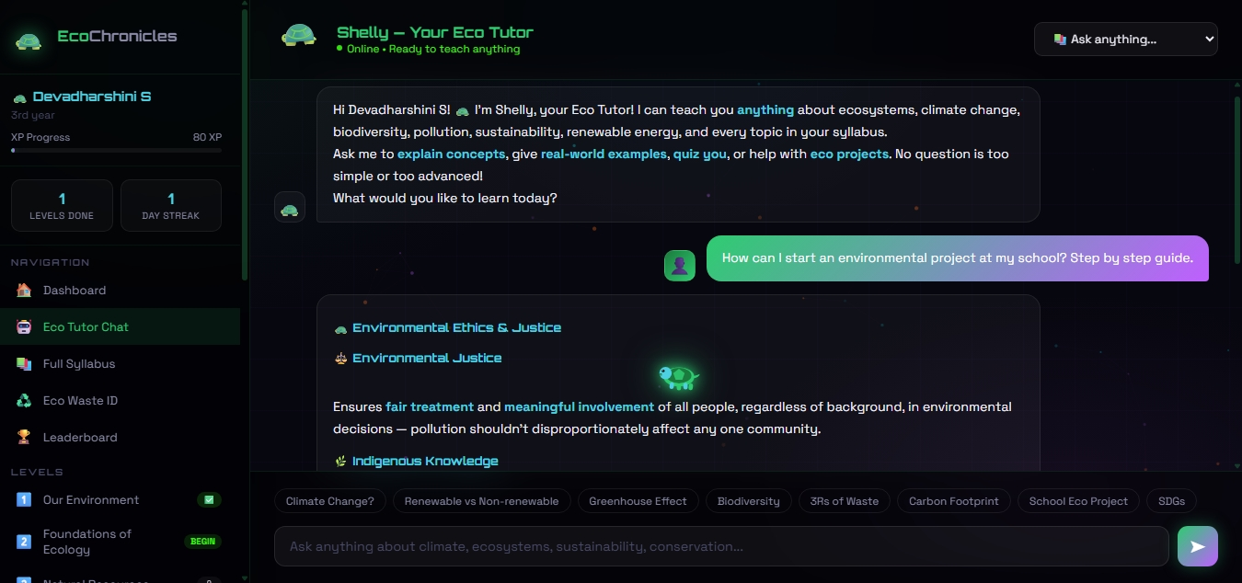

6.5 QUIZ RESULT SCREEN
The Quiz Result screen displays the student's performance after completing a level-based environmental quiz. It shows the obtained score, XP earned, level completion status, and personalized recommendations for future learning.
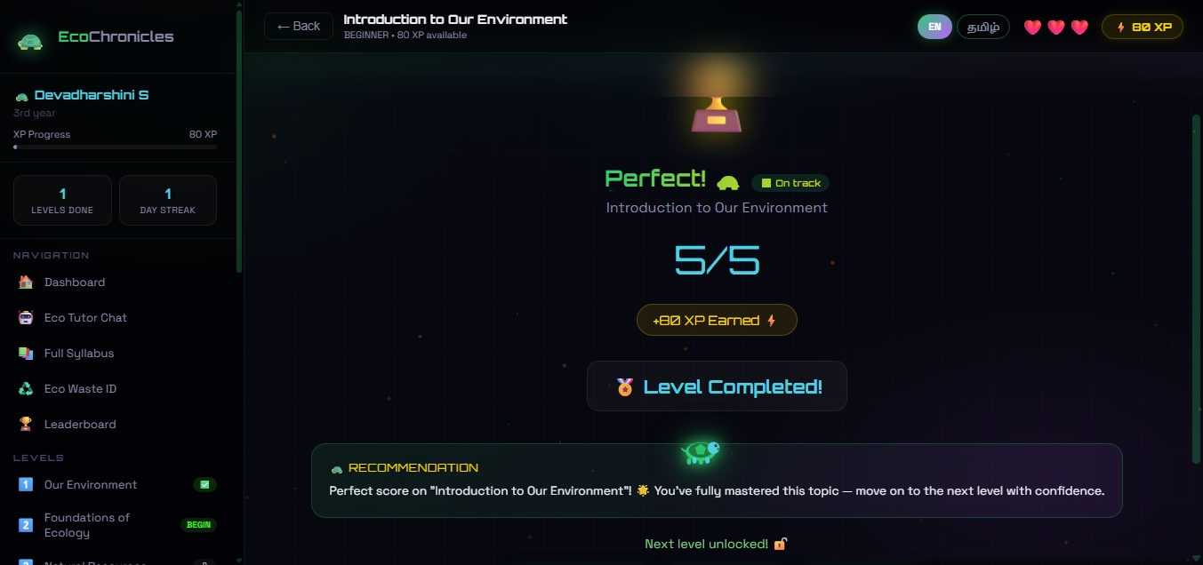

6.6 LEADERBOARD SCREEN
The Leaderboard screen ranks students based on Eco Points, completed levels, and quiz accuracy. This feature promotes healthy competition among learners and encourages continuous participation in environmental activities.
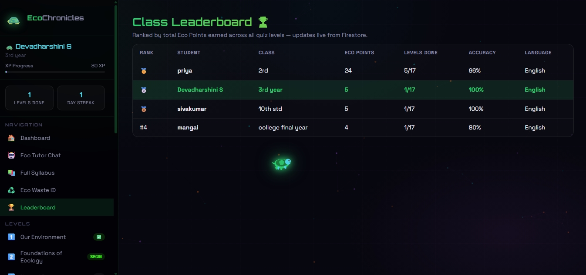

6.7 ECO WASTE IDENTIFICATION SCREEN
The Eco Waste Identification screen allows students to explore different waste materials and learn their environmental impact. The system provides waste categories, recycling methods, disposal procedures, and sustainability tips for each item.
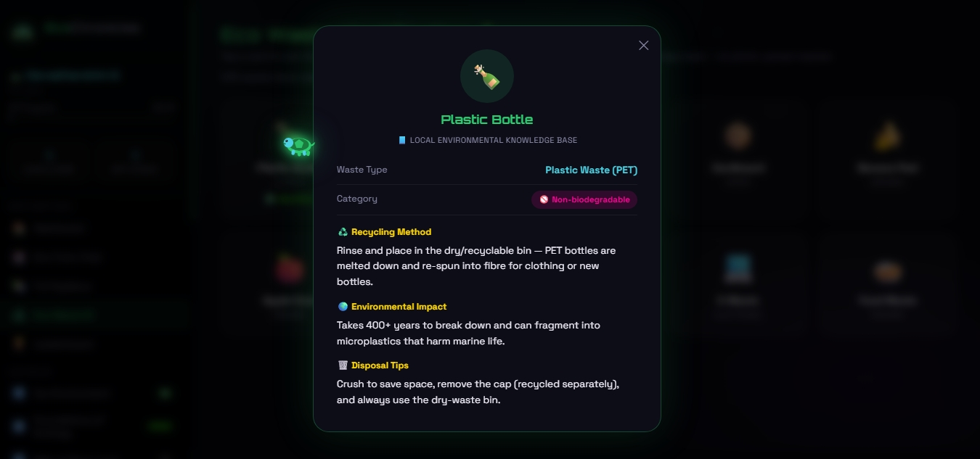

6.8 TEACHER LOGIN AND DASHBOARD SCREEN
The Teacher Login screen provides secure access to the mentor dashboard using predefined credentials. This module ensures that only authorized teachers can view student analytics and performance reports.
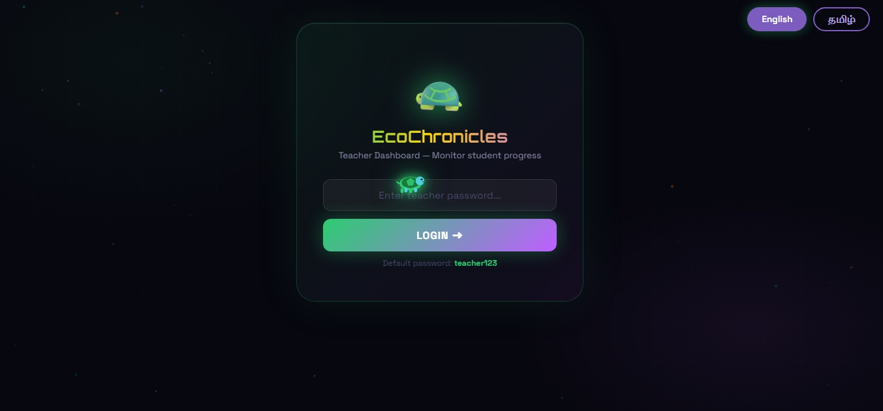The All Learners screen displays the complete list of students along with their quiz scores, performance levels, language preferences, and completion timestamps. Teachers can monitor the progress of all learners in a centralized interface.
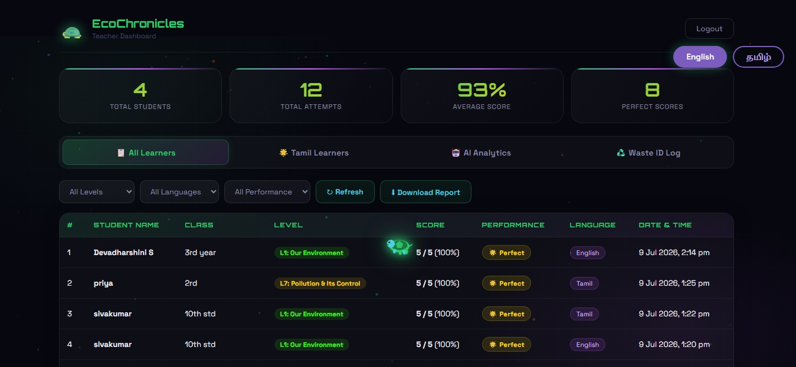

6.9 AI ANALYTICS SCREEN, WASTE SCREEN ID
The AI Analytics screen presents graphical visualizations such as module-wise scores, language distribution, and performance trends. These insights assist teachers in identifying strengths, weaknesses, and learning patterns within the classroom.
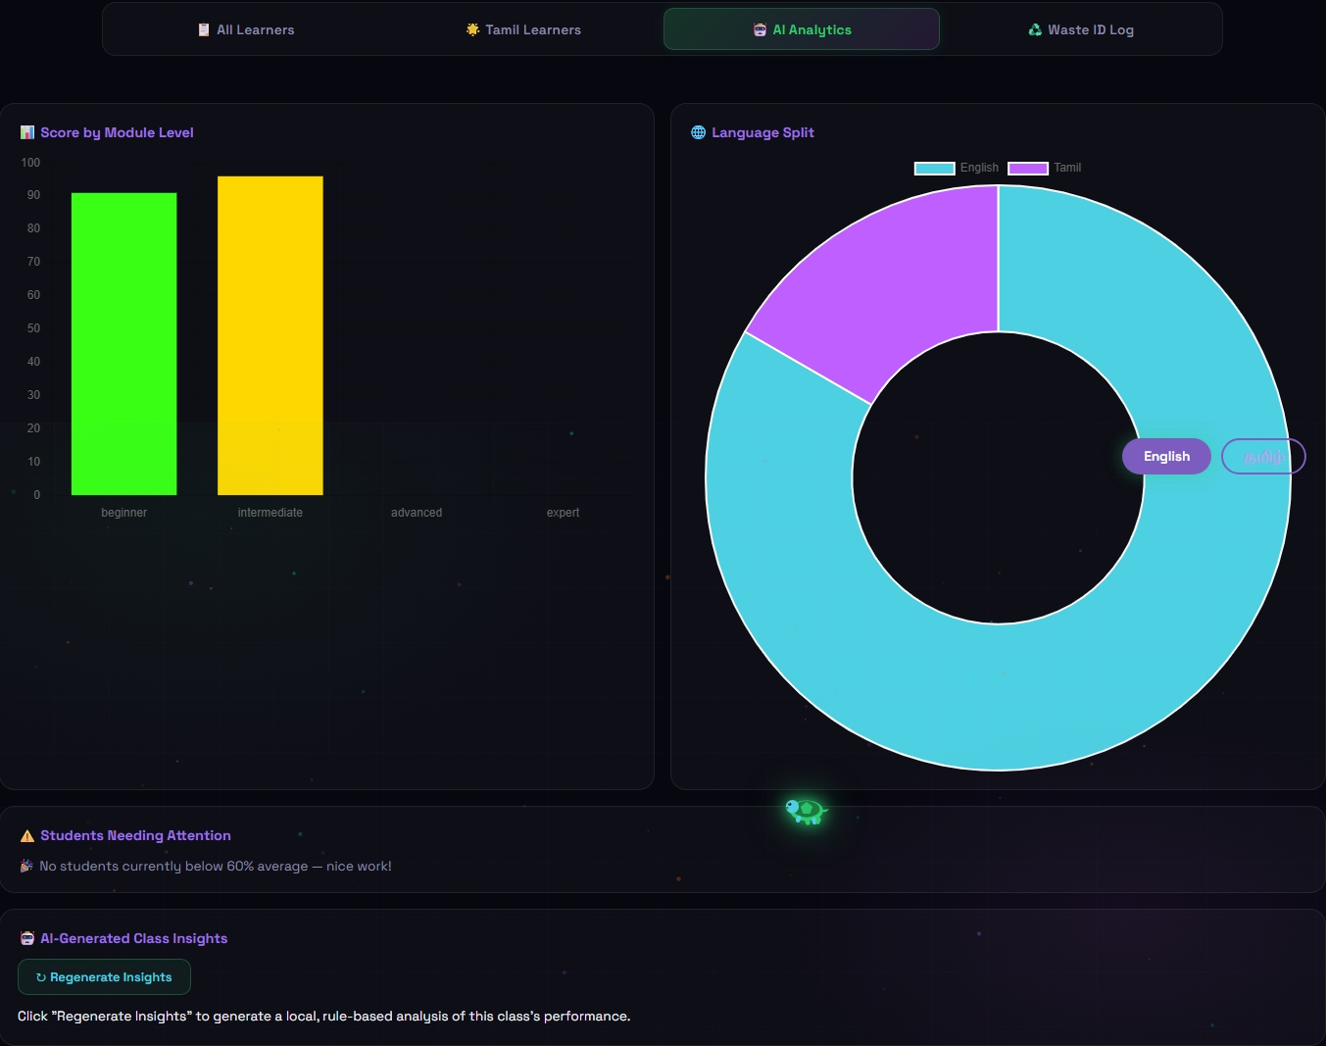
The Waste ID Log screen records all waste identification activities performed by students during learning sessions. Teachers can review the identified waste categories and assess students' awareness of proper waste management practices.
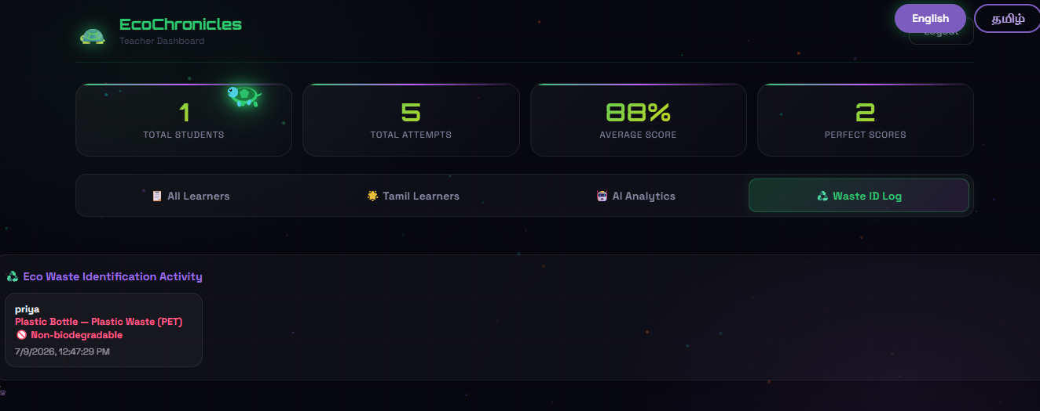

FUTURE WORK AND CONCLUSION

CHAPTER 9
FUTURE WORK AND CONCLUSION

9.1 FUTURE WORK
Section | Key Points | Details / Highlights
Conclusion | AI-Powered Environmental Learning | Integrates Gemini AI, gamification, multilingual support, Firebase Firestore, and interactive quizzes to provide an engaging environmental education platform.
 | Interactive Student Experience | Enables students to learn through AI tutoring, environmental quizzes, eco challenges, waste identification, badges, and progress tracking.
 | Teacher Analytics Dashboard | Allows teachers to monitor student performance, quiz scores, leaderboard rankings, achievements, and learning progress through a centralized dashboard.
 | Tested and Validated | Successfully verified through Unit Testing, Integration Testing, System Testing, and Validation Testing to ensure accuracy, reliability, and smooth functionality.
 | Cloud-Based Data Management | Firebase Firestore securely stores quiz scores, student progress, and achievement data for efficient access and synchronization.
Future Work  Overall Goal | AI Waste Image Recognition | Integrate computer vision to identify waste from real-time images and provide recycling recommendations automatically.
 | Voice-Based AI Eco Tutor | Enable speech recognition and voice responses for natural conversational learning experiences.
 | Personalized Learning | Recommend quizzes and learning materials based on individual student performance using AI.
 | Mobile Application | Develop Android and iOS applications to improve accessibility and support learning on mobile devices.
 | Advanced Teacher Analytics | Include graphical reports, performance trends, predictive analytics, and class-wise comparisons for better educational insights.
 | Smart Environmental Learning Platform | To develop a scalable AI-powered educational platform that promotes environmental awareness through interactive learning, cloud technology, and intelligent tutoring while supporting both students and teachers effectively.

9.2 CONCLUSION
EcoChronicles demonstrates that a lightweight, browser-based application built with standard HTML, CSS, and JavaScript, backed by a serverless Firebase Firestore database, can deliver a structured, gamified, and bilingual environmental-education experience without the cost or complexity of a dedicated application server or a paid AI service. By combining a seventeen-level graded curriculum, XP- and streak-based motivation, an always-available rule-based Eco Tutor, and a Teacher Dashboard for real-time class analytics, the platform addresses the key shortcomings of existing textbook-based and generic quiz-based approaches to environmental education identified in this report.
Testing across unit, integration, system, and validation levels confirmed that the core learner and teacher journeys behave correctly and predictably, and the output screens presented in Chapter 8 illustrate a cohesive, visually consistent experience across both English and Tamil. The project fulfils its stated objectives of engagement, accessibility, and teacher visibility within a compact, dependency-light codebase.

REFERENCES
[1] Deterding, S., Dixon, D., Khaled, R., and Nacke, L., "From Game Design Elements to Gamefulness: Defining Gamification," Proceedings of the 15th International Academic MindTrek Conference, 2011.
[2] Hamari, J., Koivisto, J., and Sarsa, H., "Does Gamification Work? A Literature Review of Empirical Studies on Gamification," Proceedings of the 47th Hawaii International Conference on System Sciences, 2014.
[3] UNESCO, "Education for Sustainable Development: A Roadmap," United Nations Educational, Scientific and Cultural Organization, Paris, 2020.
[4] Google Firebase Documentation, "Cloud Firestore," firebase.google.com/docs/firestore, accessed 2026.
[5] Mozilla Developer Network, "Web APIs — Window.localStorage," developer.mozilla.org, accessed 2026.
[6] World Wide Web Consortium (W3C), "HTML5 and CSS3 Specifications," w3.org, accessed 2026.
[7] Sweetser, P., and Wyeth, P., "GameFlow: A Model for Evaluating Player Enjoyment in Games," ACM Computers in Entertainment, Vol. 3, No. 3, 2005.
[8] Ministry of Environment, Forest and Climate Change, Government of India, "National Action Plan on Climate Change," 2021.

