ASSIGNMENT



TITLE: INTRODUCTION TO PROMPT ENGINEERING FOR LARGE LANGUAGE MODELS



OBJECTIVES

* Understand the fundamentals of prompt engineering.
* Design and refine prompts to achieve desired outcomes from language models.
* Analyse the performance and limitations of prompts.
* Explore use cases and ethical considerations.

INTRODUCTION

 **What is prompt engineering**

P

rompt Engineering is the art and science of designing and optimizing prompts to guide AI models, particularly LLMs, towards generating the desired responses. By carefully crafting prompts, you provide the model with context, instructions, and examples that help it understand your intent and respond in a meaningful way. Think of it as providing a roadmap for the AI, steering it towards the specific output you have in mind.

***Types of prompts***

*There are various types of prompts used in AI, each serving a specific purpose****:***

***Direct prompts (Zero-shot)***

Zero-shot prompting involves providing the model with a direct instruction or question without any additional context or examples.

An example of this is idea generation, where the model is prompted to generate creative ideas or brainstorming solutions. Another example is summarization, or translation, where the model is asked to summarize or translate some piece of content.

***One-, few- and multi-shot prompts***

This method involves providing the model with one or more examples of the desired input-output pairs before presenting the actual prompt. This can help the model better understand the task and generate more accurate responses.

***Chain of Thought Prompts***

CoT prompting encourages the model to break down complex reasoning into a series of intermediate steps, leading to a more comprehensive and well-structured final output.

***Zero-shot CoT Prompts***

Combines chain of thought prompting with zero-shot prompting by asking the model to perform reasoning steps, which may often produce better output.

***What Does a Prompt Engineer Do?***

prompt engineers also do a lot more technical aspects of dealing with large language models. **They test and fine-tune AI models** using prompts. The process involves tracking an AI model’s behaviour by analysing its responses to various prompts. Then, they look for patterns and biases, run A/B tests on the output data, and refine prompts to address limitations. Similarly, they have to understand the model's limitations and strengths, and iteratively improve prompts based on model responses.

***Prompt engineer responsibilities***

*Here is a summary of what a prompt engineer does in their day-to-day work:*

* Craft effective prompts: Develop precise and contextually appropriate prompts to elicit the desired responses from AI models.
* Test AI behaviour: Analyse how models respond to different prompts, identifying patterns, biases, or inconsistencies in the generated outputs.
* Refine and optimize prompts: Continuously improve prompts through iterative testing to enhance the accuracy and reliability of model responses.
* Perform A/B testing: Compare the effectiveness of different prompts and refine them based on user feedback and performance metrics.
* Document prompt frameworks: Create libraries of reusable, optimized prompts for specific use cases or industries.
* Collaborate with stakeholders: Work with developers, product teams, and clients to align AI-generated outputs with business or project objectives.
* Fine-tune AI models: Adjust pre-trained AI models to improve their behaviour for specific applications, using tailored prompts during the training process.
* Ensure ethical AI use: Identify and mitigate biases in prompts and outputs to ensure fairness, inclusivity, and adherence to ethical guidelines.
* Train and educate users: Help end-users and teams understand best practices for interacting with AI models effectively.

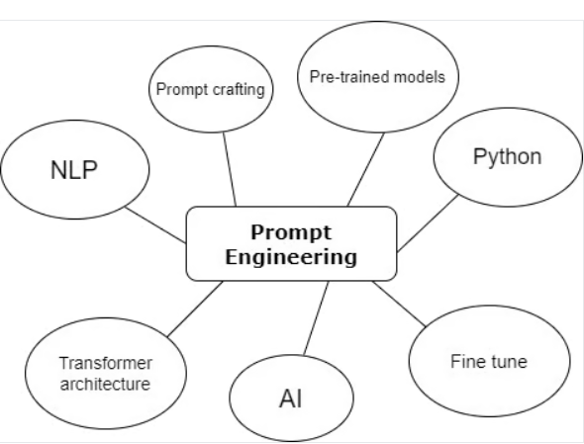

***Benefits Of Prompt Engineering*** *Effective prompt engineering offers numerous benefits, enhancing the capabilities and usability of AI models* :

***improved model performance***

Well-crafted prompts lead to more accurate, relevant, and informative outputs from AI models, as they provide clear instructions and context.

***Reduced bias and harmful responses***

By carefully controlling the input and guiding the AI's focus, prompt engineering helps mitigate bias and minimize the risk of generating inappropriate or offensive content.

***Increased control and predictability***

Prompt engineering empowers you to influence the AI's behavior and ensure consistent and predictable responses aligned with your desired outcomes.

***Enhanced user experience***

Clear and concise prompts make it easier for users to interact effectively with AI models, leading to more intuitive and satisfying experiences.

 **How large language model works?**

***What is a large language model?***

A large language model (LLM) is a type of artificial intelligence that can generate text that looks and sounds like natural language. These models train using vast amounts of data (hence why they are called large language and not small language models). Using machine learning algorithms, the LLM can generate text by predicting the next most likely word to use in a string of words based on the training data it received. LLMs can generate text successfully, partly because of the size of the training data they operate on.

***How do large language models work?***

Large language models use several different layers of other technology, including deep learning, transformer models, and, specifically, the autoregressive models within the transformer models. Take a closer look at these topics and how they work together to power large language models.

***LLM and deep learning***

Large language models can generate text that looks natural using deep learning. Deep learning is a type of machine learning that uses neural networks to analyse their own responses against a vast array of training data to learn how to give a better answer. It is different from other kinds of machine learning because it uses neural networks with huge amounts of layers that replicate the complicated process that the human brain undertakes when it thinks.

***Transformer models***

The type of neural networks that LLMs use are transformer models, skilled at understanding the context of words and how words relate to one another. Transformer architecture allows LLMs to generate text by understanding what words are most likely to come next, using principles of natural language processing. This makes the LLM better able to understand the nuances of both the prompt you offer and the sentences or paragraphs it generates as a response.

***Autoregressive models***

If you zoom in on an even closer level and look inside the transformer model, you can find another technology contributing to LLMs: the autoregressive model. The autoregressive model is found within transformer architecture and helps the LLM determine the best words to use in its response based on predictions it gathers from its training material. For example, imagine you ask an LLM, “What color is grass?” The LLM isn’t looking through its training material the way you might flip through a textbook to find the answer. Instead, it uses autoregressive models to determine that “grass is green” is statistically the answer you’re looking for.

***Examples of popular LLMs***

Llama3

DeepSeek ai

claude

ChatGPT

**Explain the importance of prompt engineering in real world applications like software development, customer support, education**

In computer programming, prompt engineering affects productivity and code quality directly. AI assistants are utilized by developers for code production, debugging, and documentation. Good prompts can create production-quality code snippets, describe intricate algorithms, or recommend optimizations. For instance, a particular query such as "Write a Python function to validate email addresses with regex, cover edge cases for international domains, and have robust error handling" yields better results compared to just asking for "email validation code." Such specificity saves debugging time and speeds up development cycles.

Customer support heavily depends on timely engineering of chatbot and auto-response systems. Well-engineered prompts help AI agents interpret customer intent, handle tone appropriately, and deliver the correct information. A customer support prompt could dictate: "Answer empathetically to angry customers, pose clarifying questions when problems are not clear, and direct to human agents when problems relate to account security." This approach enhances customer satisfaction and decreases support ticket load.

In education, prompt engineering changes the way that AI supports learning. Educators develop prompts that produce customized explanations, practice exercises, or lesson plans for various learning modalities and grade levels. An example of a prompt for a math tutor could be: "Explain quadratic equations to a visual learner through the use of real-life examples, include step-by-step solutions, and include suggested practice problems of varying difficulty." This level of customization increases the efficacy and accessibility of learning.

The greater impact reaches to cost-effectiveness, quality control, and scalability. Inadequate prompts squander computational resources and human effort in revising AI outputs. Good prompt engineering minimizes the necessity of comprehensive fine-tuning or tailored model training, bringing AI deployment within reach of organizations that lack significant technical resources.

As AI capabilities expand, prompt engineering skills become increasingly valuable for professionals who want to leverage these tools effectively in their specific domains..