RAJALAKSHMI ENGINEERING COLLEGE
RAJALAKSHMI NAGAR, THANDALAM – 602 105



Laboratory Record Note
Book

CP19211 – ADVANCE DATABASE TECHNOLOGIES LABORATORY

Name | DEVARAJ A
Branch | ME-CSE
Register No | 250711002
Semester | 1
Academic Year | 2025 -2027

RAJALAKSHMI ENGINEERING COLLEGE
RAJALAKSHMI NAGAR, THANDALAM – 602 105

BONAFIDE CERTIFICATE

Name: . . . . . . . . . . . . . . .DEVARAJ A . . . . . . . . . . . . . . . . . . . . . . . . . . . . . . . . . . . . . . . . . . . .

Academic Year : 2025 -2027 ODD Semester : I Branch: ME-CSE

Register No. 250711002

Certified that this is the bonafide record of work done by the above student in the
Laboratory during the year

Signature of Faculty in-charge

Submitted for the Practical Examination held on . . . . . . . . . . . . . . . . . . . . . . . . . . . .

Internal Examiner External Examiner

INDEX
SNO | DATE | LIST OF EXPERIMENTS | PAGE NO. | SIGN
A | 01/09/2025 | Data Definition Language  - Create, Alter and Drop  - Enforce primary key, Foreign key, Check,  Unique and Not Null Constraints  - Creating views | 04
 | 8/09/2025 | Data Manipulation Language  - Insert, Delete, Update  - Cartesian Product, Equi Join, Left outer join, Right outer join and full outer join  - Aggregate Functions  - Set operations  - Nested Queries | 09
 | 15/09/2025 | Transaction Control Language  - Commit, Rollback and Save points | 29
B | 22/09/2025 | - Distributed Database Design and Implementation | 33
 | 29/09/2025 | - Row Level and Statement Level Triggers | 37
 | 06/10/2025 | - Accessing a Relational Database using Python | 47
C | 13/10/2025 | - Creating XML Documents , Document type definition and XML Schema | 51
 | 27/10/2025 | - Using a Relational Database to store the XML documents as text | 55
 | 03/11/2025 | - Using a Relational Database to store the XML documents as Data elements | 56
 | 10/11/2025 | - Creating or Publishing customized XML Documents from Pre-existing Relational Databases | 58
 | 17/11/2025 | - Extracting XML Documents from Relational Databases | 60
 | 24/11/2025 | - XML Querying | 63
D | 01/12/2025 | - Creating Databases using MongoDB and  - Writing simple queries to access databases created using Python | 66
E | 08/12/2025 | - Implementing Access Control in Relational Databases | 74

EX.NO : A
DATE : 22 / 09 /2025
- DATA DEFINITION LANGUAGES (DDL) COMMANDS OF BASE TABLES AND VIEWS
A Data Definition Language (DDL) Statement Is Used To Define The Database Structure Or Schema.
Aim:
To Study And Execute The DDL Commands In RDBMS.
DDL Commands:
- CREATE
- ALTER
- RENAME
- TRUNCATE
- DROP
1) Create Table
To Make A New Database, Table, Index, Or Stored Query. A Create Statement In SQL Creates An Object Inside Of A Relational Database Management System (RDBMS).
-- Create Table
CREATE TABLE Player(
Id NUMBER PRIMARY KEY,
Name VARCHAR2(50),
Game VARCHAR2(50),
Location VARCHAR2(50)
);
Output >>>>>>>>>>>>>>>>>
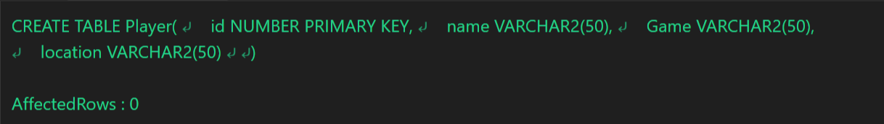

2) Alter Table (Add , Modify, Rename , Drop)
To Modify An Existing Database Object. Alter The Structure Of The Database
2.1) To Add a column in a table
-- Add
ALTER TABLE PLAYER ADD Phone NUMBER;
SELECT * FROM PLAYER;

Output >>>>>>>>>>>>>>>>>
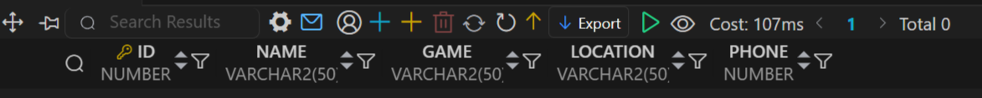

2.2) To Modify a column in a table
- Modify
ALTER Table PLAYER MODIFY Phone VARCHAR2(10);
SELECT * FROM PLAYER;

Output >>>>>>>>>>>>>>>>>
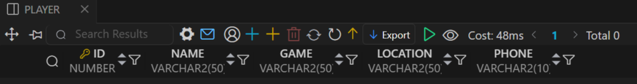

2.3) To Rename a column in a table
-- Rename
ALTER TABLE PLAYER RENAME COLUMN Phone TO Contact;
SELECT * FROM PLAYER;
Output >>>>>>>>>>>>>>>>>
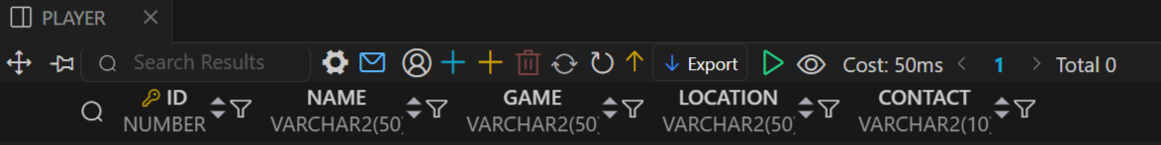

2.4) To Drop a column in a table
-- Delete
ALTER TABLE PLAYER DROP COLUMN Contact;
SELECT * FROM PLAYER;

Output >>>>>>>>>>>>>>>>>
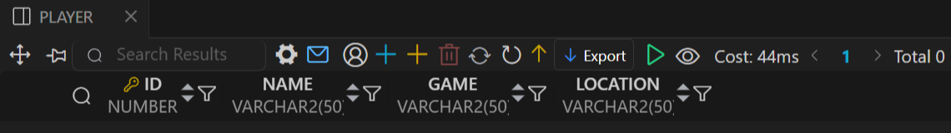

3) RENAME TABLE
Changes the name of a database object.
-- Rename Table
RENAME PLAYER TO Sports;
SELECT * FROM SPORTS ;
Output >>>>>>>>>>>>>>>>>
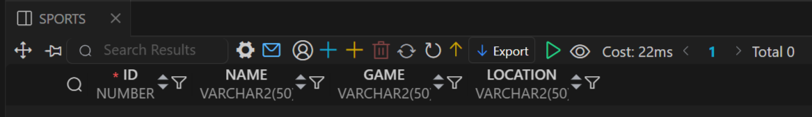

4) Truncate Table
Removes all rows from a table quickly without logs.
-- Truncate Table
TRUNCATE TABLE Student;
SELECT * FROM STUDENT
Output >>>>>>>>>>>>>>>>>
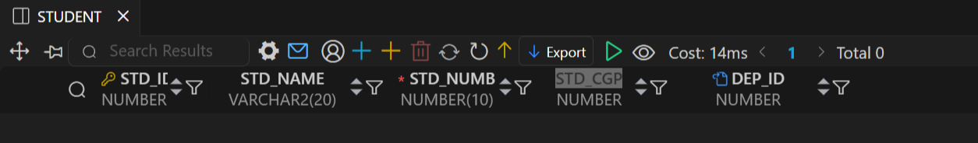
5) DROP
Deletes a database object permanently.
-- Drop Table
DROP TABLE SPORTS;

Output >>>>>>>>>>>>>>>>>
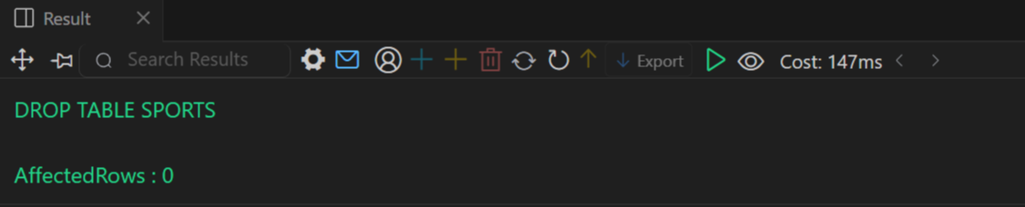

5) Constraints
Department Table
-- Create Department + CONSTRAINT
CREATE TABLE Department (
Dep_Id NUMBER PRIMARY KEY, -- PRIMARY KEY
Dep_Name VARCHAR2(20) UNIQUE -- UNIQUE
);

Output >>>>>>>>>>>>>>>>>
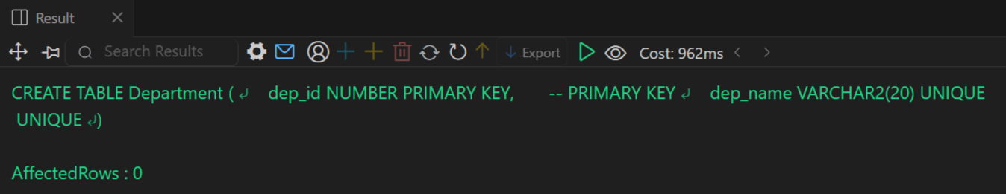

Student Table
-- Create Student Table With FK + Constraint
CREATE TABLE Student (
Std_Id NUMBER PRIMARY KEY, -- PRIMARY KEY
Std_Name VARCHAR2(20),
Std_Number NUMBER(10) NOT NULL UNIQUE, -- NOT NULL + UNIQUE
Std_Cgp NUMBER CONSTRAINT Chk_Cgp CHECK (Std_Cgp >= 7.5), -- CHECK
Dep_Id NUMBER,
CONSTRAINT Fk_Student FOREIGN KEY (Dep_Id)
REFERENCES Department(Dep_Id) ON DELETE SET NULL -- FOREIGN KEY + ON DELETE
);
SELECT * FROM STUDENT

Output >>>>>>>>>>>>>>>>>
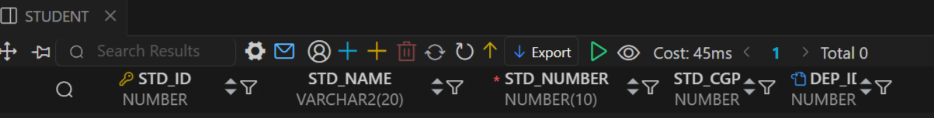

Teacher Table
-- Create Teacher
CREATE Table Teacher(
Teach_Id NUMBER PRIMARY KEY,
Teach_Name VARCHAR2(20) NOT NULL ,
Teach_Salary NUMBER(7,2),
Dep_Id NUMBER,
Constraint Fk_Teacher FOREIGN KEY(Dep_Id)
REFERENCES Department (Dep_Id) ON DELETE SET NULL);
SELECT * FROM TEACHER;

Output >>>>>>>>>>>>>>>>>
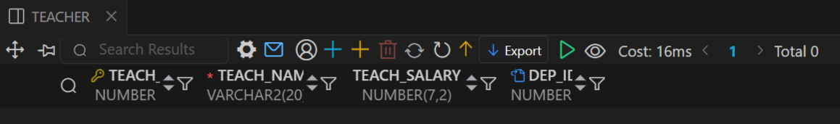

Result :
Thus executed the DDL commands in RDBMS

EX.NO:A
DATE : 29 / 09 /2025
- DATA MANIPULATION LANGUAGE (DML) COMMANDS OF BASE TABLES AND VIEWS
Data manipulation language allows the users to query and manipulate data in existing schema in object. It allows following data to insert, delete, update and recovery data in schema object.
Aim:
To Study And Execute The DML Commands In RDBMS.
DDL Commands:
- INSERT
- UPDATE
- DELETE
- SELECT

- INSERT
Adds new records into a table.
1.1) Insert One Data
-- Insert One Data
INSERT INTO STUDENT (Id , Name , DEPARTMENT )
VALUES('1' , 'Deva' , 'Cse' );

1.2) Insert Many Data
INSERT ALL
INTO STUDENT (Id , Name , DEPARTMENT ) VALUES('2' , 'Jaya' , 'Bio' )
INTO STUDENT (Id , Name , DEPARTMENT ) VALUES('3' , 'Pavi' , 'Mech' )
INTO STUDENT (Id , Name , DEPARTMENT ) VALUES('4' , 'Boomika' , 'Civil' )
SELECT * FROM Dual;

Department Table
-- Create Department + CONSTRAINT
CREATE TABLE Department (
Dep_Id NUMBER PRIMARY KEY, -- PRIMARY KEY
Dep_Name VARCHAR2(20) UNIQUE -- UNIQUE
);

Insert Department Values
-- Insert Department Values
INSERT ALL
INTO Department (Dep_Id, Dep_Name) VALUES (101, 'CSE')
INTO Department (Dep_Id, Dep_Name) VALUES (102, 'MECH')
INTO Department (Dep_Id, Dep_Name) VALUES (103, 'BIO')
INTO Department (Dep_Id, Dep_Name) VALUES (104, 'CIVIL')
INTO Department (Dep_Id, Dep_Name) VALUES (105, 'EEE')
INTO Department (Dep_Id, Dep_Name) VALUES (106, 'ECE')
SELECT * FROM Dual;
SELECT * FROM Department;

Output >>>>>>>>>>>>>>>>>
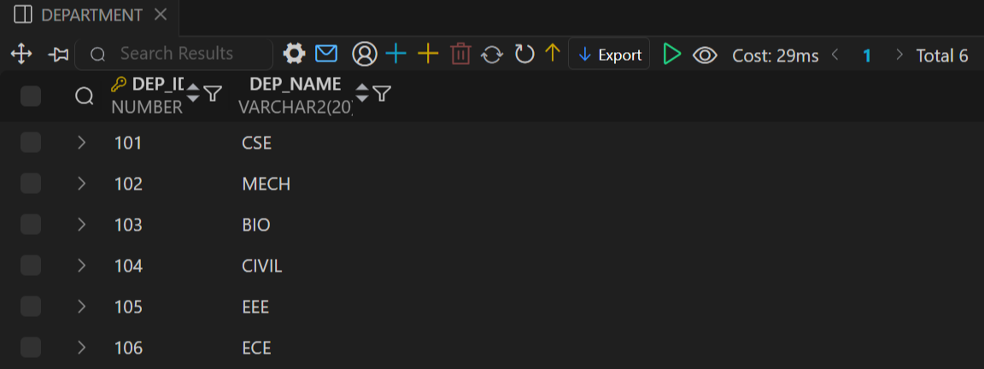
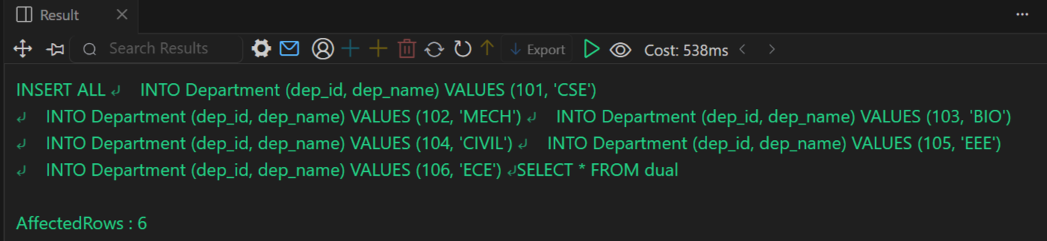

Student Table
-- Create Student Table With FK + Constraint
CREATE TABLE Student (
Std_Id NUMBER PRIMARY KEY, -- PRIMARY KEY
Std_Name VARCHAR2(20),
Std_Number NUMBER(10) NOT NULL UNIQUE, -- NOT NULL + UNIQUE
Std_Cgp NUMBER CONSTRAINT Chk_Cgp CHECK (Std_Cgp >= 7.5), -- CHECK
Dep_Id NUMBER,
CONSTRAINT Fk_Student FOREIGN KEY (Dep_Id)
REFERENCES Department(Dep_Id) ON DELETE SET NULL -- FOREIGN KEY + ON DELETE
);

Insert Student Values
INSERT ALL
INTO STUDENT (STD_ID , STD_NAME , STD_NUMBER ,STD_CGP,DEP_ID) VALUES (1, 'Gokul' , 9585502916 , 7.5 ,101)
INTO STUDENT (STD_ID , STD_NAME , STD_NUMBER ,STD_CGP,DEP_ID) VALUES (2, 'Sarath' , 9585502917 , 8.5 ,102)
INTO STUDENT (STD_ID , STD_NAME , STD_NUMBER ,STD_CGP,DEP_ID) VALUES (3, 'Deva' , 9585502918 , 9.5 ,103)
INTO STUDENT (STD_ID , STD_NAME , STD_NUMBER ,STD_CGP,DEP_ID) VALUES (4, 'Balaji' , 9585502919 , 8.6 ,104)
INTO STUDENT (STD_ID , STD_NAME , STD_NUMBER ,STD_CGP,DEP_ID) VALUES (5, 'Vicky' , 9585502910 , 9.2 ,105)
INTO STUDENT (STD_ID , STD_NAME , STD_NUMBER ,STD_CGP,DEP_ID) VALUES (6, 'Saranya' , 9585502911 , 8.7 ,101)
INTO STUDENT (STD_ID , STD_NAME , STD_NUMBER ,STD_CGP,DEP_ID) VALUES (7, 'Deva' , 9585502912 , 7.8 ,102)
INTO STUDENT (STD_ID , STD_NAME , STD_NUMBER ,STD_CGP,DEP_ID) VALUES (8, 'Boomika' , 9585502913 , 8.9 ,103)
INTO STUDENT (STD_ID , STD_NAME , STD_NUMBER ,STD_CGP,DEP_ID) VALUES (9, 'Gayathri' , 9585502914 , 7.9 ,104)
INTO STUDENT (STD_ID , STD_NAME , STD_NUMBER ,STD_CGP,DEP_ID) VALUES (10, 'Jaya' , 9585502915 , 8.7 ,105)
SELECT * FROM Dual;
-- View STUDENT
SELECT * FROM STUDENT

Output >>>>>>>>>>>>>>>>>
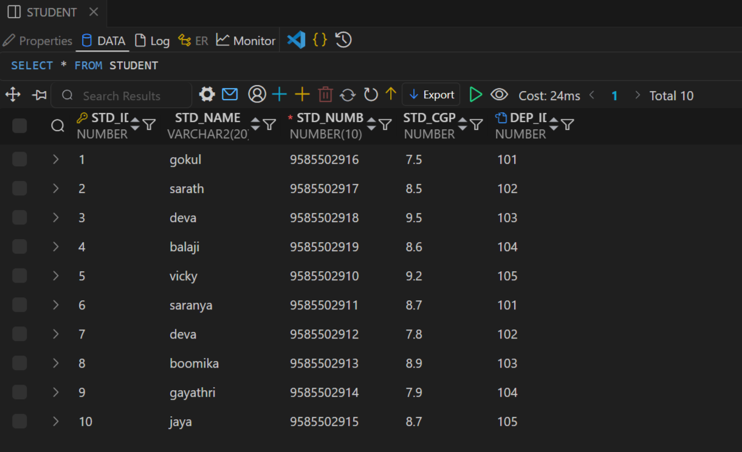

Teacher Table
-- Create Teacher
CREATE Table Teacher(
Teach_Id NUMBER PRIMARY KEY,
Teach_Name VARCHAR2(20) NOT NULL ,
Teach_Salary NUMBER(7,2),
Dep_Id NUMBER,
Constraint Fk_Teacher FOREIGN KEY(Dep_Id)
REFERENCES Department (Dep_Id) ON DELETE SET NULL
);

Insert Teacher Values
-- Insert Teacher
INSERT ALL
INTO TEACHER (TEACH_ID , TEACH_NAME ,TEACH_SALARY ,DEP_ID) VALUES (1, 'Kannan' , 25000,101)
INTO TEACHER (TEACH_ID , TEACH_NAME ,TEACH_SALARY ,DEP_ID) VALUES (2, 'Praba' , 15000,102)
INTO TEACHER (TEACH_ID , TEACH_NAME ,TEACH_SALARY ,DEP_ID) VALUES (3, 'Siva' , 20000,103)
INTO TEACHER (TEACH_ID , TEACH_NAME ,TEACH_SALARY ,DEP_ID) VALUES (4, 'Suresh' ,18000 ,104)
INTO TEACHER (TEACH_ID , TEACH_NAME ,TEACH_SALARY ,DEP_ID) VALUES (5, 'Pavithra' ,32000,105)
INTO TEACHER (TEACH_ID , TEACH_NAME ,TEACH_SALARY ,DEP_ID) VALUES (6, 'Deva' ,32000,105)
SELECT * FROM Dual;
SELECT * FROM TEACHER;

Output >>>>>>>>>>>>>>>>>
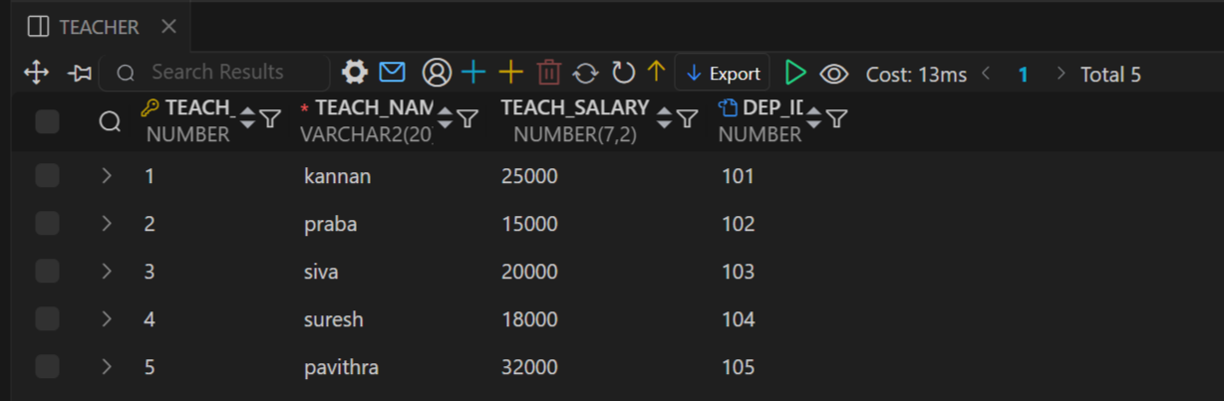

2) Update Table
Modifies existing records in a table.
-- Update
UPDATE Student Set DEP_ID = 102
WHERE STD_NAME = 'Deva' ;

SELECT * FROM STUDENT

Output >>>>>>>>>>>>>>>>>
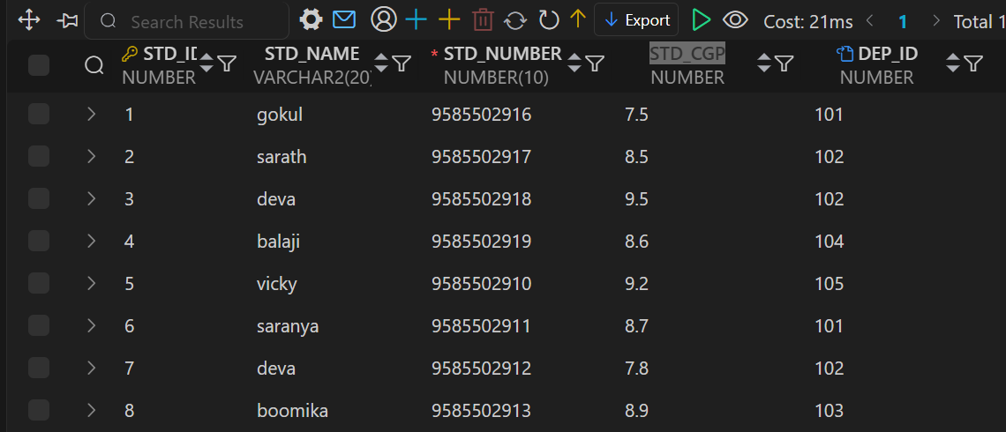

3) Delete Table
Removes specific records from a table.
-- Delete A Single Row
DELETE FROM Student
WHERE STD_ID = 2;
SELECT * FROM STUDENT

Output >>>>>>>>>>>>>>>>>
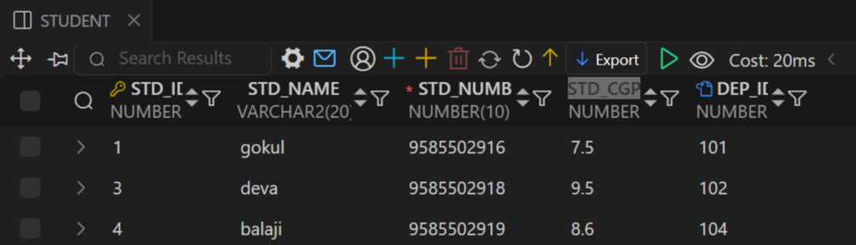
4 ) Views
A View is a virtual table created from a SQL query that displays data from one or more tables without storing it physically.
SELECT * FROM STUDENT WHERE
DEP_ID = 101;
-- Creating View Cse Students
CREATE VIEW CSE_Dept As
SELECT * FROM STUDENT WHERE
DEP_ID = 101;

SELECT * FROM CSE_DEPT;

Output >>>>>>>>>>>>>>>>>
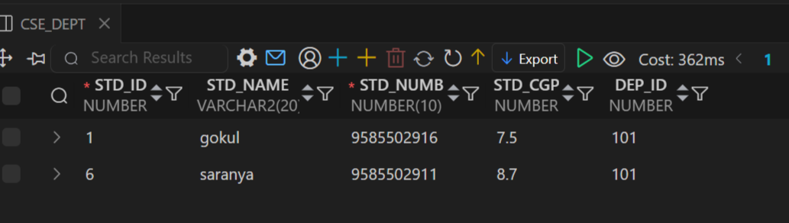

SELECT * FROM STUDENT WHERE
DEP_ID = 103;

-- Creating View BIO Students
CREATE VIEW BIO_Dept As
SELECT * FROM STUDENT WHERE
DEP_ID = 103;
SELECT * FROM BIO_DEPT;

Output >>>>>>>>>>>>>>>>>
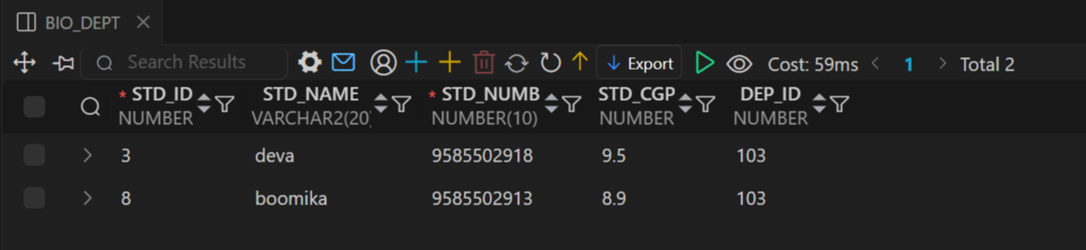

5) Foreign Key
A Foreign Key is a constraint that links one table to another by ensuring the values in a column match the primary key of another table.
Student With Department
-- Foreign Key (Student , Department)

SELECT S.Std_Name, D.Dep_Name
FROM Student S
JOIN Department D
ON D.Dep_Id = S.Dep_Id;

Output >>>>>>>>>>>>>>>>>
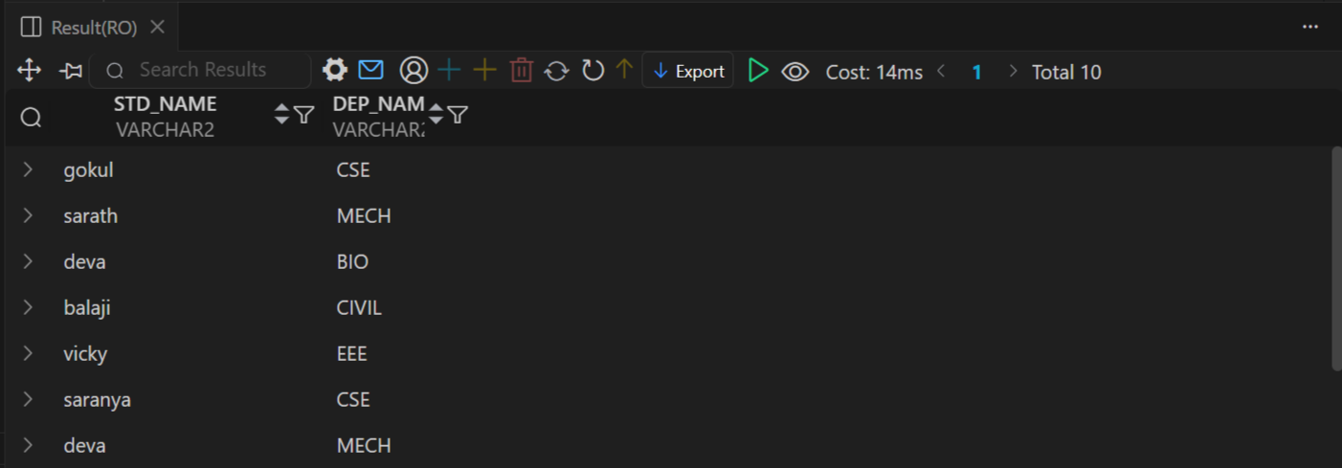

Teacher With Department
-- Foreign Key (Teacher , Department)
SELECT T.Teach_Name, D.Dep_Name
FROM TEACHER T
JOIN Department D
ON D.Dep_Id = T.Dep_Id;

Output >>>>>>>>>>>>>>>>>
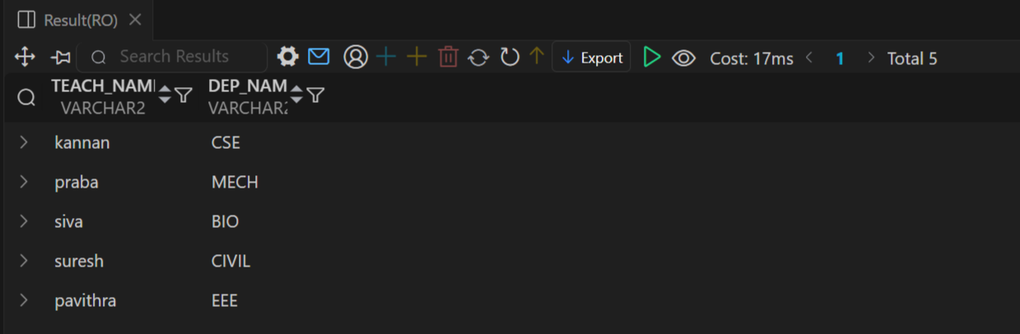

Student Teache Department
-- Foreign Key (Student , Teacher , Department) Using Join
SELECT
S.STD_ID As Id,
S.Std_Name As Student ,
D.Dep_Name As Department,
T.Teach_Name As Teacher
FROM Department D
JOIN Student S
ON D.Dep_Id = S.Dep_Id
JOIN Teacher T
ON D.Dep_Id = T.Dep_Id;

Output >>>>>>>>>>>>>>>>>
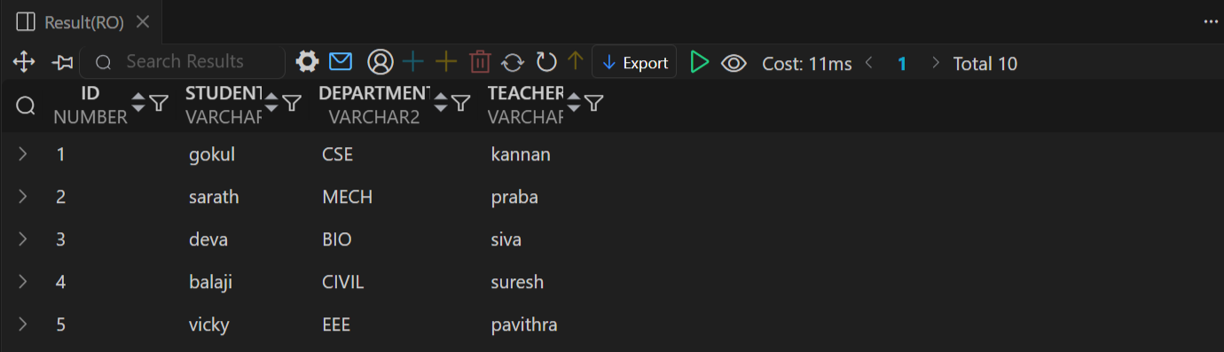

6) AGGREGATE FUNCTIONS
Aggregate functions perform a calculation on a group of rows and return a single summary value (like total, average, count, min, or max).
6.1) COUNT() – Returns the number of rows.
-- Count
SELECT Count(Std_Id)As Total_Student FROM STUDENT ;
Output >>>>>>>>>>>>>>>>>
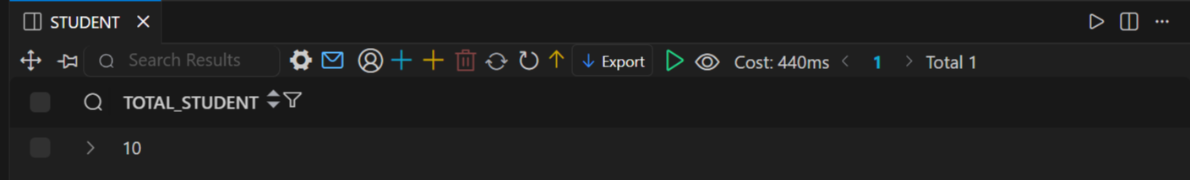

6.2) MAX() – Returns the largest value in a column.
- Max
SELECT Teach_Name, Teach_Salary
FROM Teacher
WHERE Teach_Salary = (SELECT MAX(Teach_Salary) FROM Teacher);
Output >>>>>>>>>>>>>>>>>
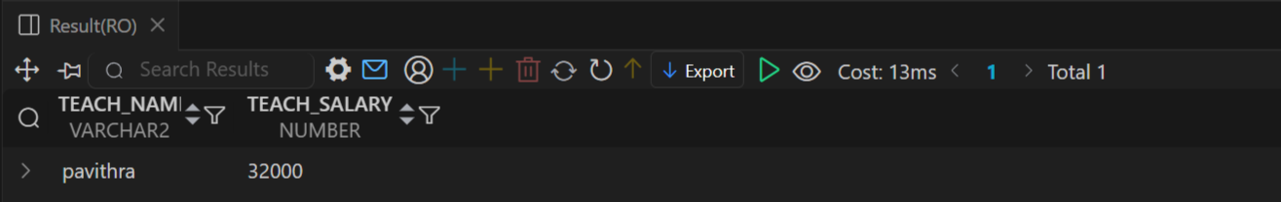
6.3) MIN() – Returns the smallest value in a column.
- Min
SELECT STD_ID , Std_Name, Std_Cgp
FROM STUDENT
WHERE STD_CGP = (SELECT Min(STD_CGP) FROM STUDENT);

Output >>>>>>>>>>>>>>>>> 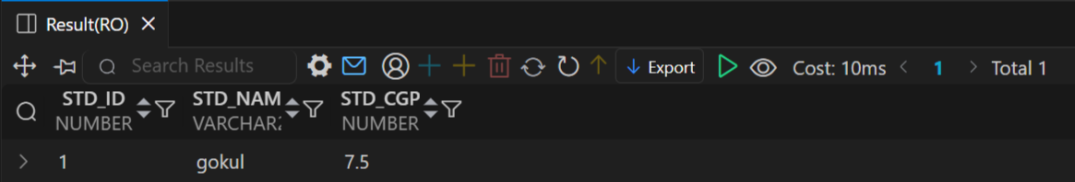

6.4) SUM() – Returns the total of numeric values.
-- Sum
SELECT SUM(Teach_Salary) As Total_Salary FROM TEACHER;
Output >>>>>>>>>>>>>>>>
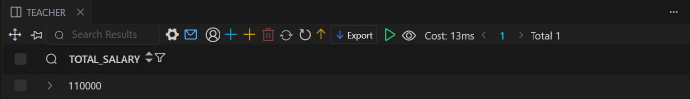

6.5) AVG() – Returns the average of numeric values.
- Avg
SELECT Avg(Teach_Salary) As Average_Salary FROM TEACHER;
Output >>>>>>>>>>>>>>>>
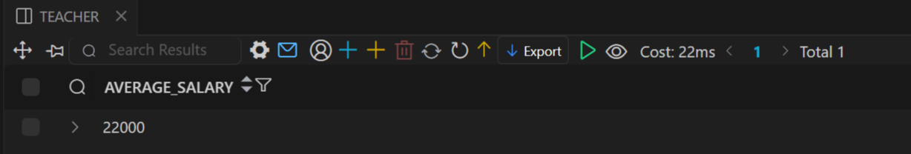

- JOINS
A JOIN is a SQL operation used to combine rows from two or more tables based on a related column between them.
7.1) INNER JOIN – Returns only the matching rows from both tables.
-- Inner JOIN
SELECT
S.Std_Id AS Id,
S.Std_Name AS Name,
D.Dep_Name AS Department,
T.Teach_Name AS Teacher
FROM Student S
JOIN Department D
ON S.Dep_Id = D.Dep_Id
JOIN Teacher T
ON T.Dep_Id = D.Dep_Id
ORDER BY S.STD_ID ;
Output >>>>>>>>>>>>>>>>

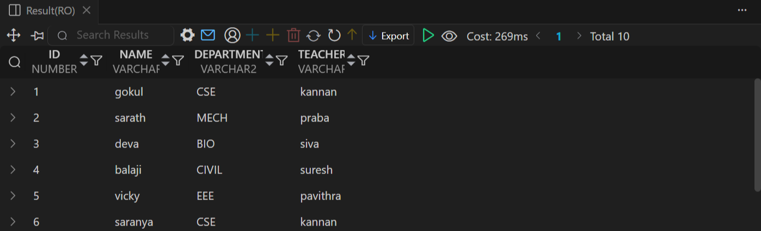

7.2) RIGHT JOIN (RIGHT OUTER JOIN) – Returns all rows from the right table and matching rows from the left table.
-- RIGHT JOIN
SELECT
S.Std_Id AS Id,
S.Std_Name AS Name,
D.Dep_Name AS Department,
T.Teach_Name AS Teacher
FROM Student S
JOIN Department D
ON S.Dep_Id = D.Dep_Id
RIGHT JOIN Teacher T
ON T.Dep_Id = D.Dep_Id
WHERE S.Dep_Id = 101
ORDER BY S.STD_ID;
Output >>>>>>>>>>>>>>>>
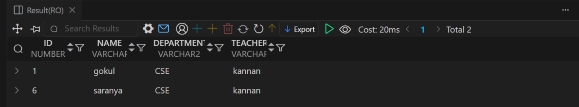

7.3 ) LEFT JOIN (LEFT OUTER JOIN) – Returns all rows from the left table and matching rows from the right table.
-- Left JOIN
SELECT
S.Std_Id AS Id,
S.Std_Name AS Name,
D.Dep_Name AS Department,
T.Teach_Name AS Teacher
FROM Student S
JOIN Department D
ON S.Dep_Id = D.Dep_Id
RIGHT JOIN Teacher T
ON T.Dep_Id = D.Dep_Id
ORDER BY S.STD_ID;

Output >>>>>>>>>>>>>>>>
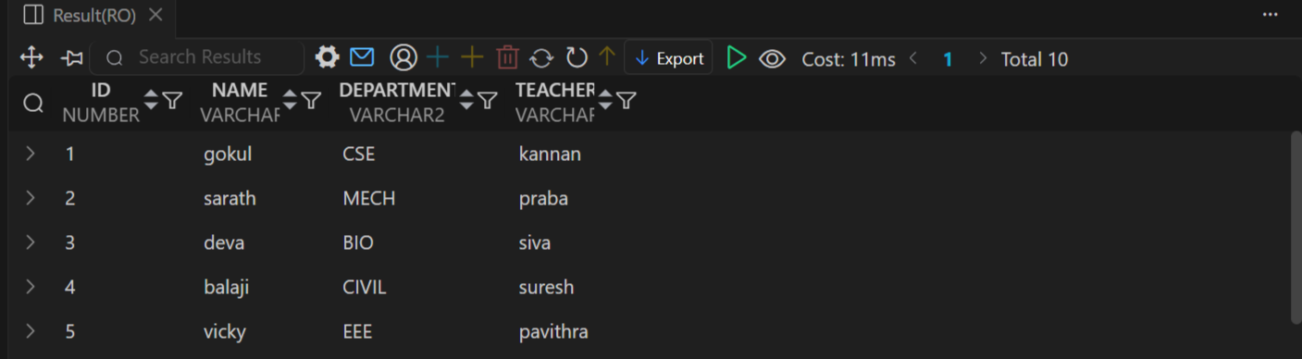

7.4) FULL JOIN (FULL OUTER JOIN) – Returns all rows when there is a match in either table.
-- Full JOIN
SELECT
S.Std_Id AS Id,
S.Std_Name AS Name,
D.Dep_Name AS Department,
T.Teach_Name AS Teacher
FROM Student S
FULL JOIN Teacher T
ON S.Dep_Id = T.Dep_Id
FULL JOIN Department D
ON S.Dep_Id = D.Dep_Id OR T.Dep_Id = D.Dep_Id
WHERE S.Dep_Id = 101 OR S.Dep_Id IS NULL;

Output >>>>>>>>>>>>>>>>
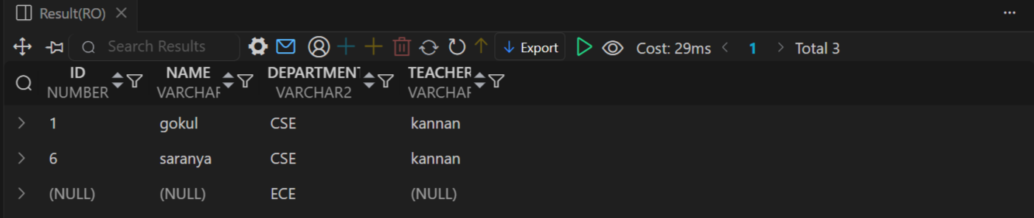

7.5) CROSS JOIN – Returns the Cartesian product of both tables (every row from table A with every row from table B).
-- CROSS Join
SELECT
S.Std_Id AS Id,
S.Std_Name AS Student_Name,
D.Dep_Name AS Department,
T.Teach_Name AS Teacher_Name
FROM Student S
JOIN Department D
ON S.Dep_Id = D.Dep_Id
CROSS JOIN Teacher T
WHERE S.Dep_Id = 101
;
Output >>>>>>>>>>>>>>>>
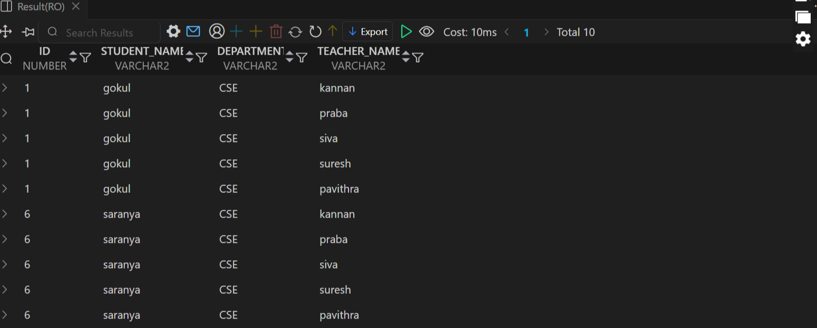

8) AGREGATE FUNCTIONS + JOINS
Aggregate functions perform a calculation on a group of rows and return a single summary value (like total, average, count, min, or max).
-- Max
SELECT DEP_ID,Max(Teach_Salary) As Salary
FROM TEACHER
GROUP BY DEP_ID
;
----------------------------------------------------------------------------------------
SELECT COUNT(*) AS Male_Count
FROM Student
WHERE Gender = 'Male' AND DEP_ID=101;

SELECT Teach_Id, Teach_Name, Teach_Salary
FROM Teacher
WHERE Teach_Salary = (SELECT MAX(Teach_Salary) FROM Teacher);
---------------------------------------------------------------------------------------------
SELECT S.Std_Id As Id ,Upper(S.Std_Name) As Name ,
Upper(D.Dep_Name) As Department , S.STD_CGP As Cgp
FROM STUDENT S
JOIN DEPARTMENT D
On S.DEP_ID = D.DEP_ID
WHERE S.STD_CGP = (SELECT Max(STD_CGP) FROM STUDENT);
--------------------------------------------------------------------------------------------
SELECT
S.Std_Id AS Id,
UPPER(S.Std_Name) AS Name,
UPPER(D.Dep_Name) AS Department,
S.Std_Cgp AS Cgp,
UPPER(T.Teach_Name) AS Teacher
FROM Student S
JOIN Department D
ON S.Dep_Id = D.Dep_Id
LEFT JOIN Teacher T
ON D.Dep_Id = T.Dep_Id
WHERE D.Dep_Id = 106
AND S.Std_Cgp = (
SELECT Avg(Std_Cgp) FROM STUDENT
WHERE DEP_ID = 106
)
ORDER BY S.Std_Id;

9) SET OPERATIONS
Set operations combine the result sets of two SELECT queries and return a single result based on rules like UNION, UNION ALL, INTERSECT, and MINUS.
9.1) UNION – Combines results of two queries and removes duplicate rows.
-- Union
(SELECT Std_Name AS Student, NULL AS Teacher
FROM Student)
UNION
(SELECT NULL AS Student, Teach_Name AS Teacher
FROM Teacher);

Output >>>>>>>>>>>>>>>>
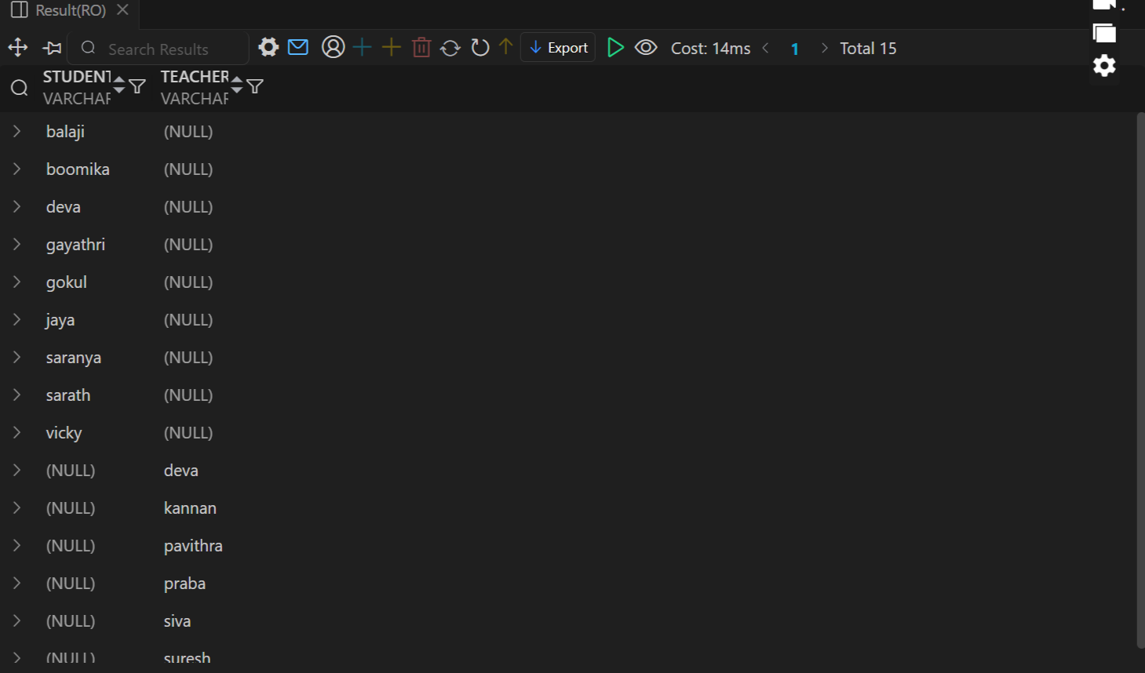

9.2) UNION ALL – Combines results of two queries but keeps all duplicate rows.
-- Union All
(SELECT Std_Name AS Student, NULL AS Teacher
FROM Student)
UNION All
(SELECT NULL AS Student, Teach_Name AS Teacher
FROM Teacher);
Output >>>>>>>>>>>>>>>>
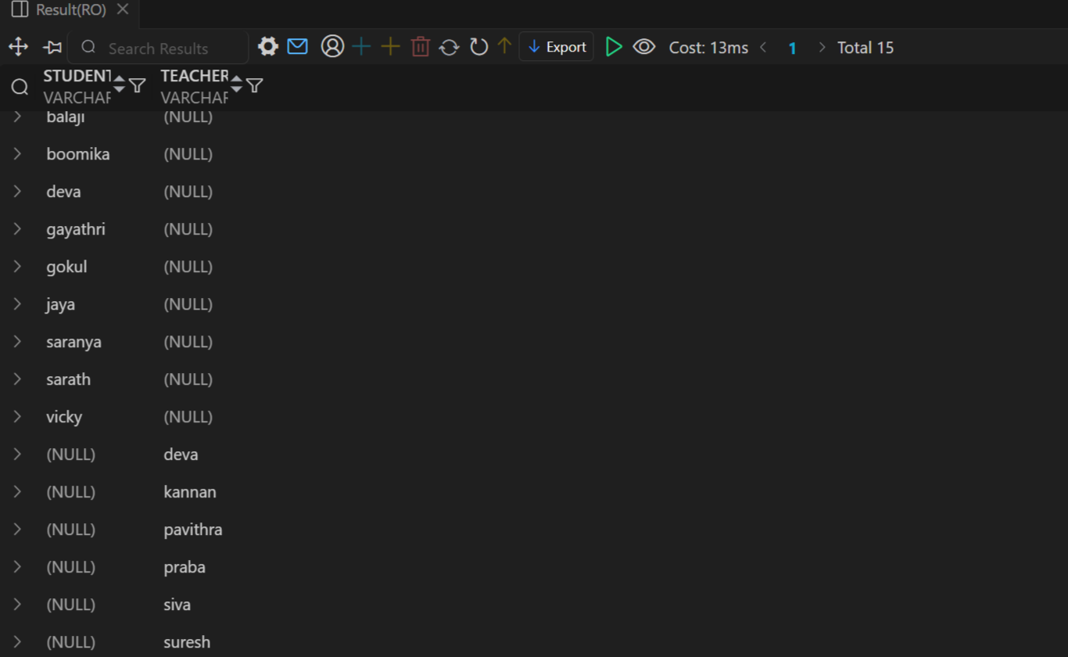

9.3) INTERSECT – Returns only the rows that are common to both queries.
-- Intersect
SELECT Std_Name FROM Student
INTERSECT
SELECT Teach_Name FROM Teacher;

Output >>>>>>>>>>>>>>>>
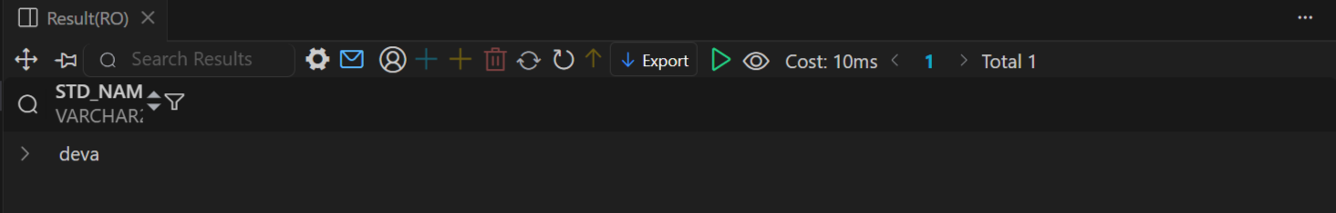

9.4) MINUS (Oracle only) – Returns rows from the first query that are not present in the second query.
-- Minus
(SELECT Std_Name AS Student, NULL AS Teacher
FROM Student)
Minus
(SELECT NULL AS Student, Teach_Name AS Teacher
FROM Teacher);

Output >>>>>>>>>>>>>>>>
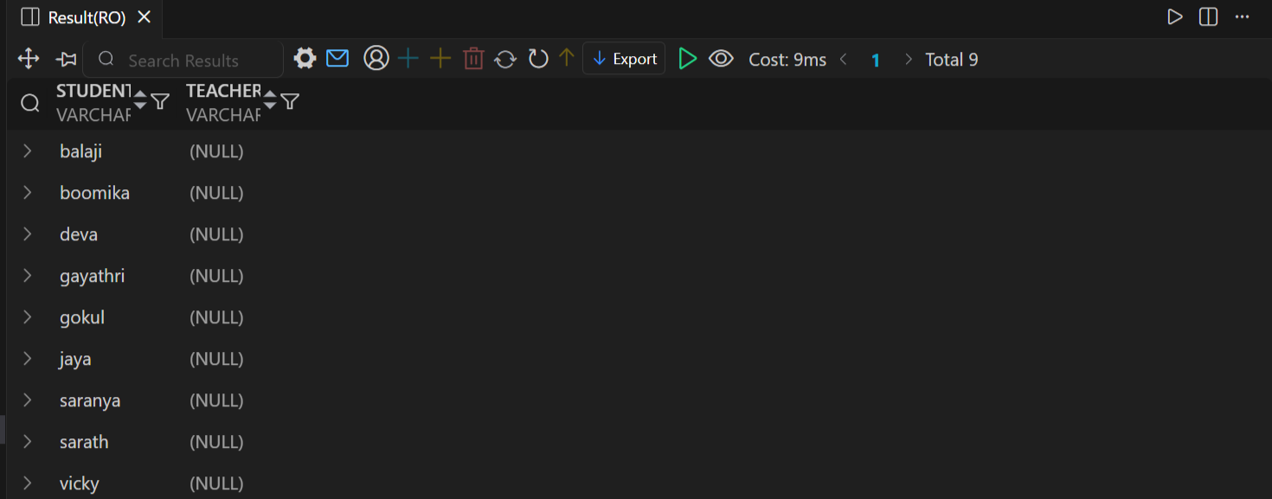

10) NESTED QUERIES
A Nested Query (or Subquery) is a query written inside another SQL query to provide results that the outer query uses.
-- Nested Queries
SELECT S.Std_Id As Id ,Upper(S.Std_Name) As Name ,
Upper(D.Dep_Name) As Department , S.STD_CGP As Cgp
FROM STUDENT S
JOIN DEPARTMENT D
On S.DEP_ID = D.DEP_ID
WHERE S.STD_CGP = (SELECT Max(STD_CGP) FROM STUDENT);

Output >>>>>>>>>>>>>>>>
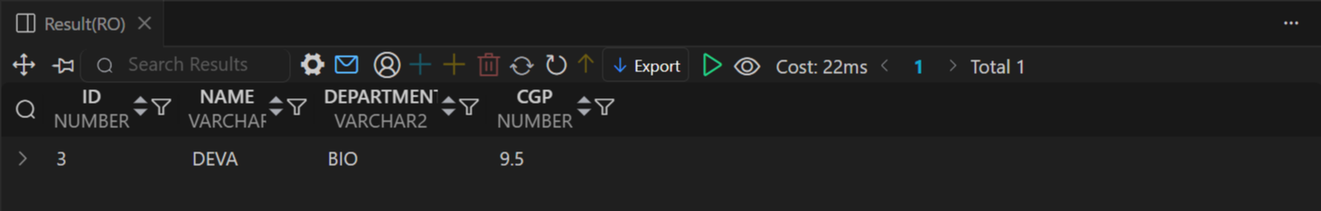

RESULT :
Thus the data manipulation language (dml) of base tables and views are executed
EX.NO:A
DATE : 06 / 10 /2025
- TRANSACTION CONTROL LANGUAGE
A Transaction Control Language (TCL) Statement Is Used To Define The Database Structure Or Schema.
Aim:
To Study And Execute The TCL Commands In RDBMS.
TCL Commands:
- COMMIT
- ROLLBACK
- SAVEPOINT
-- Table Employee
CREATE TABLE Employee (
name VARCHAR2(50),
age NUMBER,
salary NUMBER
);

SELECT * FROM EMPLOYEE;
Output >>>>>>>>>>>>>>>>
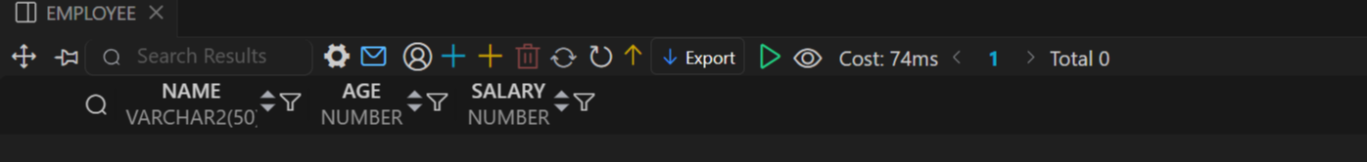

- COMMIT – Saves all changes made in the current transaction permanently.
-- Insert first row
INSERT INTO Employee (name, age, salary)
VALUES ('John', 30, 50000);

-- Insert second row
INSERT INTO Employee (name, age, salary)
VALUES ('Meena', 28, 60000);

COMMIT;
SELECT * FROM EMPLOYEE;

Output >>>>>>>>>>>>>>>>
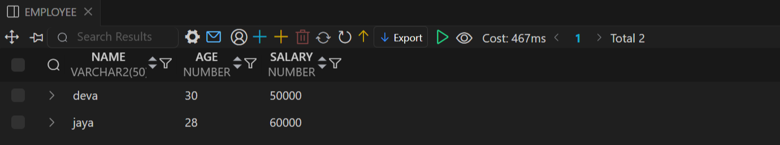

2) ROLLBACK – Reverts all changes made in the current transaction.
-- Insert 3rd row
INSERT INTO Employee (name, age, salary)
VALUES ('pavi', 21, 20000);

SELECT * FROM EMPLOYEE;

Output >>>>>>>>>>>>>>>>
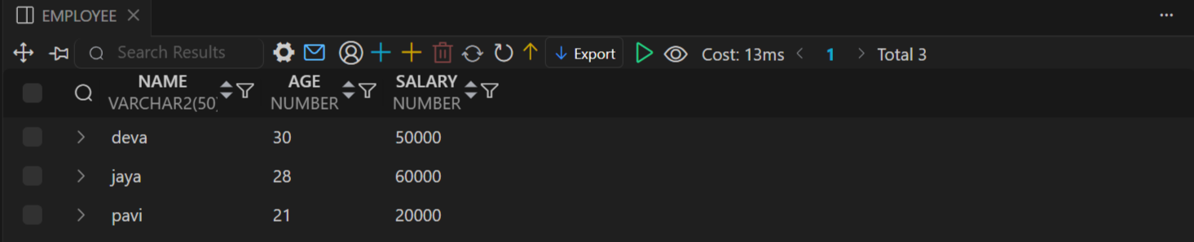

ROLLBACK;

SELECT * FROM EMPLOYEE;
Output >>>>>>>>>>>>>>>>


3) SAVEPOINT – Creates a checkpoint inside a transaction to roll back to.
-- insert 3rd row
INSERT INTO Employee (name, age, salary)
VALUES ('gokul', 35, 70000);

SAVEPOINT sp1;

-- Insert 4h row
INSERT INTO Employee (name, age, salary)
VALUES (boomika, 35, 70000);

-- Rollback to savepoint (undo boomika only)
ROLLBACK TO sp1;

-- Commit the final changes
COMMIT;

SELECT * FROM EMPLOYEE;
Output >>>>>>>>>>>>>>>>
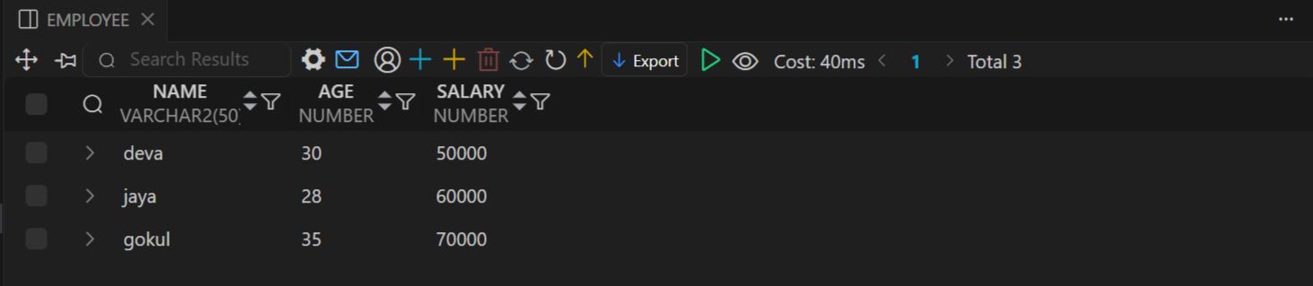

RESULT:
Thus the Transation Control Language (TCL) of base tables and views are executed.
EX.NO:B
DATE : 13 / 10 /2025

- DISTRIBUTED DATABASE DESIGN AND IMPLEMENTATION
A Distributed Database is a database in which data is stored across multiple physical locations (computers or servers), but it appears to users as a single logical database.

Aim:
A Distributed Database is a database in which data is stored across multiple physical
locations (computers or servers), but it appears to users as a single logical database.

Create Table India
-- stuent in india
CREATE TABLE STUDENT_INDIA (
student_id NUMBER PRIMARY KEY,
name VARCHAR2(100),
age NUMBER,
course VARCHAR2(50),
country VARCHAR2(50)
);

-- insert values
INSERT ALL
INTO STUDENT_INDIA VALUES (1, 'deva', 21, 'B.Sc', 'India')
INTO STUDENT_INDIA VALUES (2, 'jaya', 22, 'MBA', 'India')
INTO STUDENT_INDIA VALUES (3, 'gokul', 20, 'B.Tech', 'India')
SELECT * FROM dual;

SELECT * FROM STUDENT_INDIA ;

Output >>>>>>>>>>>>>>>>
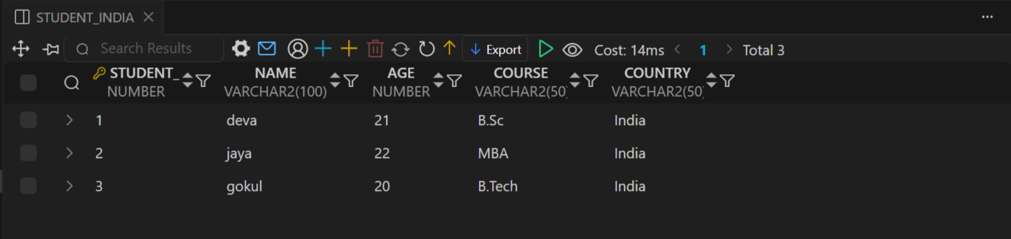
Create Table Japan
CREATE TABLE STUDENT_JAPAN (
student_id NUMBER PRIMARY KEY,
name VARCHAR2(100),
age NUMBER,
course VARCHAR2(50),
country VARCHAR2(50)
);

-- insert values
INSERT ALL
INTO STUDENT_JAPAN VALUES (101, 'Gojo', 20, 'Engineering', 'Japan')
INTO STUDENT_JAPAN VALUES (102, 'luffy', 22, 'Economics', 'Japan')
INTO STUDENT_JAPAN VALUES (103, ' Rei kamiki', 21, 'Law', 'Japan')
SELECT * FROM dual;

SELECT * FROM STUDENT_JAPAN ;

Output >>>>>>>>>>>>>>>>
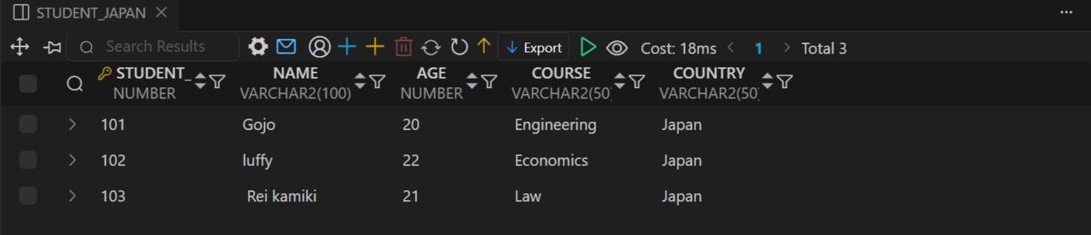

Create DataBase Link
-- Database connection link

CREATE PUBLIC DATABASE LINK siteA_link -- public link everyone access
CONNECT TO deva IDENTIFIED BY deva2003
USING 'XE';

CREATE DATABASE LINK siteB_link -- private link particular person only
CONNECT TO deva IDENTIFIED BY deva2003
USING 'XE';

DROP DATABASE link siteC_link ; -- drop link

Access Link
-- Access India
select * from student_india@siteA_link;

Output >>>>>>>>>>>>>>>>
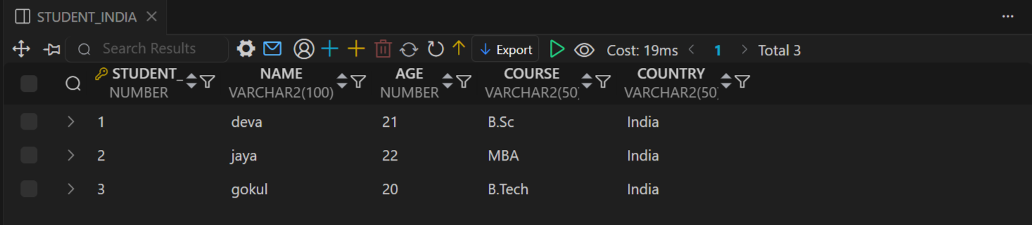

-- Access Japan

select * from student_japan@siteA_link;

Output >>>>>>>>>>>>>>>>


Join India with Japan
-- Join local STUDENT_INDIA with remote STUDENT_JAPAN
SELECT a.student_id, a.name AS india_student, b.name AS japan_student , a.age as age
FROM STUDENT_INDIA a
Right JOIN STUDENT_JAPAN@siteB_link b
ON a.age = b.age;

select * from student_japan@siteA_link;

Output >>>>>>>>>>>>>>>>
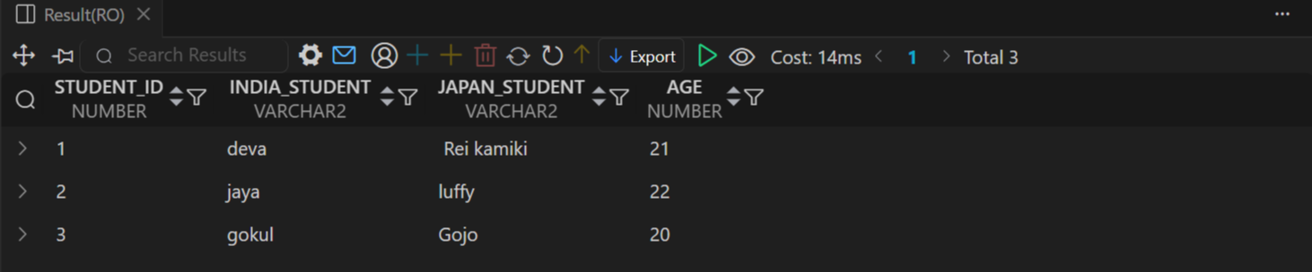

RESULT:
Thus the base tables and views are executed.

EX.NO:B
DATE : 27 / 10 /2025
- IMPLEMENTATION ROW LEVEL AND STATEMENT LEVEL TRIGGERS
A Trigger is a stored procedure in a database that automatically executes in response to certain events (INSERT, UPDATE, or DELETE) on a table or view.
Aim:
To implementation row level and statement level triggers in a database.
Types:
- Row Level
- Statement Level Triggers

1) Row Level Trigger
A trigger that fires once for each row affected by the triggering statement.
-- create table
CREATE TABLE WORKER (
worker_id NUMBER PRIMARY KEY,
name VARCHAR2(100),
age NUMBER,
work VARCHAR2(50)
);

-- create page table
CREATE TABLE AUDIT_WORKER (
audit_id NUMBER PRIMARY KEY,
worker_id NUMBER,
action VARCHAR2(20),
action_date DATE,
old_name VARCHAR2(100),
new_name VARCHAR2(100),
old_age NUMBER,
new_age NUMBER,
old_work VARCHAR2(50),
new_work VARCHAR2(50)
);
-- Create Sequence
CREATE SEQUENCE audit_worker_seq START WITH 1 INCREMENT BY 1;

-- create table
CREATE TABLE WORKER (
worker_id NUMBER PRIMARY KEY,
name VARCHAR2(100),
age NUMBER,
work VARCHAR2(50)
);

-- create page table
CREATE TABLE AUDIT_WORKER (
audit_id NUMBER PRIMARY KEY,
worker_id NUMBER,
action VARCHAR2(20),
action_date DATE,
old_name VARCHAR2(100),
new_name VARCHAR2(100),
old_age NUMBER,
new_age NUMBER,
old_work VARCHAR2(50),
new_work VARCHAR2(50)
);

-- Create Sequence
CREATE SEQUENCE audit_worker_seq START WITH 1 INCREMENT BY 1;

-- Row level Trigger

-- Create Trigger
CREATE OR REPLACE TRIGGER trg_audit_worker
AFTER INSERT OR UPDATE OR DELETE ON WORKER
FOR EACH ROW
BEGIN
IF INSERTING THEN
INSERT INTO AUDIT_WORKER (
audit_id, worker_id, action, action_date,
old_name, new_name, old_age, new_age, old_work, new_work
)

VALUES (
audit_worker_seq.NEXTVAL, -- use correct sequence name
:NEW.worker_id, 'INSERT', SYSDATE,
NULL, :NEW.name, NULL, :NEW.age, NULL, :NEW.work
);

ELSIF UPDATING THEN
INSERT INTO AUDIT_WORKER (
audit_id, worker_id, action, action_date,
old_name, new_name, old_age, new_age, old_work, new_work
)
VALUES (
audit_worker_seq.NEXTVAL,
:OLD.worker_id, 'UPDATE', SYSDATE,
:OLD.name, :NEW.name, :OLD.age, :NEW.age, :OLD.work, :NEW.work
);

ELSIF DELETING THEN
INSERT INTO AUDIT_WORKER (
audit_id, worker_id, action, action_date,
old_name, new_name, old_age, new_age, old_work, new_work
)
VALUES (
audit_worker_seq.NEXTVAL,
:OLD.worker_id, 'DELETE', SYSDATE,
:OLD.name, NULL, :OLD.age, NULL, :OLD.work, NULL
);
END IF;
END;
/

Output >>>>>>>>>>>>>>>>
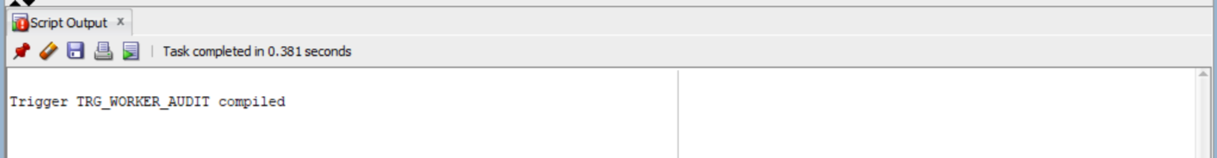

-- Insert Values
INSERT ALL
INTO WORKER (worker_id, name, age, work) VALUES (1, 'deva', 23, 'developer')
INTO WORKER (worker_id, name, age, work) VALUES (2, 'jaya', 27, 'designer')
INTO WORKER (worker_id, name, age, work) VALUES (3, 'pavithra', 23, 'Tester')
SELECT * FROM dual;

SELECT * FROM WORKER; -- view worker table

Output >>>>>>>>>>>>>>>>
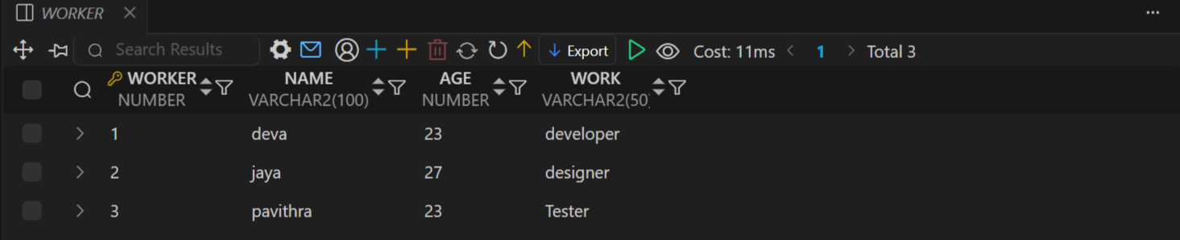

SELECT * FROM AUDIT_WORKER; -- view audit_worker table

Output >>>>>>>>>>>>>>>>
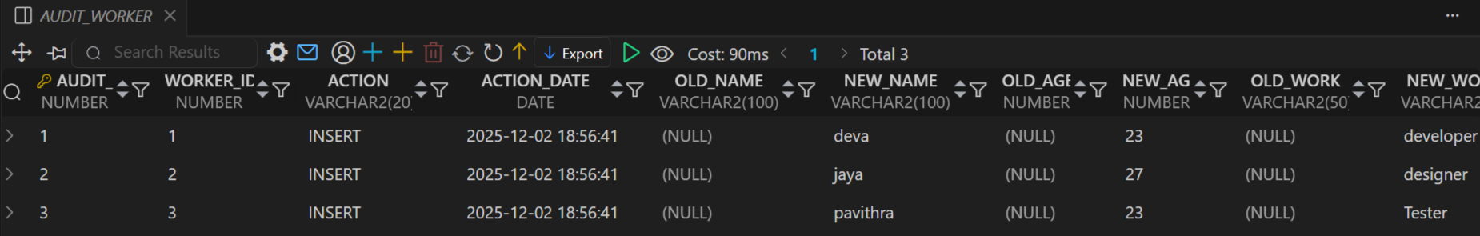

-- delete row
DELETE FROM WORKER WHERE NAME = 'pavithra';

Output >>>>>>>>>>>>>>>>
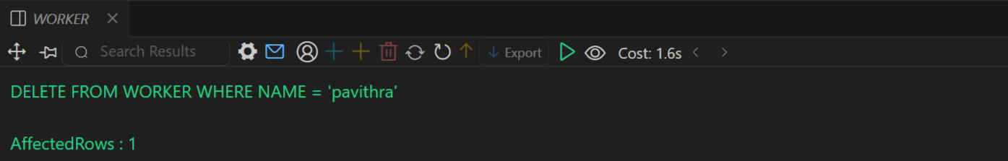

SELECT * FROM WORKER; -- view worker table

Output >>>>>>>>>>>>>>>>
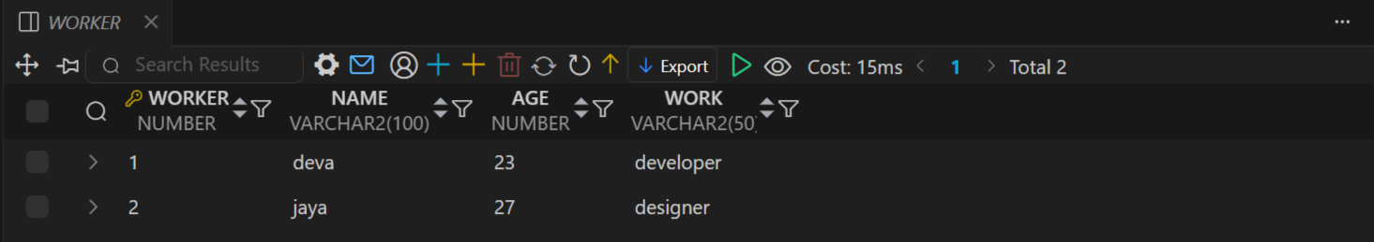

SELECT * FROM AUDIT_WORKER; -- view audit_worker table

Output >>>>>>>>>>>>>>>>
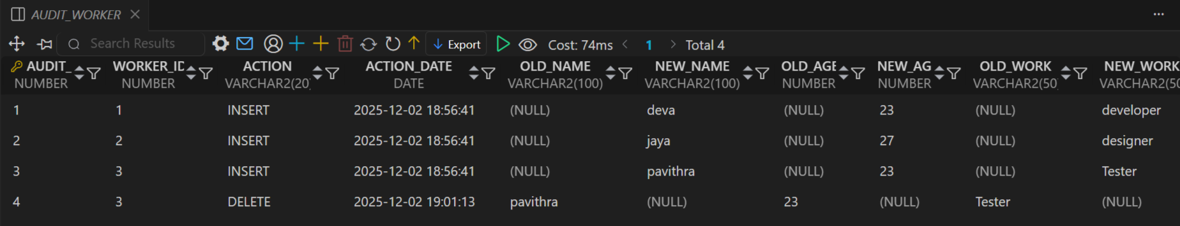

-- Update row
UPDATE WORKER set work='hacker' WHERE NAME = 'deva';

SELECT * FROM WORKER; -- view worker table

Output >>>>>>>>>>>>>>>>
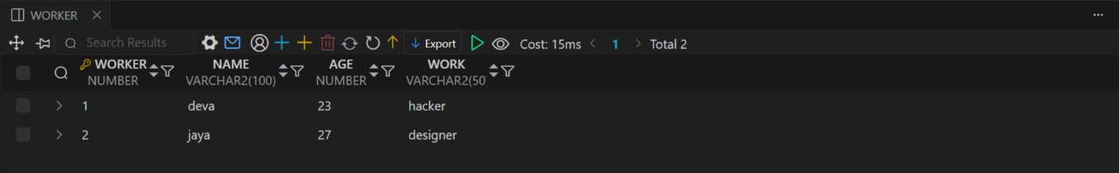

SELECT * FROM AUDIT_WORKER; -- view audit_worker table

Output >>>>>>>>>>>>>>>>
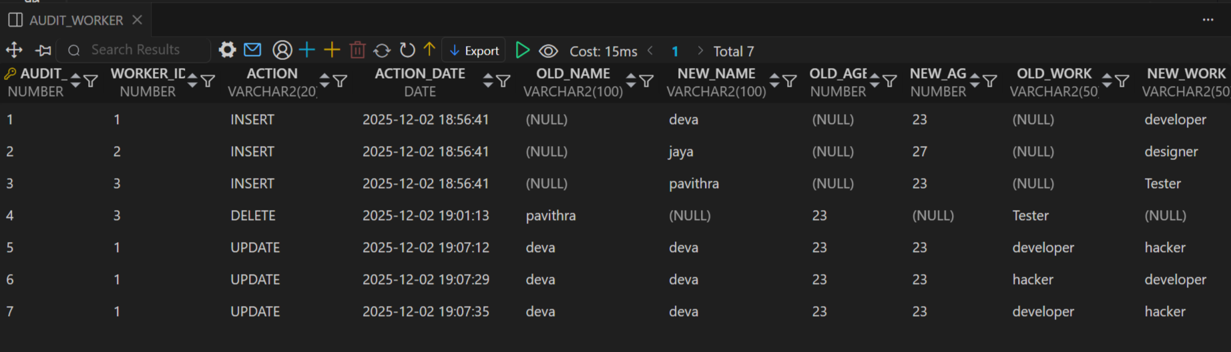
2 Statement Level Trigger
A trigger that fires once per SQL statement, regardless of how many rows are affected.
-- create table
CREATE TABLE WORKER (
worker_id NUMBER PRIMARY KEY,
name VARCHAR2(100),
age NUMBER,
work VARCHAR2(50)
);

-- create page table
CREATE TABLE AUDIT_WORKER (
audit_id NUMBER PRIMARY KEY,
worker_id NUMBER,
action VARCHAR2(20),
action_date DATE,
old_name VARCHAR2(100),
new_name VARCHAR2(100),
old_age NUMBER,
new_age NUMBER,
old_work VARCHAR2(50),
new_work VARCHAR2(50)
);

-- Create Sequence
CREATE SEQUENCE audit_worker_seq START WITH 1 INCREMENT BY 1;

-- create table
CREATE TABLE WORKER (
worker_id NUMBER PRIMARY KEY,
name VARCHAR2(100),
age NUMBER,
work VARCHAR2(50)
);

-- create page table
CREATE TABLE AUDIT_WORKER (
audit_id NUMBER PRIMARY KEY,
worker_id NUMBER,
action VARCHAR2(20),
action_date DATE,
old_name VARCHAR2(100),
new_name VARCHAR2(100),
old_age NUMBER,
new_age NUMBER,
old_work VARCHAR2(50),
new_work VARCHAR2(50)
);

-- Create Sequence
CREATE SEQUENCE audit_worker_seq START WITH 1 INCREMENT BY 1;

-- Statement level Trigger

-- Create Trigger
CREATE OR REPLACE TRIGGER trg_audit_worker_stmt
AFTER INSERT OR UPDATE OR DELETE ON WORKER
BEGIN
INSERT INTO AUDIT_WORKER (
audit_id, worker_id, action, action_date,
old_name, new_name, old_age, new_age, old_work, new_work
)
VALUES (
audit_worker_seq.NEXTVAL,
NULL,
CASE
WHEN INSERTING THEN 'INSERT'
WHEN UPDATING THEN 'UPDATE'
WHEN DELETING THEN 'DELETE'
END,
SYSDATE,
NULL, NULL, NULL, NULL, NULL, NULL
);
END;
/

Output >>>>>>>>>>>>>>>>


-- Insert Values
INSERT ALL
INTO WORKER (worker_id, name, age, work) VALUES (1, 'deva', 23, 'developer')
INTO WORKER (worker_id, name, age, work) VALUES (2, 'jaya', 27, 'designer')
INTO WORKER (worker_id, name, age, work) VALUES (3, 'pavithra', 23, 'Tester')
SELECT * FROM dual;

SELECT * FROM WORKER; -- view worker table

Output >>>>>>>>>>>>>>>>


SELECT * FROM AUDIT_WORKER; -- view audit_worker table

Output >>>>>>>>>>>>>>>>


-- delete row
DELETE FROM WORKER WHERE NAME = 'pavithra';

Output >>>>>>>>>>>>>>>>


SELECT * FROM WORKER; -- view worker table

Output >>>>>>>>>>>>>>>>


SELECT * FROM AUDIT_WORKER; -- view audit_worker table

Output >>>>>>>>>>>>>>>>


-- Update row
UPDATE WORKER set work='hacker' WHERE NAME = 'deva';

SELECT * FROM WORKER; -- view worker table

Output >>>>>>>>>>>>>>>>

SELECT * FROM AUDIT_WORKER; -- view audit_worker table

Output >>>>>>>>>>>>>>>>


RESULT:
Thus the tables and views are executed.

EX.NO : B
DATE : 06 / 10 /2025

3) ACCESSING A RELATIONAL DATABASE USING PHP, PYTHON AND R
Aim:
To write a Python program that connects to a relational database, executes basic SQL queries, and retrieves data.

Install Pip
# install Pip
import oracledb
print('install successfully')

Output >>>>>>>>>>>>>>>>
install successfully

Connect DataBase
# Path where you extracted Instant Client
oracledb.init_oracle_client(lib_dir=r"C:\oraclexe\instantclient_23_8")

connect = oracledb.connect(
user="deva",
password="deva2003",
dsn="localhost:1521/XE"
)

oracle = connect.cursor()
print('database connected')

Output >>>>>>>>>>>>>>>>
database connected

Create Table
# create Table
oracle.execute('''
create table player(
id number ,
name varchar2(20),
game varchar2(20)
)
''')
print('table created')

Output >>>>>>>>>>>>>>>>
table created

Insert Row
#insert

oracle.execute('''
insert all
into player values(1, 'deva' , 'kabaddi')
into player values(2, 'jaya' , 'chess')
select * from dual

''')

connect.commit
print('row inserted')

Output >>>>>>>>>>>>>>>>
row inserted

View Table
# display
oracle.execute('select * from player')
row =oracle.fetchall()
for i in row:
print(i)

Output >>>>>>>>>>>>>>>>
(1, deva, 'kabaddi')
(2, 'jaya', 'chess')

Condition
# chess
oracle.execute("SELECT * FROM player WHERE game='chess'")

row =oracle.fetchall()
for i in row:
print(i)

Output >>>>>>>>>>>>>>>>
(2, 'jaya', 'chess')

Delete
# delete
oracle.execute("delete from player where name = 'deva' ")
print('deleted')

Output >>>>>>>>>>>>>>>>
deleted

Drop Table
# drop
oracle.execute(" drop table player")
print('Table deleted')

Output >>>>>>>>>>>>>>>>
Table deleted

Result:
Thus To Accessing a Relational Database using Python . Has been completed successfully

EX.NO : C
DATE : 13 / 10 /2025
1) CREATING XML DOCUMENTS, DOCUMENT TYPE DEFINITION AND XML SCHEMA
Aim:
To create an XML document, define its structure using DTD, and validate it using XML Schema.
Procedure:
- Create an XML Document: Write an XML document using a text editor and save it with the xml extension.
- Define DTD: Define the document structure in a .dtd file.
- Validate with XML Schema (XSD): Create an XML Schema file (.xsd) to validate the XML document.
Create XML
Developers.xml
<?xml version="1.0" encoding="UTF-8"?>
<!-- developers.xml - simple element-based structure -->
<developers>

<developer>
<id>1</id>
<name>deva</name>
<role>ML Developer</role>
<skills>python</skills>
</developer>

<developer>
<id>2</id>
<name>jaya</name>
<role>Frontend Developer</role>
<skills>React</skills>
</developer>
</developers>
Create XML With DTD
Developers.dtd
<?xml version="1.0" encoding="UTF-8"?>

<!ELEMENT developers (developer+)>

<!ELEMENT developer (id, name, role, skills)>
<!ELEMENT id (#PCDATA)>
<!ELEMENT name (#PCDATA)>
<!ELEMENT role (#PCDATA)>
<!ELEMENT skills (#PCDATA)>

Connect dtd in Developers.xml
<?xml version="1.0" encoding="UTF-8"?>
<!DOCTYPE developers SYSTEM "developers.dtd"> <!-- developers.xtd -->

<developers>

<developer>
<id>1</id>
<name>deva</name>
<role>ML Developer</role>
<skills>python</skills>
</developer>

<developer>
<id>2</id>
<name>jaya</name>
<role>Frontend Developer</role>
<skills>React</skills>
</developer>

</developers>

Create Schema
Developers.xsd
<?xml version="1.0" encoding="UTF-8"?>
<xs:schema xmlns:xs="http://www.w3.org/2001/XMLSchema">

<!-- Root element -->
<xs:element name="developers">
<xs:complexType>
<xs:sequence>
<xs:element name="developer" maxOccurs="unbounded">
<xs:complexType>
<xs:sequence>
<xs:element name="id" type="xs:integer"/>
<xs:element name="name" type="xs:string"/>
<xs:element name="role" type="xs:string"/>
<xs:element name="skills" type="xs:string"/>
</xs:sequence>
</xs:complexType>
</xs:element>
</xs:sequence>
</xs:complexType>
</xs:element>

</xs:schema>

Developers.xml
<?xml version="1.0" encoding="UTF-8"?>
<developers xmlns:xsi="http://www.w3.org/2001/XMLSchema-instance"
xsi:noNamespaceSchemaLocation="developers.xsd"> <!—developers.xsd -->

<developer>
<id>1</id>
<name>deva</name>
<role>ML Developer</role>
<skills>python</skills>
</developer>

<developer>
<id>2</id>
<name>jaya</name>
<role>Frontend Developer</role>
<skills>React</skills>
</developer>

</developers>

RESULT:
The XML document is structured and validated using DTD & XML.

EX.NO : C
DATE : 27 / 10 /2025
2) STORE THE XML DOCUMENTS AS TEXT IN ORACLE
Aim:
To store an XML document as text in OracleSQL.
Procedure:
- Create a table to store the XML document as text.
- Insert the XML document into the table.

Create Table
-- create xml Table
CREATE TABLE developer_xml (
id NUMBER,
xml_data XMLTYPE
);

SELECT * FROM DEVELOPER_XML;

Output >>>>>>>>>>>>>>>>
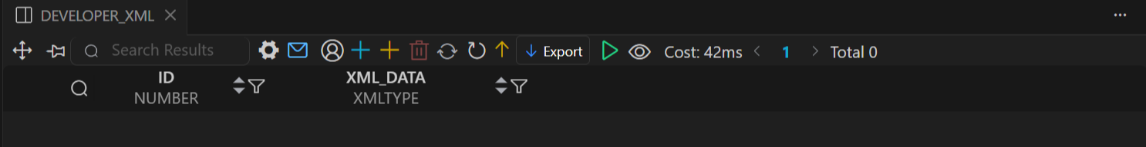

Insert XML
INSERT INTO developer_xml (id, xml_data)
VALUES ( 1,
XMLTYPE('
<developers>
<developer>
<id>1</id>
<name>deva</name>
<role>ML Developer</role>
<skills>python</skills>
</developer>
<developer>
<id>2</id>
<name>jaya</name>
<role>Frontend Developer</role>
<skills>React</skills>
</developer>

</developers>
')
);

SELECT * FROM DEVELOPER_XML;

Output >>>>>>>>>>>>>>>>
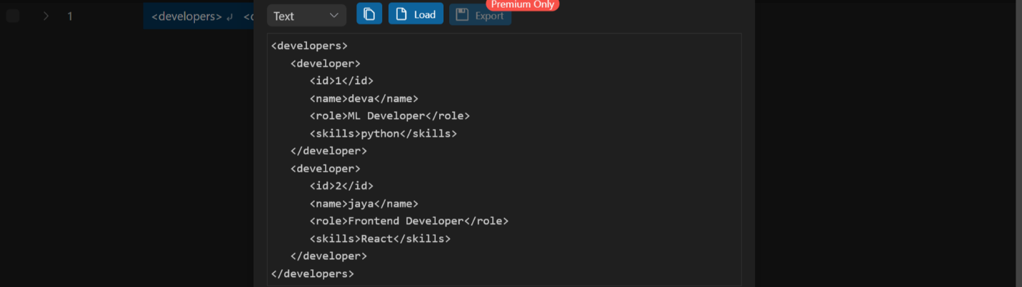

RESULT:
XML elements are successfully stored as relational data.

EX.NO: C
DATE : 03 / 11 /2025
3) STORE THE XML DOCUMENTS AS DATA ELEMENTS IN ORACLE
Aim:
To store an XML document as individual elements in OracleSQL.
Procedure:
- Create a table with columns for individual elements.
- Parse the XML and insert its elements as rows in the table.

View XML Table Format
SELECT x.id, x.name, x.role, x.skills
FROM developer_xml d,
XMLTable( '/developers/developer'
PASSING d.xml_data COLUMNS
id NUMBER PATH 'id',
name VARCHAR2(50) PATH 'name',
role VARCHAR2(50) PATH 'role',
skills VARCHAR2(200) PATH 'skills'
) x ;

Output >>>>>>>>>>>>>>>>
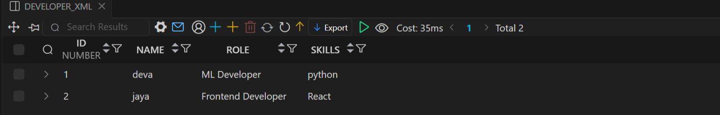

RESULT:
XML elements are successfully stored as relational data.

EX.NO:C
DATE : 10 / 11 /2025
4.) PUBLISHING A CUSTOMIZED XML DOCUMENT FROM RELATIONAL DATA
Aim:
To create a customized XML document from relational data.
Procedure:
- Use the xmlelement() function to generate an XML document.

Create table
-- Create table

CREATE Table akatsuki(
id NUMBER PRIMARY key,
name VARCHAR2(20) ,
role VARCHAR2(20),
score NUMBER
);

Output >>>>>>>>>>>>>>>>
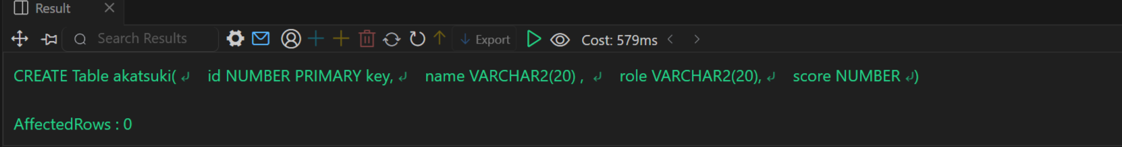

Insert data
-- insert data
INSERT ALL
INTO AKATSUKI(id , name , role , score) VALUES(1 , 'deva' , 'pain' , 100)
INTO AKATSUKI(id , name , role , score) VALUES(2 , 'jaya' , 'topy' , 100)
INTO AKATSUKI(id , name , role , score) VALUES(3 , 'boomika' , 'konan' , 100)
INTO AKATSUKI(id , name , role , score) VALUES(4 , 'pavi', 'itachi' , 100)
SELECT * FROM dual;

SELECT * FROM AKATSUKI;

Output >>>>>>>>>>>>>>>>
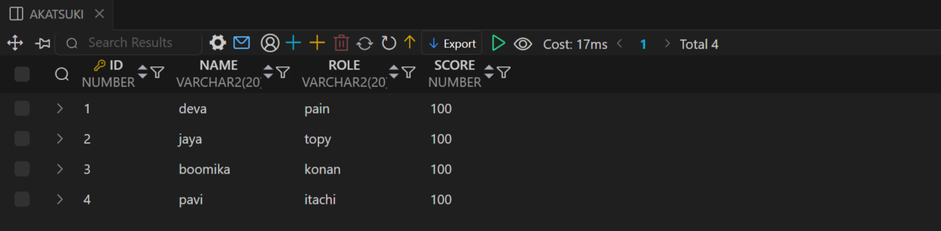

Publish XML
-- Publish XML
SELECT XMLElement(
"akatsuki",
XMLAgg(
XMLElement(
"member",
XMLForest(
id AS "id",
name AS "name",
role AS "role",
score AS "score"
)
)
)
) AS xml_data
FROM AKATSUKI;

Output >>>>>>>>>>>>>>>>
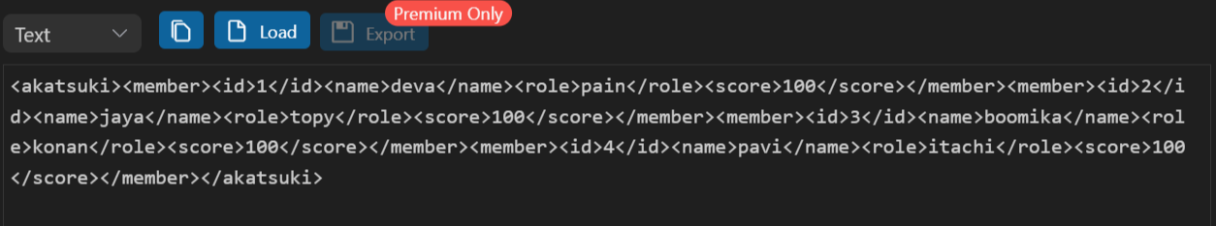
RESULT:
Relational data is successfully converted to a structured XML document.
EX.NO:C
DATE : 17 / 11 /2025
5) EXTRACTING XML DOCUMENTS FROM A RELATIONAL DATABASE
Aim:
To extract stored XML documents from OracleSQL.
Procedure:
- Retrieve the stored XML data using SQL queries.
Create table
-- create xml Table
CREATE TABLE developer_xml (
id NUMBER,
xml_data XMLTYPE
);

SELECT * FROM DEVELOPER_XML;

Output >>>>>>>>>>>>>>>>


Insert XML
INSERT INTO developer_xml (id, xml_data)
VALUES ( 1,
XMLTYPE('
<developers>

<developer>
<id>1</id>
<name>deva</name>
<role>ML Developer</role>
<skills>python</skills>
</developer>

<developer>
<id>2</id>
<name>jaya</name>
<role>Frontend Developer</role>
<skills>React</skills>
</developer>

</developers>
')
);

SELECT * FROM DEVELOPER_XML;

Output >>>>>>>>>>>>>>>>


Extrat XML
SELECT x.id, x.name, x.role, x.skills
FROM developer_xml d,
XMLTable( '/developers/developer'
PASSING d.xml_data COLUMNS
id NUMBER PATH 'id',
name VARCHAR2(50) PATH 'name',
role VARCHAR2(50) PATH 'role',
skills VARCHAR2(200) PATH 'skills'
) x ;

Output >>>>>>>>>>>>>>>>


RESULT:
Stored XML document extracted successfully.
EX.NO:C
DATE : 24 / 11 /2025
6) QUERYING XML DATA
Aim:
To perform XMLTable -based queries on XML data in OracleSQL.
Procedure:
- Use the XMLTable function to query nodes in the XML document.

Create Table
-- create xml Table
CREATE TABLE developer_xml (
id NUMBER,
xml_data XMLTYPE
);

SELECT * FROM DEVELOPER_XML;

Output >>>>>>>>>>>>>>>>


Insert XML
INSERT INTO developer_xml (id, xml_data)
VALUES ( 1,
XMLTYPE('
<developers>

<developer>
<id>1</id>
<name>deva</name>
<role>ML Developer</role>
<skills>python</skills>
</developer>

<developer>
<id>2</id>
<name>jaya</name>
<role>Frontend Developer</role>
<skills>React</skills>
</developer>

</developers>
')
);

SELECT * FROM DEVELOPER_XML;

Output >>>>>>>>>>>>>>>>


View XML Table Format
SELECT x.id, x.name, x.role, x.skills
FROM developer_xml d,
XMLTable( '/developers/developer'
PASSING d.xml_data COLUMNS
id NUMBER PATH 'id',
name VARCHAR2(50) PATH 'name',
role VARCHAR2(50) PATH 'role',
skills VARCHAR2(200) PATH 'skills'
) x ;

Output >>>>>>>>>>>>>>>>


RESULT:
The XML document is successfully queried using XPath.
EX.NO:D
DATE : 01 / 12 /2025
1) CREATING DATABASES USING MONGODB IN PYTHON
Aim:
To perform XMLTable -based queries on XML data in OracleSQL.
Procedure:

Install PIP
pip install pymongo

Connect DataBase
from pymongo import MongoClient

# 1. Connect to MongoDB (local)
client = MongoClient("mongodb://localhost:27017/")

print("Connection created successfully!")

Output >>>>>>>>>>>>>>>>
Connection created successfully!

Create DataBase
# 2. Create / select database
db = client["coe_red"] # database name

print(f"DataBase created successfully!")

Output >>>>>>>>>>>>>>>>
DataBase created successfully!

Create Collection
# 3. Create / select collection
developer = db["developer"] # Collection name

print("Collection created successfully!")

Output >>>>>>>>>>>>>>>>
Collection created successfully!

Insert Many Collection
# insert Collection
developer1 = {
"id": 1,
"name": "Deva",
"role": "ML Developer",
"skills": ["Python", "TensorFlow"]
}

developer2 = {
"id": 2,
"name": "Jaya",
"role": "Frontend Developer",
"skills": ["React", "JavaScript"]
}

developer.insert_many([developer1, developer2])

print("Collection inserted!")

Output >>>>>>>>>>>>>>>>
Collection inserted!

Insert One Collection
# insert Collection

# ONE collection
developer3 = {
"id": 3,
"name": "pavithra",
"role": " java Developer",
"skills": ["java", "Springboot"]
}

developer.insert_one(developer3)

print("Collection inserted!")

Output >>>>>>>>>>>>>>>>
Collection inserted!

Find Collection
# view collwction
result = developer.find()

for data in result:
print(data)

Output >>>>>>>>>>>>>>>>

{'_id': ObjectId('692fef6c9b8d336ea95359f3'), 'id': 1, 'name': 'Deva', 'role': 'ML Developer', 'skills': ['Python', 'TensorFlow']}

{'_id': ObjectId('692fef6c9b8d336ea95359f4'), 'id': 2, 'name': 'Jaya', 'role': 'Frontend Developer', 'skills': ['React', 'JavaScript']}

{'_id': ObjectId('693015329b8d336ea95359f9'), 'id': 3, 'name': 'pavithra', 'role': ' java Developer', 'skills': ['java', 'Springboot']}

# find deva
result = developer.find({"name": 'Deva'})

for data in result:
print(data)

Output >>>>>>>>>>>>>>>>

{'_id': ObjectId('692fef6c9b8d336ea95359f3'), 'id': 1, 'name': 'Deva', 'role': 'ML Developer', 'skills': ['Python', 'TensorFlow']}

# find java

result = developer.find({"skills":'java'})

for data in result:
print(data)
Output >>>>>>>>>>>>>>>>
{'_id': ObjectId('693015329b8d336ea95359f9'), 'id': 3, 'name': 'pavithra', 'role': ' java Developer', 'skills': ['java', 'Springboot']}

Update Collection
# Update one record
developer.update_one(
{"name": "deva"},
{"$set": {"role": "Senior Python Developer"}} # Update new data
)

print('Updata Successfully! ')

Output >>>>>>>>>>>>>>>>
Updata Successfully!

# view collwction
result = developer.find({"name":'Deva'})

for data in result:
print(data)
Output >>>>>>>>>>>>>>>>
{'_id': ObjectId('693014219b8d336ea95359f7'), 'id': 1, 'name': 'Deva', 'role': 'Senior Python Developer', 'skills': ['Python', 'TensorFlow']}
# Update one record
developer.update_one(
{"name": "pavithra"},
{"$pull": {"skills": "java"}} # remove java
)

print("Updated Successfully!")
Output >>>>>>>>>>>>>>>>
Updated Successfully!

# view collwction
result = developer.find({"name":'pavithra'})

for data in result:
print(data)

Output >>>>>>>>>>>>>>>>
{'_id': ObjectId('693015329b8d336ea95359f9'), 'id': 3, 'name': 'pavithra', 'role': ' java Developer', 'skills': ['Springboot']}

# Update one record
developer.update_one(
{"name": "Deva"},
{"$unset": {"skills": ""}} # delete Skills
)

print("Updated Successfully!")

Output >>>>>>>>>>>>>>>>
Updated Successfully!

# view collwction
result = developer.find({"name":'Deva'})

for data in result:
print(data)

Output >>>>>>>>>>>>>>>>
{'_id': ObjectId('693014219b8d336ea95359f7'), 'id': 1, 'name': 'Deva', 'role': 'Senior Python Developer'}

# Update all datas
developer.update_many(
{},
{"$set": {"company": "TCS"}} # update new data
)

print("Update record Successfully!")

Output >>>>>>>>>>>>>>>>
Update record Successfully!

# view collwction
result = developer.find()

for data in result:
print(data)

Output >>>>>>>>>>>>>>>>
{'_id': ObjectId('693014219b8d336ea95359f7'), 'id': 1, 'name': 'Deva', 'role': 'Senior Python Developer', 'company': 'TCS'}

{'_id': ObjectId('693014219b8d336ea95359f8'), 'id': 2, 'name': 'Jaya', 'role': 'Frontend Developer', 'skills': ['React', 'JavaScript'], 'company': 'TCS'}

{'_id': ObjectId('693015329b8d336ea95359f9'), 'id': 3, 'name': 'pavithra', 'role': ' java Developer', 'skills': ['Springboot'], 'company': 'TCS'}

Delete
# one record
developer.delete_one({"name": ‘Jaya’})

print('delete Successfully!')

Output >>>>>>>>>>>>>>>>
delete Successfully!

# view collwction
result = developer.find()

for data in result:
print(data)

Output >>>>>>>>>>>>>>>>
{'_id': ObjectId('693014219b8d336ea95359f7'), 'id': 1, 'name': 'Deva', 'role': 'Senior Python Developer', 'company': 'TCS'}

{'_id': ObjectId('693015329b8d336ea95359f9'), 'id': 3, 'name': 'pavithra', 'role': ' java Developer', 'skills': ['Springboot'], 'company': 'TCS'}

# many record
developer.delete_many({"company": "TCS"})

print('delete succesfully! ')

Output >>>>>>>>>>>>>>>>
delete Successfully!

# Delete Entire collection data
developer.delete_many({})

print('all collections delete successfully! ')

Output >>>>>>>>>>>>>>>>
all collection delete successfully!
Drop
# Drop Collection
developer.drop()

print('delete collection sucessfully!')

Output >>>>>>>>>>>>>>>>
delete collection successfully!

# Drop Collection
client.drop_database("code_red")

print('delete database sucessfully!')

Output >>>>>>>>>>>>>>>>
delete database successfully!

RESULT:
Thus to Create Databases using MongoDB and write simple queries to access databases using Python has been completed successfully.

EX.NO:E
DATE : 08 / 12 /2025
IMPLEMENTING ACCESS CONTROL IN RELATIONAL DATABASE
Aim:
To Implement access control in relational databases is crucial for ensuring the security and integrity of data.
Procedure:
- Download the latest Oracle SQL Server version from the official Microsoft website.
- Create Roles: Define a roles for storing customer data.
- Create Users: Define users with login credentials.
- Grant Permissions: Assign access permissions to the users for the table.
- Policy Enforcement: The filter ensures that each user can only see or modify their own data based on their name.

Create Table
-- Create Table

CREATE Table bank(
id NUMBER PRIMARY KEY,
name VARCHAR2(20),
role VARCHAR2(20)

);

Creating Roles
-- ---------Create Admin Role----------------------------------------------------

CREATE ROLE Admin_Role; -- Overall Acess

Output >>>>>>>>>>>>>>>>
2025-12-03 18:28:52 [ INFO] Executing: CREATE ROLE Admin_Role
2025-12-03 18:28:52 [ INFO] Result: 0 rows affected in 13ms

-- assign privileges to role
GRANT CREATE TABLE, ALTER ANY TABLE TO Admin_Role;

Output >>>>>>>>>>>>>>>>
2025-12-03 18:29:01 [ INFO] Executing: GRANT CREATE TABLE, ALTER ANY TABLE TO Admin_Role
2025-12-03 18:29:01 [ INFO] Result: 0 rows affected in 16ms

-- Create User
CREATE USER luffy IDENTIFIED BY luffy123;

Output >>>>>>>>>>>>>>>>
2025-12-03 18:29:41 [ INFO] Executing: CREATE USER luffy IDENTIFIED BY luffy123
2025-12-03 18:29:42 [ INFO] Result: 0 rows affected in 624ms

-- Assign role to user
GRANT Admin_Role TO luffy;

Output >>>>>>>>>>>>>>>>
2025-12-03 18:30:18 [ INFO] Executing: GRANT Admin_Role TO luffy
2025-12-03 18:30:18 [ INFO] Result: 0 rows affected in 23ms

-- ---------- Create Manager Role------------------------------------------------

CREATE ROLE Manager_Role; -- Write & Read Access

Output >>>>>>>>>>>>>>>>
2025-12-03 18:31:53 [ INFO] Executing: CREATE ROLE Manager_Role
2025-12-03 18:31:53 [ INFO] Result: 0 rows affected in 13ms

-- assign privileges to role
GRANT SELECT, INSERT, UPDATE ON deva.bank TO Manager_Role;

Output >>>>>>>>>>>>>>>>
2025-12-03 18:42:31 [ INFO] Executing: GRANT SELECT, INSERT, UPDATE ON deva.bank TO Manager_Role
2025-12-03 18:42:31 [ INFO] Result: 0 rows affected in 35ms

-- Create User
CREATE USER jaya IDENTIFIED BY jaya123;

Output >>>>>>>>>>>>>>>>
2025-12-03 18:42:47 [ INFO] Executing: CREATE USER jaya IDENTIFIED BY jaya123
2025-12-03 18:42:47 [ INFO] Result: 0 rows affected in 28ms

-- Assign role to user
GRANT Manager_Role TO jaya;

Output >>>>>>>>>>>>>>>>
2025-12-03 18:42:50 [ INFO] Executing: GRANT Manager_Role TO jaya
2025-12-03 18:42:50 [ INFO] Result: 0 rows affected in 16ms

-- -------- Create Staff Role----------------------------------------------------

CREATE Role Staff_Role; -- Read Access

Output >>>>>>>>>>>>>>>>
2025-12-03 18:42:56 [ INFO] Executing: CREATE Role Staff_Role
2025-12-03 18:42:50 [ INFO] Result: 0 rows affected in 16ms

-- assign privileges to role
GRANT SELECT ON deva.bank TO Staff_Role;

Output >>>>>>>>>>>>>>>>
2025-12-03 18:43:11 [ INFO] Executing: GRANT SELECT ON deva.bank TO Staff_Role
2025-12-03 18:43:11 [ INFO] Result: 0 rows affected in 15ms

-- Create User
CREATE USER boomika IDENTIFIED BY boomika123;

Output >>>>>>>>>>>>>>>>
2025-12-03 18:43:14 [ INFO] Executing: CREATE USER boomika IDENTIFIED BY boomika123
2025-12-03 18:43:15 [ INFO] Result: 0 rows affected in 59ms

-- Assign role to user
GRANT Staff_Role TO boomika;

Output >>>>>>>>>>>>>>>>
2025-12-03 18:43:16 [ INFO] Executing: GRANT Staff_Role TO boomika
2025-12-03 18:43:16 [ INFO] Result: 0 rows affected in 12ms

Admin Login
-- Switch User

GRANT DBA TO luff;

-- inset row
INSERT INTO BANK(id , name , role) VALUES(1 , 'deva' , 'manager');

SELECT * FROM BANK;

Output >>>>>>>>>>>>>>>>
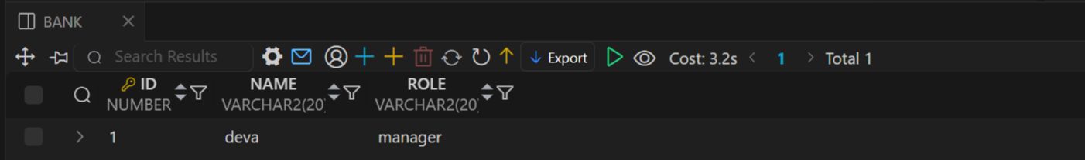

-- alter table add col

ALTER Table BANK add salary NUMBER DEFAULT '1000';

SELECT * FROM BANK;

Output >>>>>>>>>>>>>>>>
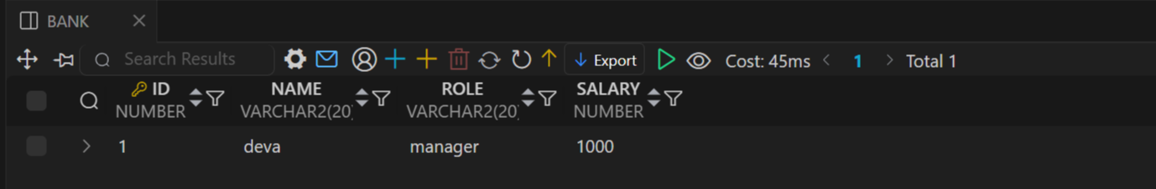

-- alter table del co;
ALTER Table BANK DROP COLUMN salary;

SELECT * FROM BANK;

Output >>>>>>>>>>>>>>>>
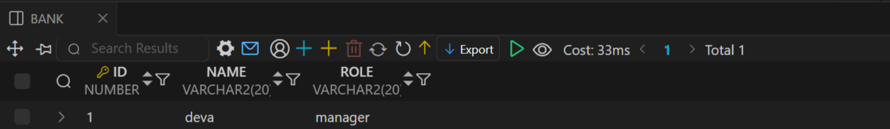

Manager Login
-- Switch user
GRANT DBA TO JAYA;

-- Insert row

INSERT INTO bank (id , name , role) VALUES(2 , 'pavi' , 'staff');

SELECT * FROM bank;

Output >>>>>>>>>>>>>>>>
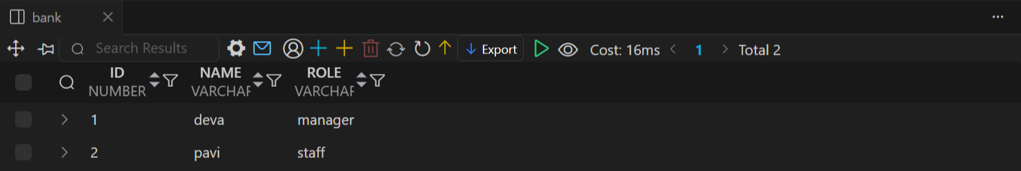

-- Delete row
DELETE from bank WHERE name='pavi';

SELECT * FROM bank;

Output >>>>>>>>>>>>>>>>
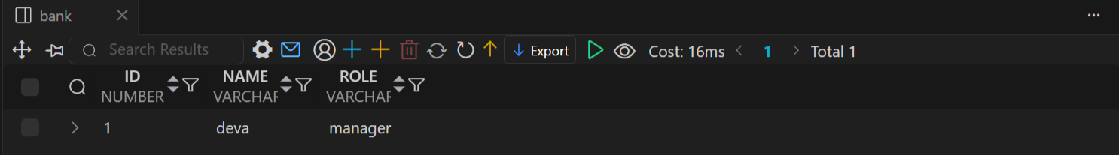

-- alter table del co;
ALTER Table BANK DROP COLUMN salary;

Output >>>>>>>>>>>>>>>>

2025-12-03 19:35:44 [ERROR] ORA-00904: "SALARY": invalid identifier

Delete
-- Drop Privileges

REVOKE PRIVILEGES FROM LUFFY;

-- drop Role

DROP Role Admin_role;

RESULT:
Thus to Create Databases using DCLand write simple queries to access completed successfully.

