Capstone Project

Machine Learning Engineering Nanodegree

Name: **Fernando Damasio** E-mail: **fernando@cashflix.com.br**  Institution: **Udacity**

Contents

1. Definition 2

1.1. Project Overview 2

1.2. Problem Statement 3

1.3. Metrics 4

2. Analysis 4

2.1. Data Exploration 4

2.1.1. Load CSV 4

2.1.2. Print Columns 5

2.1.3. Define Variables 5

2.1.4. Describe Data 6

2.1.5. Print Skew 7

2.2. Exploratory Visualization 7

2.2.1. Numerical Features 7

2.2.2. Categorical Features 10

2.2.3. Loss Target Variable 20

2.2.4. Conclusions 20

2.3. Algorithms and Techniques 21

2.4. Benchmark 21

3. Methodology 21

3.1. Data Preprocessing 21

3.1.1. Transform Data 21

3.1.2. Standardize Data 22

3.2. Implementation 23

3.2.1. Define Grid Search Function 23

3.2.2. Fit Bayesian Ridge 24

3.2.3. Fit Gradient Boosting Regressor 24

3.3. Refinement 25

4. Results 26

4.1. Model Evaluation and Validation 26

4.1.1. Predict Values 26

4.1.2. Save Predicted Data 27

4.2. Justification 27

5. Conclusion 27

5.1. Free-form Visualization 27

5.2. Reflection 29

5.3. Improvement 29

# 1. Definition

## 1.1. Project Overview

The problem and the data sets was taken from [Kaggle](https://www.kaggle.com/)[1], a website that runs programming contests to crowdsource machine learning solutions. The competition chosen was the [Allstate Claims Severity](https://www.kaggle.com/c/allstate-claims-severity)[2].

[Allstate](https://www.allstate.com/)[3] is the largest publicly held personal lines property and casualty insurer in America, serving more than 16 million households nationwide.

When you’ve been devastated by a serious car accident, your focus is on the things that matter the most: family, friends, and other loved ones. Pushing paper with your insurance agent is the last place you want your time or mental energy spent. This is why Allstate, a personal insurer in the United States, is continually seeking fresh ideas to improve their claims service for the over 16 million households they protect.

Allstate is currently developing automated methods of predicting the cost, and hence severity, of claims. In this recruitment challenge, Kagglers are invited to show off their creativity and flex their technical chops by creating an algorithm which accurately predicts claims severity. Aspiring competitors will demonstrate insight into better ways to predict claims severity for the chance to be part of Allstate’s efforts to ensure a worry-free customer experience.

Next, information about the contest:

* *Started:* 6:02 pm, Monday 10 October 2016 UTC
* *Ends:* 11:59 pm, Monday 12 December 2016 UTC (63 total days)

The given data sets have 3 files:

1. *train.csv:* The training set.
2. *test.csv:* The test set.
3. *sample_submission.csv:* A sample submission file in the correct format.

For this project, the following [AWS instance](https://aws.amazon.com/)[4] will be used to train the model.

**Infrastructure**

* VSH: Amazon EC2
* Availability zone: us-east-1d
* Instance type: C3
* Application: Compute Optimized
* Model: c3.2xlarge
* vCPU: 8
* Mem (GiB): 15
* SSD Storage (GB): 2x80
* Operational system: Windows Server 2012 R2
* Platform: Anaconda2 64 bits
* Environment: Jupyter Notebook

**Features:**

* High Frequency Intel Xeon E5-2680 v2 (Ivy Bridge) Processors
* Support for Enhanced Networking
* Support for clustering
* SSD-backed instance storage

## 1.2. Problem Statement

Each row in this dataset represents an insurance claim. Variables prefaced with ‘cat’ are categorical, while those prefaced with ‘cont’ are continuous. The ‘loss’ value must the predicted for each id in the test set. It’s a Supervised Learning type of problem.

The tasks involved are the following:

1. Download the data set.
2. Define the computation infrastructure necessary to process the data.
3. Visualize the train and test data sets.
4. Preprocess continuous features.
5. Preprocess categorical features.
6. Preprocess the target column.
7. Split the train and test data sets (as the test set of the contest is only for submitting purpose).
8. Define the best model for the problem.
9. Tune the best model.
10. Predict ‘loss’ column for the test set.
11. Postprocess the ‘loss’ column predicted.
12. Present the data as the sample_submission.csv file.

The final model is expected to predict with accuracy the loss for any new insurance claim with the same features as input.

## 1.3. Metrics

The metric used is the Mean Absolute Error as it is the score defined for the [leaderboard table](https://www.kaggle.com/c/allstate-claims-severity/leaderboard)[5] for the Kaggle contest.

In statistics, the mean absolute error (MAE) is a quantity used to measure how close forecasts or predictions are to the eventual outcomes. The mean absolute error is given by:

$$MAE= \frac{1}{n}\sum_{t=1}^{n}{\left|x_{t}-{x'}_{t}\right|}$$

Where $n$ is the number of predictions, $x_{t}$ is the t*th* true value and ${x'}_{t}$ is the t*th* predicted value.

# 2. Analysis

## 2.1. Data Exploration

After printing the data shape, we discover that the train data set has 188,318 rows and 131 columns and the test data set has 125.546 rows and 130 columns.

Both data sets have 116 categorical features and 16 numerical features. The ‘loss’ column is only presented in the train data set as it is the target variable to learn the model.

We have to join both datasets (excluding the ‘loss’ column) in order to visualize, transform and scale all data, because the parameters used for the transformations must be equal to both datasets and must be calculated with all data.

We find that both has the same columns but the categorical features can assume different values. Some categorical values in the train set are not presented in the test set, and some presented in the test set are not presented in the train set.

We will not work with dummy variables in this case, but if we would, it would be wise to exclude the columns (after the dummy transformation) only presented in the test set, because those wouldn’t carry any information about the prediction.

To better understand the numerical features, the following parameters are calculated: count, mean, std, min, 25%, 50%, 75%, max.

All the numerical features values are between 0 and 1. We can presume that the values were already scaled and transformed to be presented to the competitors of the contest. The target variable ‘loss’ values are between 0.67 and 121,012.25.

Another parameter to better understand the numerical data is the Skew. All columns, including ‘loss’ target variable area skewed, except cont 3. This is a particularly important analysis for preprocessing the data for linear models.

## 2.2. Exploratory Visualization

A different kind of plot is better to visualize each type of data. For the numerical values, the Violin Plot will be used in order to see the distribution. For the categorical values, the count plot will be used.

*Numerical Features:*

* cont1 has many values close to 0.5
* cont2 has a pattern where there are several spikes at specific points

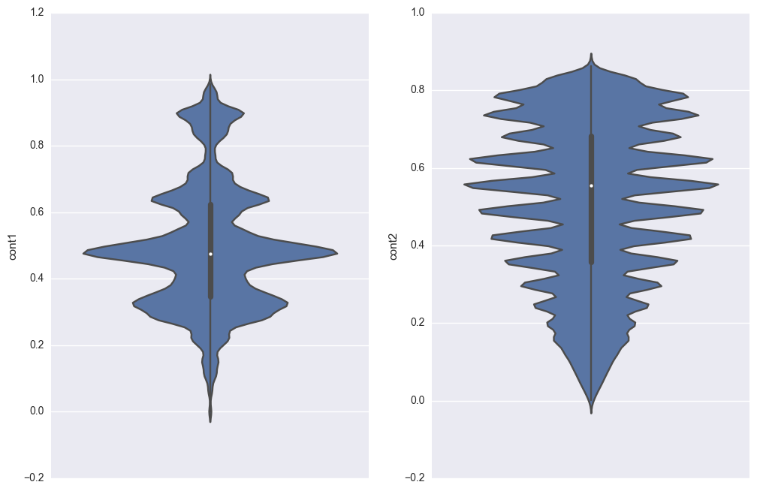

* cont5 has many values near 0.3

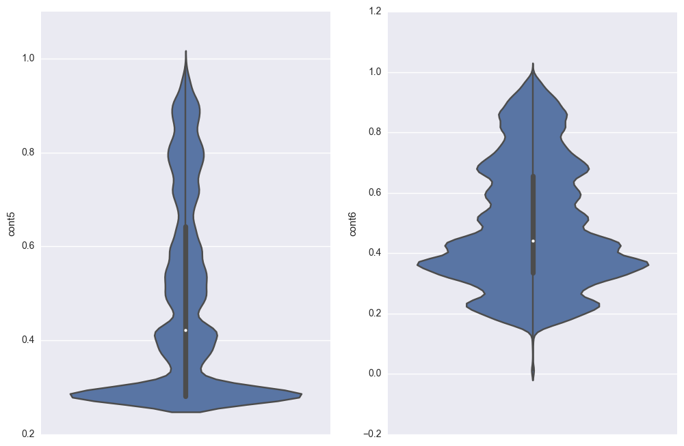

* cont14 has a distinct pattern. 0.22 and 0.82 have a lot of concentration

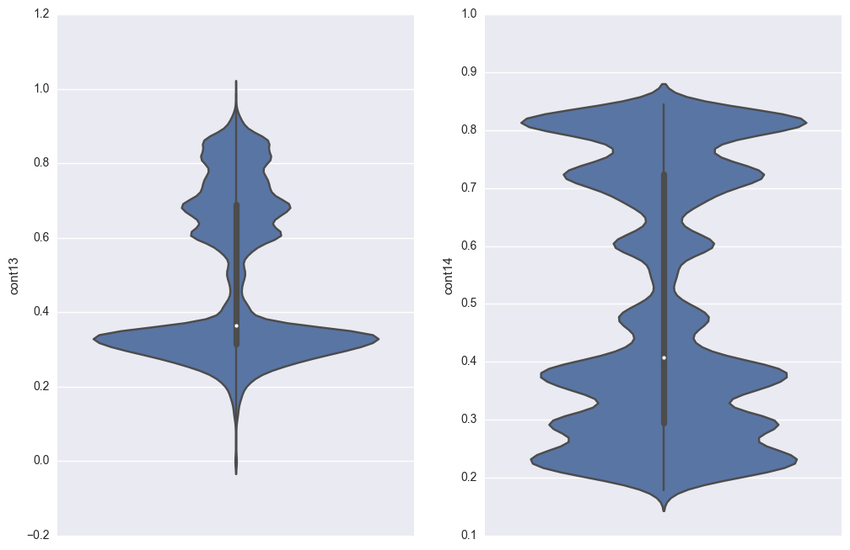

*Categorical Features:*

* cat1 to cat72 have only two labels A and B. In most of the cases, B has very few entries

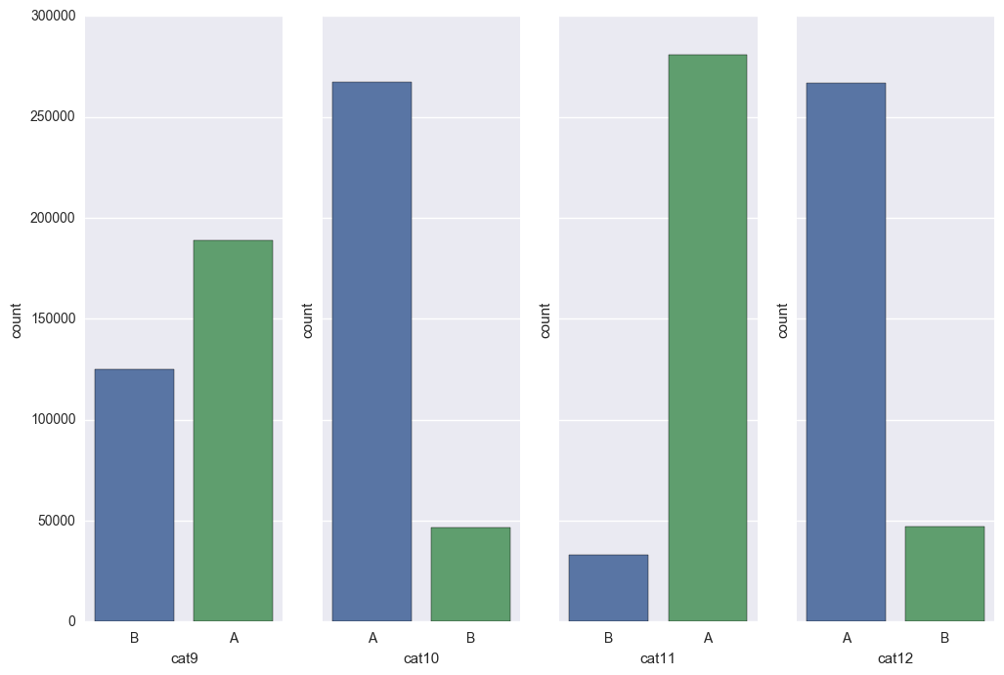

* cat73 to cat 108 have more than two labels

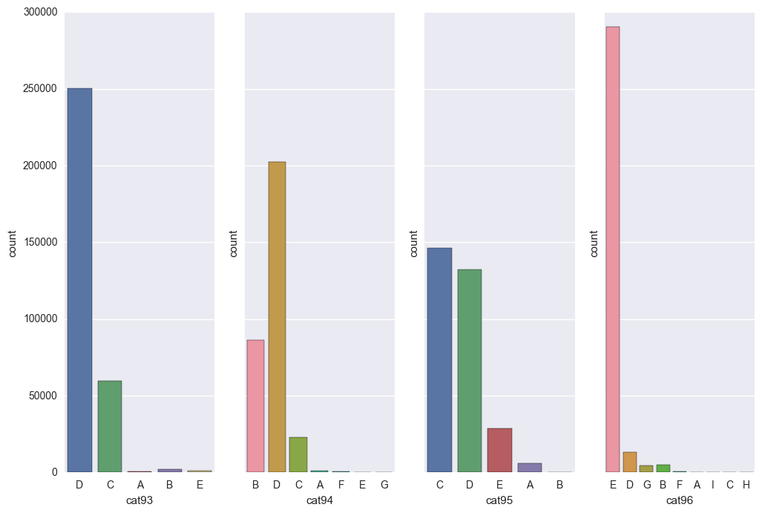

* cat109 to cat116 have many labels

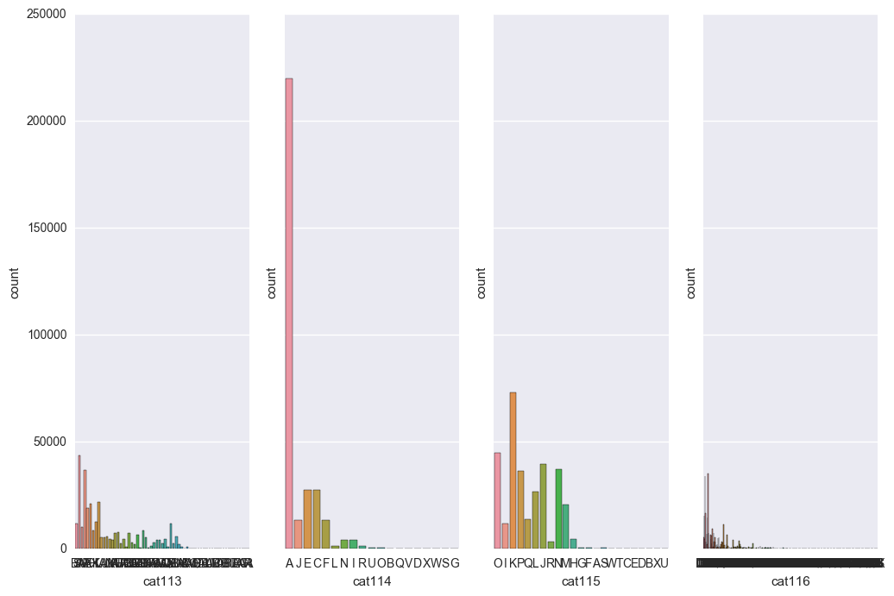

*Loss Target Variable:*

* loss distribution must be preprocessed in order to normalize the data to use with linear models.

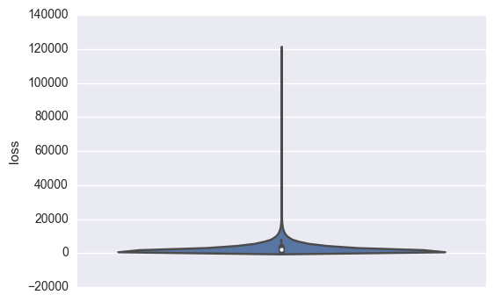

## 2.3. Algorithms and Techniques

As the numerical features are skewed, we will apply a boxcox transformation to reduce the skewness. It’s necessary to transform the categorical features in numbers to be able to use it in the learning models. We will standardize the data as well, including the target variable.

For academic purpose, two different regression models will be tested and one will be chosen to be tuned. First, we will apply the data to a generalized linear model called Bayesian Ridge Regression and then use an ensemble method called Gradient Tree Boosting.

## 2.4. Benchmark

The Kaggle competitions presents some results as benchmarks and we will use it as well. Those values are measured as Mean Absolute Square:

* All Zeros Benchmark: 3,019.71
* Random Forest Benchmark: 1,217.52

After predicting the values of the target variable ‘loss’ with the test data set, we must send to Kaggle the results and receive the score, as we don’t have access to the true values.

# 3. Methodology

## 3.1. Data Preprocessing

### 3.1.1. Transform Data

*Numerical Features*

As we can see in section 3.1.5, all columns, including ‘loss’ target variable area skewed, except cont 3. This is a particularly important analysis for preprocessing the data for linear models. To correct the skewness, the boxcox transformation will be applied.

*Categorical Features*

The categorical features values are characters. To better apply this features to the model, we will factorize this values to numbers.

*Loss Target Variable*

As it is skewed, we will apply the boxcox transformation, as we did with numerical features.

### 3.1.2. Standardize Data

After applying transformation, we need to standardize features by removing the mean and scaling to unit variance

Centering and scaling happen independently on each feature by computing the relevant statistics on the samples in the training set. Mean and standard deviation are then stored to be used on later data using the transform method.

Standardization of a dataset is a common requirement for many machine learning estimators: they might behave badly if the individual feature do not more or less look like standard normally distributed data (e.g. Gaussian with 0 mean and unit variance).

For instance, many elements used in the objective function of a learning algorithm (such as the RBF kernel of Support Vector Machines or the L1 and L2 regularizers of linear models) assume that all features are centered around 0 and have variance in the same order. If a feature has a variance that is orders of magnitude larger than others, it might dominate the objective function and make the estimator unable to learn from other features correctly as expected.

## 3.2. Implementation

As the data was transformed and scaled, we will use R2 Scorer to evaluate and tune the model. Then, we will predict the values of the test data set and submit to the Kaggle competition that will inform us the error measured in Mean Absolute Error.

First, we will define a function that will be used for both models and then will be used to tune the best parameters for the chosen model.

This function defines a scorer, split the data into 80% train and 20% test sets, apply a grid search with the parameters informed for the specific model and then return the best estimator. We will use 6 processors at the same time (n_jobs=6).

### 3.2.1. Define Grid Search Function

First, we will fit the Bayesian Ridge regressor limiting the maximum number of interactions in 2, 4 and 8.

### 3.2.2. Fit Bayesian Ridge

In almost 1 minute, the algorithm returned that the best number of interactions is 2.

Now, we will fit the Gradient Boosting Regressor with the parameters:

* Number of estimators: 25
* Maximum depth: 8

We will not use multiple parameters for the grid search as this algorithm takes a very long time to run.

### 3.2.3. Fit Gradient Boosting Regressor

After 1 hour, we have a 0.5078 score. As it’s bigger than Bayesian Ridge score, we will use this algorithm to tune our model.

## 3.3. Refinement

To tune the model, we will use different values for the maximum depth parameter: 6, 8 and 10.

With a maximum depth of 10, the result was very good and the score improved from 0.5078 0.5188, more than 0.01.

Now we will try a different set of parameters for maximum depth and number of estimators:

* N_estimators: 50
* Max_depth: 9, 10 and 12.

Again, our score improved to 0.5424 and the best value for max-depth is 10.

Now we will increase the number of estimators to 200, as we know that in ensemble methods, more is better.

The final score is 0.5457.

# 4. Results

## 4.1. Model Evaluation and Validation

After training the model and defining the best parameters, we use the estimator that was trained to predict the ‘loss’ values for each row in the test set. The values predicted will be transformed and scaled, so we have to undo all the transformations, as next:

### 4.1.1. Predict Values

To send the data predicted to the Kaggle contest, we have to save the predicted data in a CSV with a specific format.

### 4.1.2. Save Predicted Data

## 4.2. Justification

After submitting the predicted result to Kaggle, we have a score of 1,146.35.

As we have no domain knowledge at all of the problem, we can’t say for sure if the solution is significant enough to have adequately solved the problem. But we have some clues:

* Our score is better than the lowest Kaggle Benchmark score (1,217.52). So it’s a good indicator that our model works well.
* But, considering that our Mean Absolute Error (1,146.35) is almost 38% of the mean value of the target variable ‘loss’ (3,037.34), we cannot say for sure it’s a good solution for the problem.

# 5. Conclusion

## 5.1. Free-form Visualization

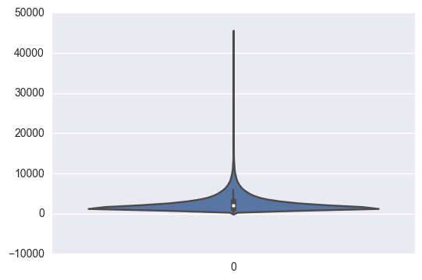

As we can compare with the loss plot, the form of the y predicted is the same as the ‘loss’ target variable, as expected.

|  |  |  |
| --- | --- | --- |
| **Y** | **‘loss’** | **predicted** |
| *Mean* | 3037.337686 | 2646.944917 |
| *std* | 2904.086186 | 2019.722474 |
| *Min* | 0.670000 | 248.732359 |
| *25%* | 1204.460000 | 1368.071047 |
| *50%* | 2115.570000 | 1994.295228 |
| *75%* | 3864.045000 | 3188.932779 |
| *max* | 121012.250000 | 45219.140168 |

The parameters above are different from the ‘loss’ target variable:

* Mean: Lower
* Std: Lower
* Min: Higher
* 25%: Higher
* 50%: Lower
* 75%: Lower
* Max: Lower

We can infer from the table that this change is a reflection of the limited maximum depth of the Gradient Boosting Regressor to avoid overfitting.

## 5.2. Reflection

After analyzing the features and the data set, we found necessary to preprocess the numerical features because of its skewness and to preprocess the categorical features as well because it wasn’t in a number format.

We have to preprocess the data all together (the train and data sets) so that we already prepare the test data for the prediction and then we just have to post process the predictions values (as we have had preprocess the target variable as well).

The target variable ‘loss’ is very concentrated in the first quartil of the data, but the numerical features are not. It may be because the features were given already preprocessed in a way that we don’t know and/or because the categorical features have more influence in the ‘loss’ value than the numerical features.

The statistical linear model runs very fast, but the ensemble tree method doesn’t.

## 5.3. Improvement

Because of the long time to fit the models to the data, it’s very difficult for academic purpose to rewrite some of the code in time to get a better result. But next we can list some improvements:

* Outliers removal: We can remove the outliers and measure the improvement of the result.
* Dummy variables: We can transform the categorical features into dummy variables and delete from the train_test data the columns that only exists in the test data set. As it will not exist in the train data set, the model will have no information about it at all.
* Features reduction: We can apply a feature reduction algorithm as a PCA to avoid overfitting, but we can avoid it by tuning the model and limiting its parameters.

# Code

## Load CSV

import pandas as pd

import numpy as np

from time import time

start = time()

train = pd.read_csv('Z:/data/allstate/train.csv', index_col='id')

test = pd.read_csv('Z:/data/allstate/test.csv', index_col='id')

end = time()

print "Load CSVs in {:.1f} seconds.\n".format(end - start)

Load CSVs in 4.4 seconds.

print train.shape

print test.shape

(188318, 131)

(125546, 130)

## Print Columns

print list(train.columns)

print ""

print list(test.columns)

['cat1', 'cat2', 'cat3', 'cat4', 'cat5', 'cat6', 'cat7', 'cat8', 'cat9', 'cat10', 'cat11', 'cat12', 'cat13', 'cat14', 'cat15', 'cat16', 'cat17', 'cat18', 'cat19', 'cat20', 'cat21', 'cat22', 'cat23', 'cat24', 'cat25', 'cat26', 'cat27', 'cat28', 'cat29', 'cat30', 'cat31', 'cat32', 'cat33', 'cat34', 'cat35', 'cat36', 'cat37', 'cat38', 'cat39', 'cat40', 'cat41', 'cat42', 'cat43', 'cat44', 'cat45', 'cat46', 'cat47', 'cat48', 'cat49', 'cat50', 'cat51', 'cat52', 'cat53', 'cat54', 'cat55', 'cat56', 'cat57', 'cat58', 'cat59', 'cat60', 'cat61', 'cat62', 'cat63', 'cat64', 'cat65', 'cat66', 'cat67', 'cat68', 'cat69', 'cat70', 'cat71', 'cat72', 'cat73', 'cat74', 'cat75', 'cat76', 'cat77', 'cat78', 'cat79', 'cat80', 'cat81', 'cat82', 'cat83', 'cat84', 'cat85', 'cat86', 'cat87', 'cat88', 'cat89', 'cat90', 'cat91', 'cat92', 'cat93', 'cat94', 'cat95', 'cat96', 'cat97', 'cat98', 'cat99', 'cat100', 'cat101', 'cat102', 'cat103', 'cat104', 'cat105', 'cat106', 'cat107', 'cat108', 'cat109', 'cat110', 'cat111', 'cat112', 'cat113', 'cat114', 'cat115', 'cat116', 'cont1', 'cont2', 'cont3', 'cont4', 'cont5', 'cont6', 'cont7', 'cont8', 'cont9', 'cont10', 'cont11', 'cont12', 'cont13', 'cont14', 'loss']

['cat1', 'cat2', 'cat3', 'cat4', 'cat5', 'cat6', 'cat7', 'cat8', 'cat9', 'cat10', 'cat11', 'cat12', 'cat13', 'cat14', 'cat15', 'cat16', 'cat17', 'cat18', 'cat19', 'cat20', 'cat21', 'cat22', 'cat23', 'cat24', 'cat25', 'cat26', 'cat27', 'cat28', 'cat29', 'cat30', 'cat31', 'cat32', 'cat33', 'cat34', 'cat35', 'cat36', 'cat37', 'cat38', 'cat39', 'cat40', 'cat41', 'cat42', 'cat43', 'cat44', 'cat45', 'cat46', 'cat47', 'cat48', 'cat49', 'cat50', 'cat51', 'cat52', 'cat53', 'cat54', 'cat55', 'cat56', 'cat57', 'cat58', 'cat59', 'cat60', 'cat61', 'cat62', 'cat63', 'cat64', 'cat65', 'cat66', 'cat67', 'cat68', 'cat69', 'cat70', 'cat71', 'cat72', 'cat73', 'cat74', 'cat75', 'cat76', 'cat77', 'cat78', 'cat79', 'cat80', 'cat81', 'cat82', 'cat83', 'cat84', 'cat85', 'cat86', 'cat87', 'cat88', 'cat89', 'cat90', 'cat91', 'cat92', 'cat93', 'cat94', 'cat95', 'cat96', 'cat97', 'cat98', 'cat99', 'cat100', 'cat101', 'cat102', 'cat103', 'cat104', 'cat105', 'cat106', 'cat107', 'cat108', 'cat109', 'cat110', 'cat111', 'cat112', 'cat113', 'cat114', 'cat115', 'cat116', 'cont1', 'cont2', 'cont3', 'cont4', 'cont5', 'cont6', 'cont7', 'cont8', 'cont9', 'cont10', 'cont11', 'cont12', 'cont13', 'cont14']

## Define Variables

loss = train['loss']

features = train.drop('loss', 1)

train_test = pd.concat((features, test))

numeric_features = list(train_test.dtypes[train_test.dtypes != "object"].index)

categorical_features = list(features.drop(numeric_features, 1))

## Describe Data

print "Train_Test Data Set Describe"

print train_test.describe()

print "\nLoss Describe"

print loss.describe()

Train_Test Data Set Describe

cont1 cont2 cont3 cont4 \

count 313864.000000 313864.000000 313864.000000 313864.000000

mean 0.494096 0.507089 0.498653 0.492021

std 0.187768 0.207056 0.201961 0.211101

min 0.000016 0.001149 0.002634 0.176921

25% 0.347403 0.358319 0.336963 0.327354

50% 0.475784 0.555782 0.527991 0.452887

75% 0.625272 0.681761 0.634224 0.652072

max 0.984975 0.862654 0.944251 0.956046

cont5 cont6 cont7 cont8 \

count 313864.000000 313864.000000 313864.000000 313864.000000

mean 0.487513 0.491442 0.485360 0.486823

std 0.209063 0.205394 0.178531 0.199442

min 0.281143 0.012683 0.069503 0.236880

25% 0.281143 0.336105 0.351299 0.317960

50% 0.422268 0.440945 0.438650 0.441060

75% 0.643315 0.655818 0.591165 0.623580

max 0.983674 0.997162 1.000000 0.982800

cont9 cont10 cont11 cont12 \

count 313864.00000 313864.000000 313864.000000 313864.000000

mean 0.48571 0.498403 0.493850 0.493503

std 0.18185 0.185906 0.210002 0.209716

min 0.00008 0.000000 0.035321 0.036232

25% 0.35897 0.364580 0.310961 0.314945

50% 0.44145 0.461190 0.457203 0.462286

75% 0.56889 0.619840 0.678924 0.679096

max 0.99540 0.994980 0.998742 0.998484

cont13 cont14

count 313864.000000 313864.000000

mean 0.493917 0.495665

std 0.212911 0.222537

min 0.000228 0.178568

25% 0.315758 0.294657

50% 0.363547 0.407020

75% 0.689974 0.724707

max 0.988494 0.844848

Loss Describe

count 188318.000000

mean 3037.337686

std 2904.086186

min 0.670000

25% 1204.460000

50% 2115.570000

75% 3864.045000

max 121012.250000

Name: loss, dtype: float64

## Print Skew

from scipy.stats import skew

print "Train_Test Data Set Skew"

print train_test.skew()

print "\nLoss Skew"

print loss.skew()

Train_Test Data Set Skew

cont1 0.513207

cont2 -0.311147

cont3 -0.007023

cont4 0.417561

cont5 0.679614

cont6 0.458415

cont7 0.825893

cont8 0.673240

cont9 1.067252

cont10 0.352118

cont11 0.281141

cont12 0.291998

cont13 0.376140

cont14 0.250674

dtype: float64

Loss Skew

3.79495837754

## Numerical Features

# Import plotting libraries

import seaborn as sns

import matplotlib.pyplot as plt

%matplotlib inline

# Create a dataframe with only numerical features

data = train_test[numeric_features]

# Get the names of the columns

cols=data.columns

# Plot violin for all attributes in a 7x2 grid

n_cols = 2

n_rows = 7

for i in range(n_rows):

fg,ax = plt.subplots(nrows=1,ncols=n_cols,figsize=(12, 8))

for j in range(n_cols):

sns.violinplot(y=cols[i*n_cols+j], data=data, ax=ax[j])





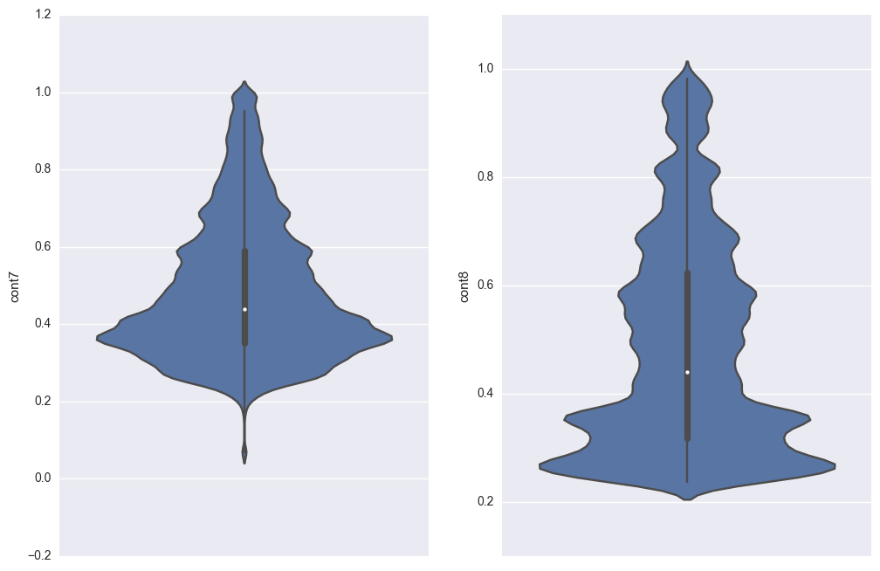

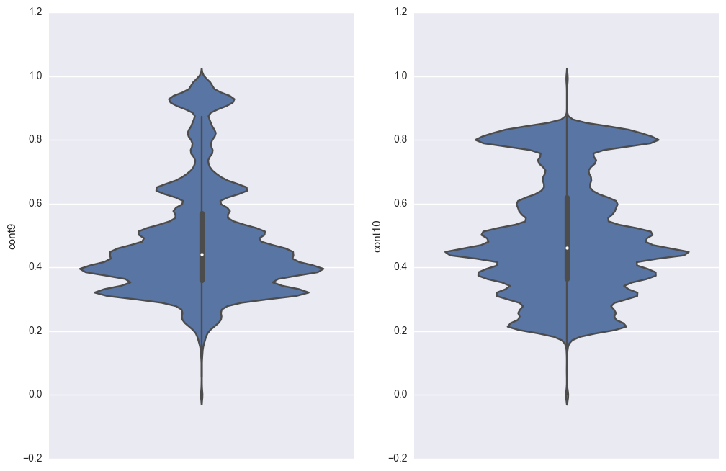

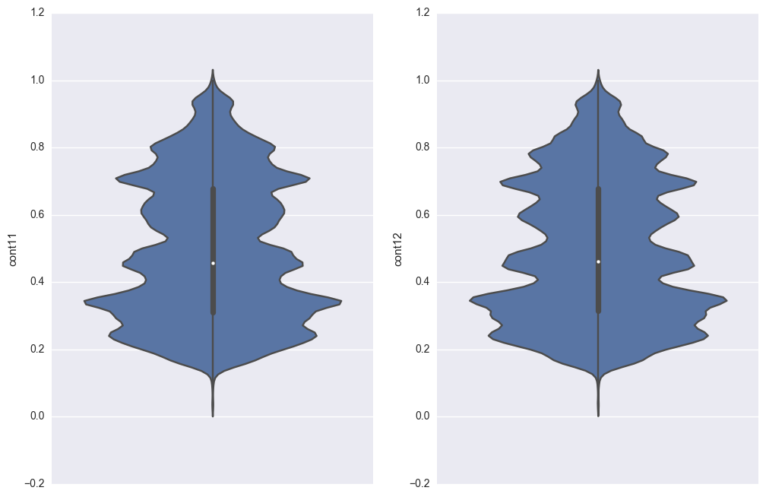



## Categorical Features

data = train_test[categorical_features]

cols = data.columns

# Count plot for all categorical features in a 29x4 grid

n_cols = 4

n_rows = 29

for i in range(n_rows):

fg,ax = plt.subplots(nrows=1,ncols=n_cols,sharey=True,figsize=(12, 8))

for j in range(n_cols):

sns.countplot(x=cols[i*n_cols+j], data=data, ax=ax[j])

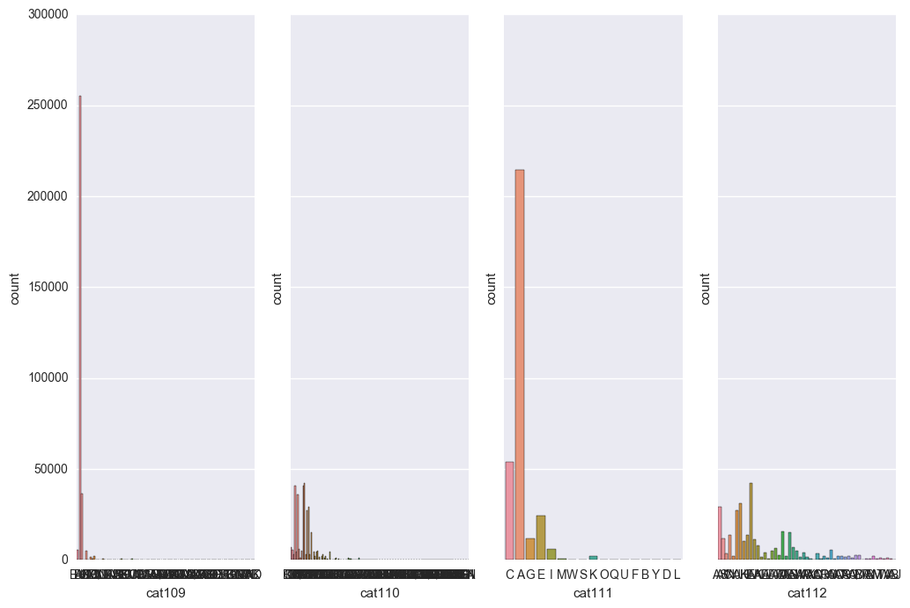

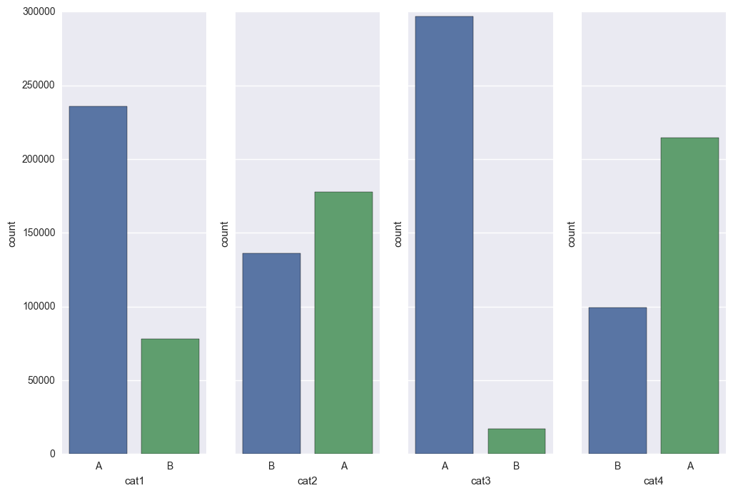

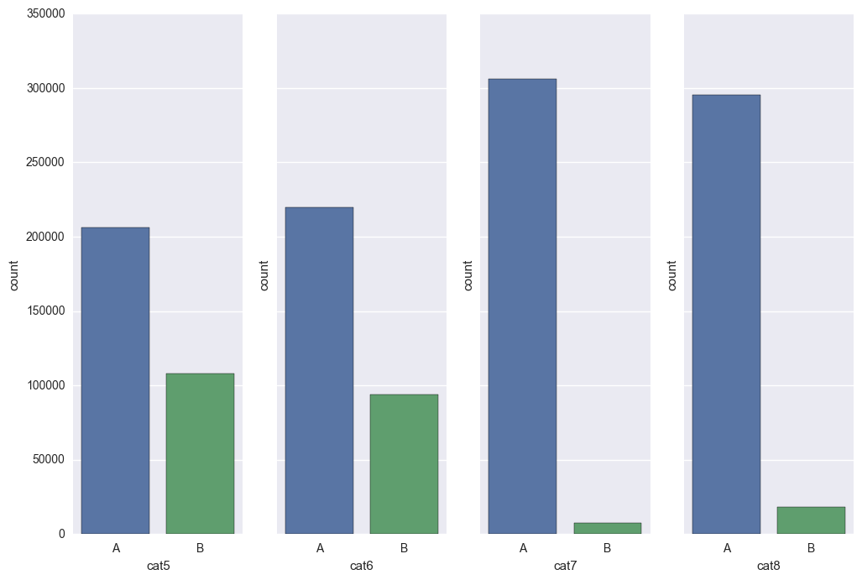



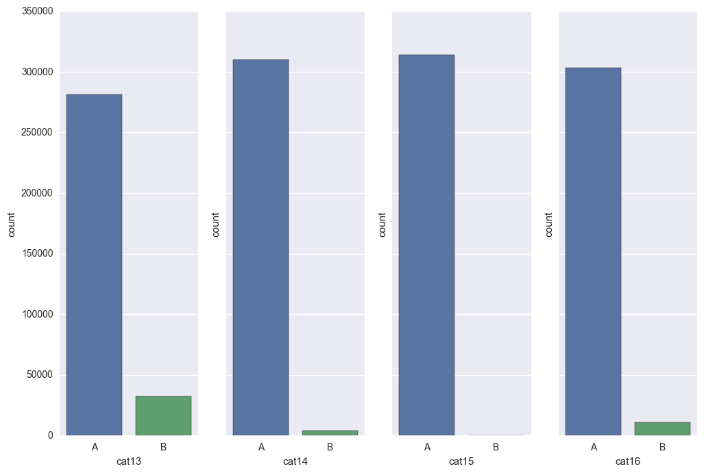

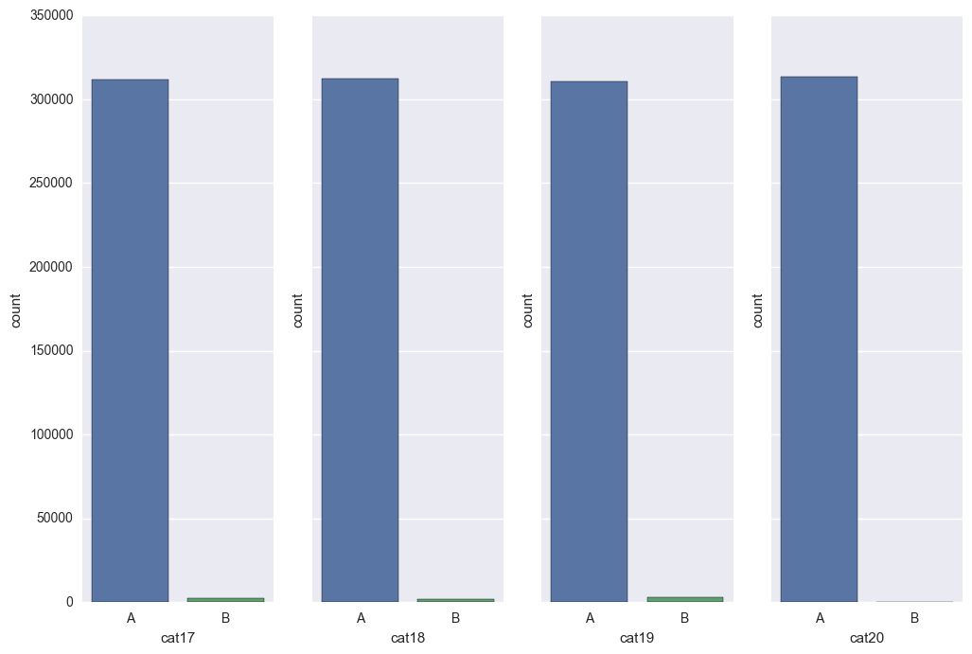

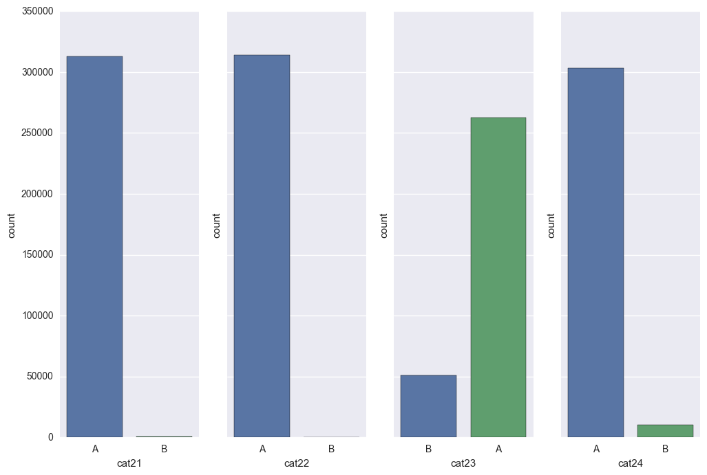

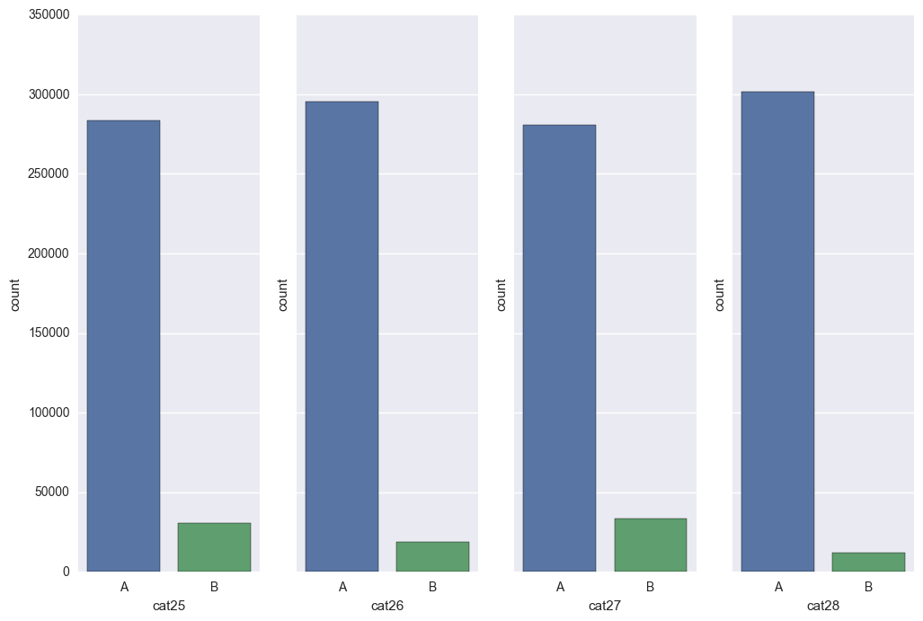

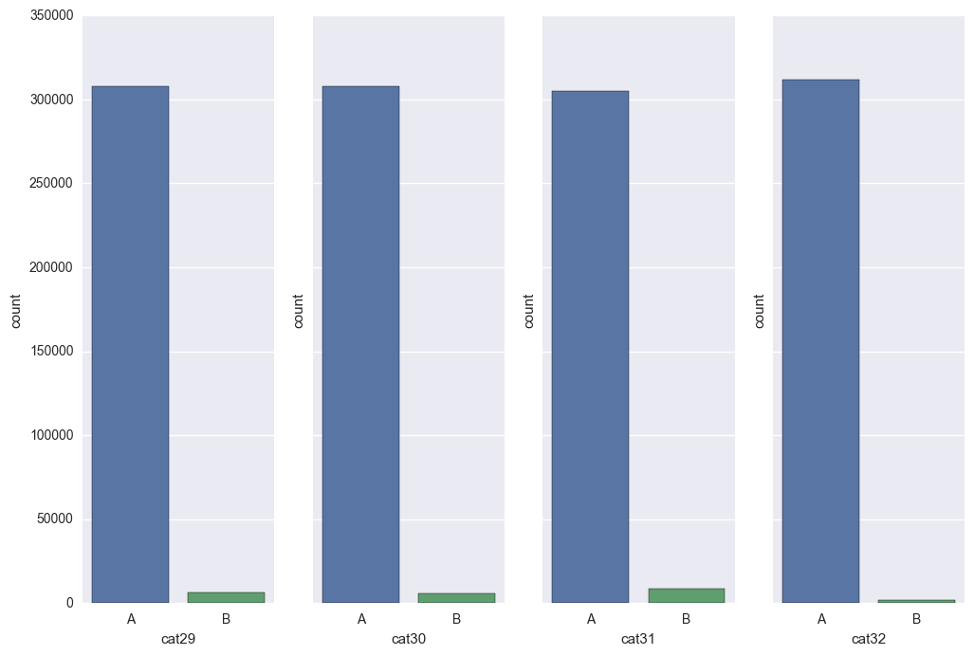

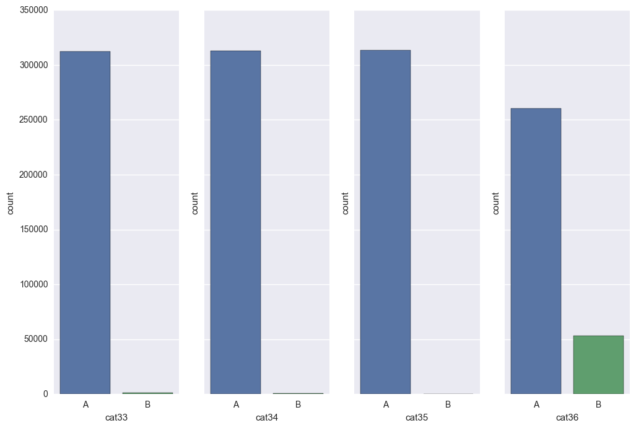

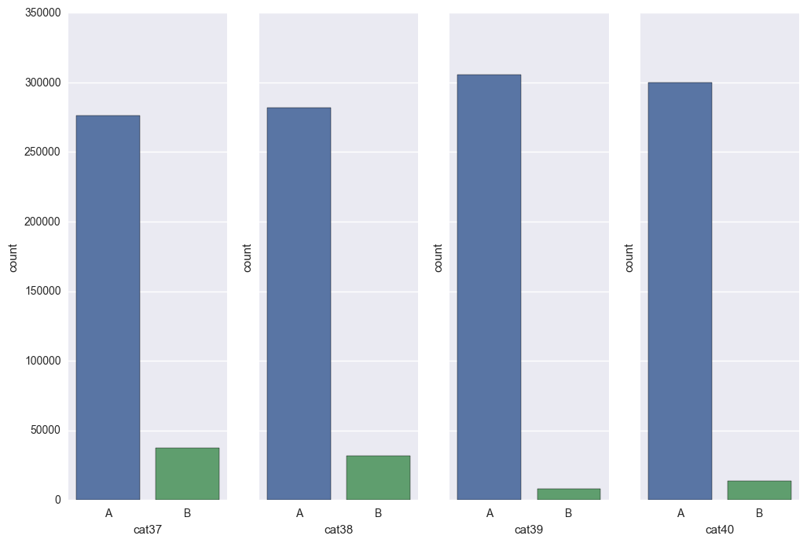

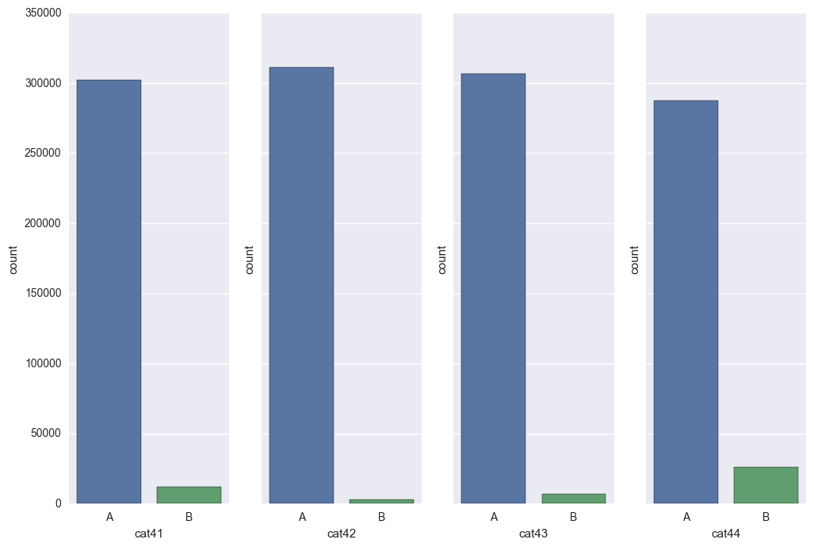

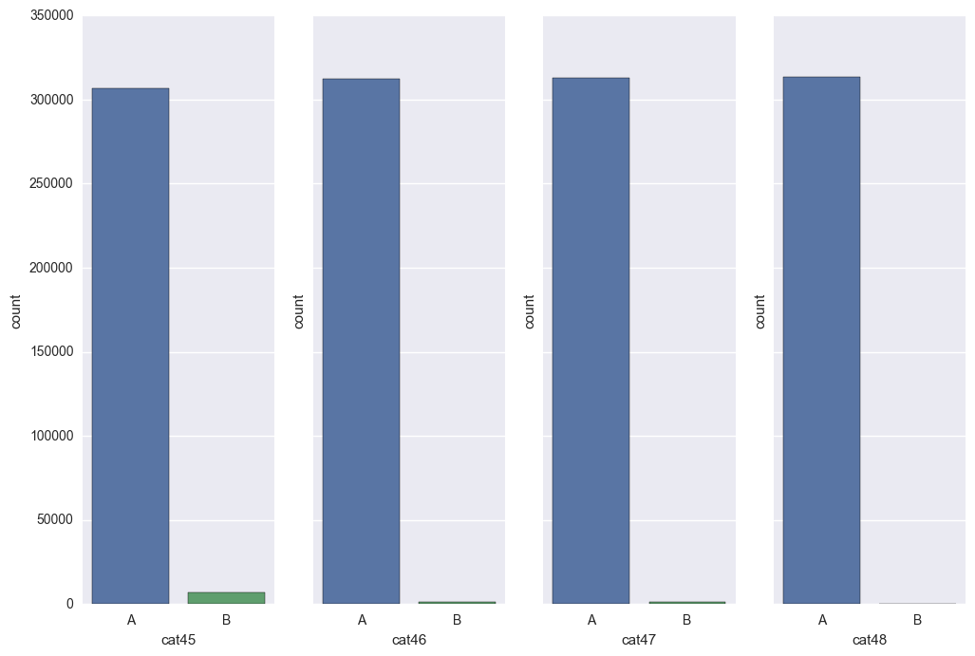

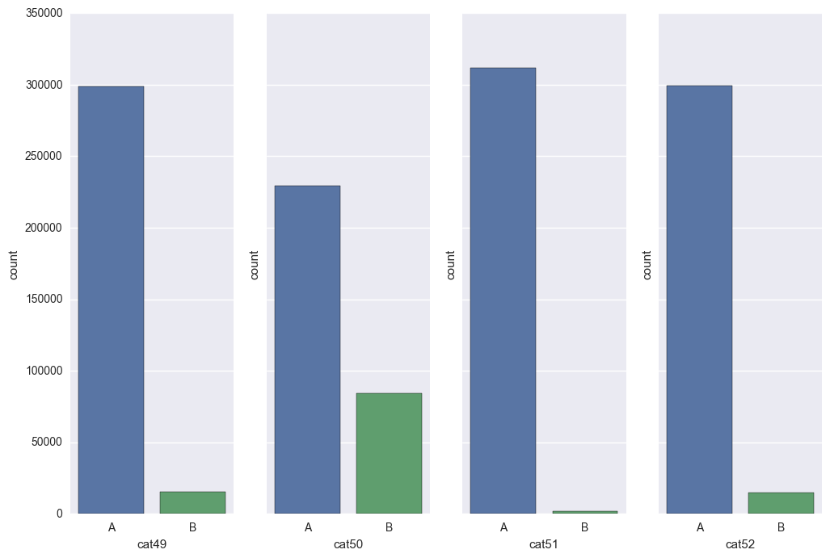

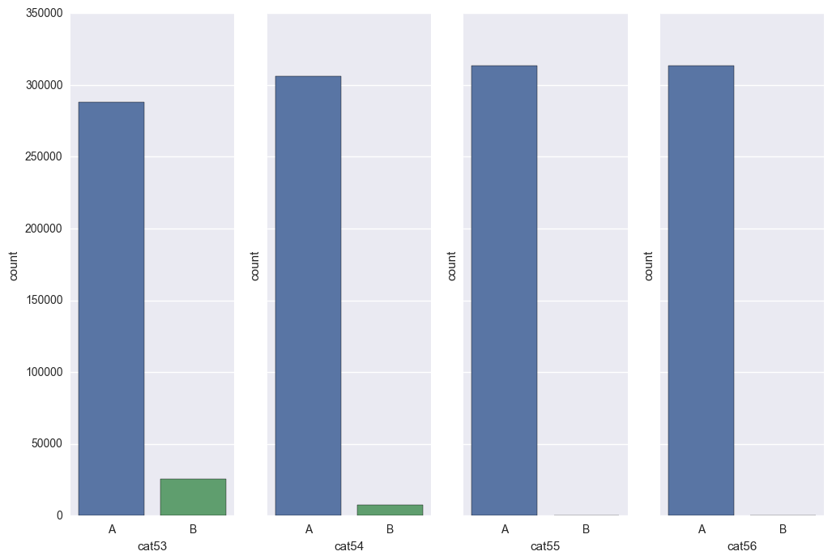

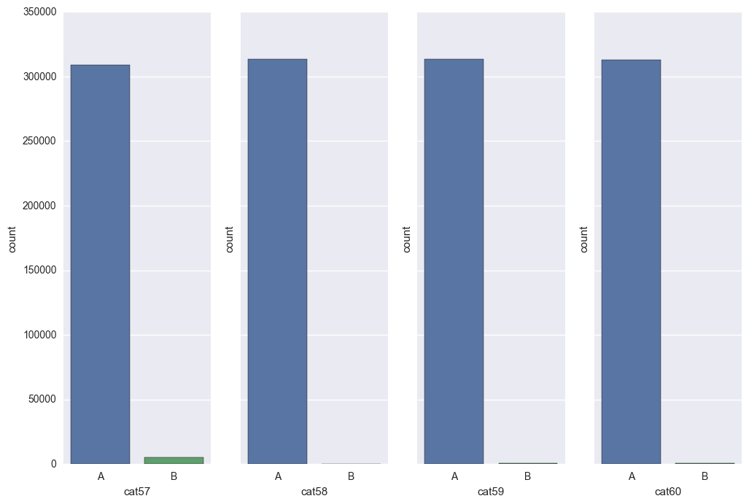

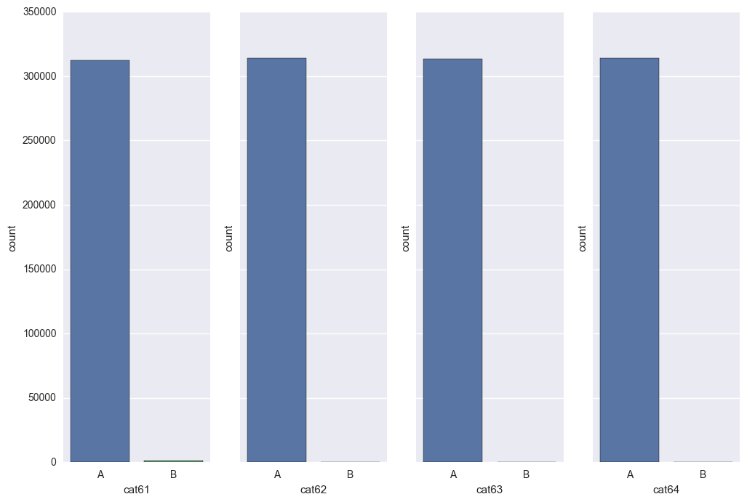

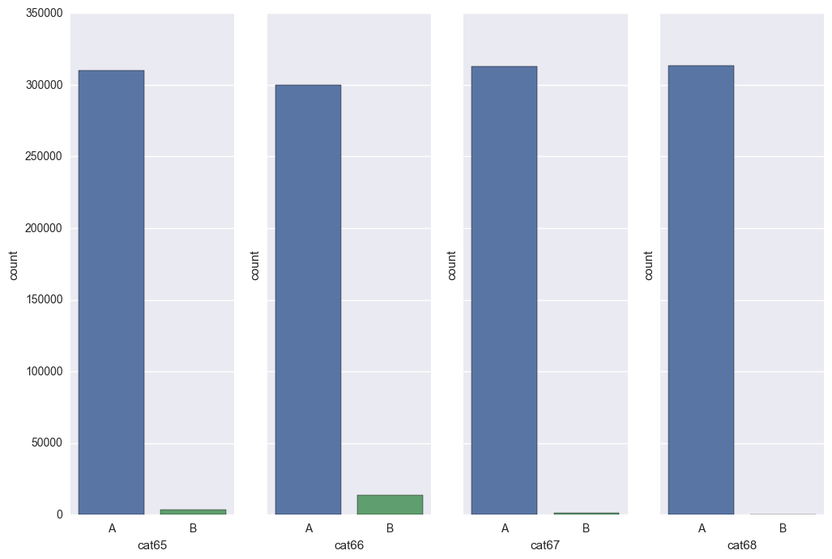

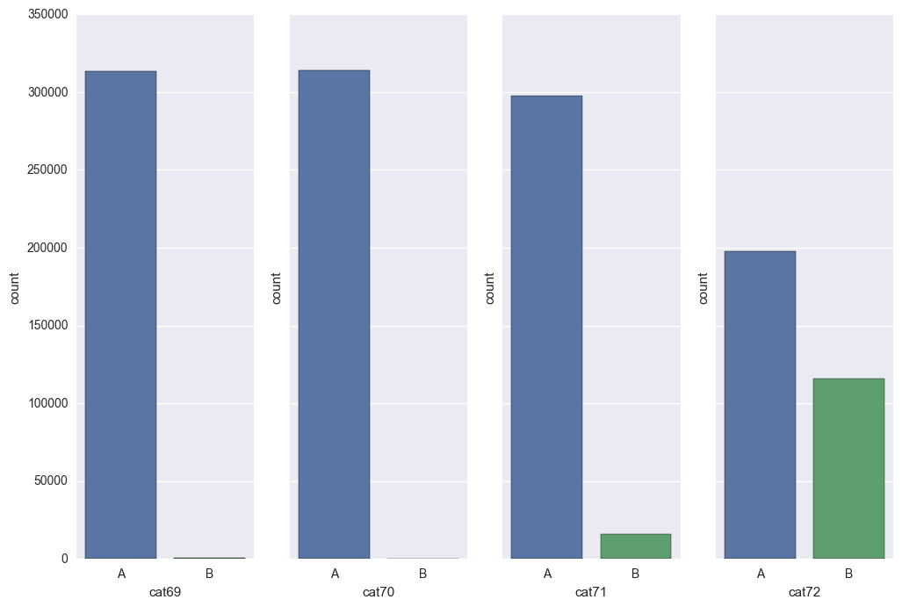

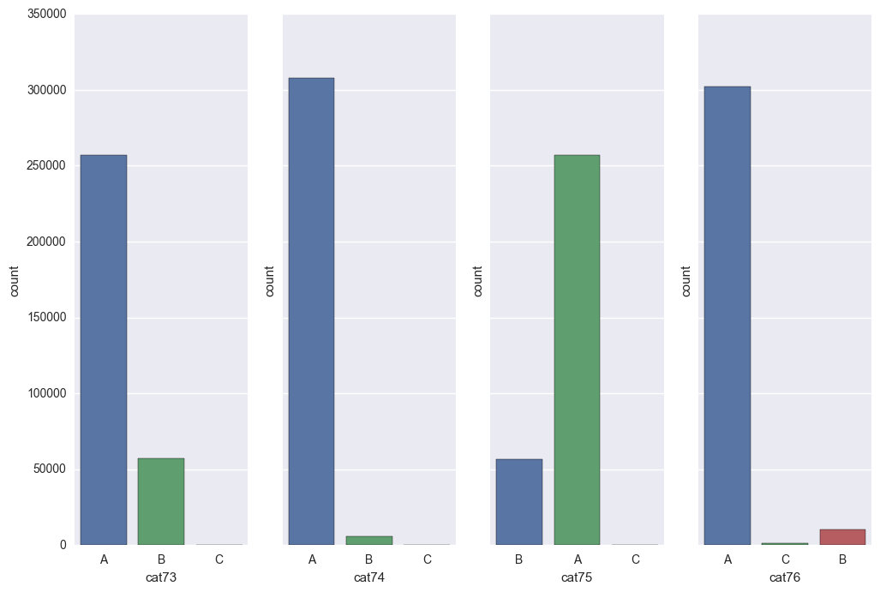

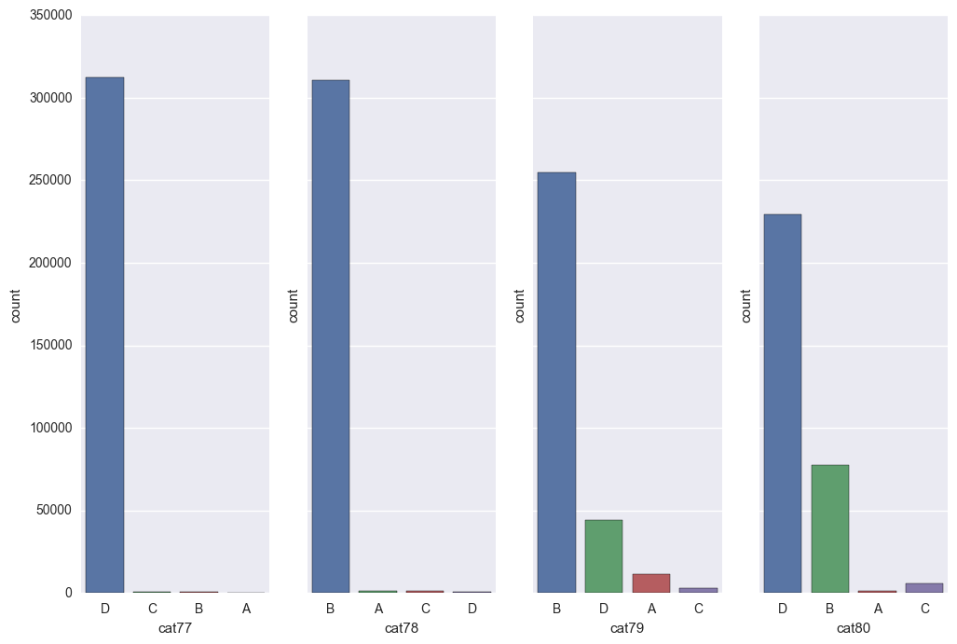

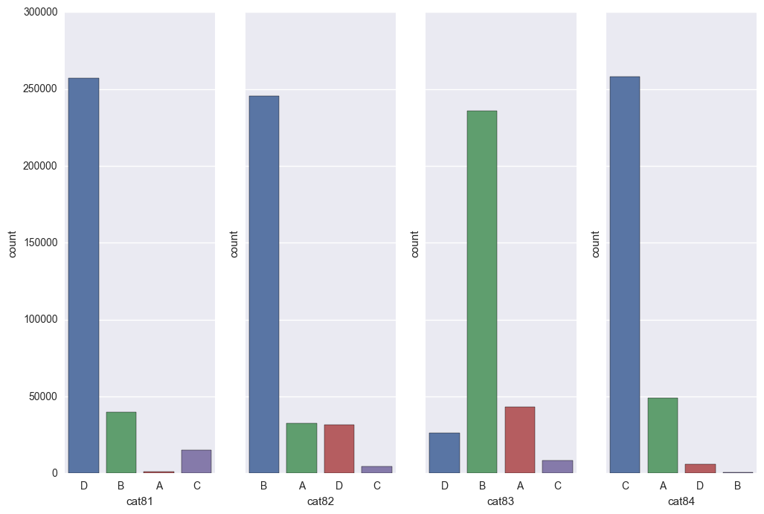

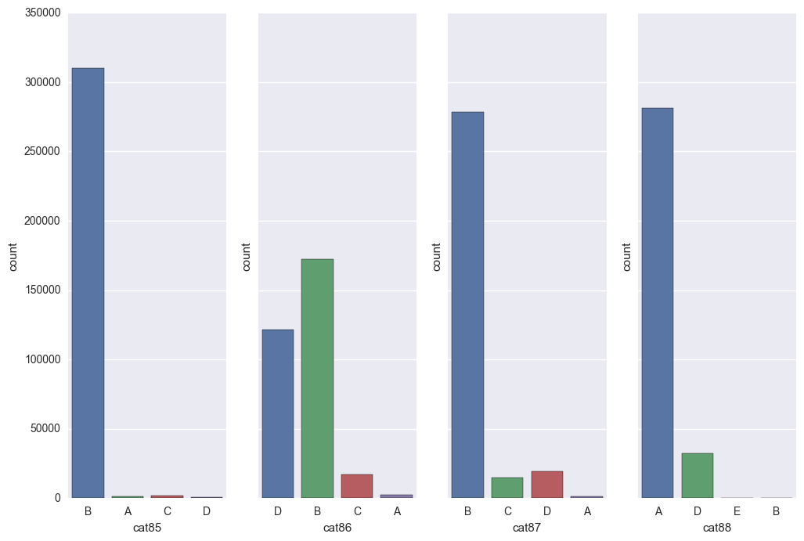

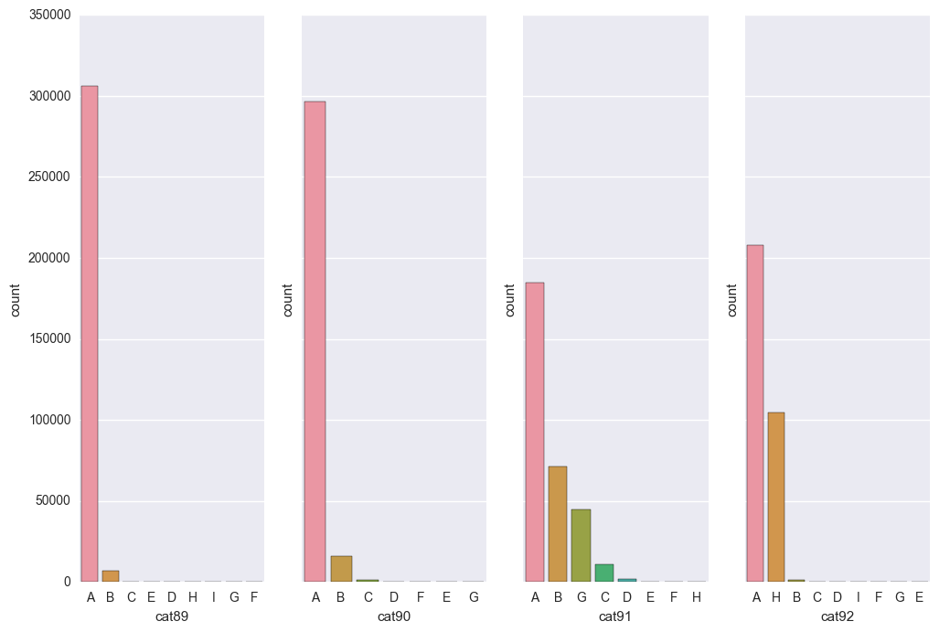



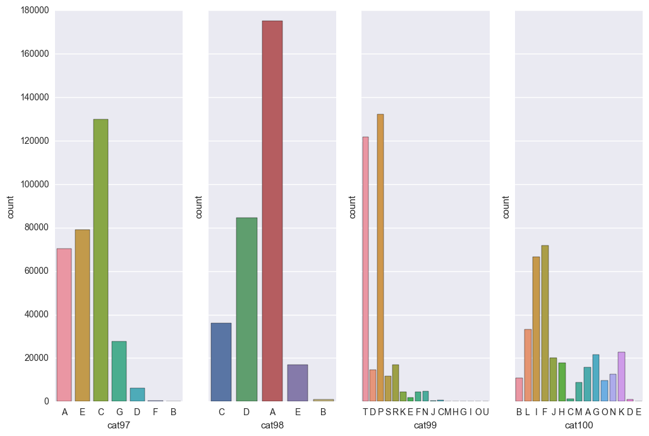

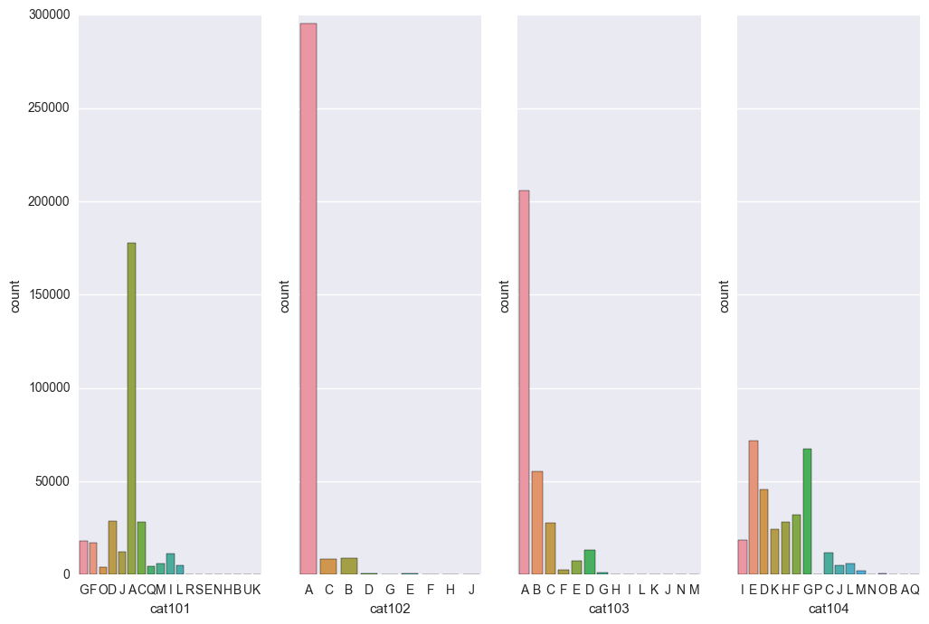

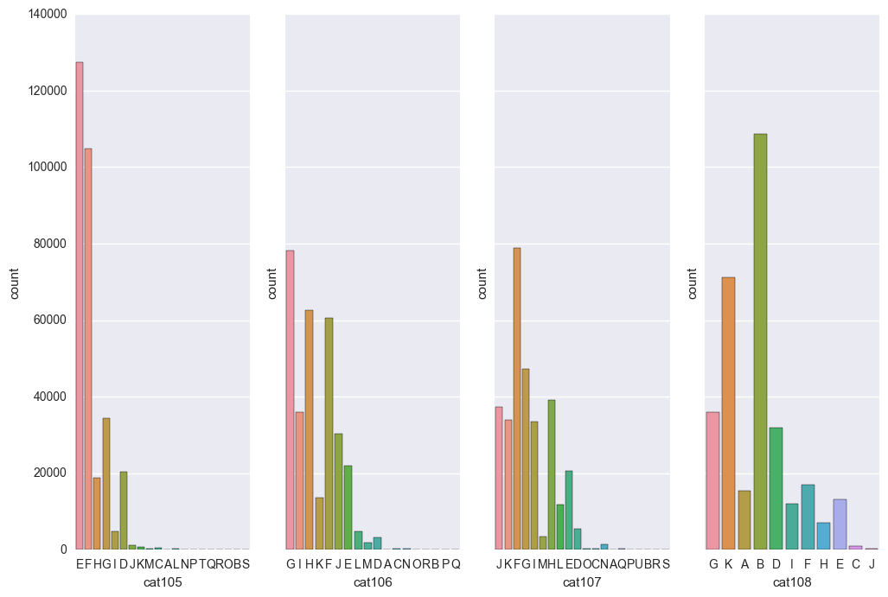



## Loss Target Variable

sns.violinplot(data=train,y="loss")

plt.show()



## Transform Data

from scipy.stats import boxcox

def aply_boxcox(df, cols, fact):

skewed_feats = df[cols].apply(lambda x: skew(x))

skewed_feats = skewed_feats[abs(skewed_feats) > fact].index

for feat in skewed_feats:

df[feat], lam = boxcox(df[feat]+1)

def factorize_features(df, cols):

for col in cols:

df[col] = pd.factorize(df[col], sort=True)[0]

start = time()

aply_boxcox(train_test, numeric_features, 0.25)

loss, loss_lam = boxcox(loss)

factorize_features(train_test, categorical_features)

train_rows = train_test.loc[features.index]

test_rows = train_test.loc[test.index]

end = time()

print "Transform data in {:.1f} seconds.".format(end - start)

Transform data in 19.7 seconds.

## Define Grid Search Function

from sklearn.metrics import make_scorer

from sklearn.metrics import r2_score

from sklearn.cross_validation import ShuffleSplit

from sklearn.grid_search import GridSearchCV

def fit_model(X, y, estim, params):

score = make_scorer(r2_score, greater_is_better=True)

sss = ShuffleSplit(len(X), n_iter = 10, test_size = 0.20, random_state = 86401)

grid = GridSearchCV(estimator=estim, param_grid=params, scoring=score, cv=sss, n_jobs=6)

grid = grid.fit(X, y)

return grid

## Fit Bayesian Ridge

from sklearn.linear_model import BayesianRidge

start = time()

bay = BayesianRidge()

param_bay = {'n_iter':[2, 4, 8]}

bay_grid = fit_model(train, y, bay, param_bay)

end = time()

print "BAY grid search in {:.1f} seconds.".format(end - start)

print "BAY best score: {:.4f}".format(bay_grid.best_score_)

print bay_grid.best_estimator_

BAY grid search in 59.2 seconds.

BAY best score: 0.4766

BayesianRidge(alpha_1=1e-06, alpha_2=1e-06, compute_score=False, copy_X=True,

fit_intercept=True, lambda_1=1e-06, lambda_2=1e-06, n_iter=2,

normalize=False, tol=0.001, verbose=False)

## Fit Gradient Boosting Regressor

start = time()

gbr = ensemble.GradientBoostingRegressor()

param_gbr = {'n_estimators' : [25], 'max_depth' : [8], 'random_state' : [864]}

gbr_grid = fit_model(train, y, gbr, param_gbr)

end = time()

print "GBR grid search in {:.1f} seconds.".format(end - start)

print "GBR best score: {:.4f}".format(gbr_grid.best_score_)

print gbr_grid.best_estimator_

GBR grid search in 3685.6 seconds.

GBR best score: 0.5078

GradientBoostingRegressor(alpha=0.9, init=None, learning_rate=0.1, loss='ls',

max_depth=8, max_features=None, max_leaf_nodes=None,

min_samples_leaf=1, min_samples_split=2,

min_weight_fraction_leaf=0.0, n_estimators=25, presort='auto',

random_state=864, subsample=1.0, verbose=0, warm_start=False)

## Refinement

start = time()

gbr = ensemble.GradientBoostingRegressor()

param_gbr = {'n_estimators' : [25], 'max_depth' : [8, 6, 10], 'random_state' : [864]}

gbr_grid = fit_model(train, y, gbr, param_gbr)

end = time()

print "GBR grid search in {:.1f} seconds.".format(end - start)

print "GBR best score: {:.4f}".format(gbr_grid.best_score_)

print gbr_grid.best_estimator_

GBR grid search in 3157.9 seconds.

GBR best score: 0.5188

GradientBoostingRegressor(alpha=0.9, init=None, learning_rate=0.1, loss='ls',

max_depth=10, max_features=None, max_leaf_nodes=None,

min_samples_leaf=1, min_samples_split=2,

min_weight_fraction_leaf=0.0, n_estimators=25, presort='auto',

random_state=864, subsample=1.0, verbose=0, warm_start=False)

start = time()

gbr = ensemble.GradientBoostingRegressor()

param_gbr = {'n_estimators' : [50], 'max_depth' : [9, 10, 12], 'random_state' : [864]}

gbr_grid = fit_model(train, y, gbr, param_gbr)

end = time()

print "GBR grid search in {:.1f} seconds.".format(end - start)

print "GBR best score: {:.4f}".format(gbr_grid.best_score_)

print gbr_grid.best_estimator_

GBR grid search in 11586.8 seconds.

GBR best score: 0.5424

GradientBoostingRegressor(alpha=0.9, init=None, learning_rate=0.1, loss='ls',

max_depth=10, max_features=None, max_leaf_nodes=None,

min_samples_leaf=1, min_samples_split=2,

min_weight_fraction_leaf=0.0, n_estimators=50, presort='auto',

random_state=864, subsample=1.0, verbose=0, warm_start=False)

start = time()

gbr = ensemble.GradientBoostingRegressor()

param_gbr = {'n_estimators' : [200], 'max_depth' : [10], 'random_state' : [864]}

gbr_grid = fit_model(train, y, gbr, param_gbr)

end = time()

print "GBR grid search in {:.1f} seconds.".format(end - start)

print "GBR best score: {:.4f}".format(gbr_grid.best_score_)

print gbr_grid.best_estimator_

GBR grid search in 11756.7 seconds.

GBR best score: 0.5457

GradientBoostingRegressor(alpha=0.9, init=None, learning_rate=0.1, loss='ls',

max_depth=10, max_features=None, max_leaf_nodes=None,

min_samples_leaf=1, min_samples_split=2,

min_weight_fraction_leaf=0.0, n_estimators=200,

presort='auto', random_state=864, subsample=1.0, verbose=0,

warm_start=False)

## Predict Values

start = time()

y_gbr = gbr_grid.best_estimator_.predict(test)

y_gbr = scaler.inverse_transform(y_gbr)

y_gbr = np.exp(np.log(loss_lam*y_gbr+1)/loss_lam)

end = time()

print "GBR predict in {:.1f} seconds.".format(end - start)

GBR predict in 0.6 seconds.

## Save Predicted Data

start = time()

df = pd.DataFrame()

df.insert(0, 'id', list(test_raw.index))

df.insert(1, 'loss', list(y_gbr))

df.to_csv('Z:/data/allstate/submission.csv',index=False)

end = time()

print "GBR predict in {:.1f} seconds.".format(end - start)

## Free-form Visualization

sns.violinplot(data=y_gbr)

plt.show()

print pd.DataFrame({'predicted': y_gbr}).describe()

predicted

count 125546.000000

mean 2646.944917

std 2019.722474

min 248.732359

25% 1368.071047

50% 1994.295228

75% 3188.932779

max 45219.140168



1. https://www.kaggle.com/
2. https://www.kaggle.com/c/allstate-claims-severity
3. https://www.allstate.com/
4. https://aws.amazon.com/
5. https://www.kaggle.com/c/allstate-claims-severity/leaderboard