**Calorie Tracker**

**A Project Report**

submitted

*in the partial fulfillment of the requirements for the award of the degree of*

**BACHELOR OF TECHNOLOGY**

**IN**

**COMPUTER SCIENCE AND ENGINEERING**

By

**P Devendhar Sai (22B81A05S8)**

**G M Teja (22B81A05W8)**

Under the guidance of

**Dr A. Soujanya**

**Assistant Professor**

**DEPARTMENT OF COMPUTER SCIENCE AND ENGINEERING**

**CVR COLLEGE OF ENGINEERING**

**(*An Autonomous institution, NBA, NAAC Accredited and Affiliated to JNTUH, Hyderabad*)**

Vastunagar, Mangalpalli (V), Ibrahimpatnam (M),  
Rangareddy (D), Telangana- 501 510

**April 2025**

****CVR College of Engineering**

ACCREDITED BY NATIONAL BOARD OF ACCREDITATION, NAAC

(Approved by AICTE & Govt. of Telangana and Affiliated by JNT University)

**DEPARTMENT OF COMPUTER SCIENCE AND ENGINEERING**

**CERTIFICATE**

This is to certify that the project entitled **“Calorie Tracker”** being submitted by **P Devendhar Sai (22B81A05S8) and G M Teja (22B81A05W8)** in partial fulfillment for the award of **Bachelor of Technology** in **Computer Science and Engineering,** to the CVR College of Engineering, is a record of bona fide work carried out by them under my guidance and supervision during the year 2025-26.

The results embodied in this project work have not been submitted to any other University or Institute for the award of any degree or diploma.

Signature of the project guide Signature of the HOD

**Dr. A . Soujanya Dr. A. Vani Vathsala**

**Assistant Professor Department of CSE**

**Professor In-charge External Examiner**

**ACKNOWLEDGEMENT**

I sincerely thank **Dr. Ramamohan Reddy Kasa,** Principal, CVR College of Engineering, for his cooperation and encouragement throughout the project

I earnestly thank **Dr. A Vani Vathsala**, HOD, Department of CSE, CVR College of Engineering, for giving timely cooperation and taking necessary action throughout the course of our project.

I express our sincere thanks and gratitude to my Mini-Project Supervisor **Dr A.Soujanya**, Assistant Professor of CSE and **Ms. T. Lavanya**, Assistant Professor of CSE, CVR College of Engineering, for their valuable help and encouragement throughout the project work.

Finally, I place in records my sincere appreciation and indebtedness to my parents and all the Faculty Members for their understanding and cooperation, without whose encouragement and blessing it would have been impossible to complete this work.

**With Regards,**

P Devendhar Sai (22B81A05S8)

G M Teja (22B81A05W8)

**LIST OF FIGURES**

**Figure** **Title**  **Page No.**

4.1 Class Diagram ………………………………………………. 17

4.2 Use Case Diagram ………………………………….............. 18

4.3 Activity Diagram ............................................................... 19

4.4 Sequence Diagram .............................................................. 20

4.5 System Architecture ............................................................ 21

**Abstract**

In recent years, there has been a significant increase in public awareness regarding health, nutrition, and fitness. As more people strive to adopt healthier lifestyles, the need for efficient tools to assist in monitoring daily dietary habits has become increasingly important. One of the most practical ways to support healthy living is through tracking calorie intake and expenditure. This project presents the development of a **Calorie Tracker**—a digital application designed to help users monitor and manage their daily caloric consumption and support their personal health and fitness goals.

The primary objective of the Calorie Tracker is to provide users with an easy-to-use interface where they can log their meals, record physical activities, and get real-time feedback on their calorie balance. The system is built to calculate the total number of calories consumed based on user input, referencing an extensive food database that includes both generic food items and popular branded products. Users can enter meals manually or select from a predefined list, which includes nutritional information such as calories, proteins, carbohydrates, and fats.

The application can be developed as a mobile app, a web-based platform, or a cross-platform solution, depending on the target audience and intended reach. Technologies such as Java, Python, React Native, or Flutter can be used for development, and cloud-based databases can ensure secure data storage and retrieval.

In conclusion, the Calorie Tracker is more than just a diet tool—it is a digital health companion aimed at empowering users to take control of their nutrition and lifestyle choices. By offering a comprehensive, data-driven approach to calorie management, it promotes awareness, consistency, and long-term healthy living.

**TABLE OF CONTENTS**

|  |  |  |  |
| --- | --- | --- | --- |
|  | | | **Page No.** |
|  |  | List of Figures | IV |
| **1** |  | **Introduction** | **1** |
|  | 1.1 | Motivation | 2 |
|  | 1.2 | Problem statement | 3 |
|  | 1.3 | Project Objectives | 4 |
|  | 1.4 | Project report Organization | 5-6 |
| **2** |  | **Literature Survey** | **7-8** |
|  | 2.1 | Existing work | 9 |
|  | 2.2 | Limitations of Existing work | 10-11 |
| **3** |  | **Software & Hardware specifications** |  |
|  | 3.1 | Software requirements | 12-14 |
|  | 3.2 | Hardware requirements | 15 |
| **4** |  | **Proposed System Design** | **16** |
|  | 4.1 | Use Case Diagram | 17 |
|  | 4.2 | Class Diagram | 18 |
|  | 4.3 | Sequence Diagram | 19 |
|  | 4.4 | Activity Diagram | 20 |
|  | 4.2 | System Architecture | 21-23 |
|  |  |  |  |
| **5** |  | **Implementation & Testing** |  |
|  | 5.1 | Module and Functional requirements | 24 |
|  | 5.2 | Interfaces, Classes and Methods | 25-26 |
|  | 5.3 | Testing | 27 |
| **6** |  | **Conclusion & Future scope** |  |
|  | 6.1 | Conclusion | 28 |
|  | 6.2 | Future scope | 29 |
| **7** |  | **References** | 30 |

**1. INTRODUCTION**

In today's fast-paced and health-conscious society, maintaining a balanced diet and keeping track of nutritional intake have become crucial components of a healthy lifestyle. With the rise in lifestyle-related diseases such as obesity, diabetes, and cardiovascular disorders, there is an increasing awareness of the importance of managing calorie consumption. However, keeping track of daily meals, snacks, and physical activity can be challenging without the help of digital tools. This is where a **Calorie Tracker** becomes an essential companion for individuals seeking to achieve or maintain a healthy body weight and improve their overall wellness.

A Calorie Tracker is a digital application that helps users log the food they eat and the physical activities they perform throughout the day. By calculating the number of calories consumed and burned, it provides valuable insights into one’s dietary habits and energy balance. These insights are especially helpful for people with specific health goals, such as weight loss, weight gain, or muscle building.

The core functionality of a calorie tracker involves a food database that contains nutritional information for a wide variety of items. Users can select their meals from this database or enter custom food entries. In addition, physical activities can be logged to estimate the number of calories burned based on duration and intensity. The application then compares calorie intake with calories expended to provide a net calorie value, helping users understand whether they are in a surplus or deficit.

Modern calorie tracking applications often include features such as personalized diet recommendations, water intake tracking, macro and micronutrient breakdowns, and progress visualization through charts and graphs. These features enhance the user experience and promote consistent usage, which is key to developing healthier habits over time.

The development of a Calorie Tracker not only addresses the growing demand for health and wellness tools but also demonstrates the integration of technology with personal healthcare management. This project aims to design and implement an efficient, user-friendly Calorie Tracker that empowers users to take control of their diet, improve nutritional awareness, and support their journey toward a healthier life.

**1.1 Motivation**

The increasing prevalence of health-related issues such as obesity, diabetes, and heart disease has made it more important than ever for individuals to monitor their daily food intake and maintain a balanced diet. With busy lifestyles, people often struggle to keep track of what they eat and how much energy they expend, leading to unhealthy eating habits and sedentary behavior. This gap between intention and action highlights the need for a simple yet effective solution to help individuals become more mindful of their nutrition and lifestyle choices.

The motivation behind developing a **Calorie Tracker** stems from the desire to provide a convenient tool that empowers users to take control of their health. By tracking daily calorie intake and expenditure, users gain a clearer understanding of their eating habits and how they impact their overall well-being. Whether the goal is to lose weight, gain muscle, or simply maintain a healthy lifestyle, having access to accurate and personalized data can significantly improve decision-making and help users stay accountable.

In an age where smartphones and digital tools are deeply integrated into daily life, creating a mobile or web-based calorie tracking solution offers a practical and accessible way to support health-conscious individuals. It eliminates the need for manual calculations, paper-based food logs, or guesswork, replacing them with real-time feedback and data-driven insights.

Furthermore, this project is also motivated by the opportunity to explore the intersection of technology and health. By using software development, database management, and user-centered design, the Calorie Tracker demonstrates how technology can contribute positively to personal wellness and lifestyle improvement.

In essence, the Calorie Tracker is more than just a tool for counting calories—it is a step toward promoting self-discipline, increasing nutritional awareness, and encouraging long-term healthy habits in a world where health often takes a backseat to convenience.

**1.2 Problem Statement**

In today’s fast-paced world, many individuals struggle to maintain a healthy lifestyle due to poor dietary habits, lack of physical activity, and limited awareness about their daily calorie consumption. Despite the growing awareness of the importance of balanced nutrition, people often find it difficult to track what they eat, how much energy they expend, and how these factors impact their health over time. Manual methods of tracking food intake and exercise are time-consuming, prone to error, and often unsustainable in the long term.

There is a clear need for a digital solution that can assist individuals in monitoring their daily caloric intake and expenditure in a simple, efficient, and accessible manner. The absence of such a system may lead to poor health decisions, resulting in weight gain, nutritional deficiencies, or other lifestyle-related health issues. The challenge lies in developing an application that is not only accurate and data-driven but also user-friendly and engaging enough to encourage consistent use. Such a system should allow users to log their meals, track physical activities, and receive personalized insights based on their dietary goals and physical profiles.

Therefore, the goal of this project is to design and implement a **Calorie Tracker** application that addresses these issues by providing a comprehensive, real-time solution for managing nutrition and supporting healthier lifestyle choices.

**1.3 Project Objective**

The primary objective of the Calorie Tracker project is to design and develop a user-friendly application that enables individuals to effectively monitor and manage their daily calorie intake and expenditure, thereby supporting their personal health and fitness goals.

The specific objectives of the project are as follows:

1. **To develop a digital platform** (mobile or web-based) that allows users to log food items consumed throughout the day along with their corresponding calorie and nutritional values.
2. **To implement a comprehensive food database** that includes common meals, snacks, beverages, and branded food items, with detailed nutritional information such as calories, carbohydrates, proteins, and fats.
3. **To enable physical activity tracking**, allowing users to input various types of exercises and calculate calories burned based on duration, intensity, and user profile.
4. **To generate a personalized calorie plan** based on user input such as age, weight, height, gender, and activity level, helping users maintain a caloric balance aligned with their fitness goals (e.g., weight loss, maintenance, or gain).
5. **To provide real-time feedback and visual insights**, such as graphs and charts, that help users understand their eating patterns, nutritional balance, and progress over time.
6. **To promote long-term healthy habits** by integrating features like goal setting, daily reminders, and motivational tips that encourage regular use and lifestyle consistency.
7. **To ensure data security and user privacy**, especially when handling sensitive health-related information.
   1. **Project Report Organization**

The successful development of the Calorie Tracker project depends on a well-structured organization of tasks, responsibilities, and phases. The project is divided into several functional modules, each focusing on a specific aspect of the application to ensure smooth workflow, efficient development, and timely delivery.

The organizational structure includes the following components:

1. **Requirement Analysis and Planning:**
   * Define the scope and goals of the project.
   * Identify target users and their needs.
   * Determine essential features such as food logging, calorie tracking, activity tracking, and user profiling.
   * Set a timeline and allocate resources for each development phase.
2. **Design and UI/UX:**
   * Design the user interface (UI) with a focus on simplicity and ease of use.
   * Create wireframes and prototypes to visualize the application flow.
   * Ensure the user experience (UX) is intuitive and engaging for daily use.
3. **Backend Development:**
   * Set up a secure database to store user data, food information, and activity logs.
   * Develop algorithms for calculating calorie intake, calories burned, and daily calorie goals based on personal data.
   * Implement user authentication and data synchronization features.
4. **Frontend Development:**
   * Develop interactive screens for user registration, food logging, activity input, progress tracking, and settings.
   * Integrate with backend APIs for real-time data fetching and updates.
   * Ensure responsive design for use on various devices (mobile, tablet, web).
5. **Integration and Testing:**
   * Perform unit testing on individual modules.
   * Conduct system integration testing to ensure smooth interaction between all components.
   * Carry out usability testing with a sample group of users and gather feedback.
6. **Deployment and Maintenance:**
   * Deploy the application on the intended platform (e.g., mobile app store or web server).
   * Monitor performance and fix bugs or issues as they arise.
   * Provide updates and add new features based on user feedback and emerging health trends.
7. **Documentation and Reporting:**
   * Maintain thorough documentation of the system architecture, user guide, and codebase.
   * Prepare a final project report that outlines objectives, methodology, features, results, and conclusions.

This structured organization ensures that the Calorie Tracker project is executed in a systematic and collaborative manner, meeting both functional and quality expectations.

**2. LITERATURE REVIEW**

Calorie tracking applications have gained significant popularity over the past decade due to the increasing global focus on health, nutrition, and wellness. Numerous studies and technological developments have contributed to the design and enhancement of digital tools that aid individuals in managing their dietary habits. This literature review explores existing research, applications, and methodologies related to calorie tracking systems, highlighting their benefits, limitations, and potential improvements.

Several studies have demonstrated the positive impact of calorie tracking on weight management and lifestyle changes. According to a study published in the *Journal of Medical Internet Research*, individuals who consistently used mobile apps to track their food intake showed improved weight loss outcomes compared to those who did not. The act of logging meals encourages mindfulness and accountability, which plays a crucial role in developing healthier eating patterns.

Popular commercial applications such as **MyFitnessPal**, **Lose It!**, and **Cronometer** have set industry standards in terms of features, usability, and data integration. These platforms typically include large food databases, barcode scanners, macronutrient tracking, and goal-setting tools. Research has shown that these apps are effective in promoting dietary awareness, but they also face challenges such as user retention, data accuracy, and input fatigue. From a technological standpoint, many calorie tracking systems rely on cloud-based databases and RESTful APIs to fetch and store food and activity data. Some advanced applications use machine learning algorithms to make food recognition from images possible, or to predict user behavior and suggest meal plans. However, these systems can be resource-intensive and may raise concerns about data privacy and security.

In terms of user behavior, a study by Bardus et al. (2016) found that ease of use, personalization, and feedback are critical factors that influence user engagement with health-related mobile apps. Calorie trackers that fail to provide a smooth and tailored experience often suffer from low long-term usage rates.

**Effectiveness of Calorie Tracker:**

The effectiveness of a calorie tracker lies in its ability to help users develop awareness about their eating habits, make informed dietary decisions, and maintain consistent health practices. Over the past few years, digital calorie tracking tools have proven to be highly beneficial in supporting weight management, improving nutrition, and encouraging a more active lifestyle.

One of the most significant advantages of a calorie tracker is **increased self-awareness**. When users log their meals and track calorie intake regularly, they become more conscious of what and how much they are eating. This awareness often leads to better portion control, healthier food choices, and a more balanced diet. Studies have shown that individuals who track their calories are more likely to lose weight and maintain their weight loss over time compared to those who do not monitor their intake.

Calorie trackers also encourage **goal setting and consistency**, which are key elements in any successful health or fitness plan. By setting daily or weekly goals, such as a specific calorie limit or macronutrient ratio, users are more likely to stay focused and motivated. Many applications also use progress charts, streak tracking, and reminder notifications to reinforce consistency and build long-term habits.

Despite these benefits, some limitations affect the long-term effectiveness of calorie trackers. These include **user fatigue**, where individuals may lose motivation to log meals every day, especially when the process is time-consuming or repetitive. Additionally, **accuracy depends on the user’s input**, meaning incorrect or incomplete entries can lead to misleading results. Advanced trackers with barcode scanning, predictive search, and integration with wearable devices can help reduce such errors and improve user experience.

* 1. **Existing Works**

Calorie trackers have become widely available and increasingly popular in recent years due to the growing public interest in health, nutrition, and fitness. These digital tools, typically in the form of mobile or web applications, serve as personal health assistants that help individuals monitor their food intake, track calorie consumption and expenditure, and manage their overall wellness goals.

Several calorie tracking applications already exist in the market, each offering a variety of features tailored to different user needs. Some of the most well-known platforms include:

* **MyFitnessPal**: One of the most popular and comprehensive calorie tracking apps, MyFitnessPal offers an extensive food database, barcode scanning, personalized goals, and integration with fitness devices.
* **Lose It!**: This app focuses on simple calorie tracking and goal-setting, allowing users to log meals and exercise with ease, while also providing visual progress tracking.
* **Cronometer**: Known for its detailed nutritional breakdown, Cronometer is widely used by those who are focused on micronutrients in addition to calorie counting.

The existence of these tools highlights the **demand for convenient, on-the-go solutions** to help people stay mindful of their diet. These apps have been downloaded by millions of users worldwide and have received positive reviews for their ease of use, accuracy, and overall contribution to healthier living. However, despite the availability of such apps, not all of them are equally effective for every individual. Some are overly complex for beginners, while others lack important features like localized food databases or offline support. Additionally, many users abandon these apps after a short period due to input fatigue, lack of motivation, or poor user experience.

* 1. **Limitations of Existing Works**

While calorie trackers offer significant benefits in promoting healthy eating habits and lifestyle changes, they are not without limitations. These tools, though helpful, can face several challenges that affect their long-term accuracy, usability, and effectiveness.

1. **User Dependency and Accuracy**:

The reliability of calorie trackers heavily depends on the accuracy of user inputs. If a user forgets to log meals, underestimates portion sizes, or selects incorrect food items from the database, the calorie count becomes inaccurate. This can lead to misleading results and may negatively affect the user's dietary decisions.

1. **Data Fatigue and User Dropout**:

A common limitation is the time-consuming nature of daily logging. Users often experience "data fatigue" from having to manually enter every meal and activity. This can lead to decreased motivation, irregular usage, or complete abandonment of the app over time.

1. **Incomplete or Inaccurate Food Databases**:

While many apps offer extensive food databases, they may not include all regional or homemade dishes, especially in culturally diverse areas. This limits usability for people with diets not represented in standard Western food logs. Additionally, user-submitted food entries may contain incorrect data.

1. **Limited Nutritional Scope**:

Most calorie trackers focus primarily on calorie count and macronutrients (carbohydrates, fats, and proteins). However, they may overlook other important nutritional aspects such as fiber, vitamins, minerals, and food quality—leading users to make choices that are calorie-conscious but not necessarily healthy.

1. **Lack of Personalization**:  
   Many calorie trackers use general algorithms to suggest calorie limits without fully accounting for personal variations such as medical conditions, metabolic rate, or body composition. This one-size-fits-all approach may not work effectively for everyone.
2. **Psychological Impact**:

Over-reliance on calorie counting can sometimes lead to unhealthy behaviors, such as obsessive tracking, anxiety around food, or disordered eating patterns. For some individuals, especially those with a history of eating disorders, calorie tracking may do more harm than good.

**3.REQUIREMENT ANALYSIS**

**3.1 Software Requirements:**

The software requirements outline the necessary functionalities and performance expectations for the successful development and operation of the Calorie Tracker application. These requirements are divided into two categories: **Functional Requirements** and **Non-Functional Requirements**.

**1. Functional Requirements**

These define what the system should do.

* **User Registration and Authentication**
  + Users must be able to register with a unique username, email, and password.
  + Login/logout functionality with password recovery option.
* **User Profile Management**
  + Users can enter and update personal details such as age, weight, height, gender, and activity level.
  + Based on this data, the app will calculate daily calorie goals.
* **Food Logging System**
  + Users can log meals (breakfast, lunch, dinner, snacks).
  + Ability to search and select food items from a database.
  + Manual entry of food items and custom meals should be supported.
* **Calorie and Nutrient Tracking**
  + Display of total calories consumed versus daily goal.
  + Track macronutrients (carbs, fats, proteins) and, optionally, micronutrients.
* **Exercise Logging**
  + Users can log workouts or physical activity.
  + Calories burned are estimated based on activity type, duration, and intensity.
* **Progress Monitoring**
  + Visual graphs and charts showing daily, weekly, or monthly trends in calorie intake, burn, and weight.
  + Users can track weight changes over time.
* **Notifications and Reminders**
  + Option to set meal logging reminders.
  + Goal-related alerts or motivational messages.
* **Database Management**
  + Central database for storing food items, nutritional values, user data, and logs.

**2. Non-Functional Requirements**

These define how the system should perform.

* **Usability**
  + The application must have an intuitive and user-friendly interface suitable for all age groups.
* **Performance**
  + The system should respond to user inputs (e.g., food log entries, calculations) within 1–2 seconds.
* **Scalability**
  + The app should support a growing number of users and data without performance degradation.
* **Security**
  + User data must be securely stored and encrypted.
  + The application must implement proper authentication and authorization mechanisms.
* **Portability**
  + The application should be compatible with major mobile operating systems (Android/iOS) and optionally as a web version.
* **Maintainability**
  + Code should follow modular and clean architecture to allow easy updates, bug fixes, and feature enhancements.
* **Reliability and Availability**
  + The app should be available 24/7 with minimal downtime.
  + Proper backup mechanisms for user data.

**3.2 Hardware Requirements:**

The hardware requirements define the physical components needed to develop, test, and deploy the Calorie Tracker application. These requirements are categorized into  and  **Client-Side (User Devices)** and **Developer/Server-Side** environments.

**Client-Side (End User Devices)**

These are the hardware requirements for users who will install and run the application on their mobile or web platforms.

**Minimum Requirements:**

* **Device Type**: Smartphone (Android 8.0+ or iOS 12.0+), or a modern browser-enabled computer
* **Processor**: 1.4 GHz Dual-Core or equivalent
* **RAM**: 2 GB
* **Storage**: 100 MB free space for app installation
* **Display**: 4.7-inch screen with 720p resolution
* **Internet**: Wi-Fi or mobile data (3G/4G) connection for syncing data

**2. Developer/Server-Side (For Development and Hosting)**

These specifications are for the system used by developers or the server environment that hosts backend services and databases.

**Minimum Requirements:**

* **Processor**: Intel i5 or equivalent
* **RAM**: 8 GB
* **Tools**: Android Studio/Xcode, code editor (VS Code), database (MySQL/PostgreSQL), local server (XAMPP, Node.js)

**4. PROPOSED SYSTEM DESIGN**

**Calorie Tracker System** is a web-based (or mobile-supported) application that follows a client-server architecture with modular components such as user authentication, food logging, calorie calculation, and progress report generation.

The following methods are used in the system:

**User Registration and Login**

Handled using secure authentication (e.g., PHP sessions, JWT tokens, or Firebase Auth) to verify users such as individuals tracking their health goals. Role-based access (if applicable) distinguishes between regular users and nutritionists/admins.

**Food and Activity Logging**

Users input their meals and physical activity through form-based or mobile-friendly interfaces. The data is stored in a **MySQL** or NoSQL database, and entries include food names, quantities, timestamps, and calories (retrieved from a food database API or manually entered).

**Calorie and Nutrition Calculation**

The system automatically calculates:

* Total daily calorie intake
* Macronutrient breakdown (proteins)

These are based on predefined rules and personalized user goals (maintenance, weight loss, gain).

**Progress Display and Analytics**

Users can log in to securely view their daily summaries, weekly trends, and goal progress through charts and reports. Admins (if present) can generate anonymized usage statistics, nutrition trends, or aggregated performance analytics.

**4.1 USECASE DIAGRAM**

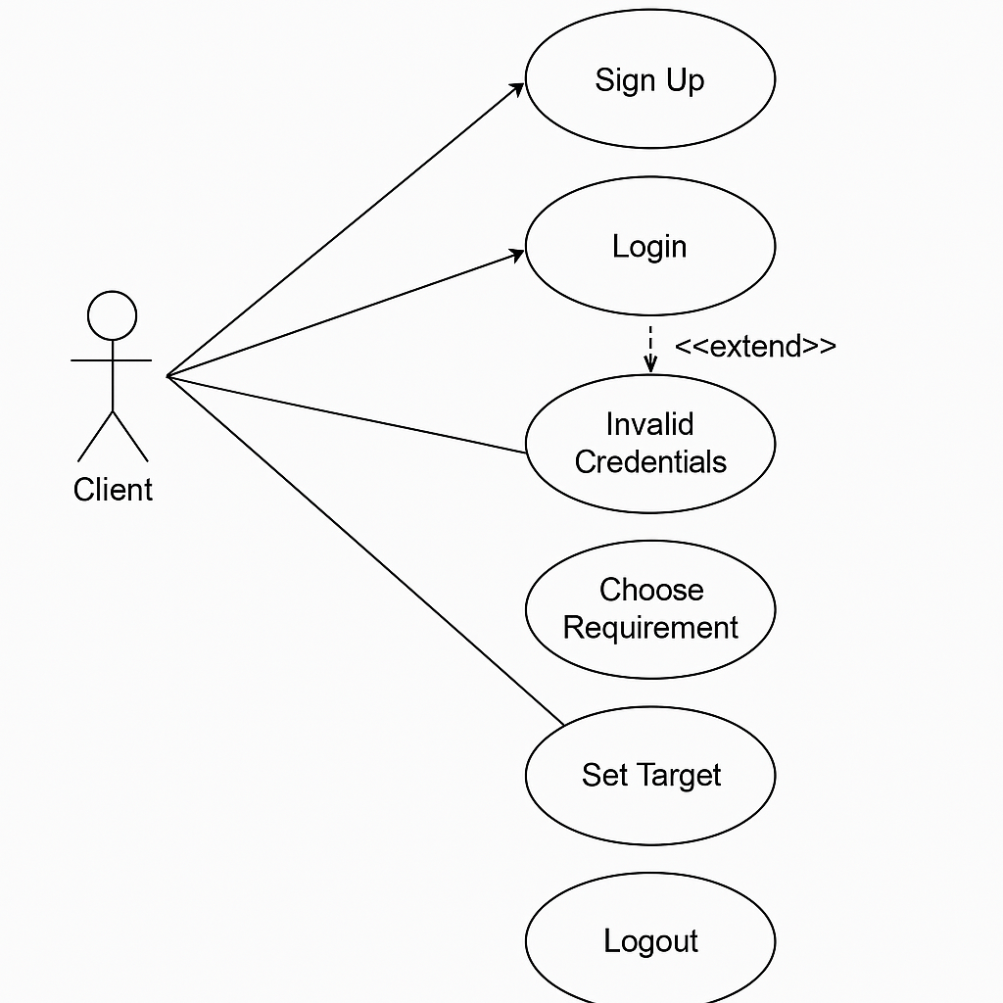

**4.2 CLASS DIAGRAM**

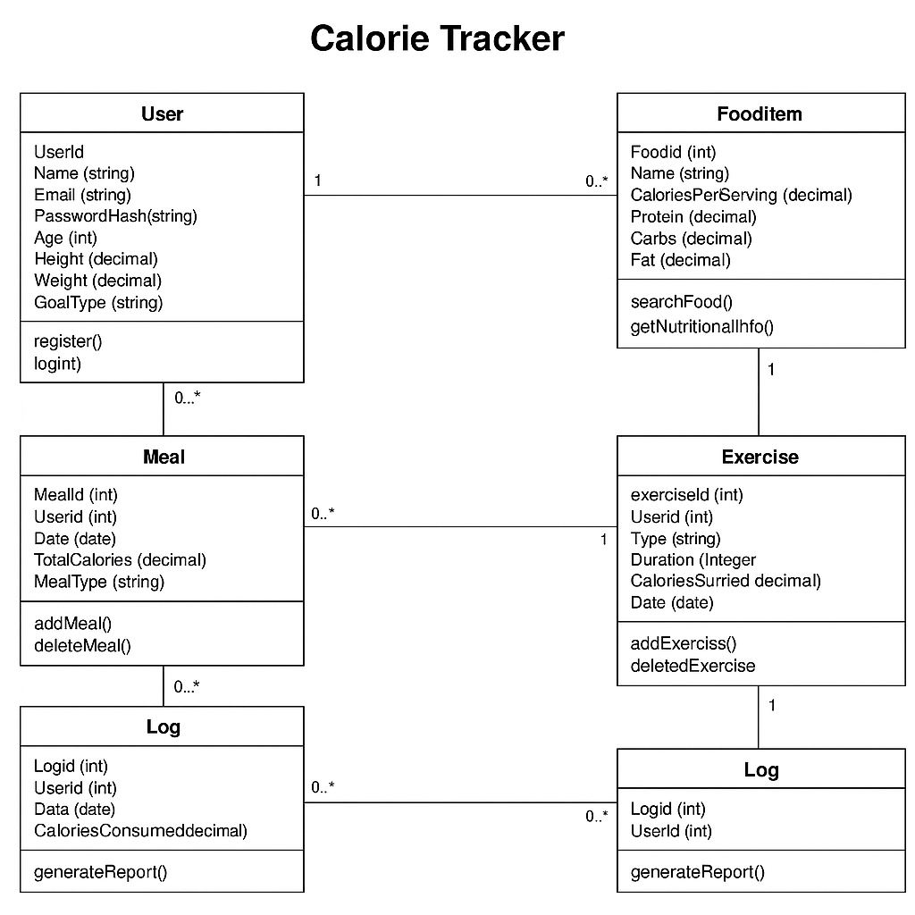

**4.3 SEQUENCE DIAGRAM**

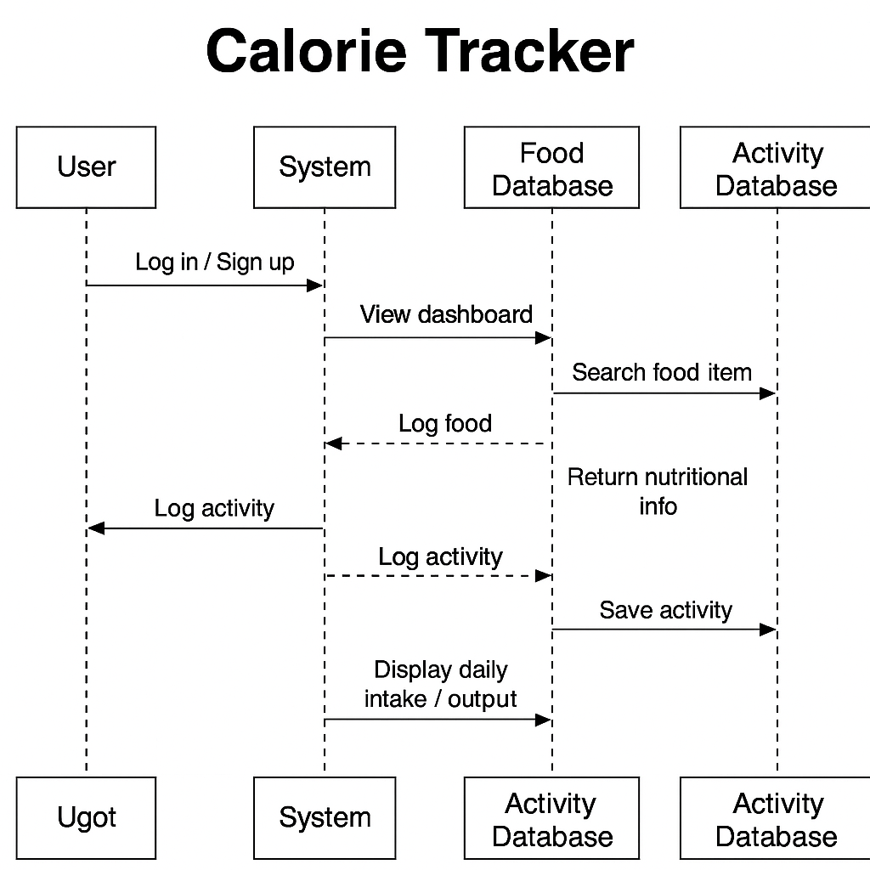

**4.4 Activity Diagram**

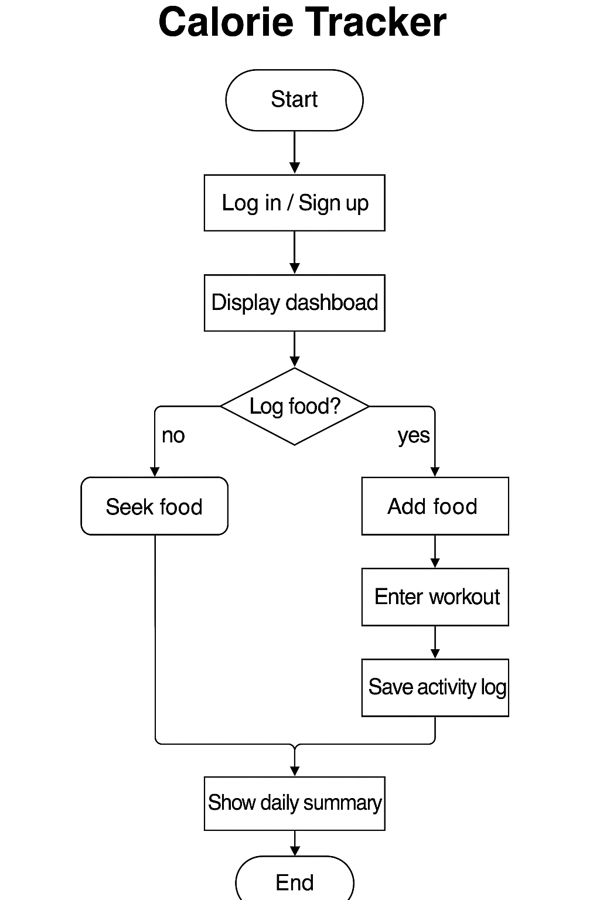

**4.5 SYSTEM ARCHITECTURE**

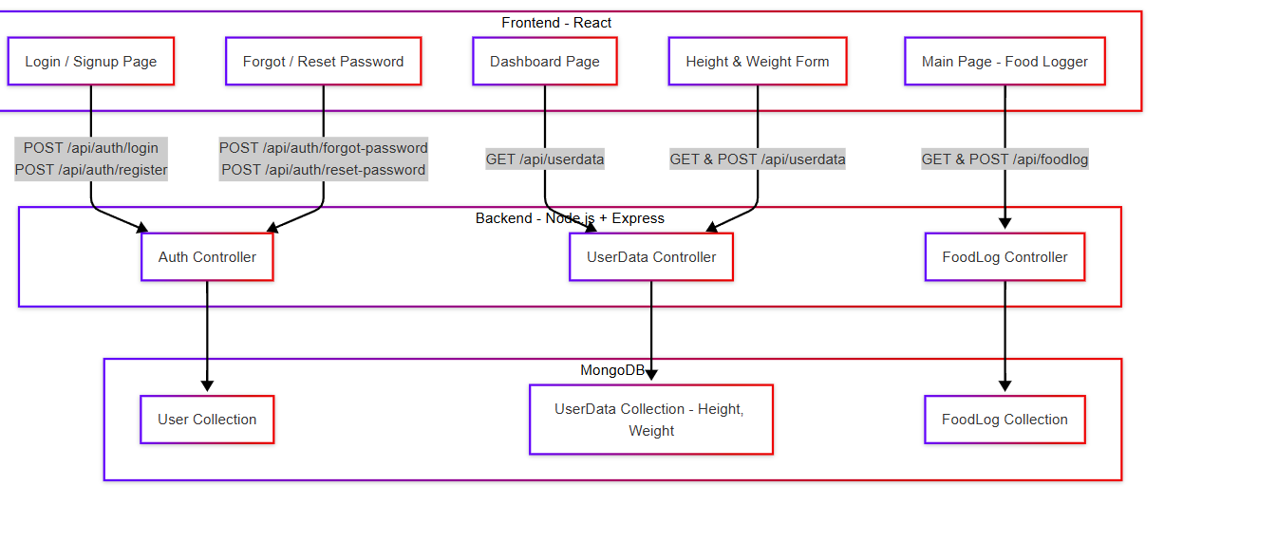

**Frontend - React**

This layer contains the user interface components where users interact with the application:

1. **Login / Signup Page**
   * Handles user authentication.
   * Sends POST requests to:
     + /api/auth/login
     + /api/auth/register
2. **Forgot / Reset Password**
   * Helps users recover or reset their password.
   * Sends POST requests to:
     + /api/auth/forgot-password
     + /api/auth/reset-password
3. **Dashboard Page**
   * Displays user data and summary.
   * Fetches data using GET /api/userdata
4. **Height & Weight Form**
   * Allows users to input/update body data.
   * Sends and receives data via GET & POST /api/userdata
5. **Main Page - Food Logger**
   * Main interface to log food and track calories.
   * Sends and receives data using GET & POST /api/foodlog

### **Backend - Node.js + Express**

This acts as the **API server**, handling business logic and connecting frontend to the database.

1. **Auth Controller**
   * Manages login, registration, and password recovery.
   * Interacts with the **User Collection** in MongoDB.
2. **UserData Controller**
   * Handles height and weight data.
   * Communicates with the **UserData Collection**.
3. **FoodLog Controller**
   * Handles food entry and calorie logging.
   * Interacts with the **FoodLog Collection**.

**Database – MongoDB**

Stores persistent data in different collections:

1. User Collection
   * Stores user credentials and profile info.
2. UserData Collection
   * Stores user-specific health data like height and weight.
3. FoodLog Collection
   * Stores food entries, calories, nutrients, timestamps, etc.

## **Flow Example:**

1. A user logs in via the Login Page → hits /api/auth/login → Auth Controller authenticates → MongoDB User Collection confirms identity.
2. User accesses Dashboard → fetches height/weight via /api/userdata → UserData Controller gets data from UserData Collection.
3. User logs a meal → hits /api/foodlog → FoodLog Controller stores meal in FoodLog Collection.

**5. IMPLEMENTATION AND TESTING**

**5.1 IMPLEMENTATION**

The **Calorie Tracker System** is composed of several modules, each with specific responsibilities to manage user data, health goals, food intake, and progress tracking. Below are the key modules and their respective functionalities:

**User Authentication Module**

The system allows users to register or log in based on their roles (Regular User or Admin/Nutritionist, if applicable). Authentication is handled using session tokens or JWT to ensure secure access.

**User Profile Management Module**

Users can input or update personal data like age, height, weight, and activity level. This data helps calculate personalized daily calorie needs and goals.

**Food Logging Module**

Users can log their meals/snacks, including food names, quantities, and meal times. Calories and nutrients are calculated based on food database values or manual input.

**Calorie & Goal Calculation Module**

Based on food logged and user profile data, the system:

* Computes daily calorie intake
* Tracks macronutrients (carbs, proteins, fats)
* Compares against personalized calorie goals

### **Progress & Report Module**

Users can view:

* Daily, weekly, and monthly summaries
* Visual graphs showing calorie intake and goal achievement Admins (if applicable) can generate overall health trend reports.

**5.2 INTERFACES, CLASSES AND METHODS**

**Interfaces (Routes):**

**User Interface:**

Includes:

* Login / Signup forms
* Profile setup page (height, weight)
* Food logging form
* Daily summary and progress tracker  
  These are built using **HTML, CSS, and JavaScript (React)** for responsive UI.

### **Key Classes & Methods**

**1. AuthController**

* POST /api/auth/login
* POST /api/auth/register
* POST /api/auth/forgot-password
* Handles user login, registration, and password reset

**2. UserDataController**

* GET /api/userdata
* POST /api/userdata
* Stores/retrieves personal data (height, weight, age, goal type)

**3. FoodLogController**

* GET /api/foodlog
* POST /api/foodlog
* Logs meals with calorie and nutrient details

**5.3 TESTING**

Testing is crucial for ensuring that the Calorie Tracker System functions accurately, efficiently, and securely. The system will undergo various types of testing to validate individual components, their integration, and the overall user experience.

**Unit Testing**

* **Purpose:**  
  To test individual functions and methods for correctness.
* **Example:**  
  Test the calculateCalories() function to ensure it correctly adds up calories from logged food items.

**Integration Testing**

* **Purpose:**  
  To ensure that different modules (frontend, backend APIs, and database) work together seamlessly.
* **Example:**  
  Test if food logs entered from the frontend are correctly stored in MongoDB and retrieved for the user's daily summary.

**Functional Testing**

* **Purpose:**  
  To verify that all system features behave according to requirements.
* **Example:**  
  Test the food logging feature to ensure users can input food items and see the updated daily calorie count.

**Security Testing**

* **Purpose:**  
  To protect user data and ensure secure access.
* **Example:**  
  Test for vulnerabilities like:
  + SQL/NoSQL Injection in login or food logging forms
  + Unauthorized access to user data

**Performance Testing**

* **Purpose:**  
  To ensure the system handles expected loads without slowdowns or crashes.
* **Example:**  
  Simulate 100+ users logging meals simultaneously and test how the system handles database writes and dashboard updates.

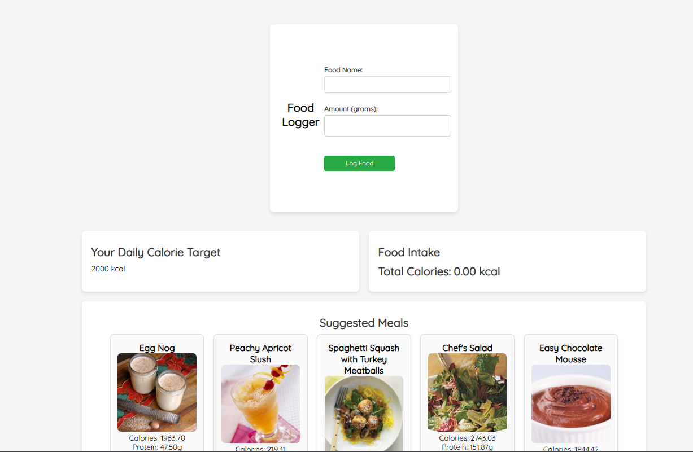

* + 1. **CONCLUSION AND FUTURE SCOPE**

**6.1 FUTURE SCOPE**

The Calorie Tracker System successfully demonstrates a modern web-based solution for managing personal health and nutrition data. By leveraging technologies such as React, Node.js, Express, and MongoDB, the application delivers a user-friendly, responsive, and secure environment for individuals to track their calorie intake, set health goals, and monitor their progress in real-time.

The system addresses key challenges in manual diet and health tracking by offering features such as **role-based access**, **automated calorie and nutrient calculation**, **real-time food logging**, and **detailed progress reporting**. It ensures accuracy and consistency in health monitoring while significantly reducing the manual effort required to maintain food logs and analyze nutritional intake.

This system contributes to the digital transformation of personal health management, enhancing **transparency**, **motivation**, and **efficiency** in fitness tracking. It empowers users with actionable insights, supports informed lifestyle decisions, and promotes sustainable wellness habits.

**6.2 FUTURE SCOPE**

The Calorie Tracker System holds significant potential for future development to enhance its utility, personalization, and integration with broader health ecosystems. Some possible areas of expansion include:

**AI-Powered Meal Suggestions**

* Use machine learning algorithms to suggest personalized meals based on user preferences, dietary restrictions, and fitness goals.
* Recommend recipes or meal plans that align with calorie targets and nutrient requirements.

**Dietitian/Nutritionist Interface**

* Create a professional dashboard for healthcare experts to monitor client progress, suggest dietary changes, and provide feedback.
* Secure communication between users and certified nutritionists.

**Enhanced Reporting and Analytics**

* Provide advanced charts, trends, and weekly/monthly comparisons.
* Predictive analytics to forecast weight loss/gain based on current habits.

**Barcode and Image Scanning**

* Implement barcode scanning for packaged foods to auto-fill nutritional data.
* Use image recognition (AI) to detect and estimate calories from photos of meals.
  + 1. **REFERENCES**

1. **Nutritionix API  
   Nutritionix. (n.d.). *Food and Nutrition Database API*. Retrieved from  
   https://developer.nutritionix.com  
   *(Used for retrieving food nutrition data and calorie values.)***
2. **USDA FoodData Central  
   U.S. Department of Agriculture. (n.d.). *FoodData Central*. Retrieved from  
   https://fdc.nal.usda.gov  
   *(Official database for nutrient information on various foods.)***
3. **React – A JavaScript Library for Building User Interfaces  
   Meta (formerly Facebook). (n.d.). *React Documentation*. Retrieved from**[**https://reactjs.org**](https://reactjs.org/) ***(Used for developing the frontend interface of the calorie tracker.)***
4. **Node.js – JavaScript Runtime Environment  
   Node.js Foundation. (n.d.). *Node.js Documentation*. Retrieved from**[**https://nodejs.org**](https://nodejs.org/) ***(Used for backend development and server-side logic.)***
5. **Express.js – Fast, Unopinionated, Minimalist Web Framework for Node.js  
   Express. (n.d.). *Express Documentation*. Retrieved from**[**https://expressjs.com**](https://expressjs.com/)
6. **MongoDB – NoSQL Database  
   MongoDB, Inc. (n.d.). *MongoDB Documentation*. Retrieved from**[**https://www.mongodb.com/docs**](https://www.mongodb.com/docs) ***(Database used for storing user logs, food entries, and profile data.)***
7. **JWT – JSON Web Tokens for Authentication  
   JWT.io. (n.d.). *Introduction to JSON Web Tokens*. Retrieved from  
   https://jwt.io/introduction**