Product Sales Analysis Development

Description:

Developing a product sales analysis involves gathering, organizing, and interpreting data related to your product's sales performance. This process is crucial for making informed business decisions, identifying trends, and optimizing your sales strategy. Here's a step-by-step guide on how to develop a product sales analysis.

Step 1: Define Your Objectives:

Determine the specific goals and questions you want to answer with your sales analysis. Common objectives include understanding sales trends, identifying top-performing products, or assessing the impact of marketing campaigns.

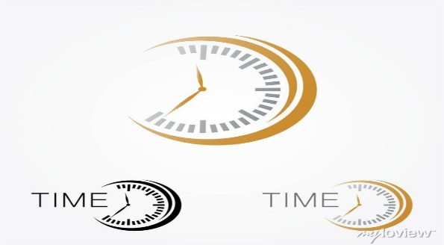

Certainly! Watch development involves multiple aspects, from design and engineering to manufacturing and marketing.

Step 2: product development chart

Link: <https://www.google.com/imgres?imgurl=https%3A%2F%2Fcdn.shopify.com%2Fs%2Ffiles%2F1%2F1232%2F7746%2Ffiles%2FTop-20-watch-brands-of-2020-market-shares-Morgan-Stanley_480x480.jpg%3Fv%3D1628601590&tbnid=mn_G1tE0JrqqJM&vet=12ahUKEwjIj5rN6P6BAxWtfGwGHdh6AEUQMygBegQIARBN..i&imgrefurl=https%3A%2F%2Fdavosa-usa.com%2Fblogs%2Fstory-time%2Fluxury-watches-industry-statistics-industry-analysis&docid=whkXDYOH_Q6qnM&w=480&h=377&q=watches%20product%20sales%20charts&ved=2ahUKEwjIj5rN6P6BAxWtfGwGHdh6AEUQMygBegQIARBN>

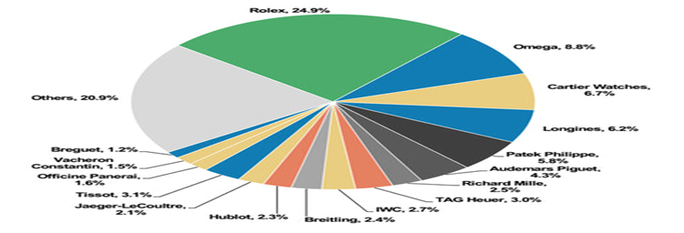

Step 3: Development in the Past years

Development in watch sales list in the past days.

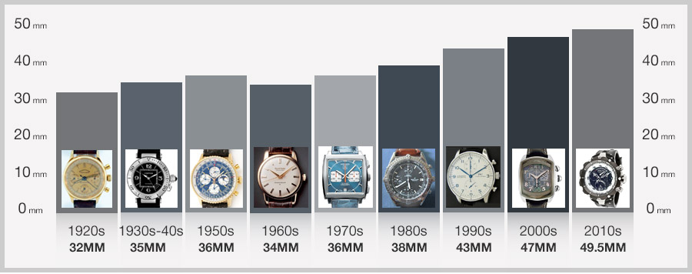

Step 4: Sketching and protocols.

Designers create sketches and digital rendering of the watch’s appearance. Prototypes are often

**Step 5: works on Excel Sheet.**

**Example:**

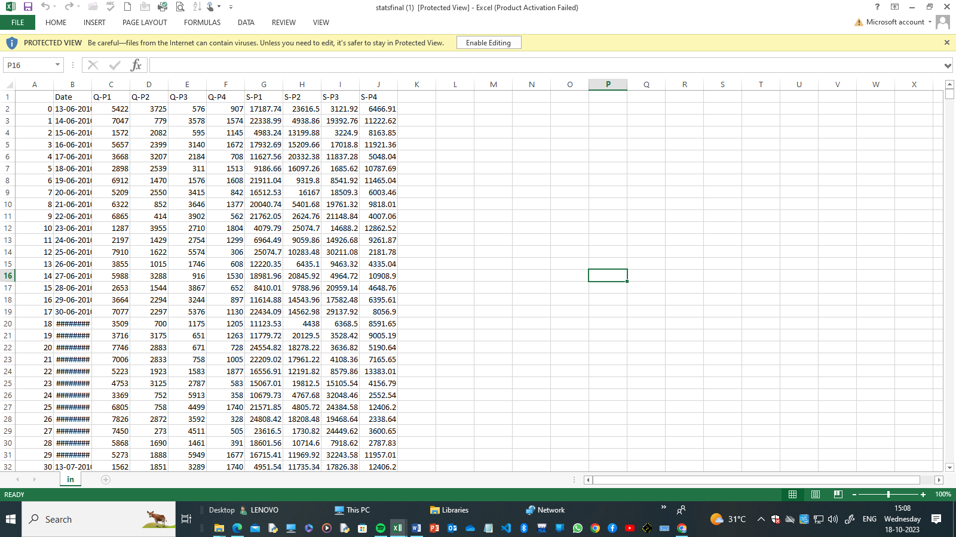

**Step 6: conclusion**

**The conclusion of a product sales analysis development would depend on the specific findings and goals of the analysis. However, in general, the conclusion should summarize key insights, trends, and recommendations.**