SIMATS ENGINEERING (SAVEETHA SCHOOL OF ENGINEERING)
Department of Computer Science and Engineering
CO2 ASSESSMENT TOOL 2 – Architecture Design Assignment

Course Code: | CSA10 / CSA1063 | Course Title: | Software Engineering
CO Assessed: | CO2 | Assessment: | Assessment Tool 2 – Architecture Design Assignment
Weightage: | 20% | Total Marks: | 25
CO2 Statement: | Perform detailed requirements analysis, design scalable architectures, and prioritize features with a focus on cross-disciplinary skills
Student Name: | V. Deva chary | Reg. No.: | 192465041
Date: | 05/08/2026 | Duration: | 60 minutes

Code of Conduct
I _V. Devachary / 192465041 (Name / Reg No) certify that this submission is my original work and that I have adhered to the guidelines specified for this assessment. I understand that any violation of academic integrity rules will result in disciplinary action.
Signature of the Student: V. Devachary
Annexure A – Architecture Design Assignment

Travel Expense Tracking and Budget Management Application

Question
Based on your assigned problem statement, perform an Architecture Design Analysis and prepare an architecture design report by answering the following questions:

1. Analyze System Requirements
- Study the given problem statement and identify the system objectives.
- To simplify travel expense tracking and budget management.
- To allow users to create trips and set planned travel budgets.
- To record and categorize travel expenses accurately.
- To automatically calculate total expenses and the remaining budget.
- To provide alerts when spending approaches or exceeds the budget limit.
- To generate expense reports and summaries for better financial analysis.
- To securely store travel expense data for future reference.
- To reduce manual calculations, errors, and unnecessary spending.

- Analyze the functional and non-functional requirements that influence the software architecture.
Functional Requirements Influencing Architecture
- User Management: Requires secure registration, login, authentication, and profile management components.
- Trip and Budget Management: Requires modules for creating trips, setting budgets, and updating budget information.
- Expense Management: Requires components for recording, editing, deleting, categorizing, and storing expenses.
- Reports and Alerts: Requires services for generating reports, calculating remaining budgets, and sending budget notifications.
Non-Functional Requirements Influencing Architecture
- Performance: The architecture should support fast expense processing and budget calculations.
- Security: User and financial data must be protected through authentication, authorization, and encryption.
- Scalability: The architecture should handle increasing users, trips, and expense records.
- Reliability & Availability: The system should provide accurate calculations, reliable data storage, backup, and continuous access.
- Maintainability: A modular architecture should be used so features can be updated and maintained easily.
- Identify key quality attributes such as scalability, maintainability, reliability, availability, performance, and security.
- Scalability: The system should support an increasing number of users, trips, budgets, and expense records without affecting performance.
- Maintainability: The application should have a modular design so that updates, bug fixes, and new features can be implemented easily.
- Reliability: The system should provide accurate expense calculations and maintain consistent financial records.
- Availability: The application should remain accessible whenever users need to record expenses or monitor their budgets.
- Performance: The system should process expense entries, budget calculations, and reports quickly with minimal delay.
- Security: User accounts and financial data should be protected using authentication, authorization, encryption, and secure data storage.

2. Select a Suitable Software Architecture
- Select an appropriate architectural style for the proposed system (e.g., Layered Architecture, Client-Server, MVC, Microservices, Event-Driven, Service-Oriented Architecture, Serverless, or Hybrid Architecture).
The Layered Architecture is suitable for the Travel Expense Tracking and Budget Management Application because it separates the system into manageable layers.
- Presentation Layer: Handles the user interface, dashboard, expense forms, budgets, and reports.
- Business Logic Layer: Handles expense calculations, budget monitoring, categorization, and alerts.
- Data Access Layer: Manages communication between the application and database.
- Database Layer: Stores user, trip, budget, expense, and report information securely.
Reason for Selection: Layered Architecture provides good maintainability, security, scalability, and separation of responsibilities, making the application easier to develop, test, and update.
- Justify why the selected architecture is the most suitable for the given problem.
- Separation of Responsibilities: Each layer performs a specific function such as user interface, business logic, data access, and storage.
- Easy Maintenance: Changes or updates can be made to one layer without significantly affecting other layers.
- Improved Security: Sensitive financial data can be protected through controlled access between different layers.
- Better Scalability: Individual layers can be improved or expanded as the number of users and expense records increases.
- Easy Testing: Each layer can be tested independently, making errors easier to identify and correct.
- Suitable for the Application: It clearly separates expense tracking, budget calculations, reports, user interactions, and database operations, making development simpler and more organized.

3. Draw the Software Architecture Diagram
- Design a clear architecture diagram illustrating the overall structure of the proposed system.
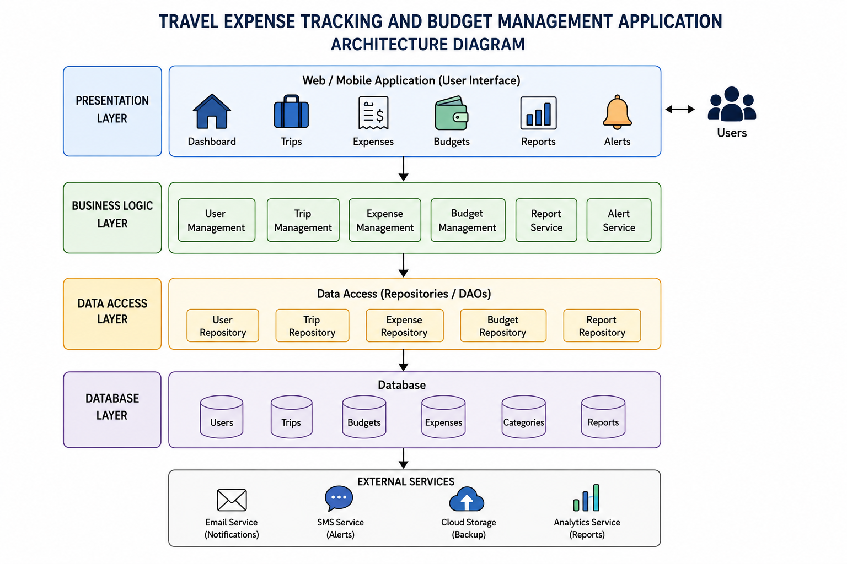
- Include all major layers/components, databases, external systems, APIs, and communication mechanisms.
- Presentation Layer: Includes the web/mobile interface, dashboard, trip management, expense entry, budget monitoring, reports, and alerts.
- Business Logic Layer: Includes user management, trip management, expense management, budget calculation, report generation, and notification services.
- Data Access Layer: Handles communication between the business logic and database through repositories or DAOs.
- Database Layer: Stores user details, trips, budgets, expenses, categories, reports, and notification information.
- External Systems: Includes cloud storage, email/SMS notification services, and optional payment services.
- APIs: REST APIs can connect the user interface with backend services and integrate external services.
- Communication Mechanisms: HTTPS is used for secure client-server communication, while API requests and responses can exchange data in JSON format.
- Use appropriate software architecture notations and labels.
Use the following standard notations in the architecture diagram:
- Rectangle: Represents system layers and software components.
- Cylinder: Represents the database or persistent data storage.
- User/Actor Symbol: Represents travelers, administrators, and other system users.
- Solid Arrow (→): Represents data flow or communication between components.
- Bidirectional Arrow (↔): Represents two-way communication.
- Dashed Arrow (⇢): Represents communication with external services or APIs.
- REST API: Label communication between the Presentation Layer and Business Logic Layer as REST API (HTTPS/JSON).
- Database Connection: Label communication between the Data Access Layer and Database Layer as Database Query/Response.
- External API: Label connections to payment, notification, cloud, or other external services as External API (HTTPS).
The layers should be clearly labelled Presentation Layer → Business Logic Layer → Data Access Layer → Database Layer, with External Systems/APIs shown separately.

4. Explain Components and Their Interactions
- Describe the purpose and responsibilities of each architectural component.
- Presentation Layer: Provides the web/mobile user interface and allows users to access trips, expenses, budgets, reports, and alerts.
- Business Logic Layer: Processes application rules such as expense calculations, budget monitoring, trip management, report generation, and notifications.
- Data Access Layer: Manages the transfer of data between the business logic and the database using repositories or DAOs.
- Database Layer: Securely stores users, trips, budgets, expenses, categories, reports, and other application data.
- REST API: Enables secure communication between the frontend and backend using HTTPS and JSON.
- External Services: Provide additional functions such as cloud backup, email/SMS notifications, and optional payment processing.
- Security Component: Handles authentication, authorization, encryption, and protection of sensitive user and financial information.
- Explain how the components communicate and exchange data.
- User → Presentation Layer: Users interact with the application through the web or mobile interface.
- Presentation → Business Logic Layer: User requests are sent to backend services through REST APIs using HTTPS/JSON.
- Business Logic → Data Access Layer: The business layer processes requests and sends required data operations to repositories or DAOs.
- Data Access → Database Layer: The data access layer performs database queries to store, retrieve, update, or delete records.
- Business Logic → External Services: External APIs are used for email/SMS alerts, cloud services, and optional payment processing.
- Response to User: The processed results are returned through the layers and displayed on the user interface as budgets, expenses, alerts, or reports.
- Illustrate the overall workflow of the system.
- User Registration/Login: The traveler registers or securely logs into the application.
- Create Trip: The user creates a new trip by entering the required travel details.
- Set Budget: A planned budget is assigned to the selected trip.
- Record Expenses: The user enters expenses such as transportation, accommodation, food, shopping, and entertainment.
- Process Expenses: The system stores expenses and automatically calculates the total amount spent.
- Monitor Budget: The system compares total expenses with the planned budget and calculates the remaining amount.
- Budget Alerts: Notifications are provided when spending approaches or exceeds the budget limit.
- Reports & Analysis: The system generates expense summaries and reports for spending analysis.
- Data Storage: Trip, budget, and expense information is securely stored in the database and can be backed up using cloud services.

5. Discuss Quality Attributes
Evaluate how the proposed architecture addresses the following aspects:

Scalability: The layered architecture allows individual components to be expanded as the number of users, trips, and expense records increases.

Security: Authentication, authorization, HTTPS communication, and secure database access protect user and financial information.

Performance: Separate business and data-access layers help process expense calculations, budget updates, and database operations efficiently.

Reliability: Centralized database management, validation, and backup mechanisms help maintain accurate and consistent travel expense records.

Maintainability: Each layer has a specific responsibility, making the system easier to modify, test, debug, and upgrade.

Availability: Cloud hosting, database backups, and recovery mechanisms help keep the application accessible and reduce service interruptions.

6. Justify Architectural Decisions
- Explain the rationale behind your architectural choices.
- Layered Architecture: Selected because it clearly separates the user interface, business logic, data access, and database functions.
- Modular Design: Makes the application easier to develop, test, maintain, and upgrade.
- REST API: Provides simple and secure communication between the frontend and backend using HTTPS/JSON.
- Centralized Database: Ensures consistent and organized storage of user, trip, budget, and expense information.
- External Services: Cloud storage and notification services can be integrated without significantly changing the core system.
- Security: Authentication, authorization, encryption, and controlled database access help protect sensitive financial data.
- Future Expansion: The architecture can support additional features such as multi-currency support, payment integration, and advanced analytics.
- Discuss the trade-offs considered while selecting the architecture.
- Simplicity vs. Flexibility: Layered architecture is simple to understand and implement, but communication between multiple layers can add complexity.
- Performance vs. Modularity: Separating functions into layers improves organization and maintainability but may introduce slight processing overhead.
- Security vs. Accessibility: Strong authentication and authorization improve security but add extra steps for users.
- Scalability vs. Cost: Cloud services improve scalability and availability but increase hosting and maintenance costs.
- Centralized Database vs. Dependency: A centralized database provides consistent data management, but database failure can affect the entire application.
- Maintainability vs. Development Effort: Modular components simplify future updates, but require careful initial design and development.
- Explain how the chosen architecture supports future enhancements, system integration, and long-term maintainability.
- Future Enhancements: The layered architecture allows new features such as multi-currency support, receipt scanning, bank integration, and advanced analytics to be added easily.
- System Integration: REST APIs allow the application to connect with external services such as payment gateways, cloud storage, and notification services.
- Modular Development: Each layer can be modified or upgraded independently without significantly affecting other layers.
- Easy Maintenance: Separation of presentation, business logic, data access, and database components makes errors easier to identify and fix.
- Scalability: Individual components can be expanded as the number of users, trips, and expense records increases.
- Long-Term Support: The organized architecture makes testing, updating, security improvements, and addition of new modules easier over time.
Rubrics for Calculation
Evaluation Criteria | Excellent (4 Marks) | Good (3 Marks) | Satisfactory (2 Marks) | Needs Improvement (1 Mark)
System Requirement Analysis | Thoroughly analyzes the problem statement, accurately identifies functional and non-functional requirements, and clearly explains quality attributes influencing the architecture. | Analyzes most requirements with minor omissions or limited explanation. | Identifies only basic requirements with partial analysis. | Requirement analysis is incomplete, inaccurate, or lacks clarity.
Selection of Software Architecture | Selects the most appropriate architectural style with strong technical justification aligned to system requirements. | Selects a suitable architecture with reasonable justification. | Architecture is partially suitable with limited justification. | Inappropriate architecture selected or justification is missing.
Architecture Diagram and Component Design | Produces a clear, complete, and well-structured architecture diagram with all major components, interfaces, and interactions accurately represented. | Diagram is mostly complete with minor omissions or notation issues. | Diagram includes only essential components and lacks sufficient detail. | Diagram is incomplete, unclear, or technically incorrect.
Component Interaction and Quality Attribute Analysis | Clearly explains component responsibilities, interactions, and thoroughly discusses scalability, security, performance, reliability, maintainability, and availability. | Explains most components and quality attributes with minor gaps. | Provides limited explanation of interactions and addresses only some quality attributes. | Component interactions and quality attributes are poorly explained or missing.
Architectural Justification and Technical Presentation | Provides strong justification for architectural decisions, discusses trade-offs and future enhancements, and presents a well-organized, professional report. | Provides adequate justification with minor gaps; report is well organized. | Limited justification with minimal discussion of trade-offs or future scope; report needs improvement. | Justification is weak or absent; report lacks organization and technical clarity.

Criteria | Mark
System Requirement Analysis | /5
Selection of Software Architecture | /5
Architecture Diagram and Component Design | /5
Component Interaction and Quality Attribute Analysis | /5
Architectural Justification and Technical Presentation | /5
TOTAL | /5

