SIMATS ENGINEERING (SAVEETHA SCHOOL OF ENGINEERING)
Department of Computer Science and Engineering
CO2 ASSESSMENT TOOL 1 – Scenario-Based Requirement Analysis

Course Code: | CSA10 / CSA1003 | Course Title: | Software Engineering
CO Assessed: | CO2 | Assessment: | Assessment Tool 2 – Scenario-Based Requirement Analysis
Weightage: | 20% | Total Marks: | 25
CO2 Statement: | Perform detailed requirements analysis, design scalable architectures, and prioritize features with a focus on cross-disciplinary skills
Student Name: | V. Deva chary | Reg. No.: | 192465041
Date: | 04/08/2026 | Duration: | 60 minutes

Code of Conduct
I _V. Devachary / 192465041 (Name / Reg No) certify that this submission is my original work and that I have adhered to the guidelines specified for this assessment. I understand that any violation of academic integrity rules will result in disciplinary action.
Signature of the Student: V. Devachary
Annexure A – Scenario-Based Requirement Analysis

Travel Expense Tracking and Budget Management Application

Question
Based on the assigned problem statement, perform a Scenario-Based Requirement Analysis and prepare a Software Requirement Specification (SRS) document. Your analysis should include the following:
- Study and Analyze the Scenario
  - Carefully understand the given problem statement.
The Travel Expense Tracking and Budget Management Application is designed to help travelers manage their expenses and budgets efficiently during trips. It allows users to create trips, set budgets, record and categorize expenses, and monitor their spending. The system automatically calculates total expenses and remaining budget and provides alerts when budget limits are reached. It also generates expense reports for better financial analysis. Overall, the application reduces manual work, minimizes errors, and improves travel budget management.
- Identify the business domain, stakeholders, existing challenges, and system objectives.
Business Domain
- Travel expense and financial management.
- Budget planning and expense tracking during trips.
- Financial reporting and spending analysis.
Stakeholders
- Travelers / Users.
- Administrators and software development team.
- Business organizations and cloud service providers.
Existing Challenges
- Manual expense recording is time-consuming and prone to errors.
- Lack of real-time budget monitoring and alerts.
- Risk of incomplete records, data loss, and difficult report preparation.
System Objectives
- To simplify travel expense tracking and budget management.
- To automatically calculate expenses and monitor the remaining budget.
- To generate reports, provide budget alerts, and securely store financial records.
- Identify Functional and Non-Functional Requirements
  - List all functional requirements required by the proposed system.
- User Registration and Login: Users can create accounts and securely log in to the application.
- Trip Management: Users can create, edit, view, and delete travel trips.
- Budget Management: Users can set and update budgets for individual trips.
- Expense Management: Users can add, edit, delete, and view travel expenses.
- Expense Categorization: Expenses can be organized into categories such as food, transportation, accommodation, shopping, and entertainment.
- Automatic Calculation: The system automatically calculates total expenses and the remaining budget.
- Budget Monitoring: Users can monitor their spending against the planned budget in real time.
- Budget Alerts: The system notifies users when they approach or exceed their budget limit.
- Reports and Analytics: The system generates expense reports, summaries, and category-wise spending analysis.
- Expense History: Users can view and search previous trip and expense records.
- Data Backup: Travel and expense information can be securely stored and backed up.
- Admin Management: Administrators can manage users, monitor system activities, and maintain system settings.
  - Identify suitable non-functional requirements such as performance, security, reliability, usability, scalability, maintainability, and availability.
- Performance: The system should process expense entries, budget calculations, and reports quickly.
- Security: User accounts and financial data should be protected using secure authentication and encryption.
- Reliability: The system should provide accurate calculations and maintain consistent expense records.
- Usability: The application should have a simple, clear, and user-friendly interface.
- Scalability: The system should support an increasing number of users, trips, and expense records.
- Maintainability: The application should be easy to update, modify, and fix when issues occur.
- Availability: The system should be accessible whenever users need to record or monitor travel expenses.
- Identify Actors and Use Cases
  - Identify all primary and secondary actors interacting with the system.
Primary Actors
- Travelers / Users: Create trips, set budgets, record expenses, monitor spending, and generate reports.
- Business Travelers: Track official travel expenses and prepare reimbursement reports.
- Administrator: Manages user accounts, expense records, and system settings.
Secondary Actors
- Cloud Service Provider: Provides data storage, synchronization, backup, and system availability.
- Payment Service Provider: Supports secure payment processing when required.
- Business Organization: Reviews employee travel expense and reimbursement reports.

  - List the major use cases associated with each actor.
- Travelers / Users: Register, login, create trips, set budgets, add expenses, categorize expenses, monitor spending, receive budget alerts, and generate reports.
- Business Travelers: Record business travel expenses, monitor trip budgets, and generate reimbursement reports.
- Administrator: Manage user accounts, monitor system activities, manage records, and maintain system settings.
- Cloud Service Provider: Store data, synchronize records, perform backups, and support data recovery.
- Payment Service Provider: Process secure payments and provide transaction confirmation.
- Business Organization: Review employee travel expenses and verify reimbursement reports.
  - Draw a Use Case Diagram representing the interactions between actors and the system.
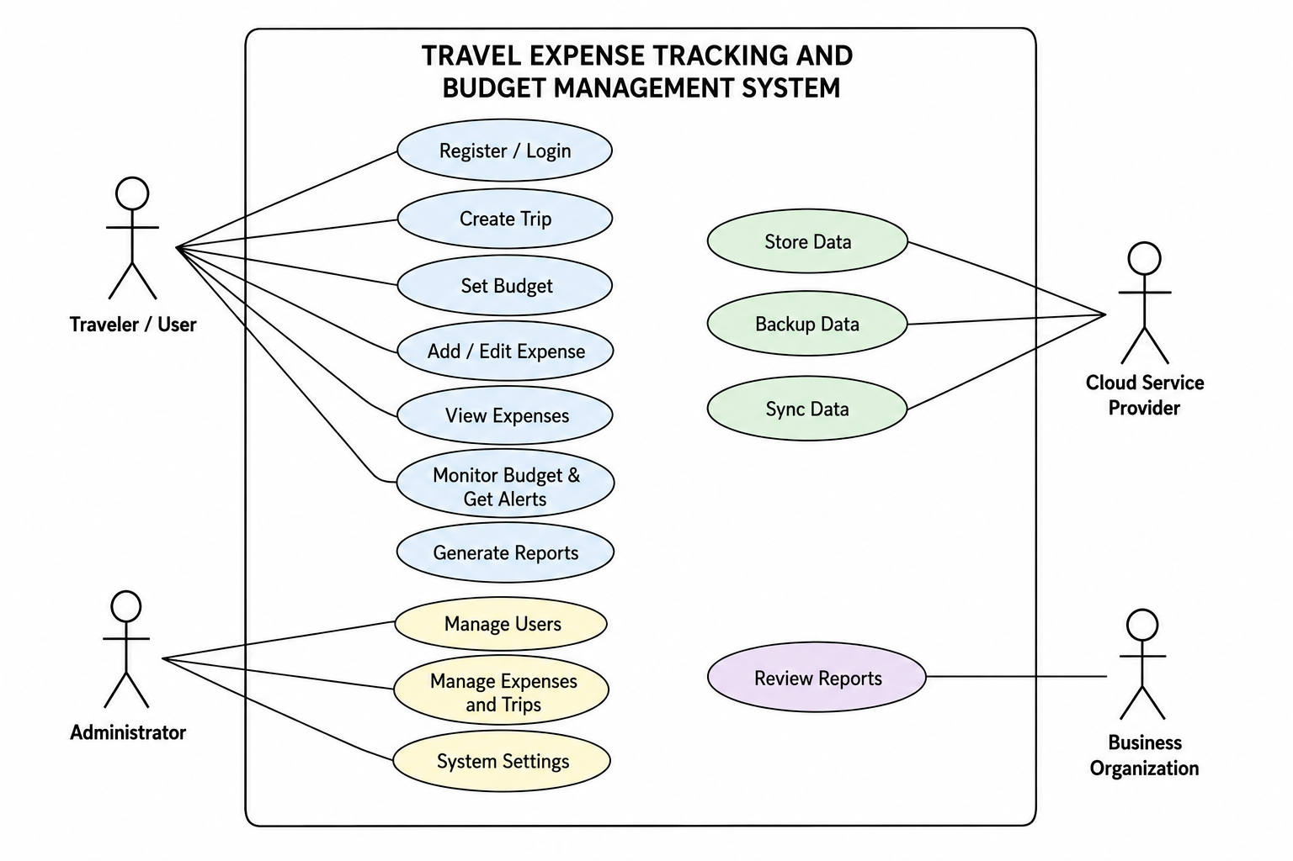

- Prepare the Software Requirement Specification (SRS)
Develop an SRS document containing:
  - Introduction
The Travel Expense Tracking and Budget Management Application is designed to help travelers efficiently record, organize, and monitor their expenses during trips. The system provides an easy way to create trip budgets, track spending, receive budget alerts, and generate expense reports. It reduces manual calculations and improves accuracy and financial control.
  - Problem Description
Traditional travel expense management relies on notebooks, receipts, calculators, or spreadsheets. These methods are time-consuming and may result in incorrect or incomplete expense records. Travelers may also find it difficult to monitor their remaining budget and prepare expense reports. The proposed system solves these problems through automated expense tracking and budget management.
  - Scope of the System
- Allows users to create and manage different trips.
- Enables users to set and update budgets for each trip.
- Records and categorizes travel expenses.
- Automatically calculates total expenses and remaining budget.
- Provides alerts when users approach or exceed their budget.
- Generates expense reports and spending summaries.
- Securely stores travel and financial records.
- Focuses on expense and budget management rather than ticket booking, hotel reservation, or navigation.
  - Functional Requirements
- User Management: Register, login, logout, and manage user profiles.
- Trip Management: Create, edit, delete, and view trips.
- Budget Management: Set and update budgets for individual trips.
- Expense Management: Add, edit, delete, and view expenses.
- Expense Categorization: Categorize expenses as food, transportation, accommodation, shopping, entertainment, etc.
- Budget Calculation: Automatically calculate total expenses and remaining budget.
- Budget Monitoring: Compare actual spending with the planned budget.
- Notifications: Alert users when spending approaches or exceeds the budget.
- Reports: Generate trip-wise and category-wise expense reports.
- Expense History: View previous trips and expense records.
  - Non-Functional Requirements
- Performance: The application should process expense entries and budget calculations quickly.
- Security: User accounts and financial information should be protected using secure authentication and encryption.
- Reliability: The system should provide accurate calculations and maintain consistent records.
- Usability: The interface should be simple and easy to understand.
- Scalability: The system should support increasing numbers of users and expense records.
- Maintainability: The application should be easy to update, modify, and maintain.
- Availability: The system should be accessible whenever users need to manage their travel expenses.
- Use Case Descriptions
Use Case | Actor | Description
Register / Login | Traveler | Creates an account and securely accesses the system.
Create Trip | Traveler | Creates a new trip with required travel details.
Set Budget | Traveler | Sets the planned spending limit for a trip.
Add / Edit Expense | Traveler | Records or modifies travel expense information.
View Expenses | Traveler | Views recorded expenses for a selected trip.
Monitor Budget | Traveler | Checks total spending and remaining budget.
Generate Reports | Traveler | Generates summaries and reports of travel expenses.
Manage Users | Administrator | Manages registered user accounts.
Manage Records | Administrator | Monitors and manages travel and expense records.
Review Reports | Business Organization | Reviews employee travel expense reports.

  - Data Requirements
- User Data: User ID, name, email, password, and profile information.
- Trip Data: Trip ID, destination, start date, end date, and trip details.
- Budget Data: Planned budget, total amount spent, and remaining budget.
- Expense Data: Expense ID, amount, date, category, description, and payment method.
- Category Data: Transportation, accommodation, food, shopping, entertainment, and others.
- Report Data: Trip-wise totals, category-wise expenses, and budget summaries.
- Notification Data: Budget alerts, messages, date, and notification status.
  - External Interface Requirements
- User Interface: Provides screens for login, dashboard, trips, budgets, expenses, alerts, and reports.
- Database Interface: Stores and retrieves user, trip, budget, and expense information.
- Cloud Interface: Supports secure storage, synchronization, backup, and recovery.
- Notification Interface: Provides budget alerts and other important notifications.
- Payment Interface: Can connect with a payment service provider if payment functionality is required.
- Report Interface: Allows users to view, download, or export expense reports.
  - System Features
- Secure user registration and login.
- Trip creation and management.
- Travel budget creation and monitoring.
- Expense recording and categorization.
- Automatic expense and remaining-budget calculations.
- Real-time budget alerts.
- Expense history management.
- Reports and spending summaries.
- Secure cloud data storage and backup.
- Administrative user and system management.
- Identify Assumptions and Constraints
  - List the assumptions considered while developing the system.
- Users have a valid account and provide accurate information while using the application.
- Users have access to a smartphone, computer, or other compatible device.
- Internet connectivity is available for cloud storage, synchronization, and online services.
- Travelers regularly enter their expenses to maintain accurate financial records.
- Cloud services are available for secure data storage, backup, and recovery.
- Users set appropriate budgets based on their travel requirements.
- Administrators have proper authorization to manage users and system settings.
  - Identify technical, operational, economic, legal, and time-related constraints affecting the project.
- Technical Constraints: The application depends on compatible devices, internet connectivity, database systems, cloud services, and supported browsers.
- Operational Constraints: Users must regularly enter correct expense details for accurate budget tracking and reports.
- Economic Constraints: Development, cloud hosting, maintenance, security, and testing costs must remain within the available project budget.
- Legal Constraints: The system must protect users’ personal and financial information and follow applicable data privacy and security regulations.
- Time-Related Constraints: The application must be designed, developed, tested, and completed within the specified project schedule.
- Validate Requirement Completeness and Consistency
  - Verify whether all stakeholder requirements have been addressed.
- Travelers / Users: Requirements for trip creation, budget setting, expense tracking, alerts, and reports have been addressed.
- Business Travelers: Expense recording and reimbursement report requirements have been included.
- Administrators: User management, record monitoring, security, and system settings have been addressed.
- Cloud Service Providers: Data storage, synchronization, backup, and recovery requirements have been included.
- Business Organizations: Expense report review and reimbursement verification requirements have been addressed.
  - Check for ambiguity, redundancy, inconsistency, and missing requirements.
- Ambiguity: Requirements are clearly defined using simple and understandable terms to avoid multiple interpretations.
- Redundancy: Duplicate or overlapping requirements are removed or combined into appropriate modules.
- Inconsistency: Functional and non-functional requirements are checked to ensure they do not conflict with each other.
- Missing Requirements: Important requirements such as security, backup, recovery, budget alerts, reports, and data management are included.
- Validation Result: The requirements are clear, consistent, complete, and suitable for developing the proposed system.
  - Suggest improvements to enhance the quality and completeness of the requirement specification.
- Clear Requirements: Define each requirement clearly and precisely to avoid misunderstanding.
- Detailed Security: Include stronger authentication, encryption, access control, and data privacy requirements.
- Performance Measures: Specify expected response time, system availability, and data-processing limits.
- User Feedback: Collect feedback from travelers and administrators to identify additional requirements.
- Future Enhancements: Include provisions for multi-currency support, receipt scanning, bank integration, and advanced spending analytics.
- Regular Review: Review and update the SRS periodically when stakeholder needs or system features change.
Rubrics for Calculation
Criteria | Excellent (4 Marks) | Good (3 Marks) | Satisfactory (2 Marks) | Needs Improvement (1 Mark)
Scenario Understanding and Problem Analysis (30%) | Demonstrates thorough understanding of the scenario, stakeholders, objectives, and business context with clear analysis. | Demonstrates good understanding with minor omissions. | Basic understanding with limited analysis. | Poor understanding; major aspects missing or incorrect.
Functional and Non-Functional Requirement Identification (25%) | Clearly identifies comprehensive, accurate, and well-classified functional and non-functional requirements. | Identifies most requirements with minor classification errors. | Identifies only basic requirements; several omissions. | Requirements are incomplete, inaccurate, or poorly classified.
Actor Identification and Use Case Modelling (20%) | Correctly identifies all relevant actors and use cases; use case diagram is complete, accurate, and follows UML standards. | Most actors and use cases identified; diagram has minor errors. | Limited actors/use cases identified; diagram partially correct. | Actors/use cases missing or incorrect; diagram absent or inaccurate.
Software Requirement Specification (SRS) Documentation (15%) | SRS is well-structured, complete, professionally organized, and includes all required sections. | SRS is organized with minor missing sections or formatting issues. | SRS includes only essential sections with limited detail. | SRS is incomplete, poorly organized, or lacks essential components.
Assumptions, Constraints, and Requirement Validation (10%) | Clearly identifies realistic assumptions and constraints; validates requirements for completeness, consistency, and ambiguity with appropriate justification. | Identifies most assumptions and constraints; validation is adequate. | Limited assumptions/constraints; validation is superficial. | Assumptions, constraints, and validation are missing or incorrect.

Criteria | Mark
Scenario Understanding and Problem Analysis (30%) | /5
Functional and Non-Functional Requirement Identification (25%) | /5
Actor Identification and Use Case Modelling (20%) | /5
Software Requirement Specification (SRS) Documentation (15%) | /5
Assumptions, Constraints, and Requirement Validation (10%) | /5
TOTAL | /25

