CAR BOOKING APPLICATION

EXPERIMENT -4

AIM:

To create a simple cloud software application for the Car Booking Reservation System using a Cloud Service Provider to demonstrate Software as a Service (SaaS).

PROCEDURE:

1. Go to https://creator.zoho.com on your browser.

* + If you already have a Zoho account, click Sign In and enter your

credentials. o If not, click Sign Up Now and create a new account.

1. Once logged in, you’ll be directed to the Zoho Creator dashboard. Click

the “Create New App” button to begin building your application.

1. Select “Create from Scratch” to make a custom app.

* + Enter the app name as Car Booking Reservation System, then click Create.

1. Inside your new app workspace, click on Create New Form. You’ll need three main forms:
   * Car Details Form – to store information about available cars.

o Customer Booking Form – for users to book a car.

o Booking Status Form – to update and view booking confirmations.

1. Use the drag-and-drop form builder to add fields:
   * Car Details Form:

Car ID, Car Name, Type (Sedan/SUV/etc.), Fuel Type, Rate per Day, Availability.

* + Customer Booking Form:

Booking ID, Customer Name, Contact Number, Car (lookup from Car Details), Pickup Date, Drop Date, Number of Days.

* + Booking Status Form:

Booking ID (lookup), Status (Confirmed/Pending/Cancelled), Payment Status, Remarks.

1. After creating each form, click Done to save your progress.

1. Zoho Creator automatically generates Reports (tabular views) for each form, which can be used to manage and track entries.
2. Configure automation/workflows if needed:

* + Auto-calculate total cost (e.g., days × rate).

* + Send confirmation emails using Deluge scripts.

* + Update car availability after booking.

1. Set up User Roles & Permissions:

o Admin: Full access to car listings and bookings.

o Customer: Can only book cars and view their booking status.

1. Click Access this Application to test and preview the system.

Submit sample bookings to verify form interactions and booking logic.

1. To demonstrate SaaS, share the app URL with others (via email or link).

This allows real-time cloud-based access without any installation.

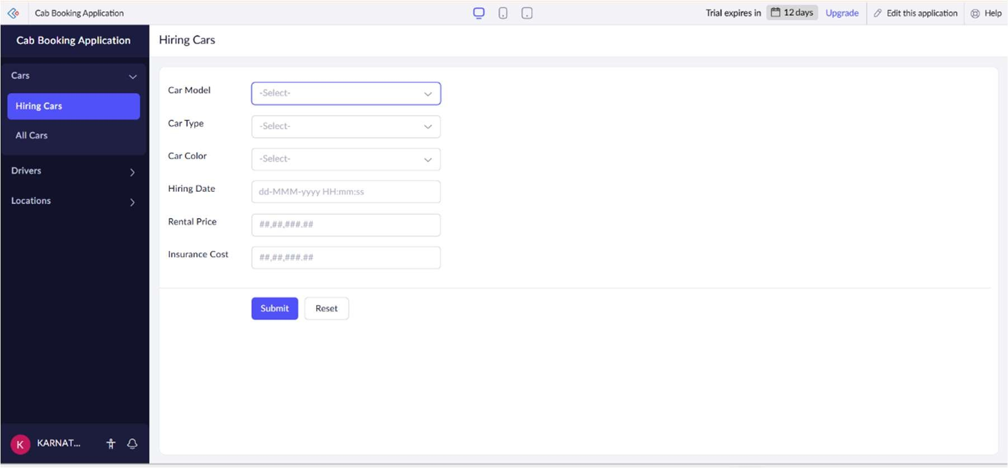

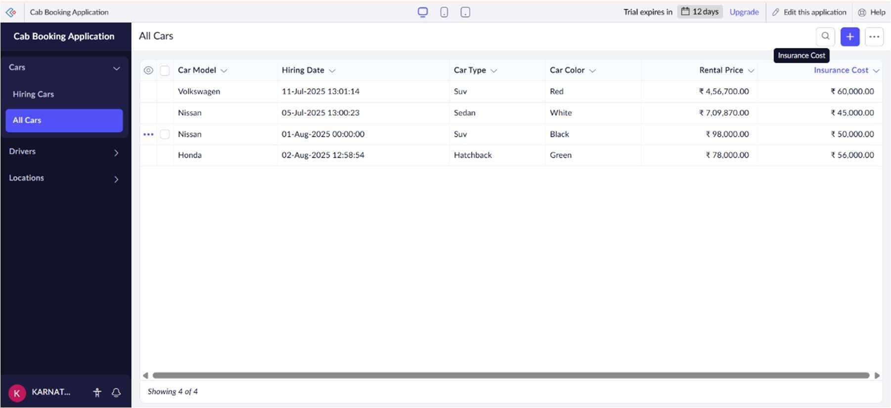

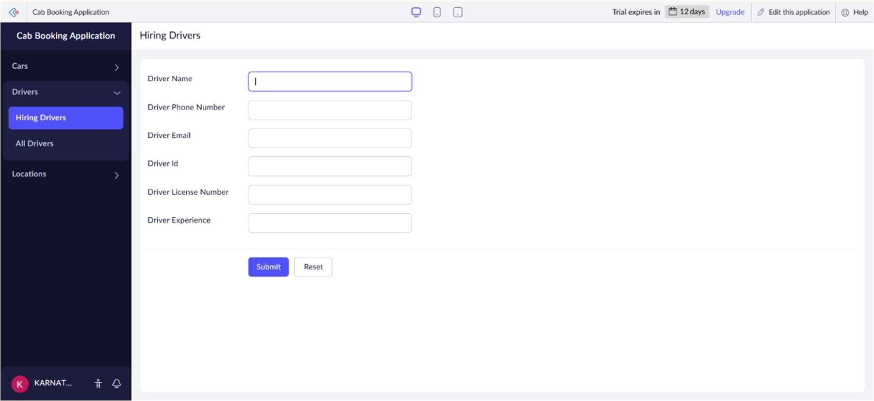

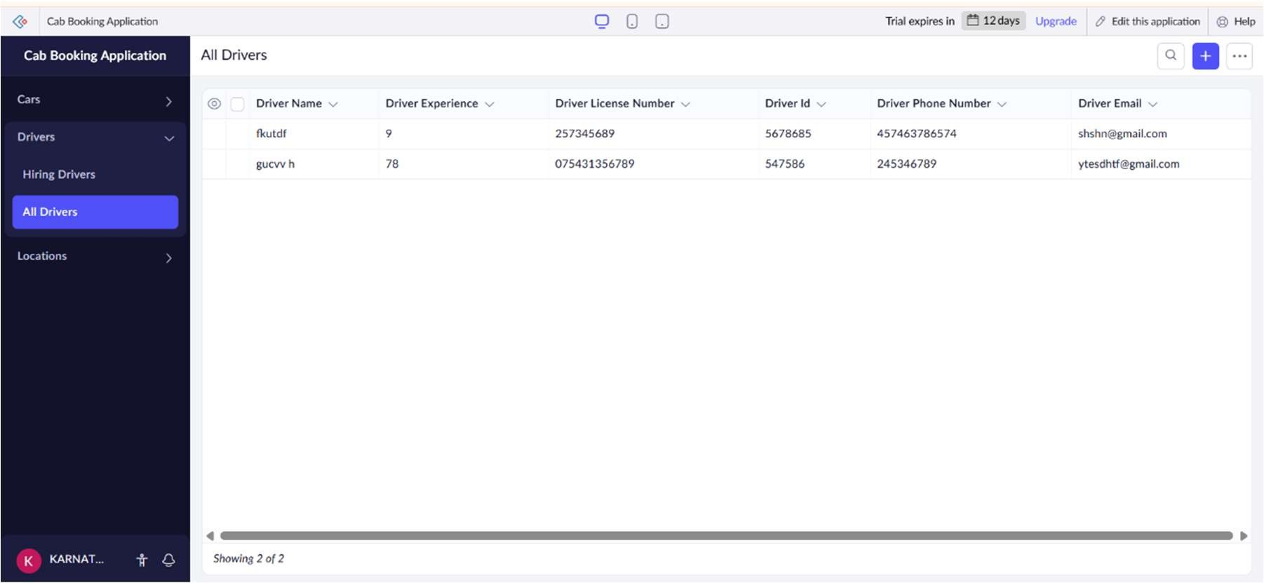

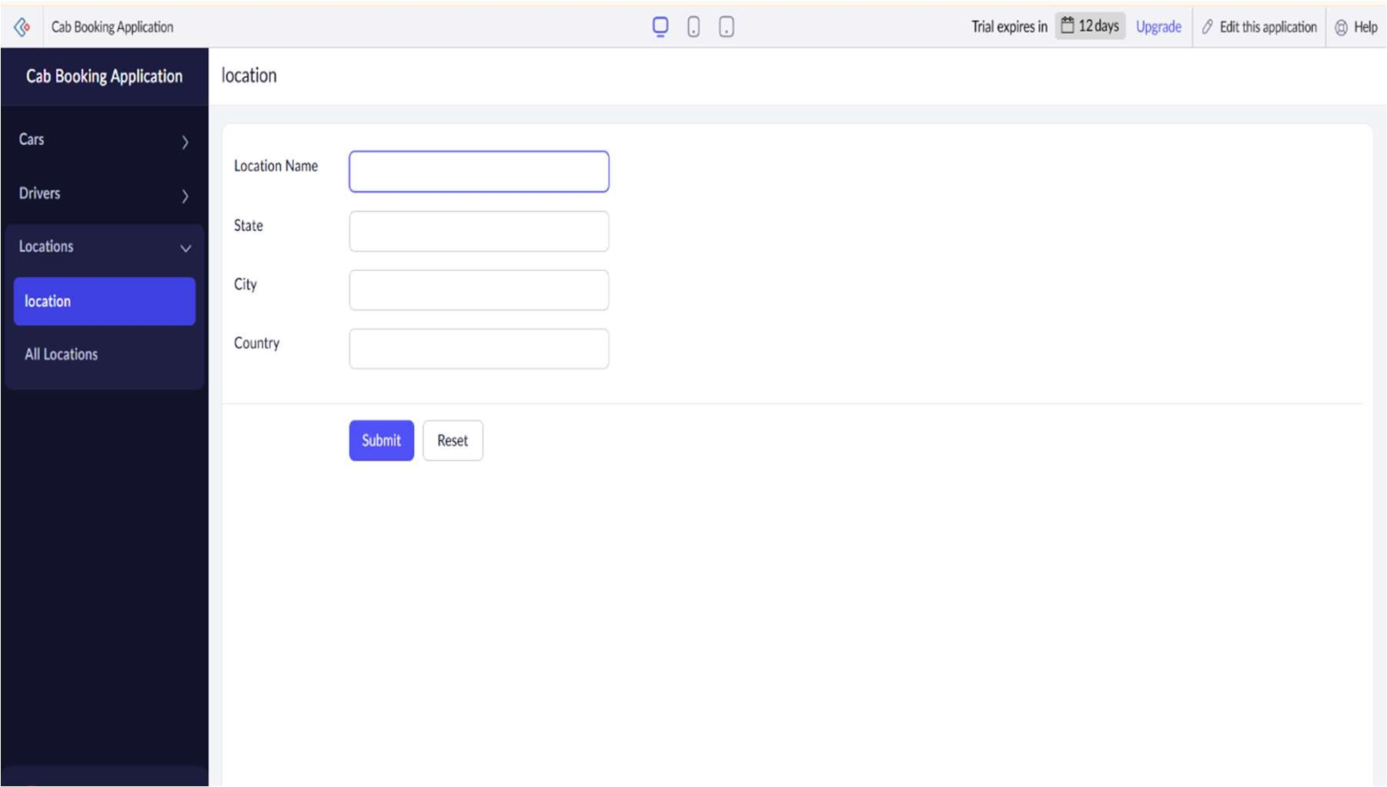

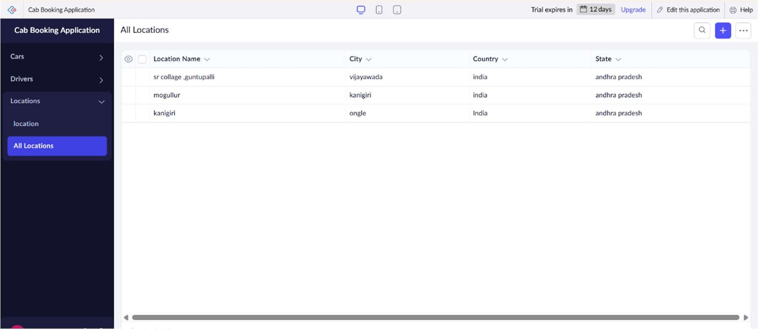

RESULT:

Thus, the Car Booking Reservation System cloud software application was successfully developed and deployed using Zoho Creator. The application was tested and verified for proper functionality. It demonstrated the key features of Software as a Service (SaaS), allowing users to access and manage car bookings over the internet in real-time.