**Devadharshini. S**

|  |
| --- |
| **B.Tech.(Information Technology)** |
| MailID:[**sdevasekar2002@gmail.com**](mailto:sdevasekar2002@gmail.com)  Mobile:**6382600140** |

**OBJECTIVES:**

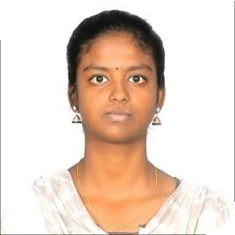

A smart working and self-motivated student looking for a job to build a technical skills and knowledge with a bachelor’s degree in Information Technology.

**EDUCATION:**

|  |  |  |  |
| --- | --- | --- | --- |
| **QUALIFICATION** | **BOARD/UNIVERSITY** | **YEAR** | **PERCENTAGE** |
| B.Tech.(Information Technology) | IFET College of Engineering, Gangarampalayam.(autonomous institute) | 2019-2023 | 8.47 CGPA |
| HSC | Govt. Hr. Sec. school, V. Puthur  (State Board Examinations) | 2019 | 76% |
| SSLC | Govt. Hr . Sec. school, V. Puthur  (State Board Examinations) | 2017 | 88.6% |

**TECHNICALSKILLS:**

Basics of

# C, Java, Python.

# Asp.Net

**INTERNSHIP:**

* Cloud Logic Technologies, Pondicherry.
* Aspire Systems, Chennai(Online Mode).

**MINIPROJECTS:**

* Project Title1 :**Online Assignment Plagiarism Checker**
  + - * Project language:**Java**
      * Duration :**One month**
* Project Titl2 :**Employee Leave Management System**
  + - * Project language :**Dotnet**
      * Duration : **Three months**

**PERSONALSKILLS:**

* Quick Learner & Self Motivator.
* Flexible & Excellent Team Player.

**PERSONALDETAILS:**

|  |  |  |
| --- | --- | --- |
| Name | **:** | Devadharshini S |
| Gender | **:** | Female |
| Date ofBirth | **:** | 15.08.2002 |
| Religion | **:** | Hindu |
| Nationality | **:** | Indian |
| Languages Known | **:** | English,Tamil |
| Residential Address | **:** | 1/5,North(st),Emapper,  V.Puthur(po),Villupuram(DT),  TamilNadu |

**DECLARATION:**

Ihere by declare that the information furnished above is true to the best of my

knowledge and belief.

**Place:** your faithfully,

# Date: DEVADHARSHINI.S