DAY2-SET2

Qn1: Insurance Claims Processing

claim_ids = [105, 103, 108, 101, 104, 107, 110]

Insertion:
INSERT(root, value)
IF root is NULL
CREATE a new node with value
RETURN the new node
IF value < root.data
root.left = INSERT(root.left, value)
ELSE IF value > root.data
root.right = INSERT(root.right, value)
RETURN root

Search:
SEARCH(root, target)
IF root is NULL
RETURN NOT FOUND
IF root.data == target
RETURN FOUND
IF target < root.data
RETURN SEARCH(root.left, target)
ELSE
RETURN SEARCH(root.right, target)

Inorder traversel is responsible for sorted order.

Inorder:
SEARCH(root, target)
IF root is NULL
RETURN NOT FOUND
IF root.data == target
RETURN FOUND
IF target < root.data
RETURN SEARCH(root.left, target)
ELSE
RETURN SEARCH(root.right, target)

Qn2: Hashing: Duplicate and Near-Duplicate Insurance Claims
Check whether the policy number is repeated in the insurance claims dataset. If the same policy number appears again, compare its incident date with the previously recorded incident date. If both dates are the same, classify it as a duplicate claim. If the date difference is within 3 days, classify it as a near-duplicate claim.

Pseudocode:
CREATE an empty HASH MAP
FOR each claim:
policy = claim.policy_number
date = claim.incident_date
IF policy exists in HASH MAP:
FOR each old_date in HASH MAP[policy]:
IF old_date == date:
PRINT "Duplicate claim"
ELSE IF difference between dates <= 3 days:
PRINT "Near-duplicate claim"
ADD date to HASH MAP[policy]
ELSE:
CREATE a new entry
HASH MAP[policy] = [date]

Sample Input:
claims = [
(105, "POL101", "2026-10-01"),
(103, "POL102", "2026-10-02"),
(108, "POL103", "2026-10-03"),
(101, "POL101", "2026-10-01"),
(104, "POL105", "2026-10-05"),
(107, "POL106", "2026-10-06"),
(110, "POL102", "2026-10-04")
]

Output:
Duplicate Claim ID: 101
Near-Duplicate Claim ID: 110

Qn3: Graphs: Insurance Claims Processing Dependencies
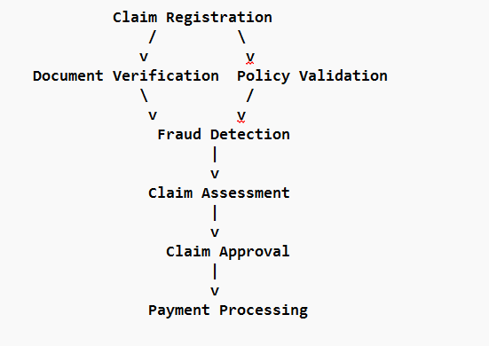

BFS-Finding the shortest path

BFS_SHORTEST_PATH(graph, start, target):
CREATE an empty queue
CREATE an empty visited set
CREATE a parent dictionary
ADD start to queue
ADD start to visited
parent[start] = NULL
WHILE queue is not empty:
current = REMOVE from queue
IF current == target:
BREAK
FOR each neighbor in graph[current]:
IF neighbor is not visited:
ADD neighbor to visited
parent[neighbor] = current
ADD neighbor to queue
IF target is not visited:
PRINT "Path not found"
RETURN
path = empty list
current = target
WHILE current is not NULL:
ADD current to path
current = parent[current]
REVERSE path
PRINT path

Cycle Detection using DFS:

DFS_CYCLE(graph, node, visited, recursion_stack):
ADD node to visited
ADD node to recursion_stack
FOR each neighbor in graph[node]:
IF neighbor is not visited:
IF DFS_CYCLE(neighbor, visited, recursion_stack):
RETURN TRUE
ELSE IF neighbor is in recursion_stack:
RETURN TRUE
REMOVE node from recursion_stack
RETURN FALSE

Qn4: Sliding Window: Insurance Claims Analysis

The longest consecutive period (days) during which the number of insurance claims exceeds 100 per day.

Pseudocode:

START
SET count = 0
SET max_count = 0
FOR each day's claim count:
IF claim count > 100:
INCREMENT count
IF count > max_count:
max_count = count
ELSE:
RESET count = 0
PRINT Longest consecutive days: max_count
STOP

Sample Input:
claims_per_day = [120, 90, 130, 110, 150, 80, 140]

Output:
Longest consecutive days: 3

Qn5: Two Pointers: Insurance Claim Amounts

We need to find all pairs of claim amounts whose sum equals a given target amount (gift-card value).

Pseudocode:
SORT the claim_amounts
SET count=0
SET left = 0
SET right = length - 1
WHILE left < right:
sum = claim_amounts[left] + claim_amounts[right]
IF sum == target:
INCREMENT count
left = left + 1
right = right - 1
ELSE IF sum < target:
left = left + 1
ELSE:
right = right – 1
PRINT TOTAL PAIRS FOUND:

Sample Input:
claim_amounts = [15000, 25000, 18000, 30000, 12000, 22000, 28000]
target = 40000

Output:
Total pairs found: 3

