**Expt No 06:**

Create a simple cloud software application for Payroll Processing System using any Cloud Service Provider to demonstrate SaaS include the necessary fields such as Name of the employee, experience in present org , over all experience, basic pay, HRA, DA, TA, net pay, gross pay etc.

**Date:** 22/02/2024

**Aim:**

To Create a simple cloud software application for Payroll Processing System using any Cloud Service Provider to demonstrate SaaS include the necessary fields such as Name of the employee, experience in present org , over all experience, basic pay, HRA, DA, TA, net pay, gross pay etc.

**STEP 01:**

Open a Zoho web application and click a Create a New application and Create a New Component And select a Component Type as Form Type.

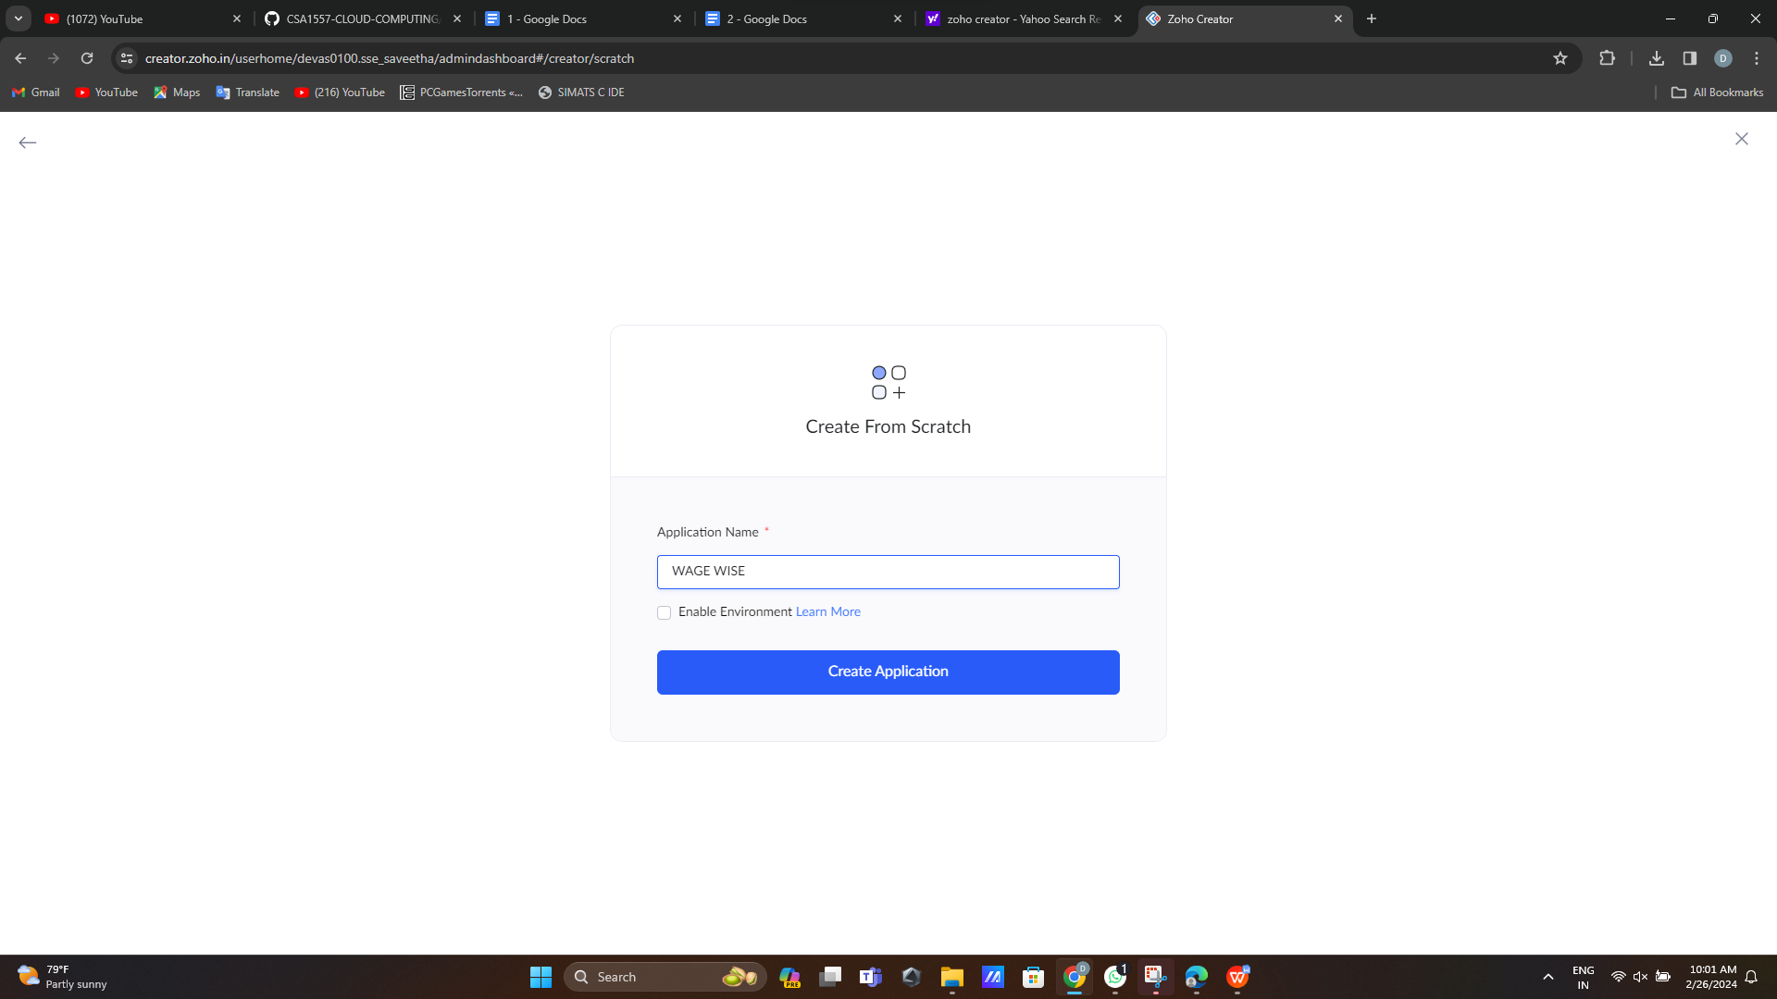 **step 2: create login form**

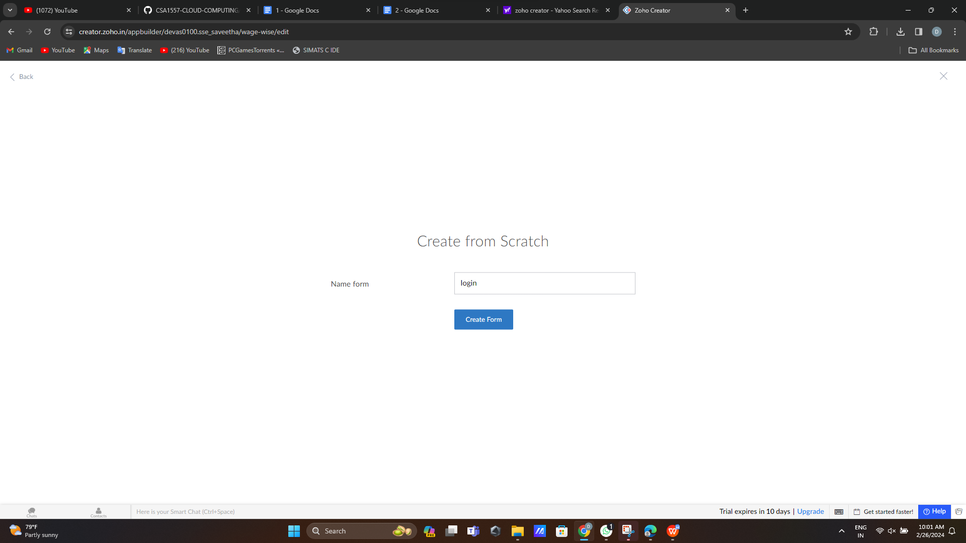**step 3:**

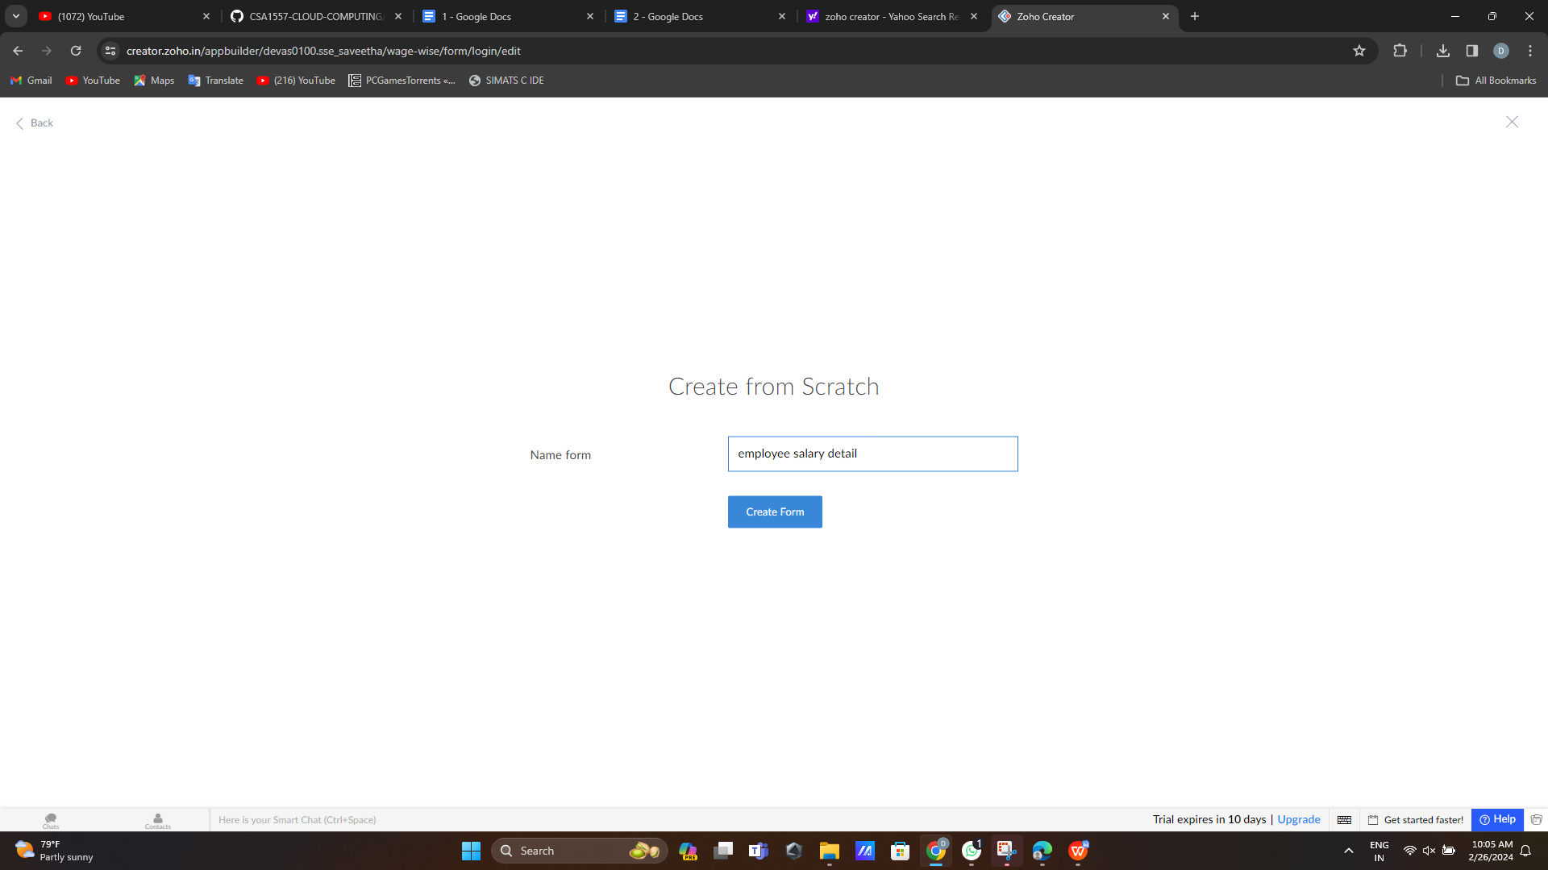step 4: create employee salary details 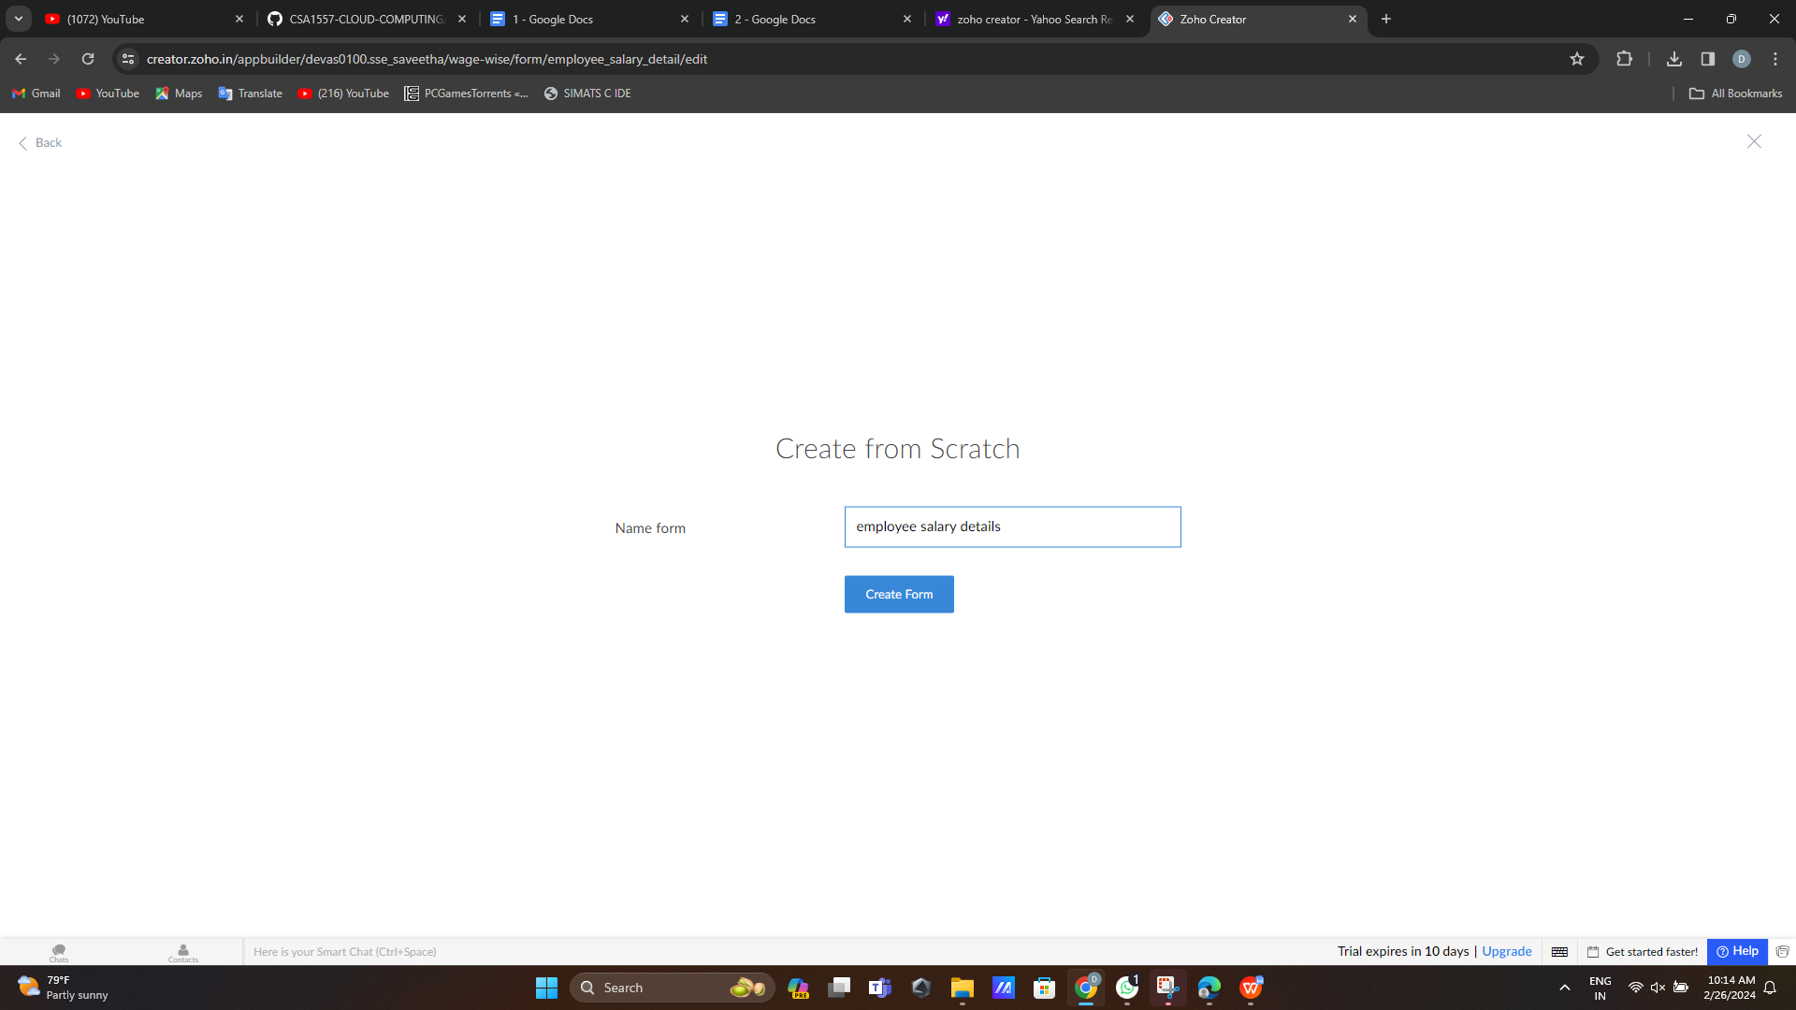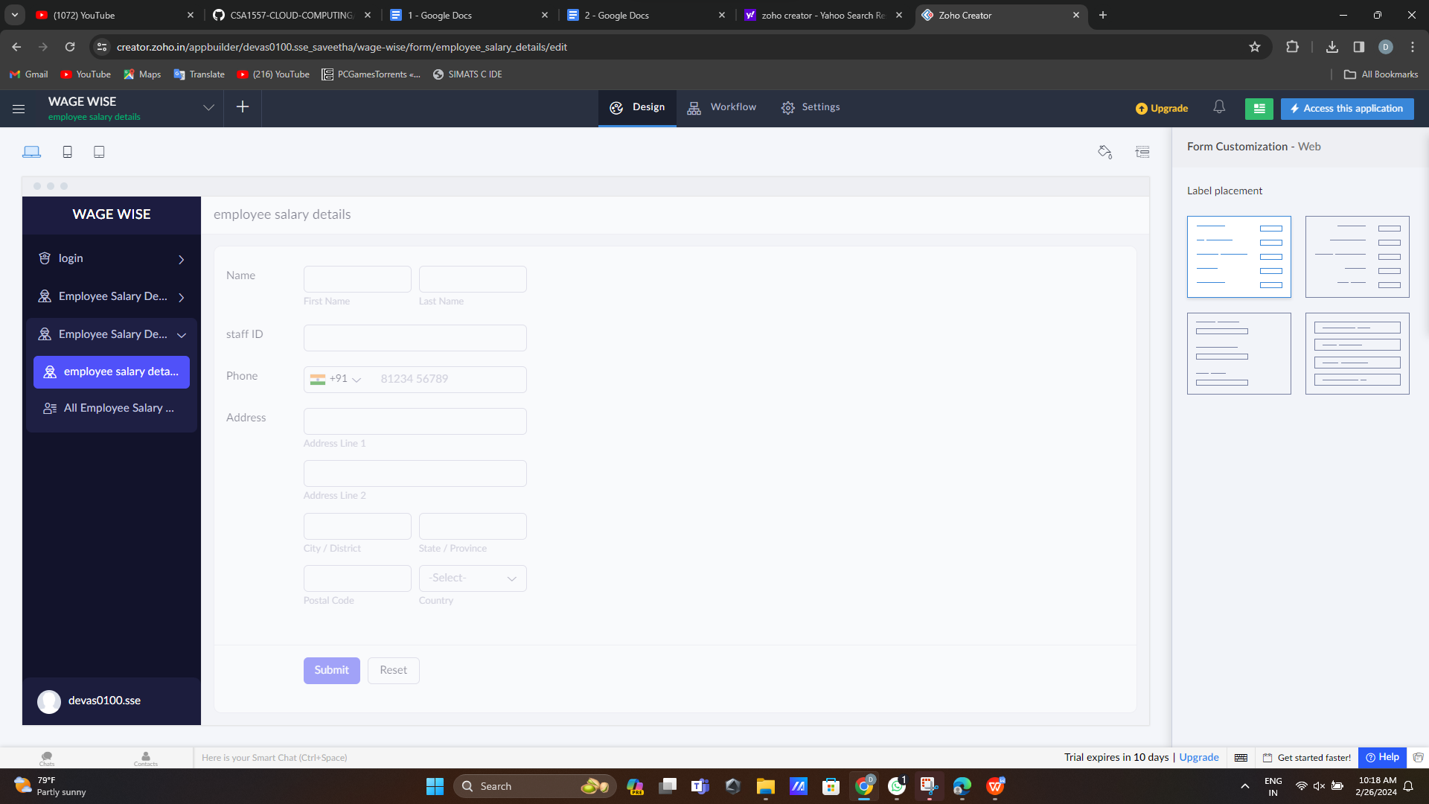step 5: create logout form

