**Expt No 08:**

Create a simple cloud web application for student counselling system using any Cloud Service Provider to demonstrate SaaS with the fields of student name, age, address, phone, subjects studied, Year of passing, percentage of marks, domain interest, etc.

**Date:** 22/02/2024

**Aim:**

To Create a simple cloud web application for student counselling system using any Cloud Service Provider to demonstrate SaaS with the fields of student name, age, address, phone, subjects studied, Year of passing, percentage of marks, domain interest, etc.

**STEP 01:**

Open a Zoho web application and click a Create a New application and Create a New Component And select a Component Type as Form Type.

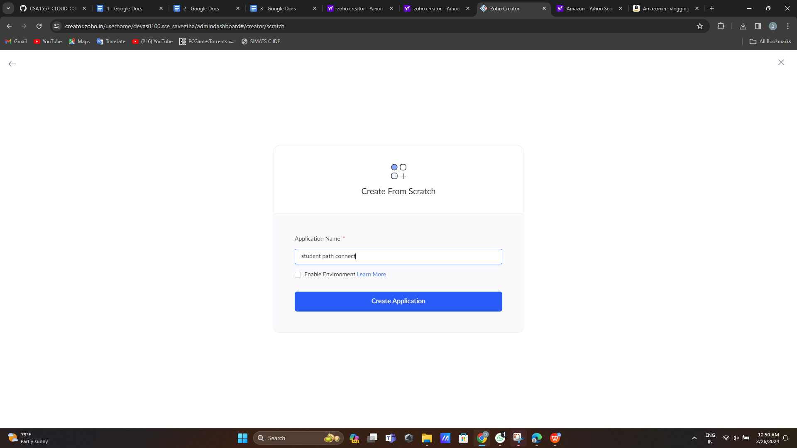step 2:**create login form**

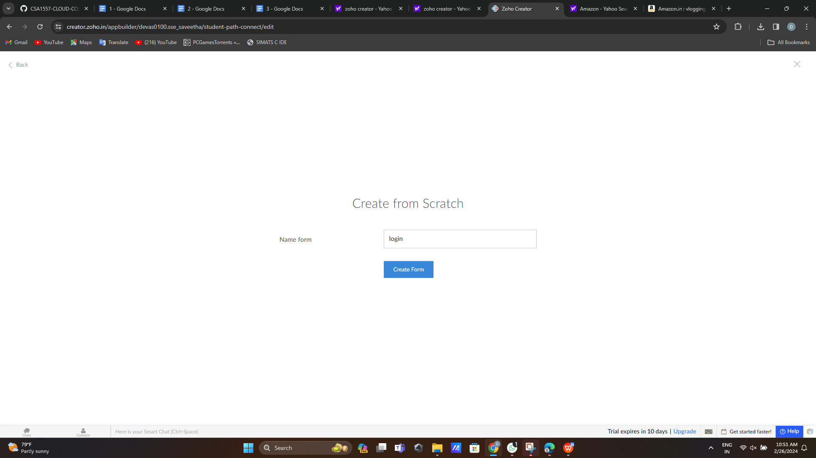**s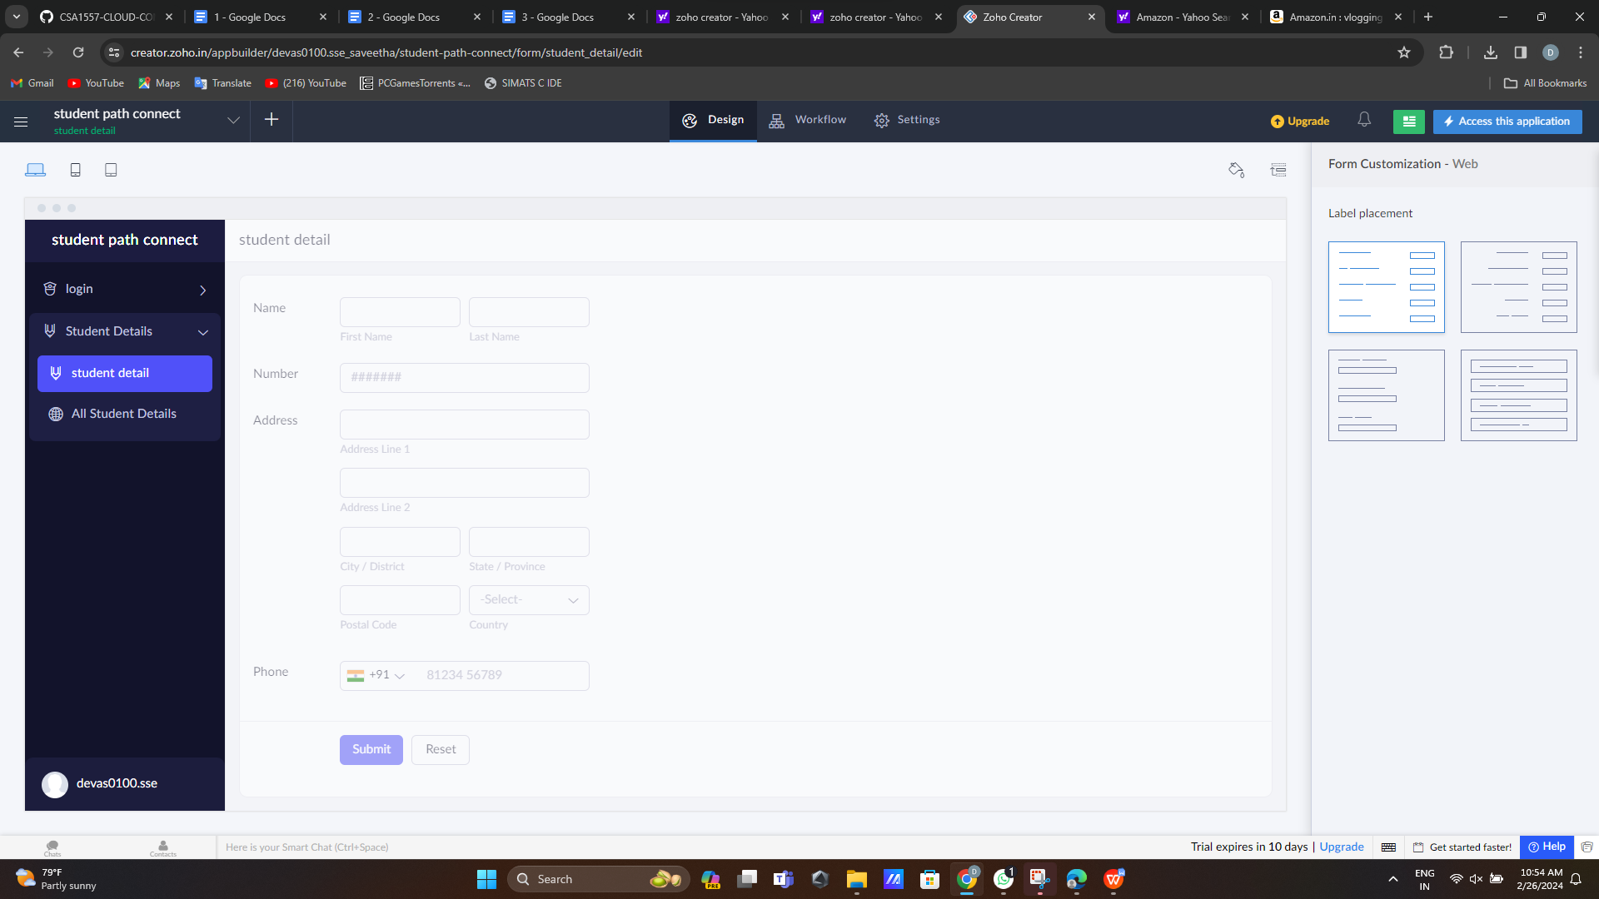step 3: create bookig form**

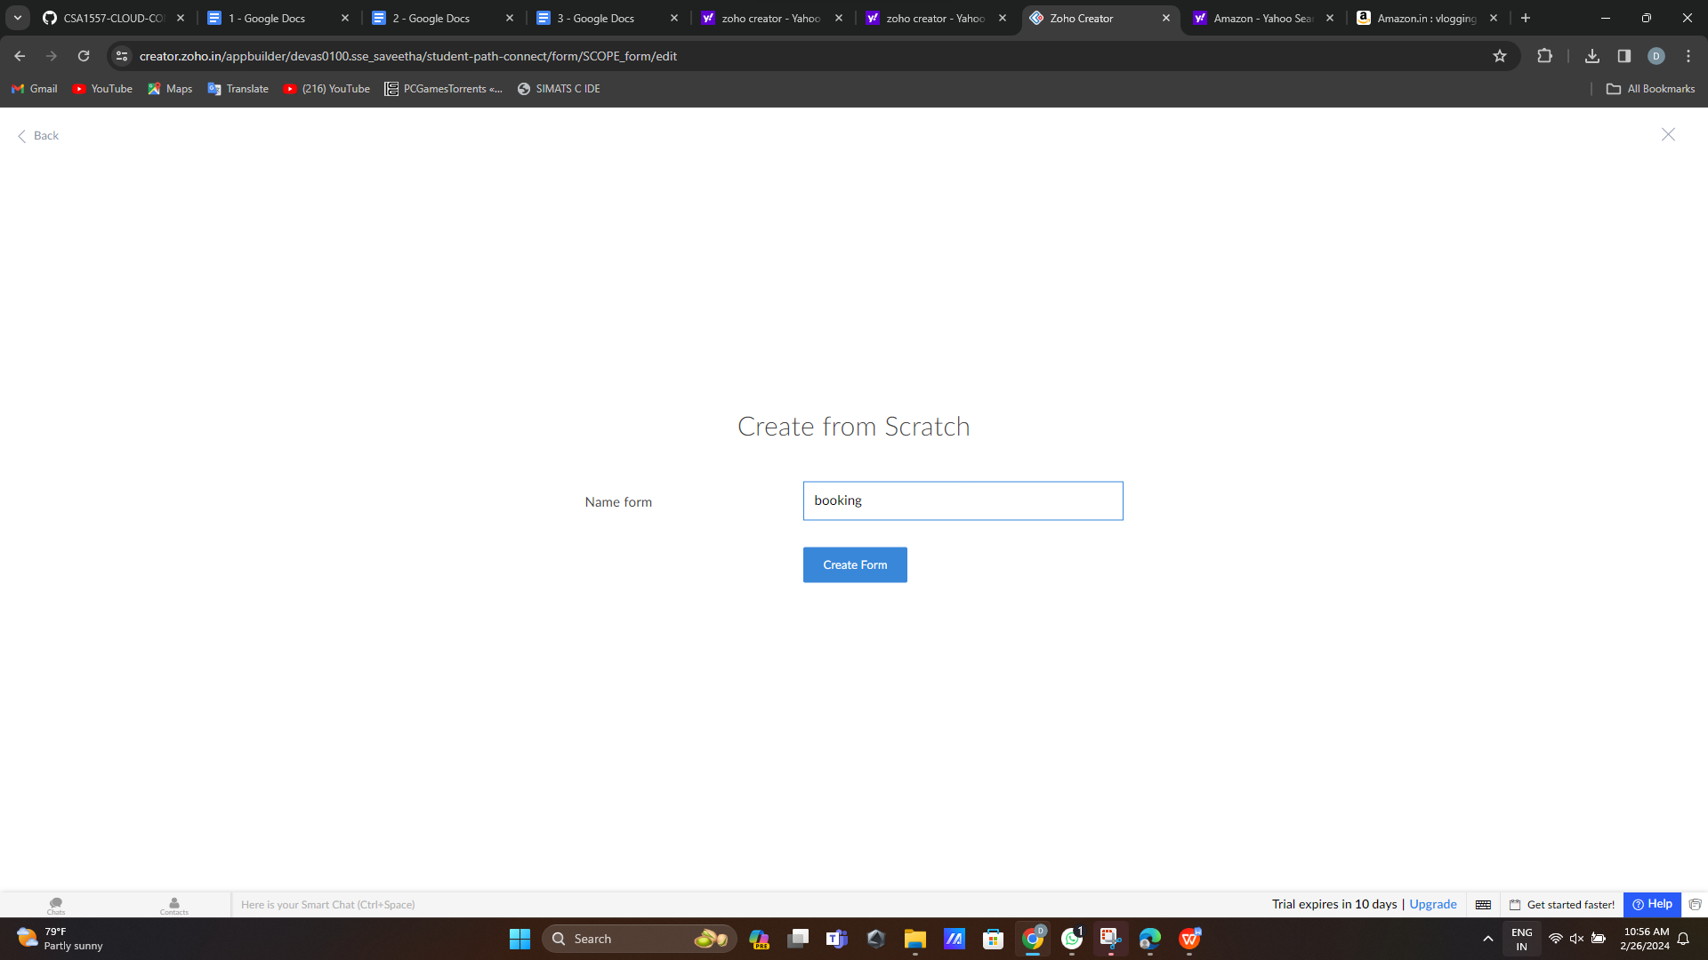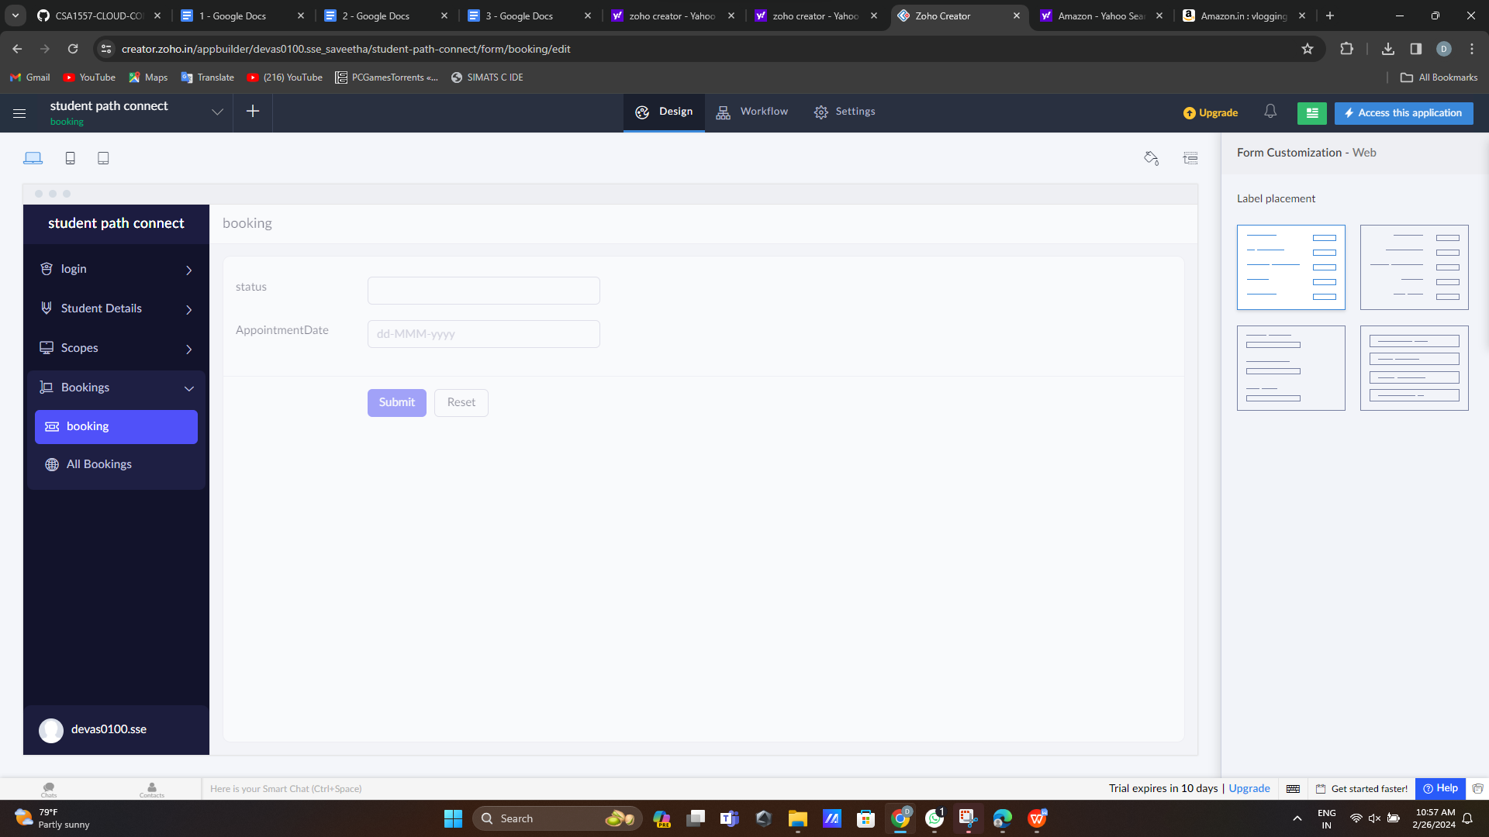**step 6:. Create sign out**

