Looker Deep Dive: Looks and Dashboards

by [Queeny Srivastava](https://acrotrend.com/author/queenysrivastava/) | [Business Intelligence](https://acrotrend.com/category/business-intelligence/), [Hands On](https://acrotrend.com/category/blog/hands-on/), [Visualisation](https://acrotrend.com/category/blog/visualisation/)

In earlier blogs we gave an [*introduction on Looker*](https://www.acrotrend.com/an-introduction-to-looker/) and in the subsequent one discussed about some [*advanced functionalities available in LookML*](https://www.acrotrend.com/deep-dive-on-looker-liquid-parameter-and-templated-filters/). In this blog we will cover the visualization layer of Looker and will talk about some unique possibilities from the same.

Looker is a cloud-based business intelligence (BI) platform designed to explore and analyze data. The solution helps businesses to capture and analyze data from multiple sources and make data-driven decisions.

Looker provides business teams the ability to analyze supply chains, market digitally, quantify customer value, interpret customer behavior, and evaluate distribution processes. Users can also “view source” to understand how the data they are viewing is being manipulated. The dashboards allow presenting data and insights using customizable charts, graphs and reports. All dashboards and queries can be drilled into, so users can discover information in multiple layers. Looks and dashboards are the two major building blocks in Looker.

**Looks:**

Looks are the saved visualizations that can be created by the Business User. These single visualizations are created in the explore section of the Looker and are used to understand and analyze the data. These Looks can be shared and reused in multiple other dashboard implementations.

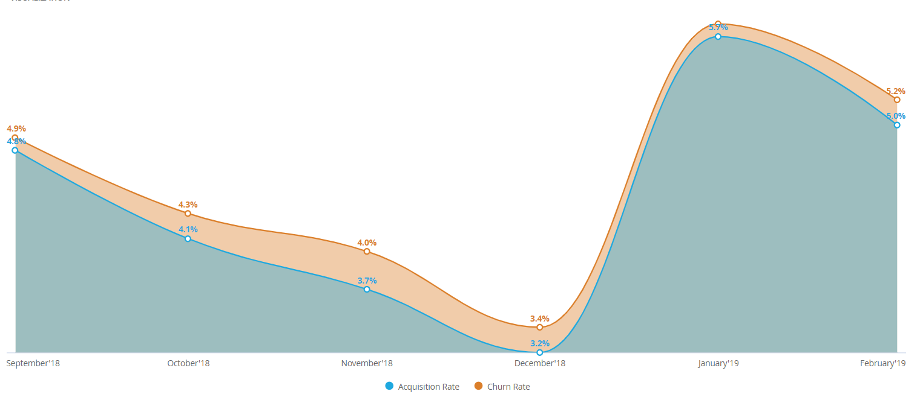**Dashboards:**

Dashboards allow you to place multiple tables or graphs or looks on one page, so that you can get a quick view of the related content. If you like, you can also make dashboards interactive, so that users can filter them down to the specific data they are interested in.

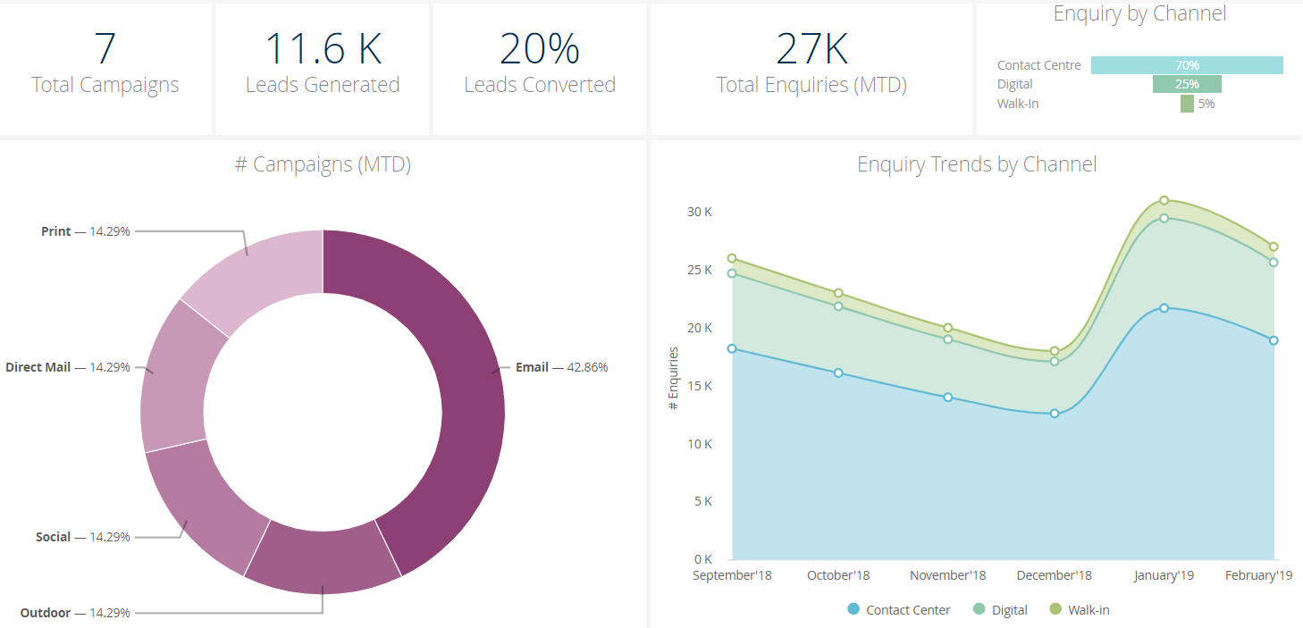Now that we have understood the basic layout of Looks and Dashboards in the Looker Software, let us delve into understanding some new and unique features that we can implement in our dashboards to make them more interactive and aesthetically pleasing.

1. **Customize Drill Downs**

One of the interesting things about Looker is that it connects to the database directly, so we always get the fresh data for analysis. The dashboards provide the functionality to drill down into the data of the graphs and tables created and help us understand it on a granular level. For example, to understand the churn pattern of customers in a gym we investigated the customer visits, age distribution and their customer service touch points for the complaints they have registered.

With the overall view of the dashboard we can understand the number of customers that belong to the complaints that are registered. When we further drill into the problem, we also want to look at what are those specific complaint words that are being reported by these churning customers that can help us eliminate those problems and in turn reduce the churn rate. We thus provide the functionality to further drill into the touch points graph as shown below:



1. **Hyperlinks on Dashboards**

How many times have you come across a situation where you wanted to add-in a link on the current dashboard to a webpage, visualization or dashboard? Looker provides an easy solution to this problem with its Hyperlinking feature on the dashboards. You can create a hyper link to another visual, dashboard and even a webpage search.

Looker uses its **Link**Parameter to achieve this functionality, it is included in the dimensions as,

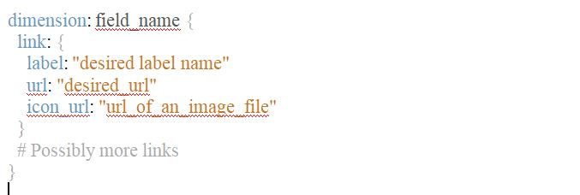

A few examples to understand the use of this are listed below,

* You can use the link parameter to provide a link to another explore page on the dimension that is being used in the current visual. Link helps you generate hyperlinks that are not otherwise created directly using the drill_fields functionality.

Suppose you want to give the functionality of exploring the city sales visuals on the basis of user city,

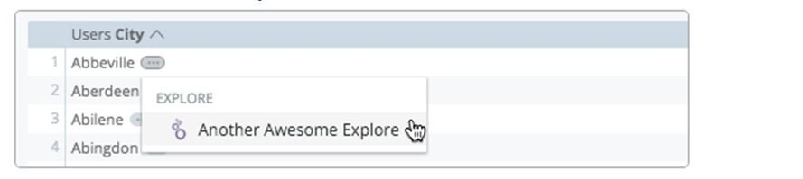

* The linkparameter supports Liquid variables to make links dynamic. For example, suppose you had an artist_name dimension, and wanted the user to have the option of executing a Google search for that artist. You could use the value Liquid variable to create a dimension like the following:

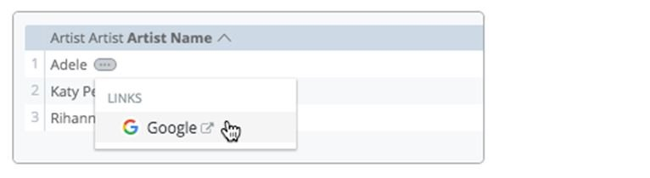

* You can also link another new dashboard to the dimensions in the view. This can be useful functionality if you plan to implement the drill down dashboards to understand the granularity of your data. Liquid variable supported by the link parameter to implement this is, **is _filters[‘view_name.field_name’].** This variable takes the values entered for a filter and passes them on to a linked query, dashboard, or Look.

For example, when you are viewing the churn rates by sites, you can further drill down to understand the reason and distribution of churn rates based on customer age, visits or touch points.



1. **Custom Visuals in dashboards**

Your visualizations can now be made aesthetically pleasing using the custom visual implementation functionality of Looker. You can implement some fancy visuals like Sankey charts, Liquid Gauge, Bubble Charts etc. The visuals generated can be stored as a Look and used in dashboards.

You can add the custom visualizations that are available freely on Looker (<https://looker.com/platform/blocks/directory#viz>).

Below you can see the implementation of a Liquid Gauge visual in the dashboards to represent the percentage of revenue growth against previous year.



These are not limited to only the ones already available, but you can create your own visuals using JavaScript.

1. **Themes in Looker Dashboards**

It is often observed that different organizations prefer all their content to have the same theme to maintain the consistency of the content shared across. Looker helps in achieving this goal of your organization with its Themes feature currently available in the Embedded versions of the dashboards. You can define your own customized theme with organization specific fonts and colors of texts and backgrounds. Here’s a sample of the embedded version of our Churn Analysis use case, which reflects customized font and color changes.

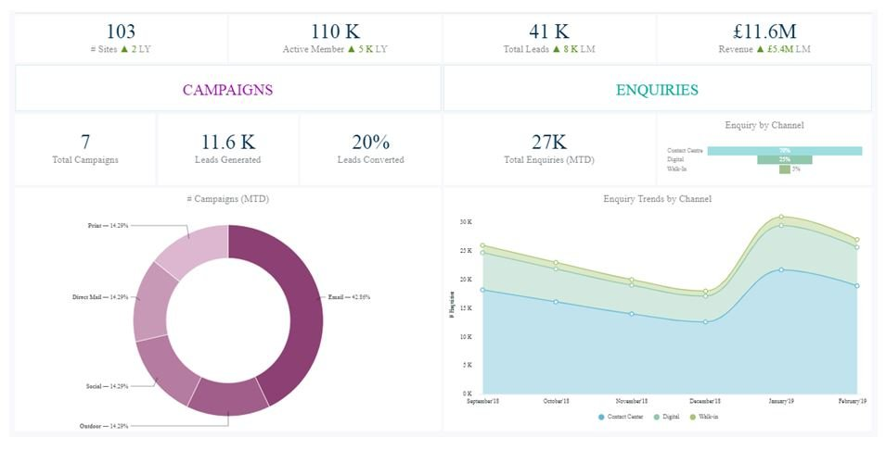

These were some new and unique features of Looker dashboards, which can help you develop more efficient set of dashboards and help your business engage with their data in a better way.

Looker is coming up with very exciting new features in upcoming releases. [Click here](https://looker.com/blog/custom-applications-for-sales-and-marketing?) to read more about the new applications feature.

Stay tuned for more such unique & exciting features.

We have implemented multiple Looker dashboards which include a lot of advanced looker functionalities. To know more and see our work, please [contact us](https://www.acrotrend.com/contact-us/).

At Acrotrend we help our clients get the right insights from the data. If you are struggling to get the right insights from your data or want to develop BI reports for your organization, then get in touch today.