## The HTML DOM (Document Object Model)

When a web page is loaded, the browser creates a ****D****ocument ****O****bject ****M****odel of the page.

The ****HTML DOM**** model is constructed as a tree of ****Objects****:

### The HTML DOM Tree of Objects

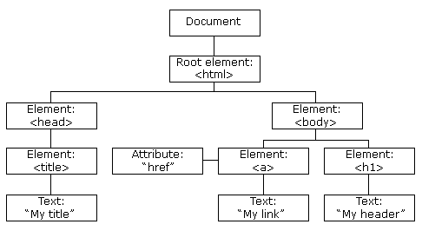

With the object model, JavaScript gets all the power it needs to create dynamic HTML:

* JavaScript can change all the HTML elements in the page
* JavaScript can change all the HTML attributes in the page
* JavaScript can change all the CSS styles in the page
* JavaScript can remove existing HTML elements and attributes
* JavaScript can add new HTML elements and attributes
* JavaScript can react to all existing HTML events in the page
* JavaScript can create new HTML events in the page

## What You Will Learn

In the next chapters of this tutorial you will learn:

* How to change the content of HTML elements
* How to change the style (CSS) of HTML elements
* How to react to HTML DOM events
* How to add and delete HTML elements

ADVERTISEMENT

## What is the DOM?

The DOM is a W3C (World Wide Web Consortium) standard.

The DOM defines a standard for accessing documents:

*"The W3C Document Object Model (DOM) is a platform and language-neutral interface that allows programs and scripts to dynamically access and update the content, structure, and style of a document."*

The W3C DOM standard is separated into 3 different parts:

* Core DOM - standard model for all document types
* XML DOM - standard model for XML documents
* HTML DOM - standard model for HTML documents

## What is the HTML DOM?

The HTML DOM is a standard ****object**** model and ****programming interface**** for HTML. It defines:

* The HTML elements as **objects**
* The **properties** of all HTML elements
* The **methods** to access all HTML elements
* The ****events**** for all HTML elements

In other words:**The HTML DOM is a standard for how to get, change, add, or delete HTML elements.**

HTML DOM methods are ****actions**** you can perform (on HTML Elements).

HTML DOM properties are ****values**** (of HTML Elements) that you can set or change.

## The DOM Programming Interface

The HTML DOM can be accessed with JavaScript (and with other programming languages).

In the DOM, all HTML elements are defined as ****objects****.

The programming interface is the properties and methods of each object.

A **property** is a value that you can get or set (like changing the content of an HTML element).

A **method** is an action you can do (like add or deleting an HTML element).

## Example

The following example changes the content (the innerHTML) of the <p> element with id="demo":

<!DOCTYPE html>

<html>

<body>

<h2>My First Page</h2>

<p id="demo"></p>

<script>

document.getElementById("demo").innerHTML = "Hello World!";

</script>

</body>

</html>

## OUTPUT:

## My First Page

Hello World!

In the example above, getElementById is a ****method****, while innerHTML is a ****property****.

## The getElementById Method

The most common way to access an HTML element is to use the id of the element.

In the example above the getElementById method used id="demo" to find the element.

## The innerHTML Property

The easiest way to get the content of an element is by using the innerHTML property.

The innerHTML property is useful for getting or replacing the content of HTML elements.

The innerHTML property can be used to get or change any HTML element, including <html> and <body>.

The HTML DOM document object is the owner of all other objects in your web page.

## The HTML DOM Document Object

The document object represents your web page.

If you want to access any element in an HTML page, you always start with accessing the document object.

Below are some examples of how you can use the document object to access and manipulate HTML.

## Finding HTML Elements

|  |  |
| --- | --- |
| **Method** | **Description** |
| document.getElementById(id) | Find an element by element id |
| document.getElementsByTagName(name) | Find elements by tag name |
| document.getElementsByClassName(name) | Find elements by class name |

## Changing HTML Elements

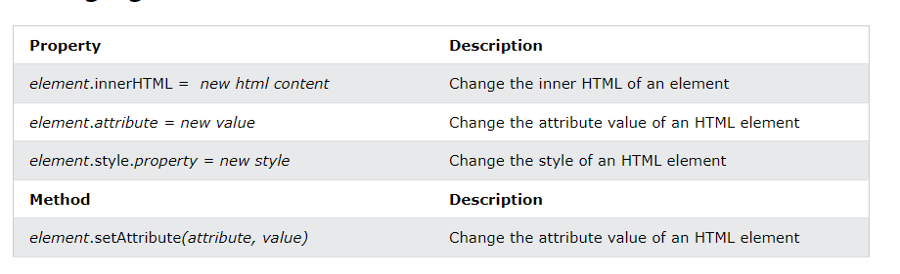

## Adding and Deleting Elements

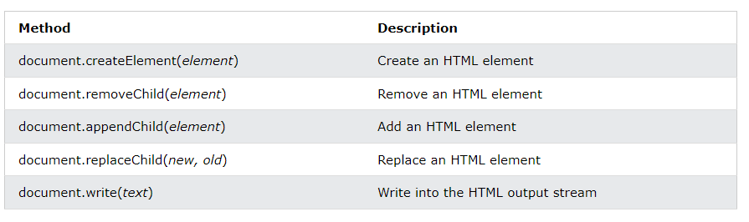

## Adding Events Handlers

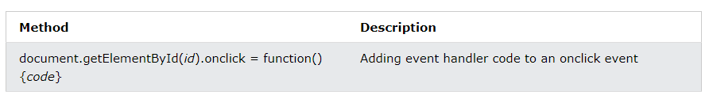

## Finding HTML Elements

Often, with JavaScript, you want to manipulate HTML elements.

To do so, you have to find the elements first. There are several ways to do this:

* Finding HTML elements by id
* Finding HTML elements by tag name
* Finding HTML elements by class name
* Finding HTML elements by CSS selectors
* Finding HTML elements by HTML object collections

## Finding HTML Element by Id

The easiest way to find an HTML element in the DOM, is by using the element id.

This example finds the element with id="intro":

### Example

<!DOCTYPE html>

<html>

<body>

<h2>JavaScript HTML DOM</h2>

<p id="intro">Finding HTML Elements by Id</p>

<p>This example demonstrates the <b>getElementsById</b> method.</p>

<p id="demo"></p>

<script>

const element = document.getElementById("intro");

document.getElementById("demo").innerHTML =

"The text from the intro paragraph is: " + element.innerHTML;

</script>

</body>

</html>

**OUTPUT:**

## JavaScript HTML DOM

Finding HTML Elements by Id

This example demonstrates the **getElementsById** method.

The text from the intro paragraph is: Finding HTML Elements by Id

If the element is found, the method will return the element as an object (in element).

If the element is not found, element will contain null.

## Finding HTML Elements by Tag Name

This example finds all <p> elements:

### Example

<!DOCTYPE html>

<html>

<body>

<h2>JavaScript HTML DOM</h2>

<p>Finding HTML Elements by Tag Name.</p>

<p>This example demonstrates the <b>getElementsByTagName</b> method.</p>

<p id="demo"></p>

<script>

const element = document.getElementsByTagName("p");

document.getElementById("demo").innerHTML = 'The text in first paragraph (index 0) is: ' + element[0].innerHTML;

</script>

</body>

</html>

**OUTPUT:**

## JavaScript HTML DOM

Finding HTML Elements by Tag Name.

This example demonstrates the **getElementsByTagName** method.

The text in first paragraph (index 0) is: Finding HTML Elements by Tag Name.

## Finding HTML Elements by Class Name

If you want to find all HTML elements with the same class name, use getElementsByClassName().

This example returns a list of all elements with class="intro".

### Example

<!DOCTYPE html>

<html>

<body>

<h2>JavaScript HTML DOM</h2>

<p>Finding HTML Elements by Class Name.</p>

<p class="intro">Hello World!</p>

<p class="intro">This example demonstrates the <b>getElementsByClassName</b> method.</p>

<p id="demo"></p>

<script>

const x = document.getElementsByClassName("intro");

document.getElementById("demo").innerHTML =

'The first paragraph (index 1) with class="intro" is: ' + x[1].innerHTML;

</script>

</body>

</html>

**OUTPUT:**

## JavaScript HTML DOM

Finding HTML Elements by Class Name.

Hello World!

This example demonstrates the **getElementsByClassName** method.

The first paragraph (index 1) with class="intro" is: This example demonstrates the **getElementsByClassName** method.

## Changing HTML Content

The easiest way to modify the content of an HTML element is by using the innerHTML property.

To change the content of an HTML element, use this syntax:

document.getElementById(*id*).innerHTML =*new HTML*

This example changes the content of a <p> element:

### Example

<html>  
<body>  
  
<p id="p1">Hello World!</p>  
  
<script>  
document.getElementById("p1").innerHTML = "New text!";  
</script>  
  
</body>  
</html>

**OUTPUT:**

## JavaScript can Change HTML

New text!

The paragraph above was changed by a script.

This example changes the content of an <h1> element:

### Example

<!DOCTYPE html>  
<html>  
<body>  
  
<h1 id="id01">Old Heading</h1>  
  
<script>  
const element = document.getElementById("id01");  
element.innerHTML = "New Heading";  
</script>  
  
</body>  
</html>

**OUTPUT:**

# New Heading

JavaScript changed "Old Heading" to "New Heading".

## Changing the Value of an Attribute

To change the value of an HTML attribute, use this syntax:

document.getElementById(*id*).*attribute = new value*

This example changes the value of the src attribute of an <img> element:

### Example

<!DOCTYPE html>  
<html>  
<body>  
  
<img id="myImage" src="smiley.gif">  
  
<script>  
document.getElementById("myImage").src = "landscape.jpg";  
</script>  
  
</body>  
</html>

OUTPUT:

## JavaScript HTML DOM



The original image was smiley.gif, but the script changed it to landscape.jpg

## Dynamic HTML content

JavaScript can create dynamic HTML content:

Date : Tue Feb 27 2024 14:55:45 GMT+0530 (India Standard Time)

### Example

<!DOCTYPE html>  
<html>  
<body>  
  
<script>  
document.getElementById("demo").innerHTML = "Date : " + Date(); </script>  
  
</body>  
</html>

OUTPUT:

Date : Tue Feb 27 2024 15:03:09 GMT+0530 (India Standard Time)