Secure Provider Acquisition for HCP Terraform Without Nexus
Reference architecture and implementation guide for a regulated banking environment
Attribute | Detail
Document type | Infrastructure architecture, design and implementation guide
Platform | HCP Terraform (agent execution mode), AWS-hosted agents and mirror
Audience | Infrastructure Architecture, Cloud Platform Engineering, Information Security, Risk and Compliance
Status | Draft for architecture review (validate version-specific items in Section 11 before approval)
Date | 9 November 2026

1. Executive summary
Nexus is not required to run HCP Terraform securely in a regulated environment. The control objective is that no production Terraform run ever pulls provider binaries directly from the public internet, and that every provider version in use has been reviewed, verified, and is traceable. That objective is met by combining four building blocks:
- Self-hosted HCP Terraform agents in private subnets, so plan and apply execution (and therefore provider download) happens inside the bank network rather than on HashiCorp-hosted workers.
- A curated provider mirror (Terraform filesystem mirror, or network mirror served from S3) populated only by an approved, audited pipeline.
- A locked-down Terraform CLI configuration baked into the agent image that excludes direct registry access, so a missing provider fails closed instead of falling back to the internet.
- Dependency lock files and policy enforcement so that workspaces can only use approved providers at pinned, hash-verified versions.
Recommended pattern: curated mirror on S3 (Pattern B) for the general estate, with a filesystem mirror baked into the agent image (Pattern A) for the most restricted zones. Both use the same intake and verification pipeline.

2. Scope, assumptions and guiding principles

2.1 Scope
- In scope: Terraform providers and the Terraform CLI binary used by HCP Terraform runs; the mirror, pipeline, agents, network and governance around them.
- Out of scope (noted for completeness): Terraform modules, which should be sourced from the HCP Terraform private registry or internal VCS and governed the same way; Sentinel/OPA policy authoring detail.

2.2 Assumptions
- The organisation has an HCP Terraform plan that includes self-hosted agents (agents are a paid-tier capability; confirm entitlement).
- Agents can make outbound-only HTTPS connections to HCP Terraform through an approved egress path. Agents do not require inbound connectivity.
- AWS is available for hosting the mirror and agents. The same design translates to on-premises object storage or an internal web tier where required.

2.3 Guiding principles
Principle | Meaning in practice
Fail closed | If a provider is not in the mirror, the run fails. No silent fallback to the public registry.
Single ingestion point | Only one pipeline, in one isolated account, may reach the public registry, through an allowlisted proxy.
Verify, then trust | Signatures and checksums are verified at ingestion; hashes are pinned in lock files and checked again at install.
Immutable and auditable | Mirror content is versioned, write-restricted, and retained; every change maps to an approved request.
Least privilege | Agents read the mirror but cannot write to it. Pipeline roles cannot run workloads.
Separation of duties | Requester, approver, and publisher are different identities for any production-bound provider.

3. How HCP Terraform obtains providers
Understanding where provider installation actually happens drives the whole design.
Execution mode | Where terraform init runs | Provider source | Fit for regulated use
Remote (HashiCorp-hosted workers) | HashiCorp-managed infrastructure | registry.terraform.io (cannot be redirected to your mirror) | Poor. You do not control the network path or the provider supply chain.
Agent (self-hosted) | Your VPC / data centre | Whatever the agent's CLI configuration allows: mirror, private registry, or direct | Strong. Network path, image and provider source are all under bank control.
Local | Operator or CI machine | CLI config on that machine | Not applicable to HCP Terraform runs; state only.

Key design decision
Standardise on agent execution mode and set the organisation default execution mode to Agent with a default agent pool, so that new workspaces cannot accidentally run on HashiCorp-hosted workers. Restrict who may change a workspace's execution mode.

4. Options considered
Option | Description | Strengths | Weaknesses | Verdict
A. Filesystem mirror in agent image | Providers pre-downloaded with terraform providers mirror and baked into the hardened agent image. | Strongest isolation; no runtime dependency; trivially auditable by image digest. | Image rebuild for every provider change; image size grows; slower rollout. | Use for highest-restriction zones
B. Network mirror on S3 / internal web tier | Static mirror served over HTTPS per the Terraform network mirror protocol. | Decouples provider updates from image releases; one mirror for many pools; easy to replicate and version. | Another service to run and protect; needs TLS and access control design. | Recommended general pattern
C. HCP Terraform private registry | Upload providers (with your GPG key and signed checksums) to the org's private registry. | Native to HCP Terraform; good for internal or custom providers. | Provider source addresses change (app.terraform.io/org/name); re-signing public providers shifts trust to you; heavy for large public provider sets. | Use for internal providers only
D. Direct egress via allowlisted proxy | Agents reach registry.terraform.io through a filtered proxy. | Lowest effort. | Runtime dependency on the internet; weak change control; difficult to evidence provider provenance. | Not recommended for production
E. Alternative artifact managers | Other repository products that support the Terraform provider protocol. | Mature access control and replication. | Introduces another product; out of scope per the no-Nexus constraint. | Optional, not required

5. Target architecture
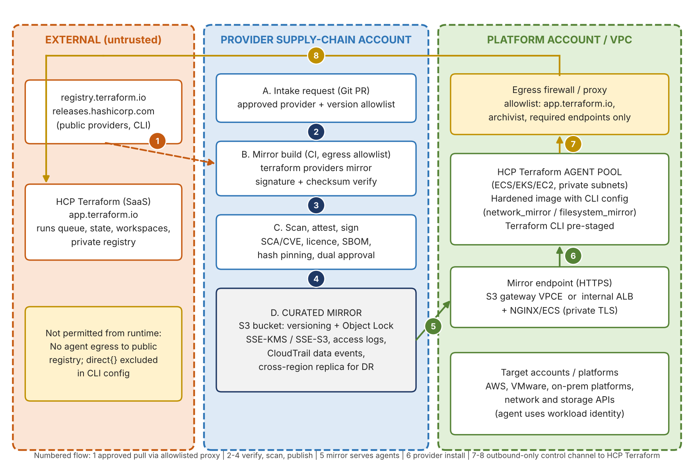
Figure 1. Curated provider supply chain feeding self-hosted HCP Terraform agents

5.1 Component responsibilities
Domain | Component | Responsibility | Key controls
Governance | Provider intake repository (Git) | Holds the approved provider and version allowlist (a versions.tf-style manifest) and the approval trail. | Branch protection, CODEOWNERS (Security + Platform), signed commits
Supply chain | Mirror build pipeline (CI) | Runs terraform providers mirror for approved providers and platforms; verifies signatures and checksums. | Ephemeral runners, egress allowlist to registry only, no workload credentials
Supply chain | Scan and attest stage | Vulnerability and licence review, SBOM, hash recording, publisher-tier check, attestation. | Fail on unapproved publisher; dual approval for new providers
Storage | Curated mirror (S3) | System of record for approved provider packages and mirror metadata. | Versioning, Object Lock, encryption, access logs, CloudTrail data events, replication
Serving | Mirror endpoint | Serves the mirror over HTTPS to agents only. | Private connectivity, TLS, bucket/endpoint policy, optional mTLS
Execution | Agent pool | Runs plan/apply inside the bank network using the hardened image. | Private subnets, no internet gateway, read-only root filesystem, image signing
Network | Egress firewall / proxy | Permits outbound agent traffic to HCP Terraform endpoints only. | FQDN allowlist, TLS inspection policy per bank standard, logging
Policy | Sentinel or OPA policies | Blocks workspaces from using non-approved provider sources or versions. | Hard-mandatory enforcement level for production organisations

5.2 Serving the mirror: two patterns

Pattern B1: S3 via gateway VPC endpoint (simplest)
- Terraform's network mirror client does not sign requests, so access must be anonymous at the HTTP layer but constrained at the network layer.
- Use a bucket policy that allows s3:GetObject on the mirror prefix only when aws:SourceVpce equals your endpoint ID, and deny everything else, including non-TLS requests.
- Constraint: anonymous requests cannot use a customer-managed KMS key, so objects must use SSE-S3. Where policy mandates a CMK, use Pattern B2.
- Use the S3 REST endpoint over HTTPS. S3 static website endpoints are HTTP-only and are not suitable.

Pattern B2: private ALB with a small proxy tier (CMK-capable)
- An internal Application Load Balancer with a private certificate fronts NGINX (or equivalent) on ECS/Fargate that reads the bucket using an IAM task role.
- Supports SSE-KMS with a CMK, mTLS between agents and mirror, request-level logging, and WAF-style rules if required.
- Costs more to operate; justified where the CMK or mTLS requirement exists.

6. Implementation

6.1 Step 1: Define the approved provider manifest
Keep one manifest per provider set in the intake repository. Pin exact versions so the mirror is reproducible.
# mirror-build/versions.tf
terraform {
required_providers {
aws = { source = "hashicorp/aws", version = "= 5.80.0" }
vsphere = { source = "hashicorp/vsphere", version = "= 2.10.0" }
random = { source = "hashicorp/random", version = "= 3.6.3" }
}
}

Note
Version numbers above are placeholders. Use the versions your security team has actually approved.

6.2 Step 2: Build the mirror in the isolated pipeline
Run this in the supply-chain account's CI, the only place with egress to registry.terraform.io (through an allowlisted proxy). List every platform your agents use.
cd mirror-build
terraform providers mirror \
-platform=linux_amd64 \
-platform=linux_arm64 \
./mirror-out

Terraform verifies each package against the signed checksums reported by the registry as it downloads. For a bank, add independent controls on top: restrict namespaces to approved publishers (for example hashicorp/* plus specifically approved partner providers), compare results to pinned key fingerprints held by Security, run vulnerability and licence scans, and generate an SBOM before publishing.

6.3 Step 3: Publish to the curated mirror
# Publish to a versioned prefix, then promote
aws s3 sync ./mirror-out s3://corp-tf-provider-mirror/releases/2026-11-09/ \
--exclude "*.json"
aws s3 sync ./mirror-out s3://corp-tf-provider-mirror/releases/2026-11-09/ \
--exclude "*" --include "*.json" --content-type application/json

- The mirror root served to agents should be a promoted, immutable release (for example via a controlled copy to the live prefix after approval), so a rollback is a prefix change rather than a rebuild.
- Enable S3 Versioning and Object Lock (compliance or governance mode per retention policy). Only the publisher role may write.
- The layout produced by terraform providers mirror includes index.json and per-version JSON files, which is what allows it to be served as a static network mirror. Confirm this against the Terraform version you use (Section 11).

6.4 Step 4: Configure Terraform CLI on the agents
Create a CLI configuration file in the agent image and point Terraform at it with the TF_CLI_CONFIG_FILE environment variable. The direct block exclusion is what makes the design fail closed.

Network mirror (Pattern B)
# /etc/terraform/terraform.rc
provider_installation {
network_mirror {
url = "https://tf-mirror.corp.example.com/providers/"
include = ["registry.terraform.io/*/*"]
}
direct {
exclude = ["registry.terraform.io/*/*"]
}
}

Filesystem mirror (Pattern A)
# /etc/terraform/terraform.rc
provider_installation {
filesystem_mirror {
path = "/opt/terraform/providers"
include = ["registry.terraform.io/*/*"]
}
direct {
exclude = ["registry.terraform.io/*/*"]
}
}

Set TF_CLI_CONFIG_FILE=/etc/terraform/terraform.rc in the agent container environment. As a secondary control, also define it as an environment variable in a variable set applied to all workspaces, so the intent is visible in HCP Terraform and survives image changes.

6.5 Step 5: Build the hardened agent image
- Start from the official HCP Terraform agent image, pinned by digest, and rebuild on a defined cadence.
- Add the CLI configuration file, the corporate CA bundle (for the private mirror certificate), and, for Pattern A, the providers directory.
- Pre-stage the Terraform CLI versions you support rather than letting agents download them at runtime, or allowlist releases.hashicorp.com through the proxy as a documented exception. Confirm the supported mechanism for your agent version (Section 11).
- Run as non-root, read-only root filesystem where possible, no shell tooling beyond what hooks require, scan with your image scanner, and sign the image (for example with Sigstore Cosign) and enforce signature verification at deploy time.

6.6 Step 6: Deploy the agent pool
- Run agents on ECS, EKS or EC2 in private subnets with no route to an internet gateway. Egress only to the firewall/proxy and the mirror endpoint.
- Create an agent pool per environment tier (non-production, production, and optionally per regulated zone). Use separate agent tokens, stored in Secrets Manager, rotated on schedule.
- Give agents workload identity (for example IAM roles) scoped to what their pool is allowed to deploy. Prefer dynamic credentials via OIDC from HCP Terraform over static keys.

6.7 Step 7: Network allowlist for agents
Destination | Port | Purpose | Notes
app.terraform.io | 443 | Agent control channel, run dispatch, API | Required. Outbound only.
archivist.terraform.io | 443 | Run artefacts and state-related storage | Required per current HashiCorp agent documentation; verify
Mirror endpoint (internal) | 443 | Provider download | Private connectivity only (VPCE or internal ALB)
registry.terraform.io | 443 | Public registry (modules, providers) | Do not allow from agents when using the mirror. Source modules internally.
releases.hashicorp.com | 443 | Terraform CLI download | Avoid by pre-staging the CLI; otherwise a controlled exception

6.8 Step 8: Lock files and workspace discipline
Generate and commit .terraform.lock.hcl so that hashes of the exact approved packages are recorded and verified at every init. Generate the hashes against the mirror, for the platforms your agents run on.
terraform providers lock \
-net-mirror=https://tf-mirror.corp.example.com/providers/ \
-platform=linux_amd64 -platform=linux_arm64

- Commit the lock file to the workspace's repository and require review on changes to it.
- Pin required_providers with exact or tightly bounded versions in every root module.
- Use a policy (Sentinel tfconfig import or OPA) to deny any provider source or version not on the approved list, as a backstop to the mirror itself.

6.9 Step 9: Internal and custom providers
For providers built in-house, publish them to the HCP Terraform private registry, signed with a bank-controlled GPG key, and reference them by the private registry address. Add an equivalent include rule or a separate provider_installation entry as required. Keep the signing key in an HSM-backed or KMS-backed process with restricted access.

7. Security controls and evidence
Control objective | Implementation | Evidence for audit
Only approved provider versions in use | Intake PR approval; mirror contains only approved versions; lock files; policy checks | PR history, mirror object inventory, policy results per run
Provider integrity and provenance | Signature/checksum verification at ingestion; hashes pinned in lock files; publisher allowlist | Pipeline logs, SBOM and attestation records, lock file diffs
No uncontrolled internet access from runtime | Private subnets, firewall FQDN allowlist, direct{} excluded in CLI config | Firewall rules and logs, VPC route tables, agent config in image
Tamper resistance of artefacts | S3 Versioning and Object Lock, restricted write role, image signing | Bucket configuration, CloudTrail data events, image signature verification logs
Separation of duties | Separate requester, approver, and publisher roles; protected branches | IAM role mappings, CODEOWNERS, approval records
Traceability | Release prefixes tagged to request ID; run-to-provider-version evidence in run logs | Release manifest, HCP Terraform run history
Resilience | Cross-region replication or secondary mirror; image registry replication | DR test results, replication metrics
Vulnerability response | Revocation process: remove or block version in the mirror and policy, notify workspace owners | Incident or change tickets, revocation log

8. Operating model and governance cadence

8.1 Change workflows
Workflow | Trigger | Steps | Target SLA
Add new provider | Team request | Intake PR, security review, licence and vulnerability scan, dual approval, mirror build, publish, notify | 5 business days
Version upgrade | Planned upgrade or new feature | Manifest PR, automated scans, approval, mirror build, promote, lock file update by consuming teams | 2 business days
Emergency security fix | Critical CVE | Expedited approval, build, promote; policy block for vulnerable version | Same day
Revocation | Compromise or critical defect | Block in policy, remove from live prefix (retain evidence), notify owners, track remediation | Immediate

8.2 Governance cadence
Cadence | Forum | Agenda | Owner
Weekly | Platform change review | Pending intake requests, mirror releases, failed runs caused by missing providers | Cloud Platform Engineering
Monthly | Provider and image hygiene | Version currency, CVE exposure, agent image rebuild, lock file drift | Platform Engineering + Security
Quarterly | Architecture and risk review | Control effectiveness, exceptions, DR test, access recertification, cost | Infrastructure Architecture + Risk
Annually | Design and audit review | Pattern fit against HashiCorp roadmap, regulatory changes, penetration test results | Architecture Board

8.3 Roles
Role | Responsibilities
Requesting team | Raises intake request, owns lock file updates and testing against new versions
Platform Engineering | Operates pipeline, mirror, agent pools and image; executes publishes
Information Security | Approves new providers and publishers, owns scanning and revocation decisions
Infrastructure Architecture | Owns the reference design, exceptions, and pattern evolution
Risk and Compliance | Reviews control evidence and exceptions

9. Capacity, performance and resilience
- Mirror size: each provider version is roughly tens to a couple of hundred megabytes per platform (the AWS provider is among the largest). Estimate as providers x versions retained x platforms, and set a retention policy (for example, current and previous two minor versions).
- Init time: a local or in-region mirror typically shortens terraform init compared with the public registry. Cache provider plugins on agents using a plugin cache directory where it does not weaken isolation.
- Concurrency: size the agent pool for peak concurrent runs; each agent handles one run at a time. Autoscale on queue depth.
- Availability: S3 plus VPC endpoint is regionally resilient. Replicate to a second region and keep a documented failover (change the mirror URL via a new agent image or an environment-driven config template).
- Monitoring: alarm on mirror 4xx/5xx rates, agent pool saturation, failed runs with provider install errors, and unexpected writes to the bucket.

10. Implementation roadmap
Phase | Duration | Deliverables | Exit criteria
0. Design and approvals | 2 weeks | This design, security and network sign-off, tier entitlement confirmed | Architecture Board approval
1. Foundation | 3 weeks | Supply-chain account, bucket and endpoint, CI pipeline, intake repo | First mirror built and verified in non-production
2. Agents | 3 weeks | Hardened image, agent pools, CLI config, firewall rules | Non-production workspaces running on agents with mirror only
3. Policy and pilot | 3 weeks | Policies, lock file standards, pilot with 3 to 5 teams | Pilot teams run clean for two release cycles
4. Production rollout | 4 to 6 weeks | Production pools, org default execution mode set to Agent, DR test | All production workspaces migrated; audit evidence pack complete

11. Items to validate before approval
The following depend on product versions and current vendor documentation, and should be confirmed in a proof of concept rather than assumed:
- That the HCP Terraform tier in use includes self-hosted agents and the organisation-level default execution mode setting.
- The exact set of HashiCorp endpoints agents must reach for your agent version, and how the agent obtains the Terraform CLI (pre-staged versus downloaded).
- That terraform providers mirror output (including index.json and version JSON files) is served correctly as a static network mirror with your Terraform version, including Content-Type handling.
- That TF_CLI_CONFIG_FILE set in the agent environment and/or as a workspace variable is honoured in your agent version for plan and apply.
- The behaviour of lock-file hashes when providers are installed from a mirror (mirror-derived hashes versus registry-derived hashes) across your target platforms, using terraform providers lock.
- Whether Information Security requires a customer-managed KMS key on the mirror bucket, which decides between Pattern B1 and B2.
- If regulation prohibits any SaaS control plane for infrastructure orchestration, evaluate self-hosted Terraform Enterprise instead; the mirror pattern in this document still applies.

12. Summary of recommendations
- Run all production workloads on self-hosted HCP Terraform agents and make Agent the organisation default execution mode.
- Adopt a curated S3-based network mirror as the standard, with a baked filesystem mirror for the most restricted zones.
- Exclude direct registry access in the CLI configuration so the platform fails closed.
- Gate every provider and version through a single, audited intake and verification pipeline with dual approval.
- Enforce with lock files and policy, and evidence with the controls in Section 7 and the cadence in Section 8.

