Variables & Operators

Variables:

a name for a location in main memory which uses a particular data type to hold a value.

in java every value has a type to tell what you can do
with it

typeName variableName = value;

the value given should match the type

the variableNames or references on stack are called
identifiers.

These & values are called literals.

1).Identifiers can be made up of letters,digits and the
underscores, they can not start with a digit.
Do not start with a digit.
An identifier can be any length.

2).you can not use other symbols like '?', '%'
"hello!" is not a legal identifier

3).spaces are not allowed inside identifiers.

4).You can not use any reserved words for them

5). identifiers are also case sensitive

6).variable,method names should start with a lower case
letter and at word separation capitalization should take
place called camelcase

7).class names should start with an uppercase letter
- member variable
- local variable
- method parameter
- exception-handler parameter

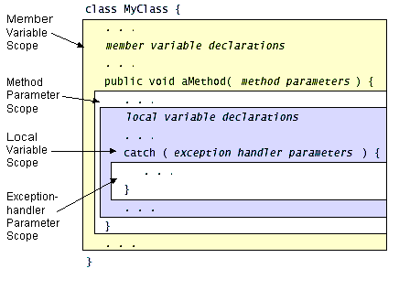

The shortcut increment/decrement operators are summarized in the following table.
Operator | Use | Description
++ | op++ | Increments op by 1; evaluates to the value of op before it was incremented
++ | ++op | Increments op by 1; evaluates to the value of op after it was incremented
-- | op-- | Decrements op by 1; evaluates to the value of op before it was decremented
-- | --op | Decrements op by 1; evaluates to the value of op after it was decremented

The following table lists the shortcut assignment operators and their lengthy equivalents:
Operator | Use | Equivalent to
+= | op1 += op2 | op1 = op1 + op2
-= | op1 -= op2 | op1 = op1 - op2
*= | op1 *= op2 | op1 = op1 * op2
/= | op1 /= op2 | op1 = op1 / op2
%= | op1 %= op2 | op1 = op1 % op2
&= | op1 &= op2 | op1 = op1 & op2
|= | op1 |= op2 | op1 = op1 | op2
^= | op1 ^= op2 | op1 = op1 ^ op2
<<= | op1 <<= op2 | op1 = op1 << op2
>>= | op1 >>= op2 | op1 = op1 >> op2
>>>= | op1 >>>= op2 | op1 = op1 >>> op2

