SafePulse
Smart Wearable Personal Safety & Emergency Response System
IoT Task Documentation
Technical Report
Submitted by: Devadharshini K
Register Number: 250801084
Department: Electronics and Communication Engineering
Rajalakshmi Engineering College

3.1 Problem Statement

Problem Being Addressed
Despite the availability of emergency helpline numbers such as 100, existing emergency response mechanisms depend heavily on the victim being able to make a phone call - a condition that frequently cannot be met during an actual emergency. In situations involving physical restraint, harassment, sudden medical distress, or scenarios where speaking aloud could escalate danger, the standard call-based emergency system becomes difficult or impossible to use. This creates a critical gap between the moment help is needed and the moment help can actually be requested.

Target Users
- Women commuting alone, especially during late hours
- Elderly individuals living alone or with limited mobility
- Solo travelers and night-shift workers
- Students commuting to and from campus or hostel

Motivation
National Crime Records Bureau (NCRB) data shows that reported crimes against women in India increased from just over 3.1 lakh cases in 2017 to more than 3.6 lakh cases in 2023, with the crime rate per lakh female population continuing to rise. A significant proportion of these incidents occur in circumstances where the victim has no safe or practical way to alert anyone in real time. This project is motivated by the need for an emergency response mechanism that functions independently of the victim's ability to speak, dial a number, or unlock a phone - reducing response time from minutes to seconds while operating discreetly enough not to provoke the very danger it responds to.

3.2 Proposed Solution

Overview
SafePulse is a wearable IoT-based personal safety device that allows a user to silently raise an emergency alert through a simple physical gesture - a long press or a hidden shake pattern - without needing to speak, unlock a phone, or navigate an app. On activation, the device captures the user's location and a short audio clip, then transmits this information to pre-registered emergency contacts and a monitoring dashboard through WiFi, with an automatic GSM/SMS fallback when no internet connection is available.

Objectives
- Enable emergency alert activation without requiring the user to speak or operate a smartphone
- Ensure alert delivery even in low-network or no-network conditions
- Minimize false alarms through a confirm-and-cancel mechanism
- Provide responders with real-time location and audio context automatically, removing the need for manual explanation

Expected Outcome
A functional wearable prototype (or simulated equivalent) that reliably detects a trigger event, distinguishes it from accidental activation, and delivers a location-tagged alert with audio context to a dashboard within seconds - demonstrating a practical, low-cost, and scalable approach to personal emergency response.

3.3 System Architecture
The system follows a four-layer IoT architecture - Perception, Network, Cloud/Processing, and Application.
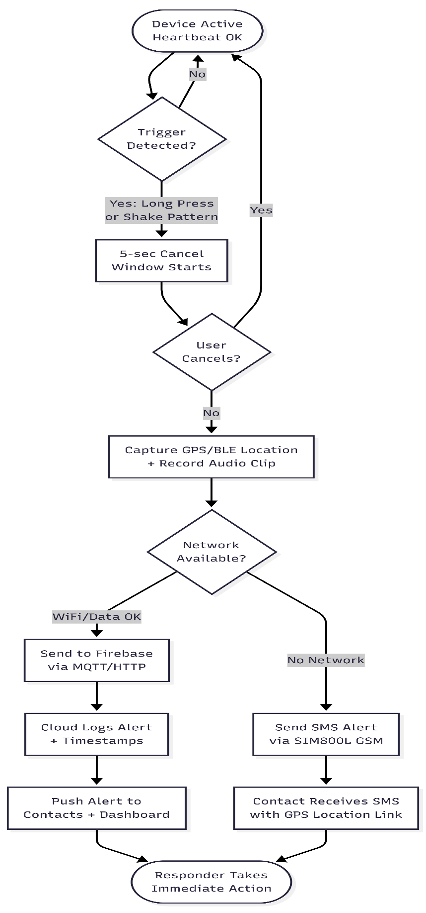.

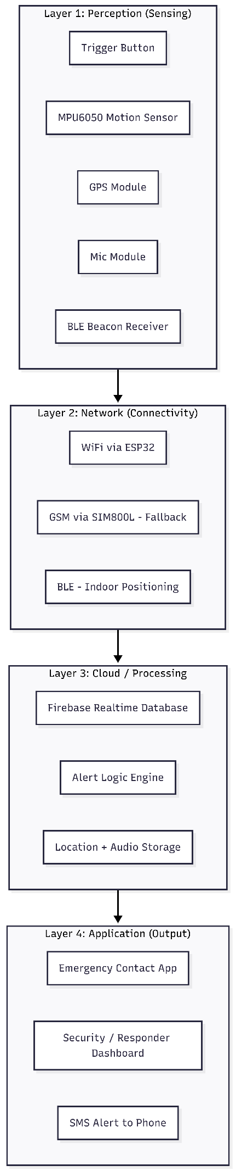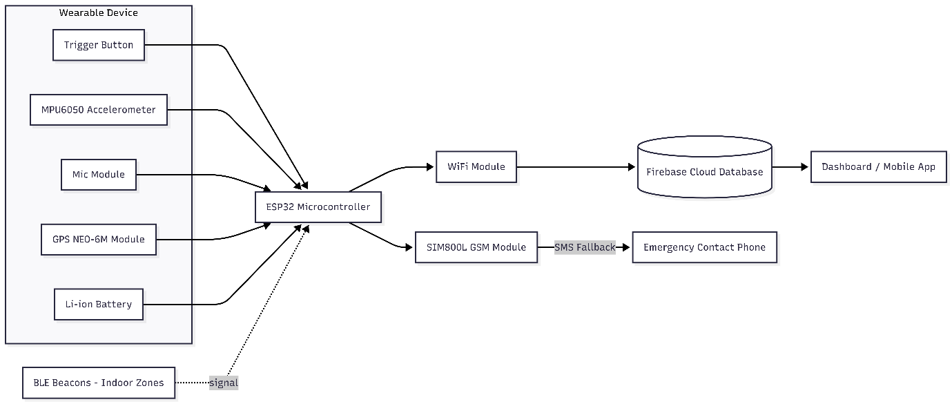

Layer Description
- Perception Layer: Trigger button, MPU6050 accelerometer, GPS module, microphone, and BLE beacon receiver capture the trigger event, motion pattern, location, and ambient audio.
- Network Layer: ESP32 transmits data over WiFi under normal conditions; the SIM800L GSM module provides an SMS-based fallback when no internet connection is available; BLE supports indoor position estimation.
- Cloud/Processing Layer: Firebase Realtime Database receives, timestamps, and logs each alert; alert logic determines what gets pushed and to whom.
- Application Layer: A dashboard/mobile app displays live alerts to registered emergency contacts or a responder, with SMS as a redundant notification channel.

3.4 Hardware & Software

Hardware Components
- ESP32 Microcontroller - core processing unit with built-in WiFi and Bluetooth
- MPU6050 Accelerometer - detects the shake-trigger pattern and confirms deliberate activation
- GPS Module (NEO-6M) - provides outdoor location coordinates
- BLE Beacons - enable indoor location estimation where GPS is unavailable
- SIM800L GSM Module - sends SMS alerts as a network fallback
- Microphone Module - captures a short audio clip at the time of the trigger
- Li-ion Battery - powers the wearable device
- Push Button / Trigger Switch - physical long-press trigger input

Software & Cloud Tools
- Firebase Realtime Database - stores and syncs alert data in real time
- Arduino IDE - firmware development for ESP32
- Wokwi - circuit simulation, if a physical prototype is not built
- Web/Android Dashboard - displays live alerts to contacts and responders

3.5 Working Methodology
- The device remains active and periodically sends a heartbeat signal to confirm it is functioning.
- When the user performs the trigger action (long press or shake pattern), the MPU6050 confirms it as a deliberate activation rather than accidental motion.
- A 5-second cancel window begins, during which the device vibrates; the user may cancel if the trigger was unintentional.
- If not cancelled, the device captures GPS/BLE-based location data and records a short audio clip.
- The ESP32 checks network availability. If WiFi/mobile data is available, the alert (location, audio, and user ID) is sent to Firebase via MQTT/HTTP.
- If no network is available, the SIM800L module sends an SMS containing the GPS coordinates directly to the emergency contact.
- On the cloud side, Firebase logs and timestamps the alert and pushes a real-time notification to the dashboard and registered contacts.
- The responder or emergency contact receives the alert with location and audio context, enabling an immediate, informed response without needing prior explanation from the user.

3.6 Feasibility

Estimated Cost
Component | Approx. Cost (Rs.)
ESP32 Development Board | 450
GPS Module (NEO-6M) | 500
SIM800L GSM Module | 350
MPU6050 Accelerometer | 120
Microphone Module | 100
Li-ion Battery + Holder | 200
BLE Beacons (x3) | 450
Casing, Wires & Misc. | 300
Total (approx.) | Rs. 2,470

Note: Prices are approximate and indicative; actual cost may vary by vendor and region.

Scalability
The system is modular - additional BLE beacons can be added to extend indoor coverage in larger buildings, and the cloud backend (Firebase) can handle a growing number of registered devices and users without architectural changes. The same hardware design can be adapted for elderly care (fall detection) or child safety with minimal firmware changes.

Reliability
The dual-communication design (WiFi with GSM fallback) ensures the alert is not dependent on a single network type, and the periodic heartbeat signal allows the system to flag its own failure - such as device tampering or battery loss - as a secondary safety measure.

Deployment Considerations
Initial deployment would require registering emergency contacts per user, placing BLE beacons at fixed indoor locations (for a campus or hostel pilot, for instance), and ensuring GSM connectivity in the deployment region. Battery life and device durability, including water and dust resistance, would need to be addressed for continuous everyday wear.

Future Scope
- Integration with local police or campus security systems for direct dispatch
- Machine learning-based fall and anomaly detection using accelerometer data
- Solar or kinetic charging to extend battery life
- Expansion into a "Safe Route" mapping feature using historical alert and incident data

