Name: Devendra Sopan Bharambe

SeatNo-2012094

RollNo- MCA2024080

A)Interface Seven Segment Display with Arduino and write a program to print numbers from 9 to 1 on SSD  
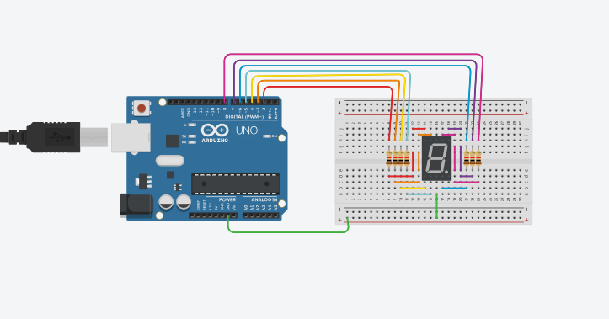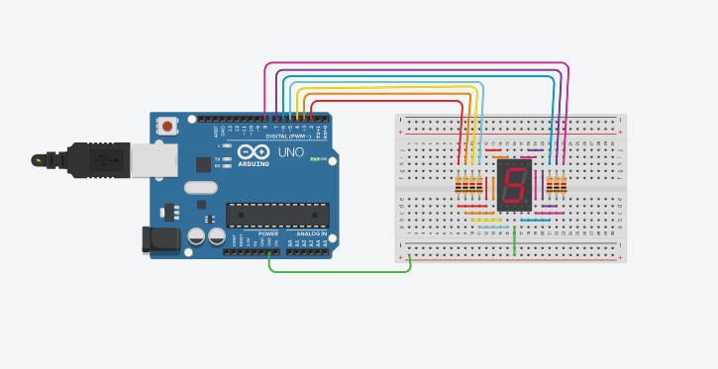

B)Interface a 4\*4 keypad with Arduino and display pressed keys on the serial monitor

