Name: Devesh Pingle

Seat No: 2012095

1. Write a program to interface LED’s, potentiometer with Arduino turn on or off more of the LEDs by turning the potentiometer knob.

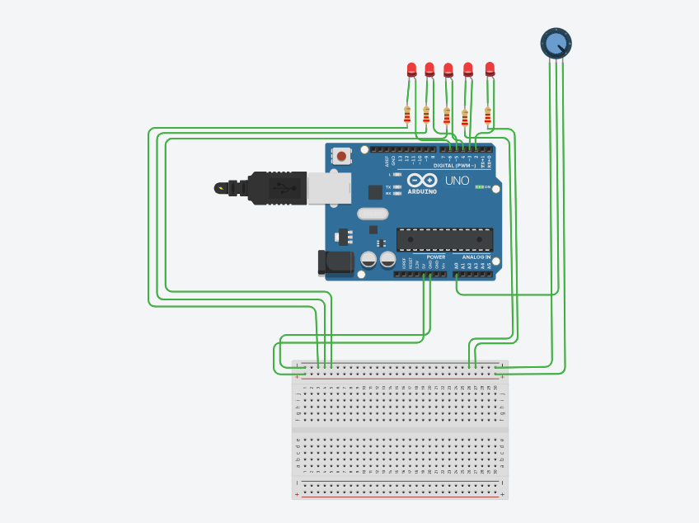

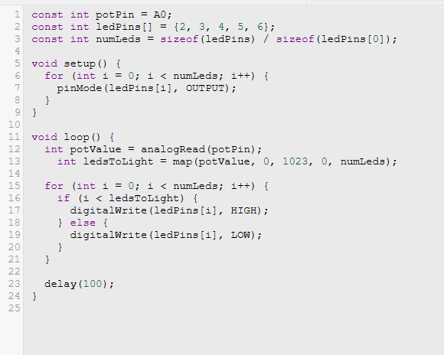

1. Interface a soil moisture sensor with Arduino and display the moisture level on the serial monitor. Trigger an LED if the soil is dry (moisture level below a threshold).

