Project Title: LAPTOP ROUTER MANAGER:

By, Group no.29.

(Deva Dharshini.R.L,Akshita Arunkumar)

Task 3: TUPLE CREATION:

Relation1: Administrator

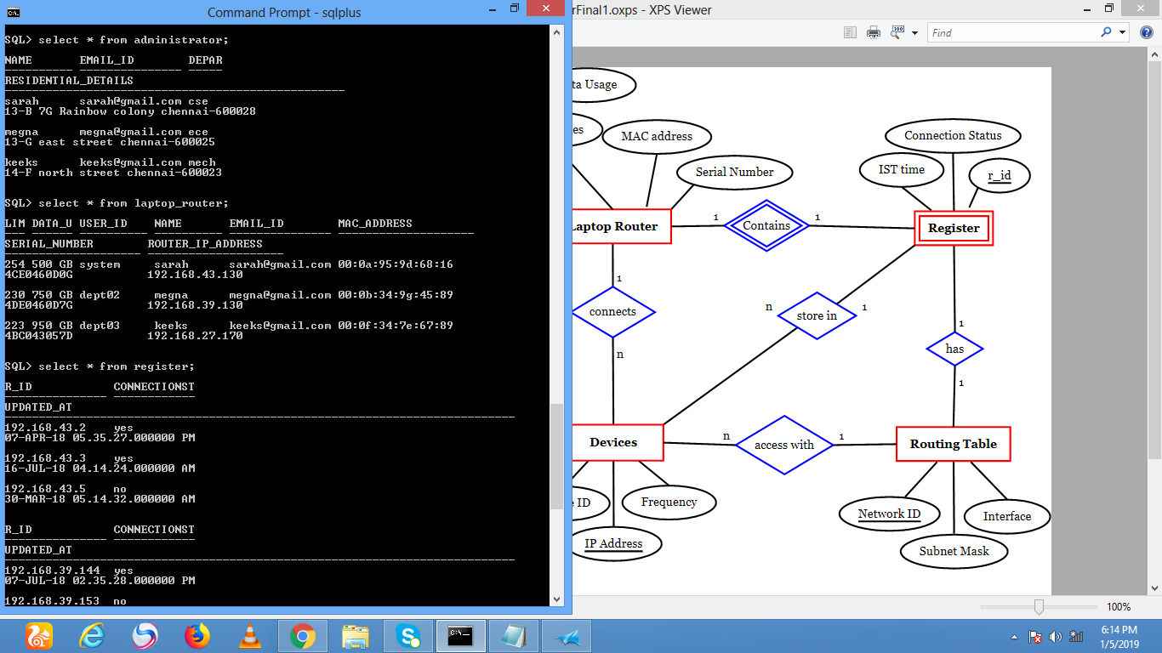

Relation 2: Laptop_Router



Relation3: Register

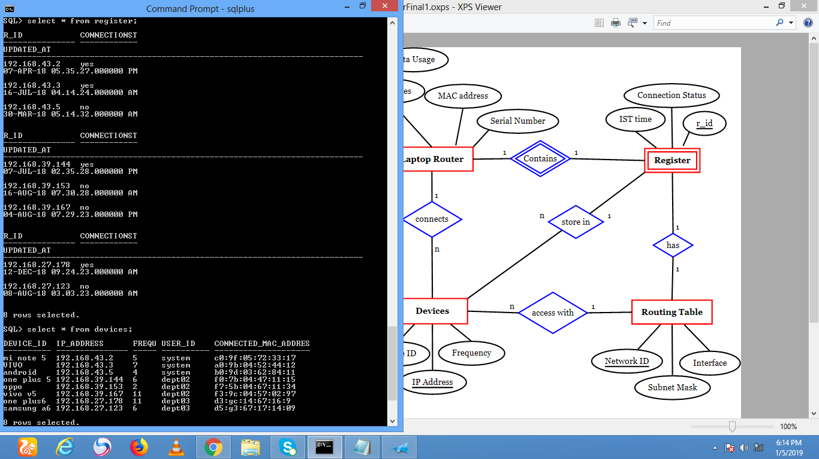

Relation 4: Block_List

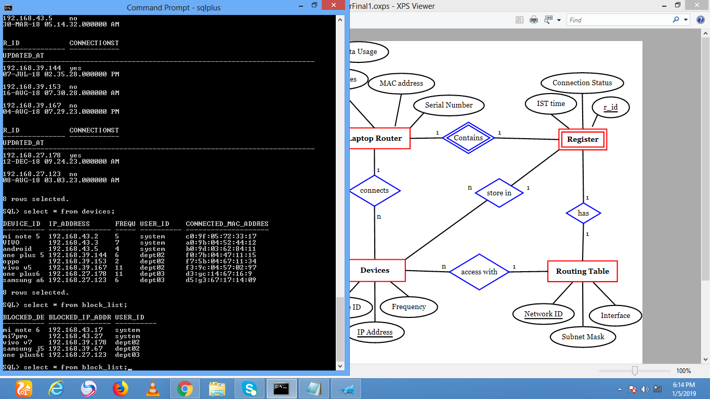

Relation 5: Devices

