PROCEDURES:

**1.Display the limit of devices of the user who gives maximum data usage.**

SET SERVEROUTPUT ON SIZE 2000;

DECLARE

PROCEDURE FINDLIM

IS

N_LIM NUMBER;

BEGIN

select limit_of_devices INTO N_LIM from laptop_router

where data_usage=(select max(data_usage) from laptop_router);

DBMS_OUTPUT.PUT_LINE('LIMIT OF DEVICES' ||N_LIM);

END;

BEGIN

FINDLIM;

END;

/

**2.Name the user who allows minimum data usage.**

SET SERVEROUTPUT ON SIZE 2000;

DECLARE

PROCEDURE MINDATA

IS

V_NAME LAPTOP_ROUTER.NAME%TYPE;

BEGIN

select name INTO V_NAME

from laptop_router

where data_usage=(select min(data_usage) from laptop_router);

DBMS_OUTPUT.PUT_LINE(V_NAME);

END;

BEGIN

MINDATA;

END;

/

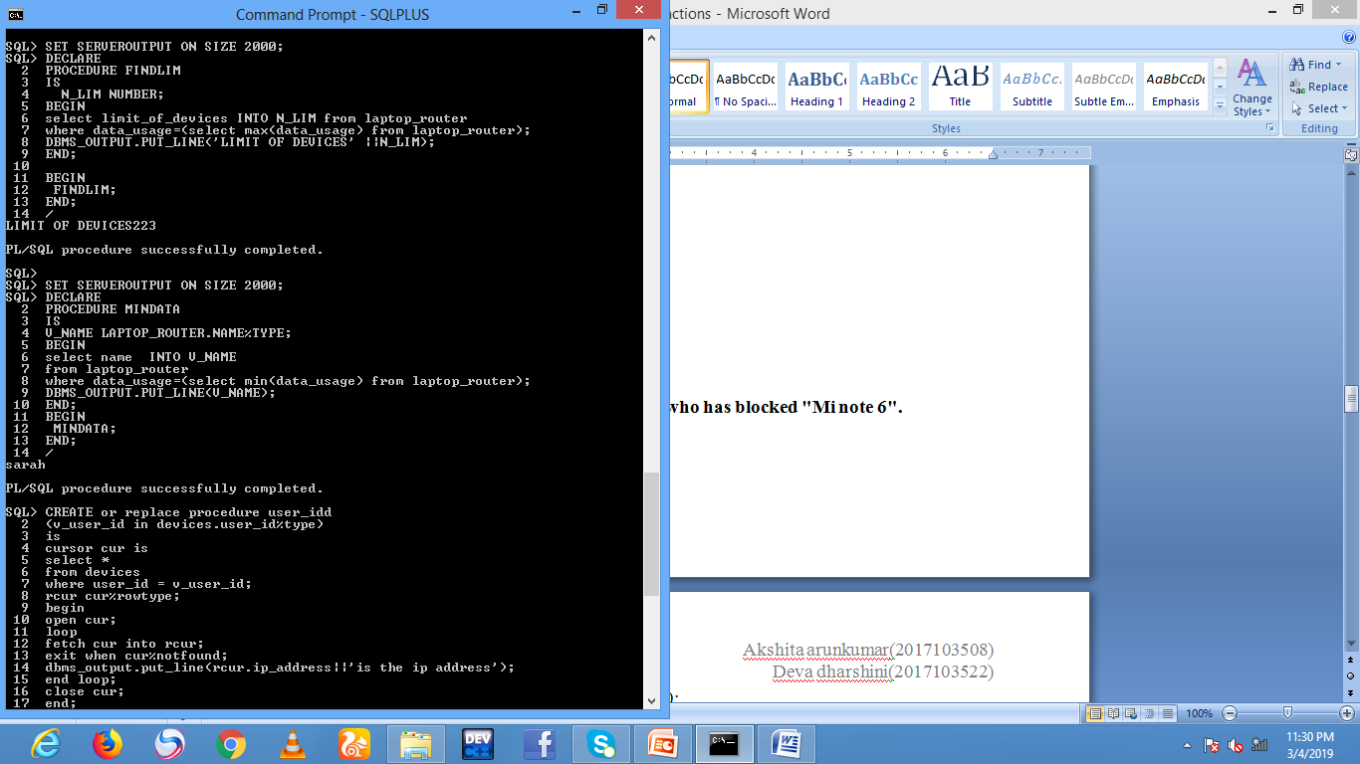

**3.List the IP address of the devices connected with the user id "system".**

CREATE or replace procedure user_idd

(v_user_id in devices.user_id%type)

is

cursor cur is

select *

from devices

where user_id = v_user_id;

rcur cur%rowtype;

begin

open cur;

loop

fetch cur into rcur;

exit when cur%notfound;

dbms_output.put_line(rcur.ip_address||'is the ip address');

end loop;

close cur;

end;

/

set serveroutput on size 2000;

begin

user_idd('system');

end;

/

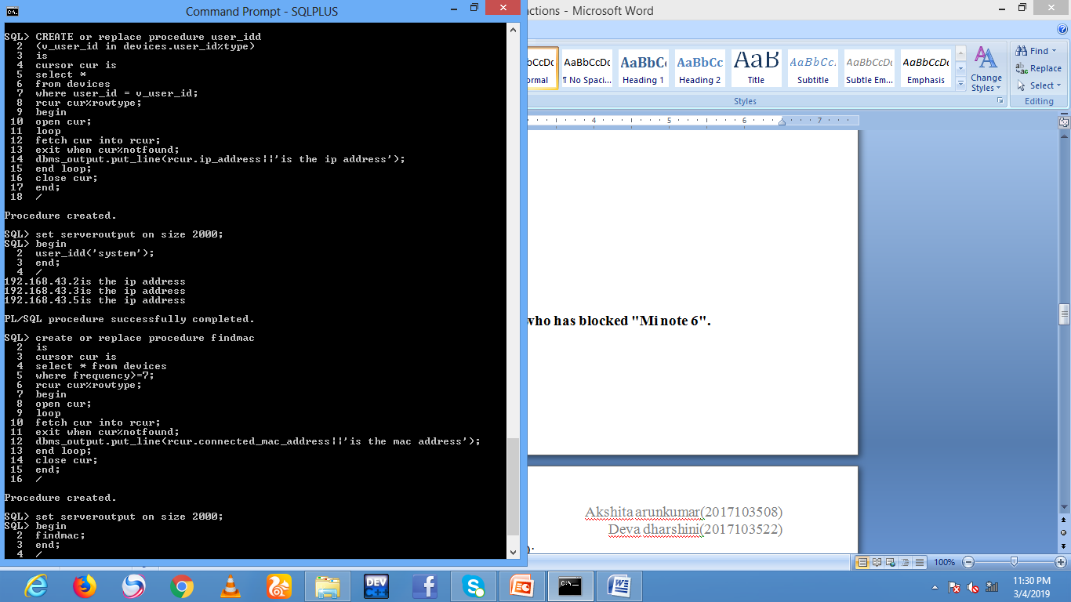

**4.Display the Mac Address of the devies which have connected more than 7 times.**

create or replace procedure findmac

is

cursor cur is

select * from devices

where frequency>=7;

rcur cur%rowtype;

begin

open cur;

loop

fetch cur into rcur;

exit when cur%notfound;

dbms_output.put_line(rcur.connected_mac_address||'is the mac address');

end loop;

close cur;

end;

/

set serveroutput on size 2000;

begin

findmac;

end;

/

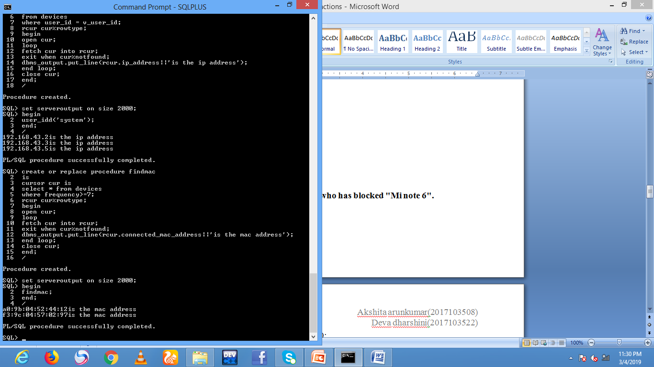

FUNCTIONS:

**1.Display the department of the user who has blocked "Mi note 6".**

SET SERVEROUTPUT ON SIZE 2000;

DECLARE

V_SYS VIEW_NEW1.DEPARTMENT%TYPE;

X BLOCK_LIST.BLOCKED_DEVICE_ID%TYPE;

FUNCTION FIND(X IN BLOCK_LIST.BLOCKED_DEVICE_ID%TYPE)

RETURN VIEW_NEW1.DEPARTMENT%TYPE

IS

C VARCHAR(10);

BEGIN

SELECT DEPARTMENT

INTO C FROM VIEW_NEW1

where user_id=(select user_id from block_list where blocked_device_id=X);

RETURN C;

END;

BEGIN

x:='mi note 6';

V_SYS:=FIND(X);

DBMS_OUTPUT.PUT_LINE('DEPARTMENT ' || V_SYS);

END;

/

**2.Display the address where the device id "192.168.43.2" is connected.**

SET SERVEROUTPUT ON SIZE 2000;

DECLARE

V_NAME VIEW_DEVICES.NAME%TYPE ;

V_ID VIEW_DEVICES.DEVICE_ID%TYPE;

FUNCTION MAXFIND(V_NAME IN VIEW_DEVICES.NAME%TYPE)

RETURN VIEW_DEVICES.DEVICE_ID%TYPE

IS

M_ID VARCHAR(10);

BEGIN

SELECT DEVICE_ID INTO M_ID

FROM VIEW_DEVICES WHERE NAME=V_NAME;

RETURN M_ID;

END;

BEGIN

V_NAME:='keeks';

V_ID:=MAXFIND(V_NAME);

DBMS_OUTPUT.PUT_LINE(V_ID);

END;

/

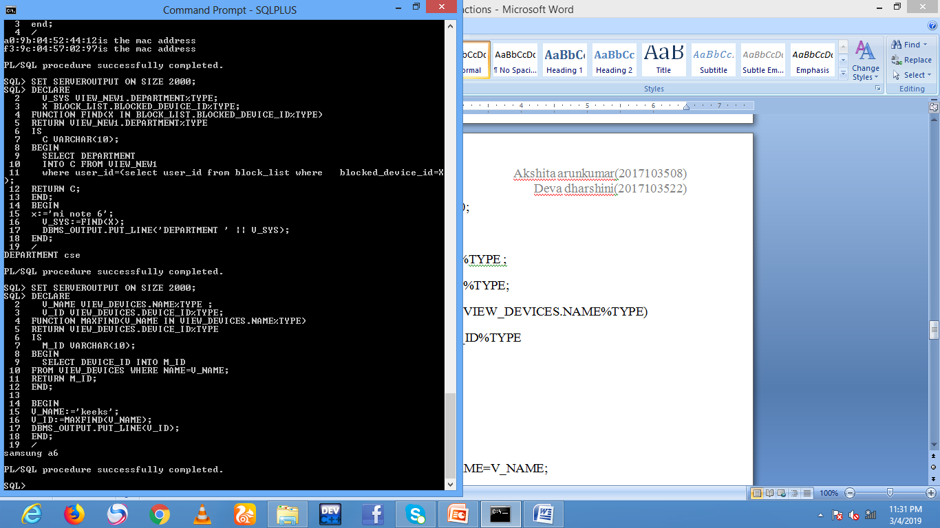

**3.Display the email where the device id "192.168.39.144" is connected.**

create or replace function findid

return administrator.email_id%type

is

v_mail administrator.email_id%type;

begin

select email_id into v_mail from administrator

where name=(select name from laptop_router

where user_id=(select user_id from devices

where ip_address='192.168.39.144'));

return v_mail;

end;

/

declare

v_id administrator.email_id%type;

begin

v_id := findid;

dbms_output.put_line(v_id);

end;

/

**4.Which device has connected often?**

create or replace function finddevice

return devices.device_id%type

is

v_id devices.device_id%type;

begin

select device_ID into v_id

from devices

where frequency=(select max(frequency) from devices);

return v_id;

end;

/

declare

v_id1 devices.device_id%type;

begin

v_id1 := finddevice;

dbms_output.put_line(v_id1);

end;

/

