A report on

Laptop Router Management

by

2017103522 | Deva Dharshini RL

2017103508 |Akshita Arunkumar

Submitted for the course

CS7411- Database Management Systems Laboratory

Evaluator Name and Signature

Date:25.03.19

ER Diagram

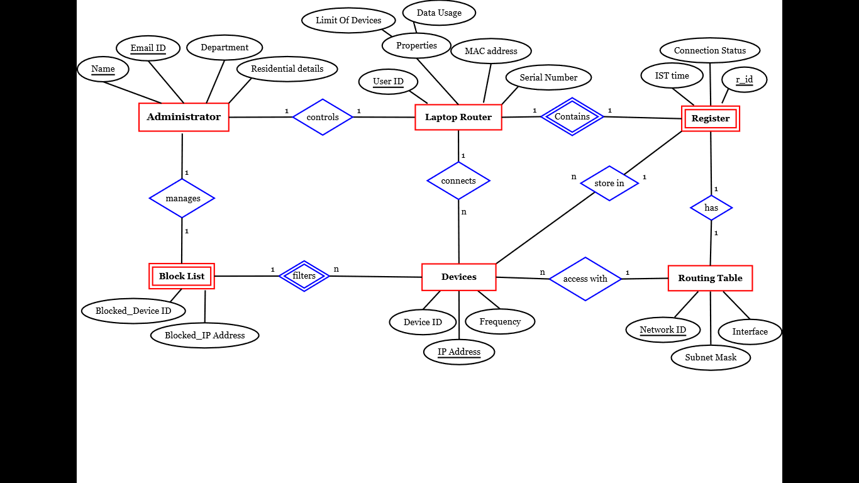

**DB SCHEMA**

**ADMINISTRATOR:**

create table Administrator(

Name varchar(10),

Email_ID varchar(15),

Department char(5),

Residential_details varchar(20),

Primary key(Email_ID,Name)

);

**LAPTOP ROUTER:**

create table Laptop_Router(

limit_of_devices varchar(3),

data_usage varchar(6),

User_ID varchar(10),

MAC_address varchar(15),

Serial_Number char(10),

Name varchar(10),

Email_ID varchar(15),

Primary key(User_ID),

Foreign key (Email_ID,Name) references Administrator

);

**REGISTER:**

create table Register(

r_id varchar(10),

IST_time timestamp,

User_ID varchar(10),

ConnectionStatus char(12),

Network_ID varchar(15),

Primary key (r_id),

Foreign key (Network_ID) references Routing_Table,

Foreign key(User_ID) references Laptop_Router

);

**DEVICES:**

create table Devices(

Device_ID varchar(10),

IP_address varchar(15),

Frequency char(5),

User_ID varchar(10),

list_id varchar(5),

Network_ID varchar(15),

Primary key(IP_address),

Foreign key(Network_ID) references Routing_Table,

Foreign key(User_ID) references Laptop_Router

)

**BLOCK LIST:**

create table Block_List(

blocked_Device_ID varchar(10),

blocked_IP_address varchar(15),

User_ID varchar(10),

Foreign key(User_ID) references Laptop_Router

);

**INSTANCES OF EACH RELATION(SNAP SHOT)**

**Relation1: Administrator**

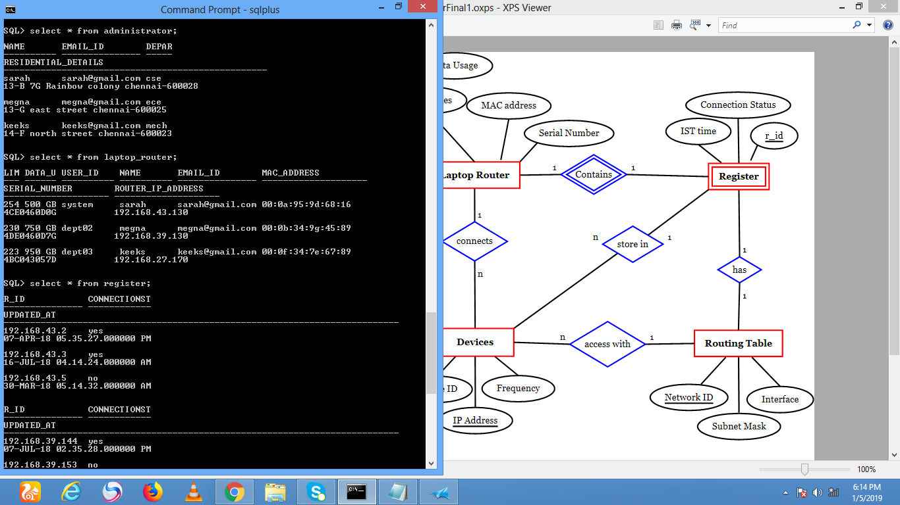

**Relation 2: Laptop Router**

**Relation3: Register**

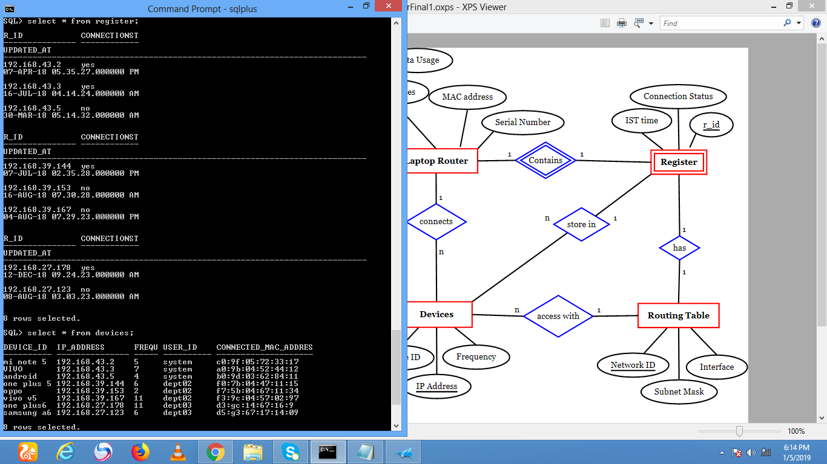

**Relation 4: Block List**

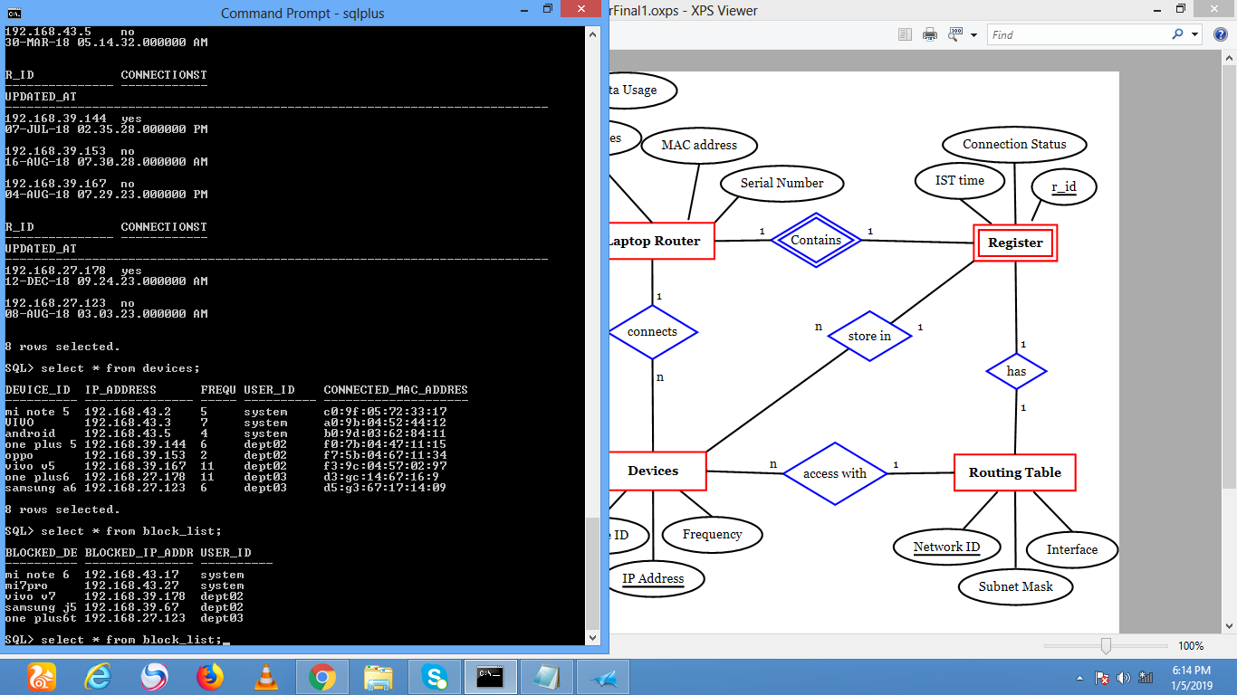

**Relation 5: Devices**



Views

|  |  |  |  |  |
| --- | --- | --- | --- | --- |
| # | Name | Tables Involved | Description | Output |
| 1 | View_devices | Devices,laptop router | Devices that are currently connected to an user | Samsung a6 |
| 2 | Count_view | devices | To find the maximum cevices connected | System,dept02 |
| 3 | View_new1 | Laptop router,administrator | To find Department of the user who has blocked mi note 6 | Cse,  Ece,mech |
| 4 | View_password | administrator | To find name and password of admins | Sarah,sarah123  Megna,megna123  Keeks,keeks123 |

Procedures

|  |  |  |  |  |
| --- | --- | --- | --- | --- |
| 1 | Findlim  To find limit of devices. | Laptop router,Devices | In:nil | 223 |
| Out:Limit of devices |
| 2 | Mindata  To find the user with lowest data usage | Laptop router | In:nil  Out:data usage | sarah |
| 3 | User_id  To find IP address of devices connected with a particular user id | Devices | In:user id  Out:ip address | 192.168.43.2  192.168.43.3  192.168.43.5 |
| 4 | Findmac  To find mac address of devices connected more than a particular number of times | Devices | In:nil  Out:mac address | Ao:9b:04:52:44:12  F3:9c:04:57:02:97 |

Functions

|  |  |  |  |  |  |
| --- | --- | --- | --- | --- | --- |
| # | Name & Description | Tables Involved | Parameter(s) | Return Type | Output |
| 1 | find  Department of the user who has blocked aparticular device id | Block list,administrator | Block_list(blocked_device_id):=mi note 6 | varchar | cse |
| 2 | findaddress  to find device id of device connected to a particular admin | Administrator,devices | View_device(device_id):=keeks | varchar | Samsung a6 |
| 3 | To find email address of  a device id | Administrator,devices,  blocked_devices | Devices(ip_address):=192.168.39.144 | varchar | megna@gmail.com |
| 4 | Device that has connected often | Devices, | Devices(frequency) | varchar | vivo |

Triggers

|  |  |  |  |  |
| --- | --- | --- | --- | --- |
| # | Name & Description | Trigger Type | Tables Involved | Output |
| 1 | Del_dev | Before delete | devices | Prevents deletion in devices |