DBMS Project Submission:

[SQL Query processing]

By,

Group no:29

Akshita Arunkumar (2017103522)

Deva Dharshini.R.L(2017103508)

**SQL Query processing:**

**1.Which device has connected often?**

select device_ID

from devices

where frequency=(select max(frequency) from devices);

**2.Display the user_id who has blocked more than two devices.**

select user_id,count(user_id) from block_list

group by user_id having count(user_id)>=2;

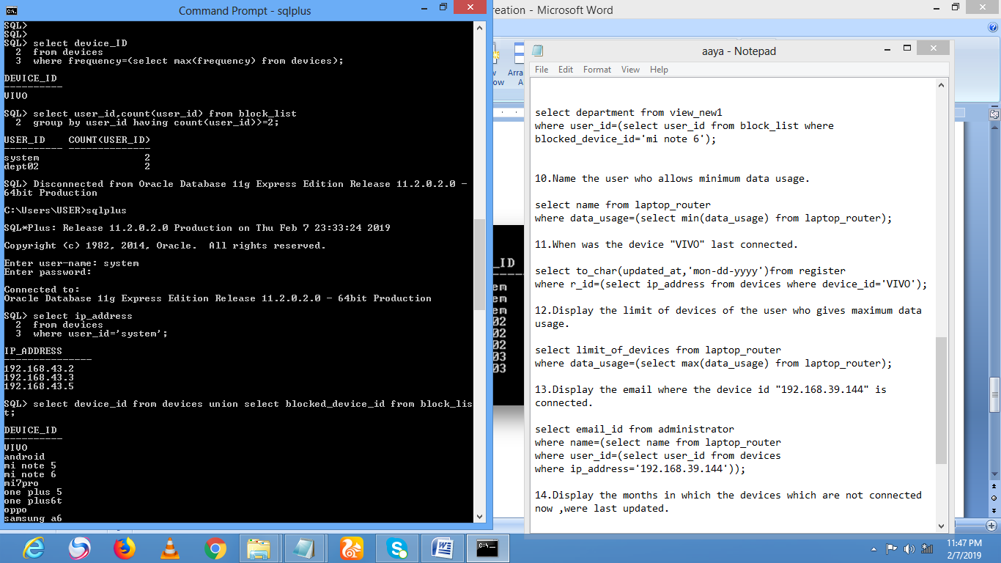

**3.List the IP address of the devices connected with the user id "system".**

select ip_address

from devices

where user_id='system';

**4.List all the devices that were connected till date with the user id "dept02".**

select device_id from devices union select blocked_device_id from block_list;

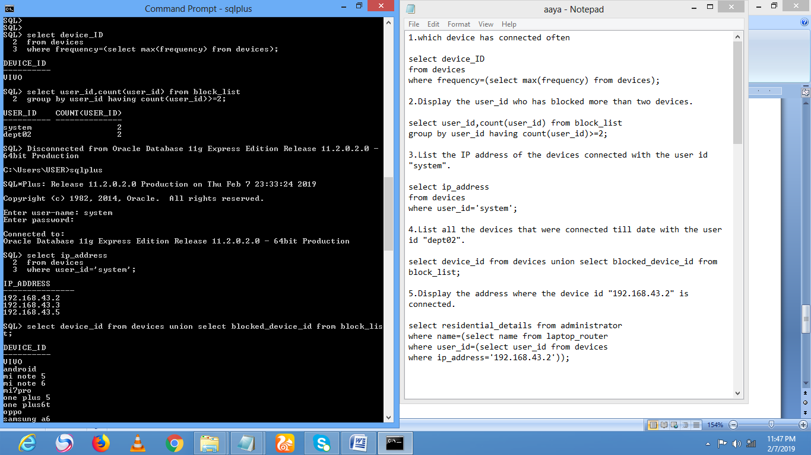

**5.Display the address where the device id "192.168.43.2" is connected.**

select residential_details from administrator

where name=(select name from laptop_router

where user_id=(select user_id from devices

where ip_address='192.168.43.2'));

**6. Update the limit of devices of the router to which one plus 5 is connected to 250.**

update laptop_router

set limit_of_devices='300'

where user_id=(select user_id from devices where device_id='one plus 5');

**7.Name all the devices that are connected currently to "Keeks".**

create view view_devices as

select device_id,name from devices D

inner join laptop_router LR

on LR.user_id=D.user_id;

select device_id from view_devices where name='keeks';

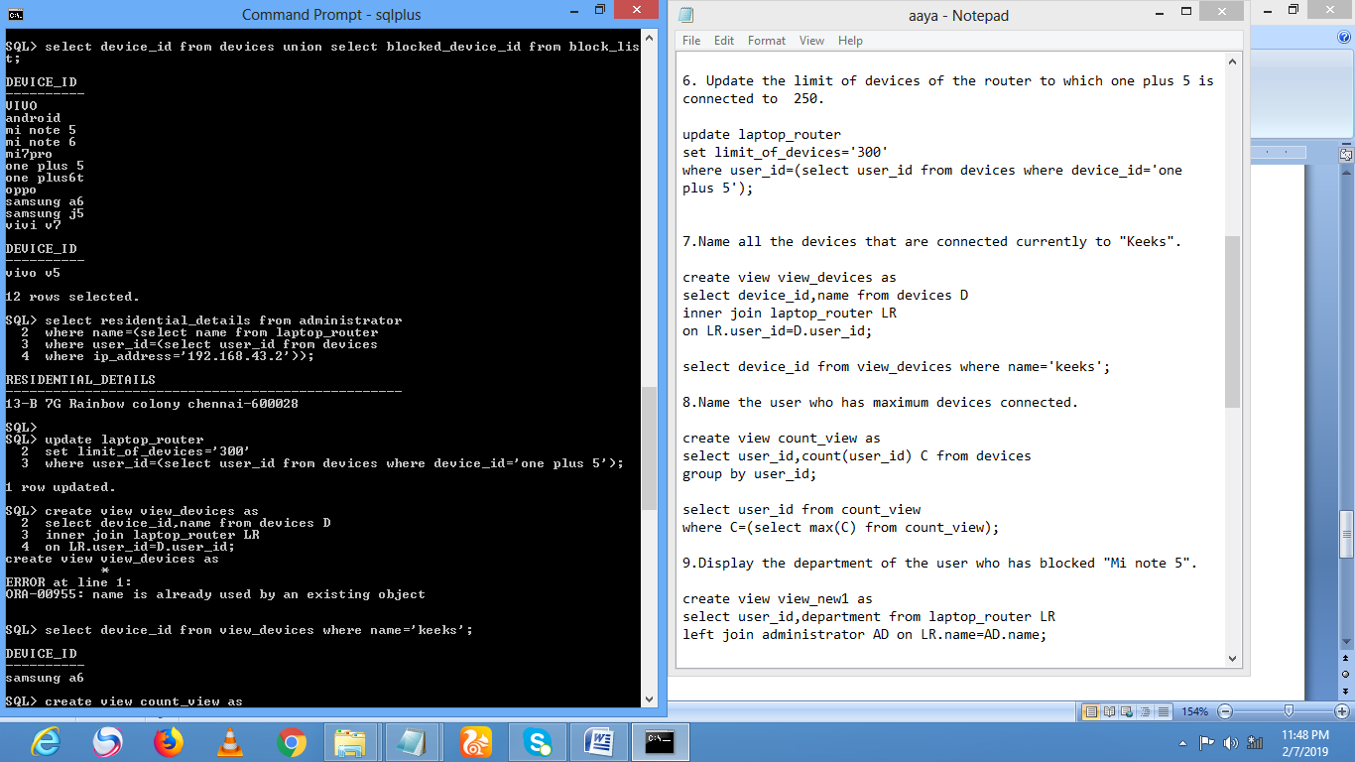

**8.Name the user who has maximum devices connected.**

create view count_view as

select user_id,count(user_id) C from devices

group by user_id;

select user_id from count_view

where C=(select max(C) from count_view);

**9.Display the department of the user who has blocked "Mi note 5".**

create view view_new1 as

select user_id,department from laptop_router LR

left join administrator AD on LR.name=AD.name;

select department from view_new1

where user_id=(select user_id from block_list where blocked_device_id='mi note 6');

**10.Name the user who allows minimum data usage.**

select name from laptop_router

where data_usage=(select min(data_usage) from laptop_router);

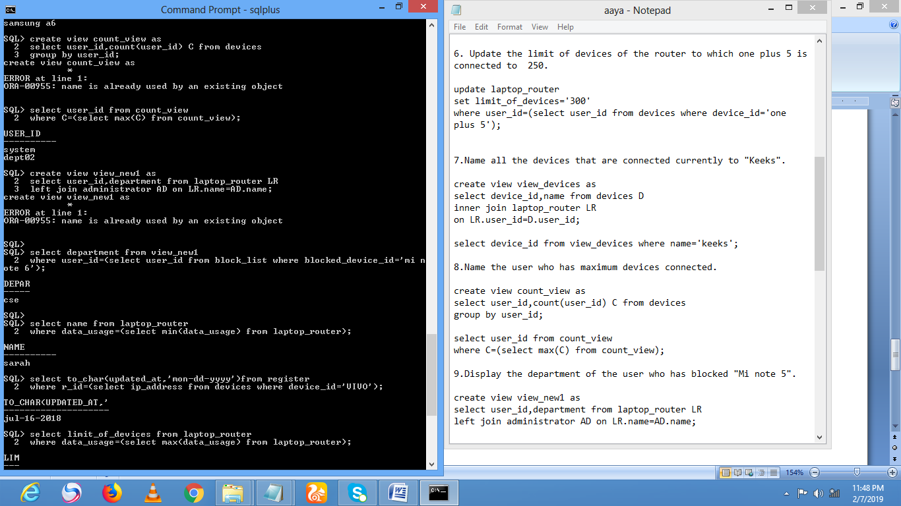

**11.When was the device "VIVO" last connected.**

select to_char(updated_at,'mon-dd-yyyy')from register

where r_id=(select ip_address from devices where device_id='VIVO');

**12.Display the limit of devices of the user who gives maximum data usage.**

select limit_of_devices from laptop_router

where data_usage=(select max(data_usage) from laptop_router);

**13.Display the email where the device id "192.168.39.144" is connected.**

select email_id from administrator

where name=(select name from laptop_router

where user_id=(select user_id from devices

where ip_address='192.168.39.144'));

**14.Display the months in which the devices which are not connected now ,were last updated.**

select extract(month from updated_at) from register

where connectionstatus='no';

**15.Display the Mac Address of the devies which have connected more than 7 times.**

select connected_mac_address from devices

where frequency>=7;

